Contents

1. Introduction to chemistry 14
   1. Definition of chemistry 14
   2. Applications of chemistry 14
   3. A laboratory 14
   4. Uses of a laboratory 14
   5. Precautions/ safety measures/rules and regulations taken in the laboratory 14
   6. Apparatus used in the laboratory 15
   7. Apparatus and their uses 18
      1. The Bunsen burner 18
      2. Flames of the Bunsen burner 19
         1. Luminous flame 19
         2. Characteristics of a luminous flame 19
         3. Non luminous flame 19
         4. Characteristics of a non luminous flame 19
         5. Parts of a non luminous flame 20
         6. Differences between luminous and non-luminous flame 20
         7. Steps followed when lighting a Bunsen burner 20
2. States of matter 21
   1. Solids 21
   2. Liquids 21
   3. Gases 22
   4. Change of state 22
   5. The Kinetic Particle Theory of Matter 25
   6. Diffusion 26
      1. Diffusion of gases 26
      2. Diffusion of liquids 26
      3. Factors Affecting Rate of Diffusion 27
         1. Temperature 27
         2. Mass of particles 27
3. Chemical and physical changes 28
   1. Differences between physical and chemical changes 28
4. Solutions, crystals, compounds and mixtures 29
   1. Solutions 29
   2. Solute 29
   3. Solvent 29
   4. Types of solutions 29
      1. A saturated solution 29
      2. A super saturated solution 29
      3. A suspension 29
   5. Differences between solutions and suspensions 29
   6. Crystals 30
   7. How to grow a large crystal of copper (II) sulphate 30
   8. Water of crystallization 30
5. Compounds and mixtures 31
   1. Compound 31
   2. Mixture 31
   3. Differences between mixtures and compounds 31
   4. Methods of separation of mixtures 32
   5. The methods of separation of mixtures include the following 32
      1. Filtration 32
      2. Crystallisation & Evaporation to Dryness 33
      3. Evaporation to dryness 33
      4. Decanting 34
      5. Using separating funnel 35
      6. Distillation 36
         1. Simple Distillation 36
         2. Separation of a mixture of water and ethanol by distillation 37
         3. Fractional distillation 37
      7. Sublimation 38
      8. Magnetic Attraction 39
      9. Chromatography 40
6. Elements, compounds, atoms and symbols 41
   1. An element 41
   2. An atom 41
   3. A molecule 41
   4. Radicals 41
   5. Chemical symbols 42
   6. Metals and non-metals 43
   7. Properties of metals and non-metals 44
7. Atomic structure and the periodic table 44
   1. An atom 44
   2. Composition of an atom 44
   3. Structure of an atom 45
   4. Atomic number 46
   5. Atomic mass 46
   6. Electronic configuration 47
   7. Electronic configuration of ions 49
   8. Isotopes 50
8. The periodic table 51
   1. Chemical families 53
   2. Bonding 60
   3. Ionic/Electrovalent Bonding 60
   4. Covalent Bonding 62
   5. Dative bonding 65
   6. Metallic Bonding 65
9. Valency 66
   1. Elements and radicals with their valencies 66
   2. Radicals 67
10. Chemical formulae 68
    1. Writing chemical formulae 68
    2. Calculating the number of atoms of elements in a compound 70
11. Chemical equations 71
    1. Balanced chemical equations 72
    2. Balancing chemical equations 72
12. Types of chemical reactions 75
    1. Direct combination or direct synthesis 75
    2. Simple decomposition 76
    3. Simple replacement 76
    4. Double replacement 76
13. The atmosphere and combustion 76
    1. Air is a mixture of gases 77
       1. Oxygen 77
       2. Uses of oxygen 77
       3. Nitrogen 77
       4. Carbon dioxide 77
       5. Noble gases 78
       6. Uses of noble gases 78
       7. Water vapour 78
    2. Hygroscopic, deliquescent and efflorescent substances 78
       1. Hygroscopic substances 78
       2. Deliquescent substances 78
       3. Efflorescent substances 79
       4. Water of crystallisation 79
    3. Drying agents 79
    4. Burning substances in air 79
    5. Rusting 82
    6. Combustion Error! Bookmark not defined.
14. Methods of gas collection Error! Bookmark not defined.
15. Oxygen Error! Bookmark not defined.
    1. Oxides 85
16. Oxidation and reduction 86
17. Water and hydrogen 88
    1. Sources of water 88
    2. Properties of pure water 88
    3. Test for water 88
    4. Purification of water 89
    5. Reactions of metals with water 89
    6. Uses of water 91
    7. Reactivity Series 91
18. Hydrogen 93
19. Acids, bases and salts 96
    1. Acids 96
       1. Common Acids 96
       2. Laboratory acids: 3 common laboratory acids/Mineral acids 96
       3. Basicity of an acid 97
       4. Some Acids with Their Basicity 97
       5. Strong and Weak Acids 97
       6. Comparing Strong and Weak Acids with Concentrated and Dilute Acids 98
       7. Properties of Dilute Acids 98
       8. Storage of Acids 99
       9. Uses of Acids 99
       10. Acids and Hydrogen Ions 99
    2. Bases and Alkalis 100
       1. Properties of Alkalis 100
       2. Neutralisation reactions 101
       3. Preparation of bases 101
       4. Strong and Weak Bases 102
       5. Uses of Alkalis 102
    3. Indicators and pH 102

19.3.1. pH 102

19.3.2. pH scale 102

* 1. Indicators 103
  2. Measuring pH of a Solution 103
  3. Ionic Equations 104
  4. Salts 107
     1. Types of salts 107
     2. Preparation of Salts 108
     3. Soluble and Insoluble Salts 108
     4. Preparation of Insoluble Salts 109
     5. Preparation of Soluble Salts 110
     6. Action of heat on salts 115
  5. Solubility of salts 117
     1. Solubility curves 118
     2. Uses of solubility 118
  6. Determination of solubility of salts 119

1. Carbon and its compounds 120
   1. Oxides of carbon 126
      1. Carbon dioxide 126
      2. Carbon monoxide 133
   2. Carbonates and hydrogen carbonates 139
   3. Calcium Oxide (quicklime) 144
   4. Sodium carbonate (soda ash) 145
   5. The Carbon cycle 148
   6. Hardness of water 152
2. Electrolysis 155
   1. Laws of electrolysis 170
   2. Application of electrolysis 175
3. Formulae, stoichiometry and the mole concept 183
   1. Relative Atomic Mass 183
   2. Percentage Composition 185
   3. Calculating the Mass of an Element in a Compound 186
   4. Calculating the Mass of Water in a Compound 186
   5. Mole 186
   6. Molar Mass 187
   7. Different Kinds of Chemical Formulae 188
   8. Calculating the Empirical Formula from Percentage Composition 189
   9. From Empirical formula to Molecular Formula 189
   10. Molar Volume of Gases 193
   11. Calculations using chemical equations 194
       1. Constructing Chemical Equations 194
       2. Calculations from Equations 196
          1. Reacting Masses 196
          2. Reacting Masses and Volumes 197
          3. Calculations involving energy changes 199
   12. Concentration of Solutions 200
   13. Quantitative analysis 203
   14. Uses of Titrations in Analysis 205
       1. Identification of Acids and Alkalis 205
       2. Determination of basicity of an acid 208
       3. Determination of water of crystallisation in oxalic acid (COOH)2. xH2O 210
   15. Calculations of volume of solutions 212
   16. Gay Lussac‘s law 214
   17. Gas laws 214
4. Qualitative analysis 216
5. Sulphur and its compounds 225
   1. Sulphur 225
   2. Extraction of sulphur by the Frasch‘s process 225
   3. Extraction of sulphur from natural gas 225
   4. Uses of sulphur 226
   5. Allotropes of sulphur 226
      1. Rhombic sulphur 226
      2. Monoclinic sulphur 227
      3. Amorphous sulphur 227
      4. Plastic sulphur 228
      5. Colloidal sulphur 228
   6. Properties of sulphur 228
      1. Physical properties 228
      2. Chemical properties of sulphur 228
6. Action of heat on sulphur (in absence of air) 228
7. Combustion of sulphur (in a plentiful supply of air) 228
8. Reaction with metals and non-metals 229
9. Action of acids on sulphur 229
   1. Oxides of sulphur 229
      1. Sulphur dioxide 229
         1. Laboratory preparation of sulphur dioxide 229
         2. Properties of sulphur dioxide 230
         3. Uses of sulphur dioxide 231
      2. Sulphur trioxide 231
         1. Preparation of sulphur trioxide 231
   2. Sulphuric acid 232
      1. Industrial manufacture of sulphuric acid by the contact process 232
      2. Properties of sulphuric acid 233
         1. Physical properties 233
         2. Chemical properties 233
      3. Uses of sulphuric acid 235
   3. Sulphates 235
   4. Hydrogen sulphide 237
      1. Laboratory preparation of hydrogen sulphide 237
      2. Testing for hydrogen sulphide 238
      3. Properties of hydrogen sulphide 238
         1. Physical properties 238
         2. Chemical properties 238
10. Nitrogen and its compounds 240
    1. Nitrogen 240
    2. Laboratory preparation of nitrogen from air 240
    3. Test for nitrogen 242
    4. Properties of nitrogen 242
    5. Uses of nitrogen 243
    6. Nitrogen monoxide (nitrogen(II) oxide) 244
       1. Laboratory preparation of nitrogen monoxide 244
       2. Tests for nitrogen monoxide 244
       3. Properties of nitrogen monoxide 245
    7. Nitrogen dioxide 245
       1. Laboratory preparation of nitrogen dioxide 245
       2. Properties of nitrogen dioxide 246
    8. Ammonia 247
       1. Laboratory preparation of ammonia 247
       2. Industrial preparation of ammonia (Haber process) 248
       3. Tests for ammonia 248
       4. Properties of ammonia 249
       5. Solubility of ammonia in water 249
       6. Experiment to demonstrate the high solubility of ammonia gas in water 249
       7. Action of ammonia on copper (II) oxide 250
       8. Combustion of ammonia 251
       9. Reaction with hydrogen chloride 252
       10. Reaction with chlorine 252
       11. Uses of ammonia 253
       12. Ammonia solution 254
           1. Preparation of ammonia solution 254
       13. Ammonium salts 254
           1. Nitrogenous fertilizers 254
           2. Effect of heat on ammonium salts 255
           3. Test for ammonium salts 256
       14. Reactions of ammonia solution and sodium hydroxide solution 257
       15. Nitric acid 259
           1. Laboratory preparation of nitric acid 259
           2. Industrial preparation of nitric acid 260
           3. Uses of nitric acid 260
           4. Properties of nitric acid 261
           5. Nitric acid acting as a strong acid 261
           6. Nitric acid as an oxidizing agent 262
    9. Nitrates 263
       1. Action of heat on nitrates 263
       2. Test for nitrates 265
11. Chlorine and its compounds 273
    1. Chlorine 273
       1. Laboratory preparation of chlorine 273
       2. Industrial manufacture of chlorine 274
       3. Properties of chlorine 275
       4. Tests for chlorine 281
       5. Uses of chlorine 281
    2. Hydrogen chloride 281
       1. Laboratory preparation of hydrogen chloride 281
       2. Test for hydrogen chloride 282
       3. Properties of hydrogen chloride 282
    3. Hydrochloric acid 282
       1. Preparation of hydrochloric acid 282
       2. Properties of hydrochloric acid 283
       3. Uses of hydrochloric acid 284
       4. Properties of hydrogen chloride in methylbenzene 284
    4. Testing for soluble chloride 284
12. Extraction of metals 289
    1. Introduction 289
    2. Concentration of ores 289
    3. Sodium 290
       1. Extraction of sodium 290
       2. Uses of sodium metal 291
    4. Copper 291
       1. Extraction of copper 292
       2. Concentration of the ore 292
       3. Roasting and reduction 292
       4. Refining of the impure copper 293
       5. Uses of copper 294
    5. Iron 294
       1. Extraction of iron 294
       2. Casting iron (pig-iron) 295
       3. Wrought iron 295
       4. Steel 296
       5. Recycling of metals 296
       6. Alloy 297
13. Organic chemistry 300
    1. Introduction 300
    2. Hydrocarbons 300
    3. Homologous series 300
    4. Functional groups 300
    5. Alkanes 301
       1. General properties of alkanes 306
          1. Physical properties 306
          2. Chemical properties 306
    6. Petroleum (crude oil) 309
       1. Fractional distillation of petroleum 309
       2. Cracking 311
       3. Bio gas 311
       4. Disadvantages of bio gas production 312
       5. Alkenes 312
    7. Ethene 313
       1. Laboratory preparation of ethene 313
          1. Physical properties 314
          2. Chemical properties 314
       2. Uses of ethene 316
       3. Alkynes 317
       4. Ethyne (acetylene) 317
          1. Physical properties of ethyne 317
          2. Chemical properties of ethyne 318
          3. Uses of ethyne 319
       5. Alkanols (alcohol) 319
    8. Ethanol (ethyl alcohol) 320
       1. Manufacture of ethanol 320
       2. Properties of ethanol 321
          1. Chemical properties 321
          2. Uses of ethanol 322
    9. Carboxylic acids and esters 322
       1. Properties of carboxylic acids 323
    10. Esters 324
        1. Uses of esters 324
    11. Soap 324
        1. Manufacture of soap 324
        2. The cleansing action of soap 325
        3. Soapless (synthetic detergents) 325
        4. Advantages of synthetic detergents over soap 326
        5. Advantages of soap over synthetic detergents 326
    12. Polymerisation 326
    13. Addition polymerization 326
    14. Polyethene 327
    15. Polypropene 327
    16. Polyvinyl chloride (P.V.C) 327
    17. Synthetic rubber 328
    18. Condensation polymerization 328
    19. Types of polymers 328
    20. Advantages of synthetic polymers over natural polymers 330
    21. Disadvantages of synthetic polymers 331
14. Energy changes 335
    1. Introduction 335
    2. Enthalpy 335
    3. Exothermic and endothermic reactions 335
    4. Types of enthalpy changes 337
       1. Determination of enthalpy (heat) of combustion of ethanol 338
    5. Determination of the enthalpy (heat) of solution o f sodium chloride 341
    6. Enthalpy of neutralization 342
    7. Determination of heat of neutralization 342
    8. Enthalpy of displacement 344
       1. Determination of the enthalpy (heat) of displacement of the reaction between copper(II) sulphate solution and zinc 344
15. Rate of reaction and equilibrium 362
    1. Rate of reaction 362
       1. Determination of rate of reaction 362
       2. Determination of rates of reaction by measuring the volume of the gas evolved with time 362
       3. Effects of temperature on the rate of reaction 366
          1. Investigation of the effect of temperature on the rate of reaction 366
       4. Effect of a catalyst on the rate of reaction 367
          1. Investigation of the effect of catalyst on the rate of reaction 367
       5. Effect of surface area on the rate of reaction 369
          1. Investigation of the effect of surface area on the rate of reaction 369
       6. Effect of light on the rate of reaction 370
          1. Investigation of the effect of light on the rate of reaction 370
       7. Effect of pressure on the rate of reaction 371
16. Equilibrium 371
    1. Factors affecting equilibrium 371

### 1. Introduction to chemistry

### Definition of chemistry

Chemistry is the scientific study of matter, its properties, composition and interactions with other matter and with energy.

### Applications of chemistry

Applied in:

Extraction of metals Fermentation to form ethanol

Manufacture of ammonia, sulphuric acid and fertilizers Water purification

Manufacture of soap

Manufacture of polymers for making plastics, clothes Manufacture of medicine and other pharmaceuticals

### A laboratory

This is a specialized and organized room where scientific experiments are conducted

### Uses of a laboratory

It is where chemicals and apparatus are kept It is a place where experiments are conducted

It is a place where all science subjects should be studied and taught from.

* 1. **Precautions/ safety measures/rules and regulations taken in the laboratory** Students should never enter the laboratory before the teacher tells them to do so Laboratory materials should be used on purposes directed by the teacher only

Students should never taste anything in the laboratory Bottles should never be handled by their necks Running is prohibited in the laboratory

Always wash or clean the apparatus and your hands after every chemical experiment Anything taken in the mouth should be pushed out immediately and the mouth washed several times with water

Do not carry out any experiments that are not authorized by the teacher

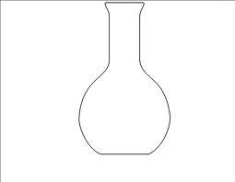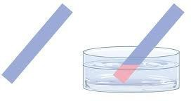Place broken glasses and solidsinto bin always located in the laboratory

When your experiment is completed, turn off the water supply and gas supply and disconnect any electrical connections and return all the materials and apparatus in their proper places

### Apparatus used in the laboratory

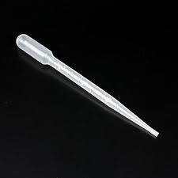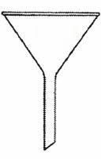

|  |  |  |
| --- | --- | --- |
| Apparatus | Name of apparatus | Function |
|  | Droppers | To allow liquids to be dispensed drop by drop |
|  | Filter funnel | Used for separating solids from liquids via the laboratory process of filtering |
|  | Filter paper | Used to separate fine solids from liquids |
|  | Flat bottomed flasks | Used to keep a liquid or solid on the flat surface for studying purpose |
|  | Litmus paper | Litmus paper contains a chemical that turns blue in basic solutions and reddish-  pink in acidic solutions |

|  |  |
| --- | --- |
| Pipette | For transferring or measuring out small quantities of liquid |
| Reagent bottles | A glass container to hold liquid chemicals |
| Retort stand | Used to support apparatus (for example a flask or thermometer) |
| Round bottomed flasks | A glass flask used I n a laboratory for holding chemical liquids and solutions, which has a spherical shape for uniform heating, and one or more long  cylindrical |

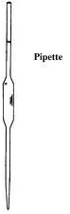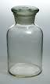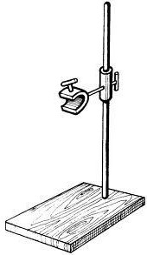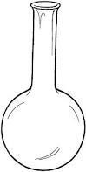

|  |  |
| --- | --- |
|  | necks. |
| Separating funnel | Laboratory equipment used to separate liquids which do not dissolve in one another, and thus forms layers (immiscible  liquids) |
| Mortar and pestle | Used for pounding and grinding solid substances to make them into smaller  particles for ease of handling |
| Beaker | A **beaker** is a container used to hold, mix, and pour liquid or powdered chemicals. |
| Boiling tube | A **boiling tube** is a small cylindrical vessel used to strongly heat substances in the  flame of a Bunsen burner |
| Bunsen burner | The**function** of a **Bunsen burner** is to heat substances. |
| Burette | A buret (burette) is used to dispense known amounts of a liquid reagent in experiments for which precision is necessary, such as a titration  experiment. |

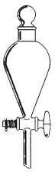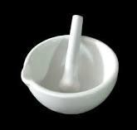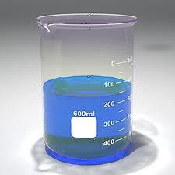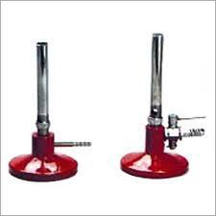

|  |  |
| --- | --- |
| Conical flasks | **Conical** flask / Erlenmeyer **flasks** are  shaped **conically** so that they can be used to mix fluids with  a lesser chance of spilling |
| Tripod stand | A **tripod** is a three legged frame for supporting a few apparatus during heating |
| Evaporating dish/crucible | The **Evaporating**dish is used to heat and evaporate liquids. |

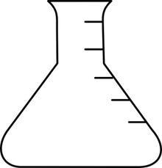

### Apparatus and their uses

* + 1. **The Bunsen burner**

The Bunsen burner is a device used as a source of heat in the laboratory. It uses gas fuel.

### Bunsen burner

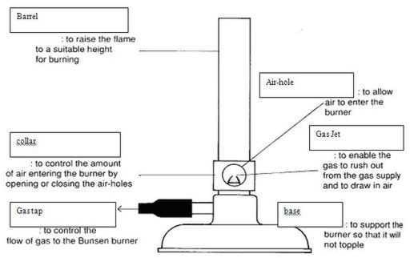

* + 1. **Flames of the Bunsen burner**

The Bunsen burner produces two different flames depending on whether the air hole is open or closed.

A flame is a combination of burning gases giving out heat and light. The Bunsen burner produces two different flames namely

1. Luminous flame
2. Non-luminous flame

### Luminous flame

A luminous flame is a flame formed when the air holes of the Bunsen burner are closed.

### Characteristics of a luminous flame

This flame produces much light

This flame is yellow in colour, unsteady and quiet The flame produces soot(smoke) when burning

It has four zones which have different colours

### Non luminous flame

This is the flame which is formed when the air holes of the Bunsen burner are open

### Characteristics of a non luminous flame

This flame produces little light

It is mainly blue in colour and produces no soot

It is very hot and noisy and therefore is commonly used for heating in the laboratories due to its being hot and producing no soot

Non luminous flame has three zone s

### Non-luminous and luminous flames

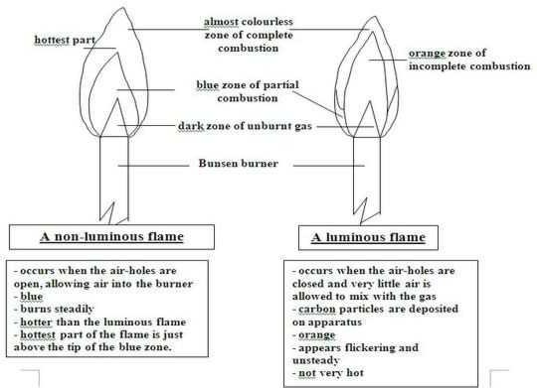

* + - 1. **Parts of a non luminous flame Inner zone:** this is a zone of cool un-burnt gas

**Middle zone:**this isblue or green in colour, here some of the gas is burnt but not all because there isno enough air

**Pale blue/ purple zone:** in this zone burning ofthe gas is complete

### Differences between luminous and non-luminous flame

|  |  |
| --- | --- |
| **Luminous flame** | **Non luminous flame** |
| Is a yellow flame | Is blue in colour |
| Is unstable | Is stable |
| Has four zones | Has three zone |
| Is quiet | Is noisy |
| Is not hot enough | Is very hot |
| Forms soot | No soot is formed |
| Produced when air holes are closed | Produced when air holes are open |
| Produces a lot of light | Produces little light |

* + - 1. **Steps followed when lighting a Bunsen burner**

Fix the Bunsen burner properly

Connect the Bunsen burner to the gas tap

Close the air holes by turning the metal rings (collar) Put on the gas tap and switch on for a few seconds

Light the gas by applying a match stick on top of the chimney Lastly open the air holes by turning on the metal rings

### 2. States of matter

Matter is anything that occupies space and has weight. The states of matter are solids, liquids and gases

### Solids

The characteristics of solids include:

* Fixed volume
* Fixed shape
* Incompressible
* Do not flow

Have a definite shape

The particles of solids are closely and regularly packed together

They are held together by strong forces which attract particles to each other

At a certain temperature the regular arrangement of particles in the solid state breaks down. At this point the solid melts and turns into liquid state. The temperature at solids change to liquid is called melting point.

### Liquids

The characteristics of liquids include:

* Fixed volume
* No fixed shape

-Takes the shape of the container

* Incompressible
* Flow easily

Have definite volume but no definite shape and take up the shapes of their containers e.g. water, milk

Liquids cannot be compressed by squeezing

When liquids are heated their particles move faster and finally turn into gas

The temperature at which a liquid changes into a gas is called the boiling point e.g. the boiling point for pure water is 100oC.

### Gases

The characteristics of gases include:

-No fixed volume

* No fixed shape
* Compressible
* Flow in all direction

Do not have a definite shape and volume

The particles cannot attract each other and can be compressed e.g. air

When gases are cooled, they turn into liquids and the process is called **condensation. The behaviour of particles in solids, liquids and gases is governed by the principle of kinetic theory of gases.**

### Change of state

Changes in state are brought about by changes in temperature e.gif a liquid is cooled at very low temperature; it will change to solid i.e. changing water to ice.

Sublimation is the process of changing a substance from a solid to a gas state without passing through the liquid state when heated. Substances which sublime include: iodine crystals, ammonium chloride and iron (III) chloride

Note: water exists in all the three states. When in solid state, it is called ice, in liquid state, it is called water, and in gaseous state, it is called water vapour/steam. But at room temperature water is in liquid state.

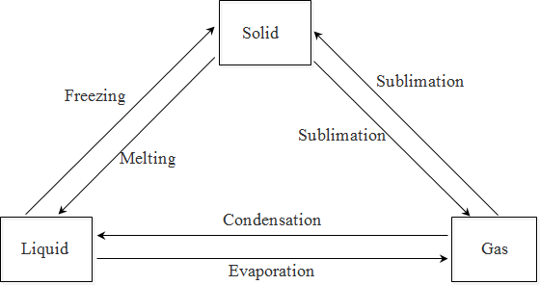

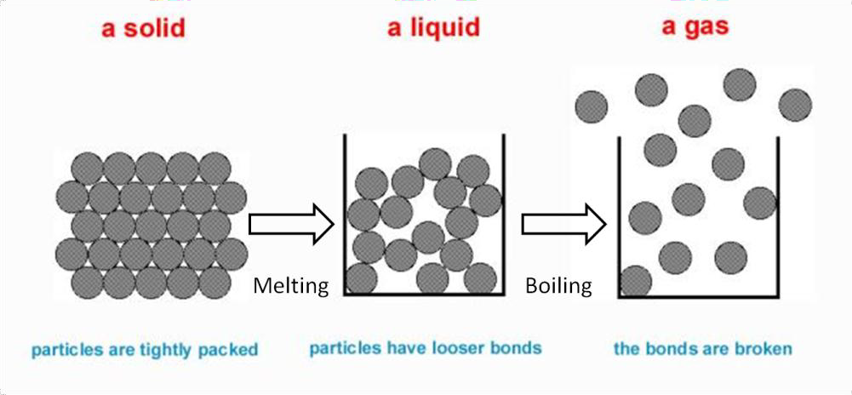

|  |  |  |
| --- | --- | --- |
| **Particles in solid:**   * Are packed close together in orderly arrangement * Have little empty space between them * Can vibrate but cannot move freely about their fixed   position | **Particles in liquid:**   * Are packed closely but not orderly arranged * Have little empty space between them but more than in solids * Are not held fixed but free to   move throughout liquid | **Particles in gas:**   * Are far apart and in random arrangement * Are free to move anywhere in the container |

### Differences between properties of matter and particles in them

1. Matter can be coloured (e.g. sulphur is yellow) but particles are not.
2. Substances feel hot/cold but particles don‘t get hot/cold. The temperature is due to speed of movement of particles. If hot, particles move fast.
3. Matter expands when heated but particles don‘t. They increase distance between particles during expansion.

***Changes of State***

### Melting

*Melting* is change from solid to liquid by absorbing heat to break force of attraction holding particles together.

The temperature at which solid melts is *melting point*.

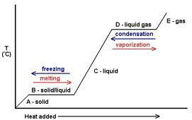

From the graph:

A-B: the temperature of solid increases to melting point.

B-C: the temperature remains constant as heat isabsorbed to break forces of attraction instead forraising temperature. Solid and liquid are present.

C-D: liquid heats as heat energy increases temperature. D-E: liquid temperature rises to boiling point.

E: heat energy is absorbed by particles to break the attractive forces so that they move freely and far apart as gas particles. That‘s why the temperature remain constant

### Freezing

*Freezing* is the change of liquid to solid by cooling down of liquid.

*Freezing point* is the temperature at which liquid freezes.

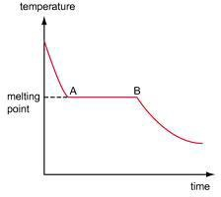

A

B

D

C

A-B: liquid temperature decreases to freezing point.

B-C: heat energy is released as particles slow down to take up fixed and orderly position of a solid. The temperature remain constant release of energy compensates for loss of heat to surroundings.

C-D: solid cools to the temperature of surroundings.

### Boiling

*Boiling* is the change of liquid to gas by absorbing heat to break the forces holding them together.

*Boiling point* is the temperature at which liquid boils.

### Evaporation

*Evaporation* is change of liquid to gas without boiling, occurs below boiling point on water surface. It gives cooling effect – heat energy absorbed from surroundings.

### Condensation

*Condensation* is the change of gas to liquid. Heat energy is given out as gas particles slow down and move closer to one another to form liquid.

**Sublimation** is the change of solid to gas without melting. Heat is absorbed.

### The Kinetic Particle Theory of Matter

Kinetic theory assumes that

* Particles are too small to be seen directly
* There are spaces between particles of matter; the amount of space varies between each states
* The particles are constantly move; each state moves in different speed

### Diffusion

**Diffusion** is the spreading and mixing of particles in gases and liquids.

### Diffusion of gases

Bromine drops are placed into a jar. Another jar full of air is placed on top of jar with bromine, separated with cover. Cover is removed and bromine evaporates, filling both jars with dense reddish-brown bromine vapour.

*Explanation:*

Bromine particles move from lower jar into spaces between air particles in upper jar. At the same time, air particles move down from upper jar to mix with bromine particles in lower jar.

Eventually, bromine and air particles are mixed completely.

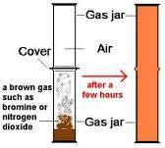

### Diffusion of liquids

CuSO4 crystals placed in beaker of water, blue particles of the crystals is spread throughout the water to form a uniformly blue solution.

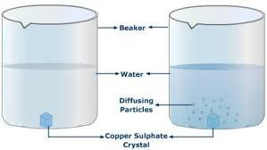

### Factors Affecting Rate of Diffusion

### Temperature

The higher the temperature, the more particles of matter absorb energy making them move faster, the higher the rate of diffusion; the lower the temperature, the slower the rate of diffusion

### Mass of particles

Greater mass, the slower it diffuses; smaller mass, the faster it diffuses

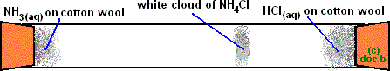

Cottonwool soaked in aqueous ammonia and another soaked in hydrochloric acid are placed on opposite sides of the tube. Ammonium hydroxide (NH4OH) vapor and hydrogen chloride (HCl)vapor diffuses in the tube and a compound is produced inside the tube closer to HClsoaked cotton as the particles are heavier. The greater the mass, the slower particles diffuse and the smaller the mass, the faster particles diffuse.

### Chemical and physical changes

**A chemical change** is a process that occurs and a new substance is formed e.g.

* + rusting, explosion of hydrogen in air,
  + burning of magnesium to ash,
  + Burning of a paper to ash, etc…

**Physical change** is a change in which no new substance is formed e.g. freezing (water to ice) Evaporation of water (water to steam)

Magnetization of iron Sublimation of solid iodine Melting of ice

### Differences between physical and chemical changes

|  |  |
| --- | --- |
| **Physical change** | **Chemical change** |
| No new **S**ubstanceis formed | A new **Substance** is formed |
| The change is reversible | The change is **irreversible** |
| No energy is evolved or absorbed during the  reaction | **Energy** is absorbed of evolved during the  reaction |
| There is no change in mass | There is change in **Mass** |

The word MISE is used to recall these differences Where M-Mass

I-Irreversible S-Substance E-energy

### Solutions, crystals, compounds and mixtures

### Solutions

A solution is a uniform mixture of two or more substances. When sugar is added to water and stirred, the sugar dissolves in water.

In this process sugar is called a solute, water is called a solvent and a mixture of sugar and water is called a solution.

### Solute

A solute is a dissolved substance e.g. sugar, salt.

### Solvent

A solvent: is a substance that dissolves a solute e.g. water, ethanol, petrol.

### Types of solutions

### A saturated solution

This is a solution which cannot dissolve any more solute at a given temperature in presence of undissolved solute.

### A super saturated solution

This is a solution which contains more solute than it can hold at a given temperature

### A suspension

This is a liquid containing small particles of a solid which are spread throughout it and settle on standing e.g. a solution of chalk in water.

### Differences between solutions and suspensions

A suspension contains solid particles which can be seen but a solution contains no solid particles.

In suspension the mixture can be separated by filtration while in solution the mixture cannot be separated by filtration.

In suspension the solid particles settle on standing but in solutions no solid particles can settle on standing.

### Crystals

A crystal is a solid that has solidified into regular fixed shape. Crystals have regular shapes, flat surfaces and sharp edges

Crystals are formed when hot solutions cool. Is a hot saturated solution cools rapidly, crystals formed are many and small but once cooled slowly crystals formed are few and big in size Substances which form crystals are called crystalline substances i.e. sodium chloride and copper

(II) sulphate. Some solids do not form crystals e.g. charcoal and glass; and these are called non- crystalline substances.

### How to grow a large crystal of copper (II) sulphate

Fill the beaker with a saturated solution of copper (II) sulphate

Choose one good crystal of copper (II) sulphate and tie a thin thread around it. Hang it in the solution and place the beaker in a warm place for several days. The crystals grow large and the solvent slowly evaporates

### Water of crystallization

This is a definite amount of water some substances chemically combine with when they form crystals from their solutions in water

A crystalline substance that contains water of crystallization is said to be **hydrated A hydrated substance** is that which contains water of crystallization

Examples of hydrated salts include Copper (II) sulphate (CuSO4. 5H2O) Iron (II) sulphate (FeSO4. 5H2O) Sodium carbonate (Na2SO4. 10H2O) etc.

Some substances do not contain water of crystallization and are said to be **anhydrous** e.g. sodium chloride (NaCl), potassium nitrate (KNO3) etc.

When a hydrated substance is heated, it loses its water of crystallization CuSO4. 5H2O (s) CuSO4(s) + 5H2O (g)

Blue solid white solid

### Compounds and mixtures

### Compound

**A compound** is a substance which consists of two or more elements chemically combined together

### Examples of compounds include:

**Water (H2O)**: this is a compound made up of hydrogen (H) and oxygen (O) as elements Common salt**sodium chloride (NaCl)**: this is a compound made up of sodium (Na) and chlorine (Cl)

**Glucose (C6 H12O6)**: this is a compound made up of carbon (C), hydrogen (H) and oxygen (O)

**Iron (II) sulphide (FeS)**: this is a compound made up of iron (Fe) and sulphur (S)

### Mixture

A mixture is a substance which consists of two or more elements or compounds not chemically combined together.

**Examples include:**Salt and water, Salt and sand, Water and alcohol, Chalk and water, Air

### Differences between mixtures and compounds

|  |  |
| --- | --- |
| **Mixture** | **Compound** |
| Can be **s**eparated by physical means e.g.  filtration | Substances in it can‘t be separated by physical  means |
| Physical **P**roperties of mixtures e.g. colour and  density are the average of constituent substances | Physical properties of compounds are quite different from those elements in them |
| **E**nergy is not usually given out or absorbed  when a mixture is formed | Energy is given out or absorbed when a  compound is made |

|  |  |
| --- | --- |
| Its **C**omposition is variable, the substances can  be combined in any proportion by mass | Its composition is not variable; the elements  are combined in definite proportions by mass |

The word SPEC is used to recall these differences Where S- **S**eparated

P- **P**roperties E- **E**nergy

C- **C**omposition

### Methods of separation of mixtures Liquid mixtures

There are two types of liquid mixtures i.e. immiscible and miscible liquid mixtures

### Miscible liquids:

These are liquids which mix freely and form one layer

### Immiscible liquids

These are liquids which do not mix easily and form more than one layer

### The methods of separation of mixtures include the following

### Filtration

*Filtration –* separates **insoluble solid** from a **liquid**.

* Mixture is poured through a filter paper with tiny holes
* Large solid particles cannot pass through the pores and trapped in it as **residue** while tiny liquid particles pass through as **filtrate**.

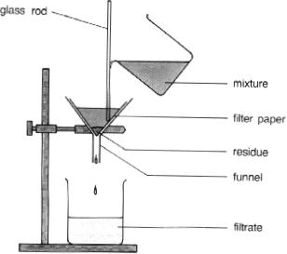

### Crystallisation & Evaporation to Dryness

*Crystallisation* – separation of dissolved solid from a solution as well-formed crystals *Evaporation to Dryness* – separation of dissolved solid from a solution as crystals of salt by evaporating all the liquid off.

*Why crystallisation occurs?*

* Solubility of most solutes decrease as temperature decrease, when solution cools, solution can‘t hold more solute (*saturated*) so the extra solute separates as pure crystals.

### Evaporation to dryness

* To obtain the solute from a solution
* Requires an evaporating dish

### How to separate common salt (sodium chloride) from sand

Common salt and sand are placed in a beaker and water is then added. The mixture is warmed gently while stirring until the salt completely dissolves. Salt dissolves but sand does not dissolve. The solution is then filtered. After filtering, the salt solution is obtained separate from sand. The salt solution is therefore called a**filtrat**e and sand, the **residue**.

The salt solution is then poured into an evaporating basin. The water evaporates when the salt solution is heated. It evaporates completely, leaving salt crystals behind on the evaporating dish. This is called **evapouration to dryness.**

### Using water bath carry out evapouration to dryness

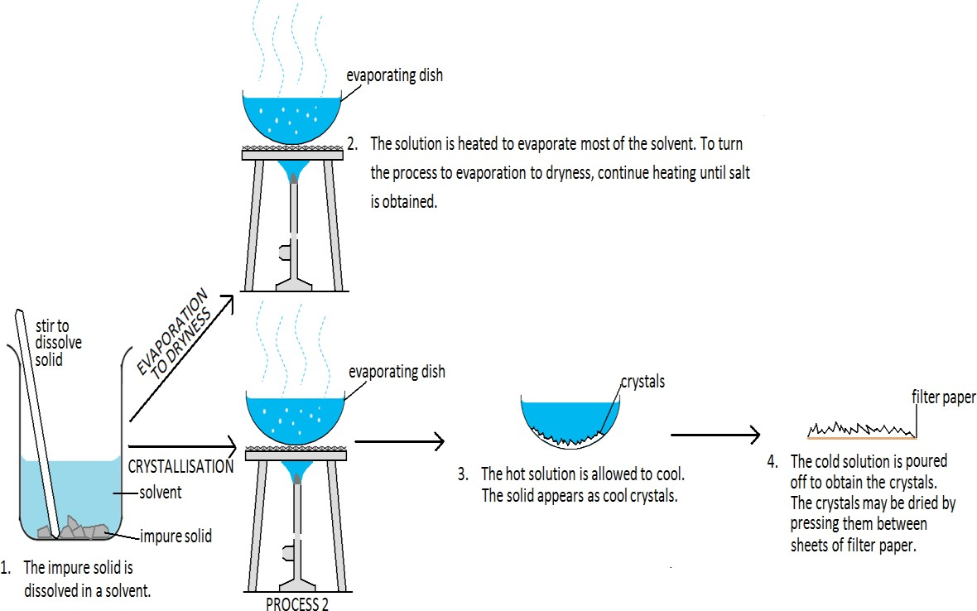

To avoid spitting off (jumping off) of salt crystals formed, the evapourating basin is placed on a water bath or sand bath. The steam produced from the water bath will heat up the salt solution until crystals are formed.

### Decanting

This method can also be used to separate a mixture of sand and salt in water

Put the mixture of sand and salt in the beaker and add water. Stir the mixture. Salt will dissolve but sand will not. Leave the beaker tostand for a few minutes for the sand to settle.

The sand will settle on the bottom of the salt solution. Pour off the salt solution carefully without disturbing the mixture.

The sand will be left on the bottom of the beaker. Then evaporate the salt solution to dryness.

### NB:

This method is not as good as filtration and should always be discouraged in the laboratory This method can also be used to separate chalk from water

### Diagram showing decanting

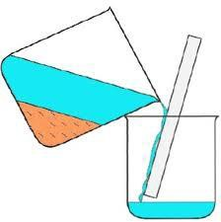

### Using separating funnel

* To separate two liquids thatdo not mix
* Requires the separating funnel

This method is used in separating immiscible liquids.

Immiscible liquids are those which do not mix at all. Such liquids separate into distinct layers according to their densities. Examples include:

Water and paraffin Water and mercury Water and oil

To separate such liquids using a separating funnel, the following procedures are followed. The mixture of paraffin/oil and water is poured into a separating funnel. Shake vigorously and then allow tosettle

Results

Water has a high density than paraffin and therefore water separates to the bottom and paraffin goes on top of water making different layers

The tap is opened and the water layer runs out first

Close the tap and put another container where paraffin will be collected. Open the tap to collect paraffin in a separate container

### Separating funnel

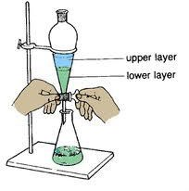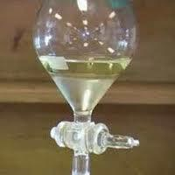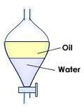

### Distillation

This is the process of heating a liquid to form vapour and then cooling it back to form a liquid Distillation helps in separating of substances

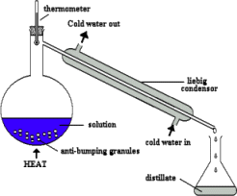(miscible liquid) and also in purification of liquids

### Simple Distillation

* To obtain the solvent from the solution
* Requires a Liebig condenser and a distilling flask *Used to obtain the solvent from the solution During distillation, the solution is heated so that its liquid component boils and escapes as a vapour.*

*The vapour is then cooled by running water and condensed into liquid called the* ***distillate****.*

*To achieve even boiling and preventing too much bumping (frothing and bubbling) in the flask,* ***anti-bumping granules*** *or* ***boiling chips*** *is added to the* ***distilling flask*** *containing the mixture.*

### In some countries, distillation is used to obtain pure water.

The distillation apparatus can also be used to determine the boiling point of a liquid. This is done by use of a thermometer. The thermometer is passed through one – holed stopper (cork) of the flask and the temperature of the vapour is noted. This will be the boiling point of the liquid.

**NB:** The impurities which contain dissolved salts remain in the flask and therefore pure water is not good for drinking because it lacks mineral salts.

* + - 1. **Separation of a mixture of water and ethanol by distillation** Water and ethanol are two miscible liquids and they have different boiling points, they are therefore separated by fractional distillation

The boiling point of pure water is 100oC and that of ethanol is 78oC

The mixture of ethanol and water is poured into a boiling flask fitted with a fractionating column.

Glass beads are placed in the fractionating column. The use of the glass beads in the fractionating column is to increase the surface area for effective separation of vapours

The mixture is then heated up to 78oC; temperature reading on the thermometer becomes steady for some time. Ethanol vapourises and ethanol vapour is condensed by cold water flowing in the condenser forming a liquid. The liquid which is received now is pure ethanol and is then collected in the receiving flask.

Heating is continued up to 100o when water evapourates and is collected in a different container The use of the thermometer is to record temperature of the two vapours

The use of porcelain pieces which are placed in the distilling flask is to enable the mixture boil gently

### Fractional distillation

*- To separate two or more liquids with different boiling points into different fractions.*

This is a process of separation of two or more liquids with different boiling points into different fractions.

Fractional distillation is the process used to separate liquids which are miscible

Miscible liquids are those which mix freely in all proportions to form one uniform solution

### The process can therefore be used to separate

Liquefied air into nitrogen and oxygen Crude oil into petrol, diesel and kerosene

**Crude oil is separated into its constituents such as petrol,diesel and kerosene**

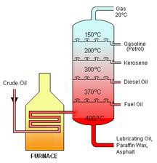

**Fractional distillation of liquefied air**

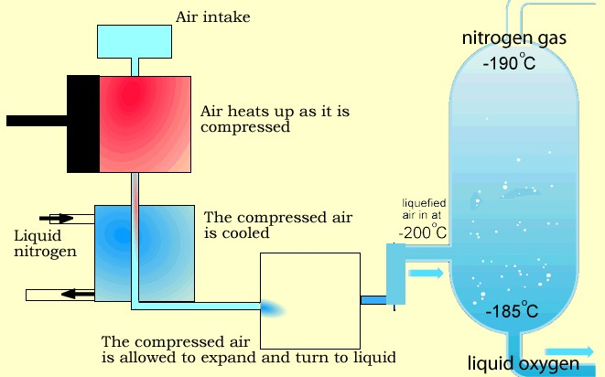

### Sublimation

This is the process where when a solid is heated; it changes to a gas directly without passing through the liquid state.

### Separation of mixtures by sublimation

Sublimation can be used to separate a mixture of two substances where one sublimes and the other does not. It can therefore be used to separate a mixture of iodine and common salt (sodium chloride)

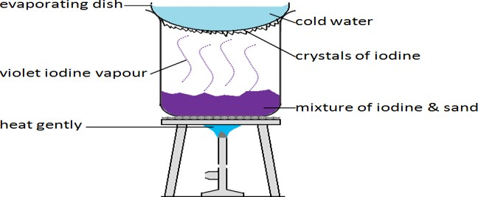

When a mixture of iodine and common salt (sodium chloride) is heated, iodine changes to a gas and common salt remains in solid form. Therefore the two substances can be separated from one another.

### Other substances which sublime other than iodine include:

Ammonium chloride Anhydrous aluminum chloride Iron (III) chloride

Benzoic acid

### Magnetic Attraction

* To separate magnetic substances from non-magnetic substances

In hospitals, magnets are often used to remove iron splinters from a patient‘s eyes. Electromagnets are also used for removing scrap steel and iron at the junkyard. These scrap metal can then be sent for recycling.

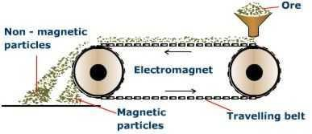



Magnetic substances are substances which can be attracted by a magnet e.g. iron. Therefore a magnet can be used to separate iron from sulphur because iron is attracted by a magnet and sulphur cannot be attracted by a magnet and is therefore left behind.

### Chromatography

* 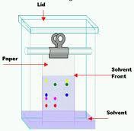To separate liquid components in a mixture

This is a process of separating different coloured substances using a porous paper. The coloured substances are moved over the paper at different rates by a moving solvent.

The components of ink are separated by chromatography Chromatography shows that ink consists of many coloured substances.

### This can be done as follows

When a spot of ink is applied to the chromatography paper (usually filter paper), the dyes in the ink are attracted to the surface of the paper. The chromatography paper is then immersed in

a **solvent**. The solvent level should not be above the ink spot.

As the solvent (usually water or ethanol) is soaked up by the paper, the solvent dissolves the dyes.

A dye that is strongly attracted to the paper and not very soluble in the solvent will be left behind. A dye that is weakly attracted to the paper and very soluble in the solvent will move up with the solvent through the paper.

### Elements, compounds, atoms and symbols

### An element

An element is a substance which cannot be split up into two or more simpler particles by chemical means. Examples of elements include

Copper Sulphur Carbon Oxygen Hydrogen Iron

### An atom

An atom is the smallest indivisible particle of an element which can take part in a chemical reaction

### A molecule

A molecule is the smallest indivisible particle of an element which can exist in free and separate state. Molecules are formed when two or more atoms combine together e.g. water (H2O) is a moleculemade up of 2 atoms of hydrogen and 1 atom of oxygen

### Radicals

A radical is a group of atoms which cannot exist on their own but exists in a compound. Examples include:

Sulphate (SO4) Carbonate(CO3)

Nitrate (NO3)

Sulphate radical cannot exist on its own but can exist in composition like in sulphuric acid (H2SO4), calcium sulphate (CaSO4), sodium sulphate (Na2SO4)

### Chemical symbols

A chemical symbol of an element is one or two letters which represent one atom of an element. The letters used are the first letters of an element in English or Latin names of the element. The first letter should be **CAPITAL** and the second letter should be **small**.

Common elements and their symbols include

|  |  |
| --- | --- |
| **Element** | **Symbol** |
| Hydrogen | H |
| Helium | He |
| Lithium | Li |
| Beryllium | Be |
| Boron | B |
| Carbon | C |
| Nitrogen | N |
| Oxygen | O |
| Fluorine | F |
| Neon | Ne |
| Sodium | Na |
| Magnesium | Mg |
| Aluminum | Al |
| Silicon | Si |
| Phosphorous | P |
| Sulphur | S |
| Chlorine | Cl |
| Argon | Ar |
| Potassium | K |
| Calcium | Ca |
| Scandium | Sc |

|  |  |
| --- | --- |
| Titanium | Ti |
| Vanadium | V |
| Chromium | Cr |
| Manganese | Mn |
| Iron | Fe |
| Cobalt | Co |
| Nickel | Ni |
| Copper | Cu |
| Zinc | Zn |
| Lead | Pb |
| Mercury | Hg |
| Silver | Ag |
| Gold | Au |
| Xenon | Xe |
| Iodine | I |
| Barium | Ba |

Elements whose symbols were derived from their Latin names are summarized below

|  |  |  |
| --- | --- | --- |
| **Element** | **Latin names** | **Symbol** |
| Potassium | Kalium | K |
| Sodium | Natrium | Na |
| Iron | Ferrum | Fe |
| Copper | Cupium | Cu |
| Lead | Plumbium | Pb |
| Mercury | Hydrogyrum | Hg |
| Silver | Argentums | Ag |

### Metals and non-metals

Elements are grouped into two;

Metals: Copper (Cu), Iron (Fe), Sodium (Na), Potassium (K), Mercury (Hg), Silver (Ag), Gold (Au) etc…

Non-metals: Chlorine (Cl), Carbon (C), Oxygen (O), Hydrogen (H), Helium (He), Nitrogen (N), Fluorine (F), Bromine (Br) etc..

A metal: is an element which forms positive ions by losing electrons An ion: is a charged particle e.g. Cu2+, Pb2+, Al3+, Zn2+

A non-metal: is an element which forms negative ions by gaining electrons e.g. Cl-, Br- etc…

### Properties of metals and non-metals

|  |  |
| --- | --- |
| **Metals** | **Non-metals** |
| Good conductors of heat and electricity | Poor conductors of heat and electricity |
| Have high density | Have low density |
| Solids with high melting points | Most are gases. Solids have low melting points |
| Ductile i.e. can be drawn into wires | Not ductile |
| Malleable i.e. can be made into sheets | Not malleable |
| Strong and tough i.e. have high tensile strength | Not strong i.e. have low tensile strength |
| Are rustrous i.e can be polished | Not rustrous i.e. cannot be polished |

### Atomic structure and the periodic table

### An atom

An atom is the smallest indivisible particle of an element which can take part in a chemical reaction.

### Composition of an atom

An atom is mainly composed of three particles namely:- electrons, protons and neutrons

### Electrons

These are negatively charged particles of an atom. They are found outside the nucleus of an atom.

They have a charge of negative one (**-1**). NB: They are symbolized by **e**.

### Protons

These are positively charged particles found in the nucleus of an atom. Mass (1)

They have a charge of **+1**.

NB: They are represented by letter **P**. **Neutrons**

These are neutral particles found in the nucleus of an atom. Have no charge.

Mass (1)

NB: Neutrons are symbolized by **N**. Both neutrons and protons are found inside the nucleus and are together called **nucleons**.

### Structure of an atom

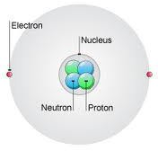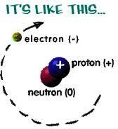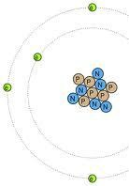

The central part of an atom is called the nucleus. Protons and neutrons are located in the nucleus. These make up **nucleon number**.

|  |  |  |  |
| --- | --- | --- | --- |
| **Particle** | **Symbol** | **Relative mass** | **Charge** |
| Proton | P | +1 | +1 |
| Neutron | N | 0 | 0 |
| Electron | e- |  | -1 |

Electrons move around nucleus in an orbit called **energy level**.

In a neutral atom the number of electrons is equal to the number of protons. The charge of an electron is equal but opposite to that of a proton.

***PROTON NUMBER*** is the number of protons in an atom.

***NUCLEON NUMBER*** is the number of protons and neutrons in nucleus of an atom.

Therefore, to find the number of neutrons, we subtract proton number from nucleon number, i.e.:

### Nucleon number – Proton number = Neutrons

***ELECTRONS*** have the same number as protons to balance the charges.

### Atomic number

This is the number of protons in the nucleus of an atom. Since protons are equal to electrons in an atom, atomic number can also be defined as the number of electrons found in an atom.

### Atomic mass

This is the number of protons plus the number of neutrons in the nucleus of an atom. It is the sum of protons and neutrons in an atom.

Atomic mass = protons + neutrons Consider the following element

―Z‖ is the atomic mass and ―A‖ is the atomic number

The number of protons =number of electrons = b = atomic number The **number of neutrons = atomic mass – atomic number i.e. Z-A Example**

1. An atom of an element is represented by the symbol State

* 1. Its atomic number = 8
  2. The mass number = 16
  3. The number of neutrons = 8 (i.e. 16 -8 =8)

1. Work out the following, State

* 1. Its atomic number = 11
  2. The mass number = 23
  3. The number of neutrons = 12 (i.e. 23 - 11 = 12) Examples of electronic structures of some elements:

Oxygen

Calcium Argon Chlorine

### Electronic configuration

This is the arrangement of electrons in an atom.

In an atom, electrons occupy levels or shells and move in these shells around the nucleus. The number of shells in an atom depends on the number of electrons present. The maximum number of electrons occupying the innermost shell is 2. The rest of the shells contain a maximum of 8 electrons.

To write electronic configuration we write as *n:n:n.* where first *n* denotes the first shell, second

the second shell and so and so for.

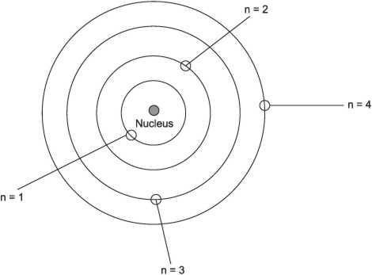

### Examples

Draw the structure of the following atoms and state their electronic configuration.

1. 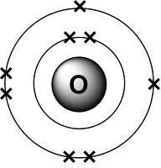Oxygen (O): atomic number = 8

2:6 (Oxygen)

1. Carbon (C): atomic number = 6

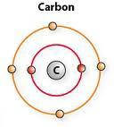2:4 (Carbon)

1. Chlorine (Cl): atomic number =17

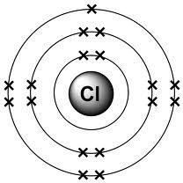2:8:7 (Chlorine)

1. Sulphur (S): atomic number = 16

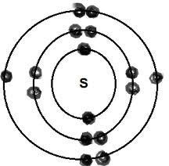2:8:6 (Sulphur)

5.

* 1. Draw the electronic structure of element X represented by
  2. State the number of neutrons and protons found inside the nucleus of X

6. Fill in the following table

|  |  |  |  |
| --- | --- | --- | --- |
| Atom | Atomic No. | No. of electrons | Electronic  configuration |
| Hydrogen (H) | 1 |  |  |
| Helium (He) | 2 |  |  |
| Lithium (Li) | 3 |  |  |
| Boron (B) | 4 |  |  |
| Nitrogen (N) | 7 |  |  |
| Neon (Ne) | 10 |  |  |
| Phosphorous (P) | 15 |  |  |
| Chlorine (Cl) | 17 |  |  |
| Potassium (K) | 19 |  |  |

### Electronic configuration of ions

An ion is an electrically charged particle. Ions are formed by gain or loss of electrons.

Metals form positively charged ions by losing electrons and non-metals form negatively charged ions by gaining electrons.

The number of electrons gained or lost is equal to the valence of the atom e.g.

1. Sodium electronic configuration 2:8:1 loses 1 electron to form Na+. Na+ therefore has electronic configuration of 2:8
2. Calcium electronic configuration 2:8:8:2 loses 2 electrons to form Ca2+. Ca2+ therefore has electronic configuration of 2:8:8
3. Oxygen electronic configuration 2:6 gains 2 electrons to form O2-. O2- therefore has electronic configuration of 2:8
4. Chlorine electronic configuration 2:8:7 gains 1 electron to form Cl-. Cl- therefore has electronic configuration of 2:8:8

### Exercise

The number of electrons, protons and neutrons in atoms W, X, Y and Z are shown in the table below.

|  |  |  |  |
| --- | --- | --- | --- |
| Atom | Electrons | Protons | Neutrons |
| W | 8 | 8 | 8 |
| X | 16 | 16 | 16 |
| Y | 13 | 13 | 14 |
| Z | A | 3 | 4 |

* 1. Determine
     1. The value of A
     2. The approximate atomic mass of Y
  2. Write the electronic configuration of the following atoms and ions
     1. W
     2. W2-
     3. Y
     4. Y3+
  3. State the two atoms that are isotopes of the same element
  4. Write the formula of the compound formed between X and Y

### Isotopes

These are atoms of the same element with Same atomic number

Different atomic masses due to difference in number of neutrons Isotopes of an element have the same chemical properties.

### E.g. Hydrogen has three isotopes

|  |  |  |  |
| --- | --- | --- | --- |
| Isotopes | Hydrogen | Deuterium | Tritium |
| Protons | 1 | 1 | 1 |
| Electrons | 1 | 1 | 1 |
| Neutrons | 0 | 1 | 2 |
| Mass No. | 1 | 2 | 3 |

**E.g. Chlorine has two isotopes**

|  |  |  |
| --- | --- | --- |
| Isotopes | Chlorine - 35 | Chlorine - 37 |
| Protons | 17 | 17 |
| Electrons | 17 | 17 |
| Neutrons | 18 | 20 |
| Mass No. | 35 | 37 |

Other examples include:

and

and

### Calculating relative atomic masses Examples

1. The relative abundances of  and are 75% and 25% respectively by weight.

Calculate the relative atomic masses of chlorine

Relative atomic mass of chlorine = Mass due to  + Mass due to

= +

### Exercise

=35.5

1. Carbon has two main isotopes  and has relative abundance of 1.11% and

has relative abundance 98.89%. Calculate the relative atomic mass of carbon.

1. Given the sodium atom,

* 1. Give the examples of isotopes of sodium
  2. Write down the electronic configuration of sodium

### 8. The periodic table

There over 103 elements so far discovered by scientists. The periodic table is a table in which all the elements so far discovered are put. It is an arrangement of elements in order of their atomic numbers.

There are 8 groups and 7 periods

### Summary of the table

Horizontal rows are called **periods** Vertical columns are called **groups Group**

An element is put in a particular group depending on the number of electrons it has in its last or outermost orbital e.g oxygen 2:6 has 6 electrons in its last orbital so its in group 6.

Sodium 2:8:1 has 1 electron in its outermost shell, so its put in group 1 etc.

### Period

An element is put in a particular period depending on the number of orbitals it has e.g. oxygen 2: 6; Has 2 orbitals so it is period 2 and group 6.

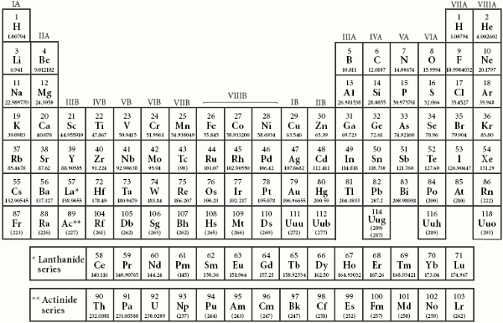

Note

All elements in the same group have the same valency and similar chemical properties Elements in group **I –III** are **metals**

Elements in group **V-VIII** are **non-metals**

Elements in group IV are **metalloidsexceptCarbon** which is a non-metal

Elements in group I are **alkaline metals** while elements in group II are called **alkaline earth metals**.

Elements in group VII are **halogens** while elements in group VIII are **Noble gases or inert gases.**

The number of electrons in the outermost shell corresponds to the group number. For elements in groups I-IV the valency is given by the group number

For elements in groups V-VII the valency is given by 8-Group number.

Hydrogen is put in groups I and VII because it behaves as both a group I and group VII element Helium is put in group VIII because it has a fully filled outermost orbital and behaves like a group VIII element.

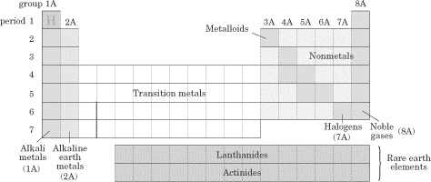

### Chemical families

On the left of the periodic table there are **metals**, and to the right lie the **nonmetals**.

In the middle are metalloids and these exhibit both metallic and nonmetallic properties.

**Metals** are malleable, ductile, and have luster; most of the elements on the periodic table are metals. They oxidize (rust and tarnish) readily and form *positive* ions (cations).

They are excellent conductors of both heat and electricity. The metals can be broken down into several groups.

**Transition metals** (also called the transition elements) are known for their ability to refract light as a result of their unpaired electrons.

They also have several possible oxidation states.

Ionic solutions of these metals are usually colored, so these metals are often used in pigments. The actinides and lanthanides are collectively called the **rare earth elements** and are filling the *f* orbitals.

They are rarely found in nature. Uranium is the last naturally occurring element; the rest are man-made.

**Non-metals** do not conduct electricity well because they do not have free electrons.

All the elemental gases are included in the nonmetals. **Notice that hydrogen is placed with the metals because it has only one valence electron, but it is a nonmetal.**

### Specific families

**Alkali metals (1A) Group one—**

They have one electron each in their outermost shell.

They are all metals which are highly electropositive i.e. they have a very high tendency to lose electrons than other elements in the period. They form ions with a single charge by loss of one electron e.g. Na+, Li+, K+.

They have a valency of one. They are strong reducing agents.

They form compounds by either metallic or ionic bonding.

They are larger than any other elements in the period e.g. lithium (Li) They have low densities, low melting points and low conductivities They are soft and shinny and hence can be cut with a knife

The most reactive metal family, these must be stored under oil because they react violently with water

They dissolve and create an alkaline, or basic, solution, hence their name

### Lithium

Has atomic number 3 and electronic configuration 2:1 Has valency 1

Silvery white in colour

Extracted by electrolysis of lithium chloride

Its compounds are mainly deliquescent

Not very typical of group I elements, but resembles them Harder than K and Na

### Reactions

1. **With water**

Lithium reacts slowly with cold water to form its hydroxide and liberates hydrogen Lithium + Water Lithium hydroxide + Hydrogen

2Li (s) + 2H2O(l) 2LiOH (aq) + H2 (aq)

### With air

Gives a red flame colour when burnt in air i.e. burns with a red flame 4Li (s) + O 2 (g) 2Li2O(s)

### With chlorine

Lithium reacts with chlorine to form lithium chloride

2Li (s) + Cl 2 (g) 2LiCl(s)

* + 1. **Sodium (Na)** Also a member of group 1 Has atomic number 11 Electronic configuration 2:8:1 Has atomic mass 23 **Occurrence**

Widely distributed in nature as sodium chloride NaCl, sodium nitrate NaNO3 or sodium carbonate Na2 CO3 etc

It‘s a soft white metal

### Reactions

1. **With water**

Sodium attacks cold water rapidly, evolving hydrogen and forming sodium hydroxide Sodium + Water Lithium hydroxide + Hydrogen

2Na (s) + 2H2O(l) 2NaOH (aq) + H2 (aq)

### With air

Very little attack by dry air

Sodium + Oxygen Sodium oxide

4Na (s) + O 2 (g) 2Na2O(s)

The sodium oxide formed absorbs water i.e. deliquescent to form sodium hydroxide solution Sodium oxide + Water Sodium hydroxide + Hydrogen

2Na2O (s) +H 2O (g) 2NaOH (aq) + H2 (g)

### With chlorine

Sodium combines directly with chlorine to form sodium chloride 2Na (s) + Cl 2 (g) 2NaCl(s)

### Alkaline earth metals (Group 2A elements)

Theseare also reactive metals, but they don‘t explode in water; pastes of these are used in batteries.

These are elements, which have two electrons each in their outermost orbital. Examples include magnesium (Mg), calcium (Ca)

1. Magnesium (Mg) Atomic number 12 Silvery white metal

Electronic configuration 2:8:2 Extracted electronically **Reactions**

1. With air

Dry air does not attack magnesium

Damp air puts a layer of an oxide on magnesium later forming a hydroxide and carbonate Burns in air with a bluish white flame leaving behind an oxide and nitride

2Mg(s) + O2 (g) → 2MgO (s) (Magnesium oxide) 3Mg(s) + N2 (g) → Mg3 N2 (s) (Magnesium Nitride)

1. With water

Magnesium reacts with steam and not water

It burns brilliantly in steam producing an oxide and hydrogen Mg(s) + H2O (g) → MgO (s) + H2 (g)

1. With dilute acids

All dilute mineral acids i.e. HCl, H2SO4, HNO3 react with magnesium liberating hydrogen Mg(s) + H2SO4 (aq) → MgSO4 (aq) + H2 (g)

Mg(s) + 2HNO3 (aq) → Mg(NO3)2 (aq) + H2 (g)

Mg(s) + 2HCl (aq) → MgCl2 (aq) + H2 (g)

NB: Hot concentrated sulphuric acid yields sulphur dioxide instead of hydrogen gas

1. With halogens

When heated, magnesium reacts with halogens to produce salts called halides Mg(s) + Cl2 (g) → MgCl2 (s)

### Calcium (Ca)

Widespread in the earth‘s crust as CaCO3, CaSO4, CaF2, Ca3(PO4)2 etc…

### Extraction

Mainly by electrolysis of its fused calcium chloride Properties of calcium

Silvery white in colour

Soft enough to cut with a knife

### Reactions

1. **With air**

On exposure to air at room temperature, calcium tarnishes in color as it froms an oxide Calcium + oxygen → calcium oxide

2Ca(s) + O2 (g) → 2CaO (s) (Calcium oxide)

Calcium oxide later combines with water to form calcium hydroxide Calcium oxide + water → calcium hydroxide

CaO (s) + H2O (aq) → Ca(OH)2 (aq)

Calcium hydroxide formed combines with carbon dioxide to form calcium carbonate Ca(OH)2 (aq) + CO2 (g) → CaCO3 (s) + H2O (l)

### Explanation

The calcium oxide (CaO) formed is deliquescent i.e. absorbs moisture from the atmosphere so it forms calcium hydroxide Ca(OH)2 (aq). The calcium hydroxide Ca(OH)2 (aq) formed later absorbs carbon dioxide (CO2), also from the atmosphere forming calcium carbonate (CaCO3)

### With water

Calcium reacts with water to form calcium hydroxide liberating hydrogen Ca (s) + 2H2O (aq) → Ca(OH)2 (aq) + H2 (g)

NB: The calcium hydroxide produced is sparingly soluble and tends to precipitate on the metal and stops any further reaction from going on.

**Halogens (7A)**—Known as the ―salt formers,‖ they are used in modern lighting and always exist as diatomic molecules in their elemental form.

They include fluorine (F2), chlorine (Cl2), bromine (Br2) and iodine (I2) Have seven electrons in their outermost shell

### Properties

**Chlorine** Greenish yellow gas Poisonous gas Denser than air

Bleaches damp litmus paper Atomic number 17

Electronic configuration 2:8:7

Atomic mass 35

### Reactions

1. **With water**

Halogens react with water forming acids. Chlorine reacts with water forming two acids i.e. hypochlorous acid (HOCl) and hydrochloric acid (HCl)

Cl2 (g) + H2O(l) → HCl (aq) + HOCl (aq)

### With dilute sodium hydroxide

Halogens generally react with NaOH to produce a pale yellow solution of sodium chloride or sodium bromide

NaOH(aq) + Cl2(g) → NaCl(aq) + H2O(l)

### Displacement reactions

Written in order Cl, Br, I each halogen displaces those on its right from their solutions of simple salts i.e. chlorine displaces bromine from its own solution and bromine forms a brown solution 2NaBr(aq) + Cl2(g) → 2NaCl (aq) + Br2(aq)

### Oxidizing reactions

Halogens are oxidizing agents i.e. they accept electrons, therefore they are electronegative elements

**Noble gases (8A)**—Known for their extremely slow reactivity, these were once thought to never react; neon, one of the noble gases, is used to make bright signs.

Sometimes referred to as Group O elements Chemically inert i.e. they don‘t react

Their outermost orbitals are full

They include helium (He), neon (Ne), argon (Ar), Krypton (Kr), xenon (Xe)

### Helium (He)

Has atomic number 2 Electronic configuration 2

Very stable because the only orbital is full

### Neon (Ne)

Has atomic number 10 Electronic configuration 2:8

Very stable because all the orbitals are full

### Argon (Ar)

Has atomic number 18

Electronic configuration 2:8:8

Very stable because all the three orbitals are full i.e. chemically satisfied

NB: their electron arrangement makes them very unreactive i.e. they do not lose or gain electrons and this accounts for their low reactivity

### Bonding

Elements always try to achieve the stable structure of the noble gases. In doing so, they combine chemically forming bonds.

### Types of bonds

They are prominently two types of bonds The electrovalent bond and covalent bonds **Elements are made of atoms**

**Atom** is smallest unit of an element, having properties of that element.

**Molecule** is group of two or more atoms chemically joined together, e.g. chlorine molecule has 2 chlorine atoms

***Chemical formula*** shows the number and kinds of atoms in a molecule, e.g. chlorine molecule has formula Cl2, where Clis chlorine symbol and the subscript number (2) shows that there are 2 atoms in a chlorine gas molecule.

#### *Compounds*

**Compound** is substance containing two or more elements chemically combined togethere.g. Magnesium is an element; oxygen is an element – they can only be burnt to form magnesium oxide compound.

### Composition of compounds

**Ions or molecules make up compounds Ions** are atoms having electrical charge

E.g. NaClmade up of 2 ions; positively charged Na, negatively charged Cl.

### Ionic/Electrovalent Bonding

**Ionic bonding** is the transfer of electrons from one atom to another to become/achieve an inert gas configuration, forming ions.

Ionic bonds are formed between **METALLIC** and **NON- METALLIC ATOMS** ONLY.

* Metals lose electrons to form positive ions (cations)
* Non-metals gain electrons to form negative ions (anions)

The formation of ions is resulted from transfer of electrons from one atom to another atom(s). The ions produced are of opposite charges and unlike charges attract, causing them to be held together with a strong electrostatic force.

*E.g. Formation of NaCl*

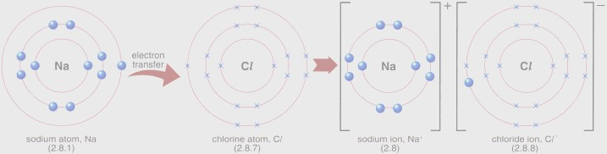

Sodium atom loses an electron by transferring the electron to chlorine atom, making both stable. The loss of electron forms a cation, Na+, and the gain of an electron forms anion, Cl-. The opposite charges acquired by both ions attract each other, forming a strong ionic bond of NaCl.

*E.g. Formation of MgF2*

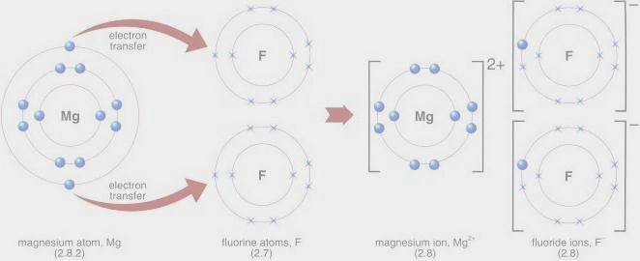

Sodium atom loses two electrons by transferring the electrons to fluorine atoms, one each, making both stable. The loss of electron forms a cation, Mg2+, as it loses 2 electrons, and the gain of electron forms anion, F-. The opposite charges acquired by both ions attract to each other, forming a strong ionic bond of MgF2.

### Deducing formula of ionic compounds

We can know the charge of elements by looking at groups of periodic table. Group I to group III elements have a charge of +1, increasing to +3, going to the right. Group V to group VII elements have a charge of -3, decreasing to -1, going to the right.

*E.g.* Aluminium sulfate

We have to balance the charges to make a stable bond

|  |  |  |
| --- | --- | --- |
| **Ions present:** | Al3+ | SO42- |
|  |  | SO42- |
|  | Al3+ | SO42- |
| **Total change:** | 6+ | 6- |

Therefore, the formula is Al2(SO4)3

1. The symbol of metal ion should always be first, e.g. NaCl
2. Polyatomic ion should be placed in brackets, e.g. Fe(NO3)2

#### *Properties*

1. Ionic compounds are hard crystalline solids with flat sides and regular shapes because the ions are arranged in straight rows in strong ionic bonds.
2. Ionic compounds have very high melting points and boiling points.
3. The strong forces holding ionic compounds prevent them to evaporate easily. Hence, ionic compounds have no smell.
4. Solid ionic compounds don‘t conduct electricity but they do when they are aqueous or molten. This is because in liquid/aqueous state the ions which conduct electricity are free to move. In solids, these ions are fixed in place.
5. Ionic compounds are soluble in water but insoluble in organic compounds. This is because the ions attract water molecules whichdisrupts the crystal structure, causing them to separate and go into solution. Vice versa is when in organic solvent.

### Covalent Bonding

**Covalent bonding** is the sharing a pair of electrons to gain electronic configuration of an inert gas, usually for molecules.

Covalent bonds occur between **NON-METALLIC ATOMS** ONLY.

### In covalent bond, TRY TO SUBTITUTE THE SHORT OF ELECTRONS OF TWO/MORE ATOMS BETWEEN EACH OTHER TO FORM THE 2 OR 8 VALENCE ELECTRONS. THE SHARED ELECTRONS APPEAR IN PAIRS!

*E.g. H2 molecule*

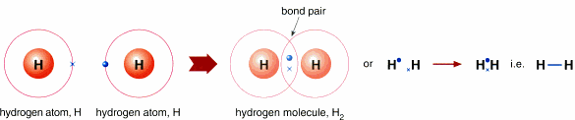

The hydrogen atom has one valency. To become stable, the hydrogen atom needs one more electron, just like helium which has 2 valency electrons. When 2 hydrogen atoms join, they share their electrons, on which, the share becomes 2 electrons, which is now a noble gas configuration, being shared between these 2 atoms. Write the bond as H – H single bond, which means they share an electron pair (2 electrons).

*E.g. Chlorine (Cl2) molecule*

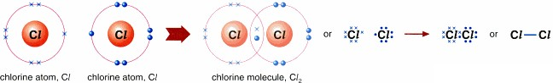

The chlorine (Cl)atom has 7 valency electrons and needs one electron, each, to form a noble gas configuration between two Cl atoms. Hence they share an electron EACH to share 2 electrons between the atoms. Hence, each Clatom now has 8 valency electrons which is a noble gas configuration.

*E.g.O2 molecule*

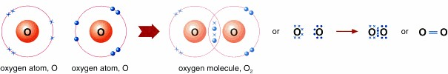

An O atom has 6 valency electrons and needs 2 electrons, each, to form a noble gas configuration. Hence, EACH SHARE THE AMOUNT OF ELECTRONS EACH IS SHORT OF,

in this case – 2 electrons, to forma stable molecule. The contribution hence now becomes 4

electrons and what left on each oxygen atom are 4 electrons. Combine each 4 electrons on oxygen atom with the 4 electrons shared and hence get 8

*E.g. H2O molecule*

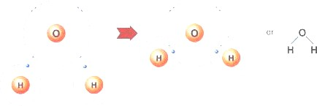

Apart from oxygen sharing between oxygen atoms, it can share electrons with other atoms. Oxygen needs 2 electrons and when bonded with hydrogen, which need an atom each, they combine to provide 2 electrons on both sides of oxygen bonded with hydrogen atoms. Each hydrogen atom with oxygen atom form a single bond: O – H.

*E.g. CO2 molecule*



Carbon needs 4, oxygen needs 2. Share two from oxygen part, WHICH HAS THE SMALLEST NUMBER OF SHORT OF ELECTRONS, TO SHARE THE AMOUNT OF ELECTRONS

THAT EACH ATOM NEEDS, to form 4 shared atoms. Now oxygen is stable but carbon needs 2 more, which it can get from another oxygen atom. The atoms are now stable and since each bond has 2 pairs of electrons, this is a double bond: C = O.

NB:

A pair of shared electrons between 2 atoms forms **SINGLE BOND**, X – Y. Two pairs of shared electrons between 2 atoms forms **DOUBLE BOND**, X = Y. Three pairs of shared electrons between 2 atoms forms **TRIPLE BOND**, X ≡ Y.

### Dative bonding

It is essentially another type of covalent bonding since it involves sharing of electrons. The difference here is that the electrons to be shared are donated solely by one of the atoms in the bond

This results from the existence of a lone pair of electrons, which are not directly concerned with valency.

This kind of bonding exists in the ammonium molecule (NH4+). Coordinate bonding is sometimes referred to as **dative bonding**.

### Metallic Bonding

**Metallic bonding** is bonding within atoms of metals caused by attractive force between positively charged metal ions and negatively charged free electrons. The atoms are packed closely together in **giant lattice structures**.

#### *Metallic bond formation*

Each atom in metal gives up valence electrons to form positive ions. There are free electrons moving between the spaces and positive metal ions are attracted to the sea of electrons which hold the atoms together.

### Structure and properties of metallic bonds

1. Metals can be bent (ductile) and can be stretched (malleable) because the layers of atoms in metals slide over each other when force is applied but will not break due to attractive force between electrons and metal ions.
2. Metals conduct electricity as it has free electrons which carry current.
3. Metals conduct heat as it has free electrons which gains energy when heated and moves faster to collide with metal atoms, releasing heat in collisions.
4. Metals have high melting and boiling points because the bond between metals is very strong. Hence very high heat energy needed to break the bonds.

### Valency

A valency is the number of hydrogen atoms which combine with or displace one atom of an element or one group of the radical e.g. one atom of oxygen combines with two atoms of hydrogen to form water.

Therefore the valency of oxygen is 2. Hydrogen is regarded as the standard and its valency is 1. A valency can also be defined as the number of electrons an element or radical must gain or lose in order to attain a stable electronic configuration e.g. oxygen has electronic configuration 2:6, therefore it needs two electrons to be a noble gas with electronic configuration of 2:8

### Elements and radicals with their valencies

|  |  |
| --- | --- |
| Element | Symbol |
| Hydrogen | 1 |
| Helium | 0 |
| Lithium | 1 |
| Beryllium | 2 |
| Boron | 3 |
| Carbon | 4 |
| Nitrogen | 3 |
| Oxygen | 2 |
| Fluorine | 1 |
| Neon | 0 |
| Sodium | 1 |
| Magnesium | 2 |
| Aluminum | 3 |
| Silicon | 4 |
| Phosphorous | 3 and 5 |
| Sulphur | 2 |
| Chlorine | 1 |
| Argon | 1 |
| Potassium | 0 |
| Calcium | 1 |

|  |  |
| --- | --- |
| Chromium | 3 |
| Manganese | 2 |
| Iron | 2 and 3 |
| Cobalt | 2 |
| Nickel | 2 |
| Copper | 2 |
| Zinc | 2 |
| Lead | 2 |
| Mercury | 2 |
| Silver | 1 |
| Bromine | 1 |
| Iodine | 1 |

### Radicals

|  |  |  |
| --- | --- | --- |
| Radical | Symbol | Valency |
| Hydroxide | OH | 1 |
| Bromide | Br | 1 |
| Nitrate | NO3 | 1 |
| Chlorine | Cl | 1 |
| Hydrogen carbonate | HCO3 | 1 |
| Hydrogen sulphate | HSO4 | 1 |
| Oxide | O | 2 |
| Carbonate | CO3 | 2 |
| Sulphate | SO4 | 2 |
| Sulphite | SO3 | 2 |
| Phosphate | PO4 | 3 |

### Chemical formulae

This is a group of letters and numbers which represent the name of a compound. In writing chemical formulae, we therefore use symbols of elements and their valences.

### Writing chemical formulae

* First write the symbols of the element or radical that makes up that compounde.g.

|  |  |  |  |  |  |
| --- | --- | --- | --- | --- | --- |
| Sodium | Chloride | Calcium | Sulphate | Aluminium | Oxide |
| Na | Cl | Ca | SO4 | Al | O |

* Write the valences on top right side of the symbols of elements or radicals

|  |  |  |  |  |  |
| --- | --- | --- | --- | --- | --- |
| Na1 | Cl1 | Ca2 | SO42 | Al3 | O2 |

* Rewrite the symbols again reversing the valences from top right side to the bottom right side of symbols and radicals

|  |  |  |  |  |  |
| --- | --- | --- | --- | --- | --- |
| Na1 | Cl1 | Ca2 | SO42 | Al3 | O2 |

Giving

|  |  |  |  |  |  |  |  |
| --- | --- | --- | --- | --- | --- | --- | --- |
| Na1 | Cl1 |  | Ca2 | (SO4)2 |  | Al2 | O3 |

Na1Cl1 Ca2 (SO4)2 Al2O3

Note: if the valency of any element is **1**, **it should not be written in the final formula. Also if the two valencies are similar, they should not be written**.

The valency of elements combined in a radical should be written outside the brackets and affects all the elements enclosed when counting the number of atoms e.g. Al2(SO4)3

For valencies in a formula which are multiples should be cancelled to their lowest possible values

|  |  |  |  |  |  |  |  |
| --- | --- | --- | --- | --- | --- | --- | --- |
| Na1 | Cl1 |  | Ca2/2 | (SO4) 2/2 |  | Al2 | O3 |

Formula: NaCl CaSO4 Al2O3

Examples

1. Sodium hydroxide

|  |  |  |
| --- | --- | --- |
|  | Sodium | Hydroxide |
| Symbols | Na | OH |
| Valencies on top | Na1 | OH1 |
| Reversing valencies | Na1 | OH1 |

Neglecting 1 in final formula: NaOH

1. Magnesium chloride

|  |  |  |
| --- | --- | --- |
|  | Magnesium | Chloride |
| Symbols | Mg | Cl |
| Valencies on top | Mg2 | Cl1 |
| Reversing valencies | Mg2 | Cl1 |

Neglecting 1 in final formula: MgCl2

1. Carbon dioxide

|  |  |  |
| --- | --- | --- |
|  | Carbon | Oxide |
| Symbols | C | O |
| Valencies on top | C4 | O2 |
| Reversing valencies | C4 | O2 |

Cancelling valencies to the lowest possible values from the final formula: CO2

1. Ammonium sulphate

|  |  |  |
| --- | --- | --- |
|  | Ammonium | Sulphate |
| Symbols | NH4 | SO4 |
| Valencies on top | NH41 | SO42 |
| Reversing valencies | NH41 | SO42 |

Neglecting 1 in the final formula: (NH4)2SO4

### Calculating the number of atoms of elements in a compound

Examples:

Calculate the number of atoms of the elements contained in the following compounds NaCl = one mole of sodium chloride contains

1 atom of sodium 1 atom of chlorine

CaSO4 = one mole of calcium sulphate contains 1 atom of calcium

1 atom of sulphur 4 atoms of oxygen

(NH4)2SO4 = one mole of ammonium sulphate contains 2 atom of nitrogen

8 atoms of hydrogen I atom of sulphur

4 atoms of oxygen

5Al2O3 = 5 moles of aluminium oxide contains 10 atoms of aluminium

15 atoms of oxygen

3CuSO4.5H2O = 3 mole of copper sulphate. 5 water molecules contains 3 atoms of copper

3 atoms of sulphur 27 atoms of oxygen

30 atoms of hydrogen

NB: From the examples, the following should be noted

1. The numeral behind the formula represents the number of molecules and is multiplied through each element in the whole formula to get total number of atoms of each element
2. The numeral in front of each element is multiplied only through that element
3. The numeral outside the brackets should be multiplied only through those elements inside the brackets

### Exercise

Write the chemical formulae of the following compounds and calculate the number of atoms of each element

|  |  |  |
| --- | --- | --- |
| **Chemical name** | **Common name** | **Formula** |
| Calcium hydroxide (solid) | Slaked lime | Ca(OH)2 |
| Calcium oxide | Lime, quick lime | CaO |
| Calcium hydroxide solution | Lime water | Ca(OH)2 |
| Potassium hydroxide | Caustic potash | KOH |
| Sodium hydrogen carbonate | Baking soda | NaHCO3 |
| Calcium carbonate | Chalk, limestone or  marble | CaCO3 |
| Sodium hydroxide | Caustic soda | NaOH |
| Iron (III) oxide (hydrated) | Iron rust | Fe2O3.xH2O |
| Potassium nitrate | Salt patre | KNO3 |
| Sodium carbonate hydrated | Washing soda | Na2CO3.10H2O |

**11. Chemical equations** Writing chemical equations Steps

Write the formula for the reactants on the left hand side and that for the products on the right hand side and check the valencies for the elements forming the formula to confirm if they are right

1. Sulphuric acid reacts with sodium hydroxide to form sodium sulphate and water H2SO4(aq) + 2NaOH(aq) Na2SO4(aq) + H2O(l)
2. Hydrogen reacts with oxygen to form water

H2(g) + O2(aq) 2H2O(l)

### NB: The following symbols represent

→ **means** to form + **means** reacts with (in reactants)

+ **means** and (in products)

### States

The following are state symbols with their meanings

g= gas; l=liquid; aq=aqueous; s=solid

Write the states of matter for each element or compound in the equation: H2SO4 (aq) + 2NaOH (aq) → Na2SO4 (aq) + H2O (l)

### Balanced chemical equations

A balanced equation is where the number of atoms on the left hand side is equal to the number of atoms on the right hand side for each kind of element e.g. 2H2 (g) + O2 (g) → H2O (l)

### Balancing chemical equations

* + Write the formula for the reactants on the left hand side and that for products on the right hand side. H2 (g) + O2 (g) → H2O (l)
  + Check the valencies for the elements forming the compounds to confirm if formulae are right

H2 (g) + O2 (g) → H1O2 (l)

=H2O

* + Count the number of atoms of each element on the right hand side and on the left hand side to see if they balance

H2 (g) + O2 (g) → H2O (l)

LHS RHS

|  |  |
| --- | --- |
| H=2 | H=2 |
| O=1 | O=1 |

* + If they don‘t balance, look for a number which can be multiplied in the formula above to make all elements balance on both sides of the equation.

|  |  |
| --- | --- |
| 2H2 (g) + O2 (g) → 2H2O (l) | |
| LHS | RHS |
| H=4 | H=4 |
| O=2 | O=2 |

NB: Balanced

1. A numeral to balance the equation must be written behind the formula of the element and affects the number of atoms of all elements in the formula e.g.**2**H2O
2. Never fix the number in front of the element or formula to be balanced or in the middle of the formula
3. Great care should be taken to ensure that all formulae are correctly written. Failure of the equation to balance is an indicator that the equation may be wrong or some formulae are wrongly written
4. Sometimes it is easier to balance an equation by using fractions and they multiplied by a number to remove the fraction

### Examples

Balance the following chemical equations

|  |  |
| --- | --- |
| i. Na (s) + O2 (g) → Na2O (s) | |
| LHS | RHS |
| Na=1 | Na=2 |
| O=2 | O=1 |
|  | Not balanced |
| 4Na (s) + O2 (g) → 2Na2O (s) | |
| LHS | RHS |
| Na=4 | Na=4 |
| O=2 | O=1 |
|  | Balanced |

|  |  |  |
| --- | --- | --- |
| Or 2Na (g) +½ O2 (g)  the fraction | → | Na2O (l) multiplying by two through out to remove |
|  | 4Na (s) + O2 (g) | → 2Na2O (s) |

|  |  |
| --- | --- |
| ii. Fe (s) + O2 (g) → Fe2O3 (s) | |
| LHS | RHS |

|  |  |
| --- | --- |
| Fe=1 | Fe=2 |
| O=2 | O=3 |
|  | Not balanced |
| iii. 4Fe (s) + 3O2 (g) → 2Fe2O3 (s) | |
| LHS | LHS |
| Fe=4 | Fe=4 |
| O=6 | O=6 |
|  | Balanced |

Or 2Fe (s) +O2 (g) → Fe2O3 (s)) multiplying by two through out to remove

the fraction

4Fe (s) + 3O2 (g) → 2Fe2O3 (s)

|  |  |
| --- | --- |
| iv. Zn (s) + HCl (aq) → ZnCl2 (aq) + H2 (g) | |
| LHS | RHS |
| Zn =1 | Zn =1 |
| H=1 | H=2 |
| Cl =1 | Cl =2 |
|  | Not balanced |
| Zn (s) + 2HCl (aq) → ZnCl2 (aq) + H2 (g) | |
| LHS | RHS |
| Zn =1 | Zn =1 |
| H=2 | H=2 |
| Cl =2 | Cl =2 |
|  | Balanced |

Note:

All the above steps are not required in examinations, but they are important to make you understand. After you have got the basics then it is advised to balance the equation using your head and directly write the balanced equation which is always required

Some equations are already balanced and therefore do not need to be balanced by fractions

### More examples:

1. KClO3 (s) → KCl (s) + O2(g) 2KClO3 (s) → 2KCl (s) + 3O2(g)
2. Mg (s) + HCl(aq)→ MgCl2(aq) + H2(g) Mg (s) + 2HCl(aq)→ MgCl2(aq) + H2(g)
3. CaCO3 (s) → CaO(s) + CO2(g)

CaCO3 (s) → CaO (s) + CO2(g) Directly balanced

1. NaOH (aq) + HCl(aq) →NaCl(s) + H2O(l)

NaOH (aq) + HCl(aq) →NaCl (s) + H2O(l) Directly balanced

### Exercise

Balance the following equations

a) C(s) + O2(g) → CO2 (g)

b) N2(g) + H2(g) → NH3 (g)

c) 4Na (s) + O2 (g) → 2Na2O (s)

d) NaNO3 (s) → NaNO2 (s) + O2 (g)

e) Pb(NO3)2(s) → PbO (s) + NO2 (g) +O2 (g)

### 12. Types of chemical reactions

There are four types of chemical reactions

### Direct combination or direct synthesis

When two or more elements or compounds combine directly to form a more complex compound, the process is called **direct combination**.

This reaction has a general formula of **A +B →AB**. Examples include

a. C(s) + O2(g) → CO2 (g)

b. N2(g) + 3H2(g) →2 NH3 (g)

c. 4Na (s) + O2 (g) → 2Na2O (s)

1. H2(g) + Cl2(g) →2 HCl (g)
2. Ca(s) + Cl2(g) → CaCl2 (s)
3. 2K(s) + Cl2(g) → 2KCl (s)

12.1 Simple decomposition

When a compound is broken down into two or more simpler substances, the type of reaction is called **decomposition**e.g. during heating. It has a general formula of **AB →A + B**.

Examples

CaCO3 (s) → CaO (s) + CO2(g) 2KClO3 (s → 2KCl (s) + 3O2 (g)

2NaNO3 (s) → 2NaNO2 (s) + O2 (g)

2H2O2 (l) → 2H2O (l) + O2 (g)

### Simple replacement

When an element in a free state replaces another element in a compound, the reaction is called simple replacement.

It has a general formula of AB + CD → AC + B

E.g. Fe (s) + CuCl2 (aq) → FeCl2 (aq) + Cu (s)

### Double replacement

When an element in a compound replaces another element in another compound, this type of reaction is called double displacement.

It has a general formula of AB + CD → AD + BC

### Examples

ZnSO4(s) + Na2CO3 (s) → ZnCO3(s) + Na2SO4 (s) 2KOH (aq) + H2SO4 (aq) → K2SO4 (aq) + 2H2O (l)

NaOH (aq) + HCl (aq) → NaCl (aq) + H2O (l) NH4OH (aq) + HCl (aq) → NH4Cl (aq) + H2O (l)

* 1. The atmosphere and combustion The composition of the atmosphere

### Air is a mixture of gases

The average composition of dry air in the atmosphere by volume is:-

* Oxygen -21%
* Nitrogen- 78%
* Carbon dioxide - 0.03%
* Noble/inert/rare gases -1%

### Oxygen

It occupies 21% of the atmospheric air

It is added to the atmosphere during the process of

* photosynthesis
* thermal decomposition of nitrates

it is removed from the atmosphere during **respiration, rusting** and **combu****stion**

### 12.4.2 Uses of oxygen

It is used for respiration in living organisms

It supports burning (combustion) and rusting of metals

It is used as fuel; liquid oxygen is used to burn fuel in some air rockets It is used in steel production

### Nitrogen

This gas occupies the largest volume of 78%

It is used to dilute air in the atmosphere so that burning and rusting do not take place so fast. Without nitrogen in the air, burning and rusting would be very fast.

### Carbon dioxide

This occupies a volume of 0.03% in the atmosphere. Carbon dioxide is added to the atmosphere through respiration and burning fossil fuels e.g. petrol, diesel etc...

It is removed from the atmosphere by green plants during the process of **photosynthesis.**

### Noble gases

These include Helium (He), Neon (Ne), Argon (Ar), Krypton (Kr), Xenon (Xe), Radon (Rn) They do not react with any substance under normal conditions because they are inert.

### Uses of noble gases

Argon is used in some electric bulbs to stop the hot filament from darkening the glass of the bulb Neon is used in coloured lights used for advertising

Helium is a very light gas used for filling balloons

### Water vapour

In addition to the gases, the atmosphere also contains water vapour. This water vapour comes as a result of evapouration from the oceans, seas, rivers etc… The percentage composition of vapour varies from 1% to 4% by volume.

### Hygroscopic, deliquescent and efflorescent substances

* + 1. **Hygroscopic substances**

Are substances which absorb water from the atmosphere e.g. sodium chloride, calcium chloride, calcium oxide, concentrated sulphuric acid and anhydrous copper (II) sulphate

### Deliquescent substances

These are substances which absorb water from the atmosphere forming solution. Examples include calcium chloride, sodium hydroxide, phosphorous oxide, iron (III) chloride and sodium nitrate.

Note:

All deliquescent substances are hygroscopic but not all hygroscopic substances are deliquescent Deliquescent substances are hygroscopic substances which absorb water from the atmosphere forming a solution.

### Efflorescent substances

These are substances which lose water of crystallisation to the atmosphere Efflorescence: is the loss of water of crystallisation to the atmosphere.

Examples include:

* + - * Sodium carbonate -10-water( Na2CO3. 10H2O)
      * Sodium sulphate -10-water (Na2SO4. 10H2O) add more examples.

### Water of crystallisation

This is a definite amount of water which some substances chemically combine with, when they form crystals from their solutions in water.

### Drying agents

They are used to dry gases because they have a high affinity for water and therefore can absorb water from moist gases.

|  |  |
| --- | --- |
| Drying agent | Gases dried |
| Calcium oxide | Ammonia |
| Concentrated sulphuric acid | All gases except ammonia |
| Anhydrous calcium chloride | All gases except ammonia |
| Phosphorous (V) oxide | All gases except ammonia |

### Burning substances in air

The part of air used for burning is oxygen

Metals burn in air to form basic oxides which when dissolved in water form alkaline solutions

### Sodium

This burns with a bright yellow flame forming a yellow solid of sodium peroxide and a little sodium oxide

2Na(s) + O2 (g) → Na2O2 (s) (sodium peroxide) 4Na(s) + O2 (g) → 2Na2O (s) (sodium oxide)

When sodium oxide is dissolved in water, sodium hydroxide is formed Na2O (s) + H2O (l) → 2NaOH (aq) (sodium hydroxide)

When sodium peroxide is dissolved in water effervescence/bubbles of a colourless gas (oxygen) are observed and a colourless solution (sodium hydroxide solution) are observed

2Na2O2(s) + 2H2O (l) → 4NaOH (aq) + O2 (g)

### Magnesium

This burns with a brilliant flame forming a white smoke and ash i.e. an oxide and a nitride 2Mg(s) + O2 (g) → 2MgO (s) (Magnesium oxide)

3Mg(s) + N2 (g) → Mg3 N2 (s) (Magnesium Nitride)

### Aluminium

This burns in air when heated strongly and becomes very hot It forms aluminium oxide and a little nitride

4Al(s) +3 O2 (g) → 2 Al2 O3 (s) (Aluminium oxide) 2Al(s) + N2 (g) → 2AlN (s) (Aluminium nitride) **Zinc**

Zinc burns in air with a green flame to form zinc oxide. It does not form a nitride. 2Zn(s) + O2 (g) → 2ZnO (s) (Zinc oxide)

### Lead

This melts on heating to shiny beads and then forms lead oxide which is brown when hot and turns yellow on cooling

2Pb(s) + O2 (g) → 2PbO (s) (Lead II oxide)

Brown when hot Yellow on cooling

### Copper

This burns with a green flame to form a black oxide 2Cu(s) + O2 (g) → 2CuO (s) (copper II oxide)

### Non metals Carbon

This burns in a plentiful supply of air to form Carbon dioxide C(s) + O2 (g) → CO2 (g)

If oxygen is in short supply, carbon burns with little oxygen to form carbon monoxide 2C(s) + O2 (g) → 2CO (g)

### Phosphorous

This burns with a bright yellow flame and produces dense white fumes of phosphorous pentoxide P4 (s) + 5O2 (g) → P2 O5 (s)

Or 4P (s) + 5O2 (g) → P2 O5 (s)

### Sulphur

This burns in air with a bright blue flame forming cloudy fumes of sulphur dioxide S(s) + O2 (g) → SO2 (g)

### An experiment to determine the percentage of oxygen(active air) in the air

Wet iron wool is put in a marked test tube and the test tube is inverted in a beaker of water.

#### *Diagram*

The length of air column X, is maked and noted

The experiment is left to stand for a week. After a week, water will rise to a certain height in the test tube.

#### *Diagram after aweek*

The new height of the air column Y.is noted

The length of the air column used in the rusting of iron wool is X-Y.

This is equal to the volume of oxygen used up because oxygen is used up in rusting.

The percentage of oxygen used up =

=  X100

From the experiment, if the value of X is 10 and that of Y is 7.9, the percentage of oxygen used up

= X100

=  X100

=21%

Therefore the volume of oxygen used in rusting is 21% which is the composition of oxygen in the atmosphere.

***Give some more examples on calculations***

### 1.8. Burning candle

Burning is a chemical reaction in which a substance chemically combines with oxygen and heat is produced.

When a candle burns, Carbon dioxide and water are produced.

### An experiment to show that Carbon dioxide and water are produced when a candle burns

The apparatus is as shown below

#### *Diagram (companion chem. Pp22)*

The gas from the burning candleis passed through a U-tube placed in cold water and then through a test tube containing lime water

Observation

After 30 seconds, drops of a colourless liquid which turns anhydrous copper (II) sulphate from white to blue collects at the bottom of the U-tube

The lime water in the test tube turns milky Conclusion

The colourless liquid is water since it turns anhydrous copper (II) sulphate from white to blue And the gas is carbon dioxide since it turns lime water milky.

Therefore when a candle burns, Carbon dioxide and water are produced

### Rusting

Rusting is a chemical change where by iron combines with oxygen under moist conditions to form a brown substance called iron rust.

Rust is a brown coat formed when iron is left in damp air. Rust is chemically called hydrated iron (III) oxide (Fe2O3.xH2O)

4Fe(s) +3O2 (g) → 2Fe2O3 (s)

Fe2O3 (s) + xH2O (l) →Fe2O3.xH2O (s)

### Conditions necessary for rusting

There are two conditions necessary for rusting to take place. These are: Oxygen

Water

For rusting to take place both of these must be present.

### An experiment to show that iron rusts when left exposed to damp air

Iron nails are placed in the test tube and the test tube closed with wet cotton wool. The experiment is left to stand for 7 days

#### *Diagram (junior chemistr, Atkinson pp50)*

After a week, the iron nails were found to have turned brown i.e. had rusted. An iron nail rusts in presence of water and air/damp air.

### An experiment to show that water is necessary for rusting

#### *Diagram (Atkinson pp50)*

Clean iron nails or iron fillings are placed at the bottom of a test tube. Cotton wool is pushed half way the tube and anhydrous calcium chloride placed on top of the cotton wool, to absorb all the moisture from air

Close the mouth of the test tube with another cotton wool to reduce the amount of air reaching calcium chloride.

Leave the experiment to stand for several weeks.

The iron nails do not rust because water is absent or because the air is dry. This proves that for rusting to take place, the air must be damp.

### An experiment to show that air is necessary for rusting

#### *(Diagram pp51 Atkinson)*

Water is boiled for 10 minutes to remove air in it. The iron nails are then placed at the bottom of the test tube. Oil or grease is added on top of water prevent any entry of air.

The experiment is left to stand for a week.

At the end of the week the iron nails do not rust due to absence of air. Therefore iron nails cannot rust in water if it does not contain air.

### An experiment to investigate the conditions needed for rusting

Set up the experiment as shown below ***(Diagram companion chemistry pp27)*** Leave the experiment to stand for 2days **Results**

1. Rusting took place
2. Rusting did not take place
3. Rusting did not take place
4. Rusting did not take place

### Explanation

A- For A all conditions for rusting are present

B- For B oxygen gas is absent

C- For C both water and oxygen gas are absent

D- For D water is is absent

Therefore rusting takes place in presence of water and oxygen gas.

### Prevention of rusting

Iron can be prevented from rusting when either air or water is kept away from it. The methods of preventing rusting include:

* Surface protection
* Sacrificial protection
* Use of stainless steel

**Surface Protection** – covers metal with a layer of substance

### Paint

1. **Grease or oil** (also help to lubricate)
   * It relight a glowing wooden splint

### Chemical properties

It reacts with metals to form basic oxides

2Mg(s) + O2 (g) → 2MgO (s) (Magnesium oxide) 4Na(s) + O2 (g) → 2Na2O (s) (sodium oxide)

It reacts with non metals to acidic oxides S(s) + O2 (g) → SO2 (g)

P4 (s) + 5O2 (g) → P2O5 (s) C(s) + O2 (g) → CO2 (g)

### Uses of oxygen

* As rocket fuel
* In steel making, to burn off impurities
* In oxy-acetylene cutting and welding
* In oxygen tanks for deep sea divers and mountain climbers to provide oxygen
* For respiration for most animals
* Used as oxygen tents in hospital to aid patients with respiratory problems

### Oxides

An oxide is a compound formed when an element combines with oxygen e.g. magnesium oxide (MgO), Calcium oxide (CaO) etc…

### Types of oxides

1. **Basic oxides**

These are oxides of metals that react with water to form alkalis. Examples of basic oxides include calcium oxide (CaO), zinc oxide (ZnO), potassium oxide (K2O), sodium oxide (Na2O) etc…

These basic oxides react with water to form corresponding alkalis e.g. Na2O (s) + H2O (l) → 2NaOH (aq) (Sodium hydroxide)

K2O (s) + H2O (l) → 2KOH (aq) (Potassium hydroxide)

### Acidic oxides/Acid anhydrides

There are oxides of non-metals which react with water to produce acids.

Examples of acidic oxides include Carbon dioxide (CO2), sulphur dioxide (SO2), sulphur trioxide (SO3), nitrogen dioxide (NO2) etc…

Examples of acids that can be produced from the reactions of these oxides with water are H2CO3, H2SO3, H2SO4, HNO3 etc…

CO2 (g) + H2O (l) → H2CO3 (aq) SO2 (g) + H2O (l) → H2SO3 (aq) SO3 (g) + H2O (l) → H2SO4 (aq)

2NO2 (g) + H2O (l) → 2HNO3 (aq)

Note:

Acidic oxides are also called acid anhydrides.

**An acid anhydride** is an oxide of a non-metal which reacts with water to form an acid.

### Amphoteric oxides

These are oxides of metals which show both acidic and basic properties e.g. ZnO, Al2O3 and PbO (Lead oxide)

### Neutral oxides

These are oxides which show neither basic nor acidic characters. They are usually the lower oxides of non-metals e.g. water (H2O), dinitrogen oxide (N2O), carbon monoxide (CO), nitrogen monoxide (NO) etc…

Mixed oxides

These are oxides which react like a mixture of two or more simpler oxides e.g trilead tetraoxide (Pb3O4), triiron tetraoxide(Fe3O4) and dinitrogen tetraoxide (N2O4)

Peroxides

These are oxides which produce twice as much oxygen as would be expected from the usual valency of the element in the oxide e.g. sodium peroxide (Na2O2), hydrogen peroxide (H2O2) etc…

### Oxidation and reduction

**Oxidation**

* + Oxidation is the addition of oxygen to a substance
  + Oxidation is the removal of hydrogen from a substance
  + Oxidation is the loss of electrons by a substance Examples of oxidation reactions include;

C(s) + O2 (g) → CO2 (g)

4Na(s) + O2 (g) → 2Na2O (s) (sodium oxide) 2Mg(s) + O2 (g) → 2MgO (s)

H2S (s) + Cl2 (g) → HCl(g) + S(s)

Na(s) → Na+ (g) + e

### Reduction

* + Reduction is the removal of oxygen from a substance
  + Reduction is the addition of hydrogen to a substance
  + Reduction is the gain of electrons by a substance Examples of reduction reactions include:

H2 (g) + Cl2 (g) → 2HCl(g)

CuO (s) + H2 (g) → Cu(s) +H2O(l)

PbO (s) + H2 (g) → Pb(s) +H2O(l)

### Oxidizing agents

An oxidizing agent is a substance which adds oxygen to another substance Or

It is a substance which removes hydrogen from another substance

Examples of oxidizing agents include: oxygen (O2), concentrated sulphuric acid (H2SO4), potassium permanganate (KMnO4) manganese (IV) oxide (MnO2), nitric acid (HNO3), potassium dichromate VII (K2CrO4), chlorine (Cl2) etc…

### Reducing agents

A reducing agent is a substance which adds hydrogen to another substance. Or it is a substance which removes oxygen from another substance.

Examples of reducing agents include Hydrogen (H2), carbon (C), carbon monoxide (CO), hydrogen sulphide (H2S), sulphurdioxide (SO2) and ammonia (NH3).

### Redox reactions

A **redox reaction** is a reaction in which reduction and oxidation occur at the same time. Therefore in such a reaction, one substance is reduced and another one oxidized.

### Water and hydrogen

**Water**

Water is a compound made up of hydrogen and oxygen in the ratio of 2:1

### Sources of water

* + Rain water: this is fairly purely than other kinds of water. It usually contains dissolved gases like Carbon dioxide, oxygen and dust particles.
  + Well or spring water: this is good for drinking because it passes through soil and rock and therefore some filtration has occurred. It also contains some dissolved gases.
  + River water: This contains a little dissolved matter e.g. salt and plenty of dirt and mud
  + Sea/lake water: This contains a lot of salt and therefore has a salty taste. Due to the presence of salt in seas and lakes, such water is not good for drinking.
  + Underground water e.g.wells, bore holes etc…
  + Surface water e.g. ponds, swamps etc…

### Synthesis of water

Experiment to show synthesis of water

### Properties of pure water

It is a colourless liquid It has a flat taste

It is neutral to litmus

It is freezes at 0oC and boils at 100oC and pressure of 1 atmosphere It has a maximum density of 1g/cm3at 4oC

### Test for water

It turns anhydrous copper (II) sulphate from white powder to blue crystals It turns anhydrous cobalt (II) chloride from blue to pink

### Purification of water

Impure water is purified by using the process of distillation. Impure water is placed in a distillation flask and heated to 100oC. The steam comes out while solid impurities remain in the flask. The steam is cooled and condensed by cold water in the condenser.

#### *Examples of pollutants of water*

* + Sewage
  + Oil
  + Detergents
  + Fertilizers
* Acidic gases
* Hot water
* Insecticides

### Reactions of metals with water

Potassium

Sodium React violently with cold water Calcium

Magnesium Aluminum Zinc

Iron Lead

React with steam

Copper Do not react with cold water or steam Mercury

Silver Gold

### Potassium

This is a bright silvery metal. It reacts explosively with cold water to produce a colourless solution of potassium hydroxide and a colourless gas of hydrogen

2K(s) +2 H2O(l) → 2KOH(aq) +H2(g)

### Sodium

This reacts vigorously with cold water to produce a colourless solution of sodium hydroxide and a colourless gas of hydrogen

2Na(s) +2 H2O(l) → 2NaOH(aq) +H2(g)

During the reaction of sodium with water, a hissing sound is produced. However, sodium is less reactive than potassium

### Calcium

This reacts quietly with cold water producing calcium hydroxide and hydrogen Ca(s) +2 H2O(l) → Ca(OH)2 (aq) +H2(g)

### Magnesium

This metal reacts with cold water very slowly but when magnesium is hot, it catches fire with steam and burns with a bright light flame to produce a white ash of magnesium oxide and hydrogen

Mg(s) +2H2O(g) → MgO (aq) +H2(g)

In cold water, it slowly forms magnesium hydroxide and hydrogen Mg(s) +2 H2O(l) → Mg(OH)2 (aq) +H2(g)

### Reaction of magnesium with steam

Clean about 6cm of magnesium ribbon with sand paper. Place wet sand in a small test tube. Heat is applied to both ends of the wet sand and magnesium ribbon.

The wet sand will produce steam on heating which will react with magnesium ribbon to form a white ash of magnesium oxide and hydrogen gas is produced

Mg(s) +H2O(g) → MgO (aq) +H2(g)

### Iron

This reacts slowly with steam and produces a black triiron tetraoxide (Fe3O4) and hydrogen gas 3Fe(s) +4H2O(g) → Fe3O4 (s) +4H2(g)

### Uses of water

Acts as a solvent

Raw material in the manufacture of ammonia and ethanol Used in the production of steam to drive turbines

For heating and cooling in industries

### Reactivity Series

This is a list of metals in order of their reactivity with air,water or dilute acids The most reactive being at the top and the least reactive at the bottom Potassium

Sodium Calcium Magnesium Aluminum Zinc

Iron Lead Copper Mercury Silver Gold

#### *Reaction of Metals with Water*

**Potassium**, **Sodium**, and **Calcium** reacts with cold water to form: M(s) + 2H2O(l) → MOH(aq) + H2(g)

Metal + Water → Metal Hydroxide + Hydrogen

**Magnesium**, **Zinc**, **Iron** reacts with steam to form:

M(s) + 2H2O(g) →MO(s) + H2(g)

Metal + Water→Metal Oxide + Hydrogen

**Iron** does not react with water

**Copper** and **gold** have no reaction with water and steam

#### *Reaction of Metals with Dilute Hydrochloric Acid*

**Potassium**, **sodium**, **calcium**, **magnesium**, **zinc** and **iron** reacts with dilute hydrochloric acid to form:

M(s) + 2HCl(aq) → MCl2(aq) + H2(g)

Metal + Acid → Metal Chloride + Hydrogen

**Lead** reacts with warm hydrochloric acid slowly

**Copper** and g**old** have no reaction with dilute hydrochloric acid

#### *Displacement Reactions*

*Displacement reaction* is the displacement of ions of metal from compounds of metals lower in reactivity series by metals higher in reactivity series.

#### *E.g. Magnesium displaces copper(II) chloride*

Mg(s) + CuCl2(aq) →MgCl2(aq) + Cu(s)

For observation, silver magnesium metal coated with brown copper metal

Displacement is due to magnesium atoms transfer electrons to copper (II)ions forming copper atoms.

Mg(s) → Mg2+(aq) + 2e- Cu2+(aq) + 2e- → Cu(s)

Loss of electrons is due to it‘s being less reactive, asthe less reactive metal has higher chances of losing electrons.

That‘s why when magnesium is placed in potassium chloride solution, no reaction occurs

#### *E.g. Displacement from metal oxides*

Metals higher in the reactivity series displace oxides of metals lower in reactivity series. When calcium burns with silver oxide, Calcium displaces silver to produce calcium oxide and silver metal.

Ca(s) + Ag2O(s) →CaO(s) + 2Ag(s)

This is called ***thermit reaction*** large amount of heat is produced.

#### *Reaction of Metal Oxides with Carbon*

*The lower the position of a metal in reactivity series, the easier for carbon to remove oxygen from the metal oxide by heating. At higher position, stronger heat is needed.*

E.g. Copper (II) oxide reacts with carbon and can be reduced by bunsen burner flame temperature

CuO(s) + C(s) → Cu(s) + CO2(g)

For iron (III) oxide to be reduced, it needs very high temperature.

#### *Reaction of Metal Oxides with Hydrogen*

*The lower the position of metal in reactivity series, the easier hydrogen removes oxygen from the metal oxide by heating. At higher position, stronger heat is needed.*

E.g. Lead (II) oxideis reduced by hydrogen at Bunsen burner flame temperature PbO(s) + H2(g) → Pb(s) + H2O(*l*)

#### *Decomposition of Metal Carbonates*

*The lower the position of a metal in the reactivity series, the easier hydrogen removes oxygen from a metal oxide by heating. At ahigher position, stronger heat is needed.*

E.g.Copper (II) carbonate is decomposed by heat atbunsen burner flame temperature CuCO3(s) → CuO(s) + CO2(g)

### Hydrogen

**Laboratory preparation of dry hydrogen gas**

Hydrogen is prepared by the action of dilute acids on metals e.g. action of dilute sulphuric acid or hydrochloric acid on zinc, magnesium or iron in the presence of a little copper (II) sulphate to speed up the reaction.

### Set up:

**Procedure**

Dilute hydrochloric acid or dilute sulphuric acid is added through a thistle funnel to zinc granules in a conical flask

The hydrogen produced is passed through anhydrous calcium chloride in a U-tube or concentrated sulphuric acid in a wash bottle for drying.

The dry hydrogen gas is then collected by upward delivery because it is lighter than air.

If the reaction is too slow, copper (II) sulphate solution is added to the flask to speed up the reaction hence acting as a catalyst.

### Equation

Zn(s) + 2HCl(aq) → ZnCl2 (aq) + H2(g)

If sulphuric acid is instead used, the equation of reaction becomes Zn(s) + H2SO4 (aq) → Zn SO4 (aq) + H2(g)

When anhydrous calcium chloride is used as a drying agent, the diagram becomes;

NB: Dilute nitric acid is not used in preparation of hydrogen because it is an oxidizing agent and would therefore oxidize hydrogen produced to water.

### Preparation of hydrogen by action of water on metals

Metals like sodium, potassium and calcium react with water to produce hydrogen. Mg(s) +2H2O(l) → MgO (aq) +H2(g)

Ca(s) +2 H2O(l) → Ca(OH)2 (aq) +H2(g) 2K(s) +2 H2O(l) → 2KOH(aq) +H2(g)

2Na(s) +2 H2O(l) → 2NaOH(aq) +H2(g)

### Test for hydrogen gas

It is tested by using a burning splint. When a burning splint is placed in a gas jar full of hydrogen gas, it burns with a pop sound.

### Properties of hydrogen Physical properties

It is a colourless, ordourless gas

It is neutral to litmus paper i.e. has no effect on litmus paper

It is the lightest gas (much less dense than air) and diffuses fast It is not very soluble in water

It is the first element in the periodic table Has an atomic number of one

Exists as a diatomic element

### Chemical properties

It does not support burning but burns readily in air with a faint blue flame forming water 2H2(g) + O2(g) → 2H2O(l)

It reacts with non-metals e.g.

Hydrogen reacts with chlorine in presence of sun light to produce hydrogen chloride H2(g) + Cl2(g) → 2HCl(l)

It also combines with nitrogen to produce ammonia gas 3H2(g) + N2(g) → 2NH3(g)

Hydrogen is a reducing agent i.e. it reduces oxides of copper, lead and iron to their metals CuO(s) + H2(g) → Cu(s) + H2O(l)

PbO(s) + H2(g) → Pb(s) + H2O(l) Fe3O2 (s) + 2H2(g) → 3Fe(s) +2 H2O(l)

### Action of hydrogen on copper (II) oxide

When hydrogen is passed over heated copper (II) oxide, copper is formed. The black copper (II) oxide turns brown. A colourless liquid (water) forms on the cooler parts of the test tube.

CuO(s) + H2(g) → Cu(s) + H2O(l)

Hydrogen also reacts with alkenes to give alkanes (hydrogenation) CH2=CH2(g) + H2(g) → CH3CH3(g)

It combines with highly electropositive metals to form hydrides 2Na(s) + H2=(g) → 2NaH (s)

NB: Hydrogen chloride (HCl), Hydrogen sulphide (H2S ), ammonia (NH3) and water (H2O ) are called hydrides.

A hydride is a compound of an element with hydrogen only.

### Uses of hydrogen

Used in the manufacture of methanol It is used a fuel in rockets

Used in the manufacture of hydrogen chloride gas It is used in hardening of oils

### Acids, bases and salts

* 1. **Acids**

An acid is a substance which when dissolved in water produces hydrogen ions as the only positively charged ions

### Common Acids

Acids in daily life:

Ethanoic acid – found in vinegar and tomato juice

Citric acid – found in citrus foods like lemons, oranges and grapefruit Lactic acid – found in sour milk and yoghurt, and in muscle respiration Tartaric acid – found in grapes

Tannic acid – found in tea and ant‘s body Formic acid – found in bee stings Hydrochloric acid – found in stomach juices

### Laboratory acids: 3 common laboratory acids/Mineral acids

Hydrochloric acid (HCl)

HCl (aq) → H+ (aq) + Cl-(aq) Sulphuric acid (H2SO4)

H2SO4 (aq) → 2H+ (aq) + SO42-(aq)

Nitric acid (HNO3)

H NO3 (aq) → H+ (aq) + NO3-(aq)

**Dilute acids** – solution containing small amount of acid dissolved in water

**Concentrated acids** – solution containing large amount of acid dissolved in water

### Basicity of an acid

**Basicity of an acid** is maximum number of hydrogen ions (H+)ions produced by a molecule of an acid

### Some Acids with Their Basicity

|  |  |  |
| --- | --- | --- |
| **Acids** | **Reaction with water** | **Basicity** |
| Hydrochloric acid | HCl(aq) → H+(aq) + Cl-(aq) | Monobasic |
| Nitric acid | HNO3(aq) → H+(aq) + NO3-(aq) | Monobasic |
| Ethanoic acid | CH3COOH(aq) ⇌ H+(aq) + CH3COO-(aq) | Monobasic |
| Sulphuric acid | H2SO4(aq) → 2H+(aq) + SO42-(aq) | Dibasic |
| Phosphoric acid | H3PO4(aq) ⇌ 3H+(aq) + PO43-(aq) | Tribasic |

*The fizz of drinks*

Soft drink tablets contains solid acid (e.g. citric acid, C6H8O7) & sodium bicarbonate

When tablet is added to water, citric acid ionises and the hydrogen ions produced reacts with sodium bicarbonate to produce carbon dioxide gas, making them fizz

### Strong and Weak Acids

Acids are grouped into weak and strong acids.

An acid is termed as strong or weak depending on its ease to release its hydrogen ions. **Strong acids** – They are those which are completely ionised in aqueous solution and they are strong electrolytes. All mineral acids are strong acids. Their reactions are irreversible. E.g.

H2SO4, HNO3, HCl

H2SO4 (aq) → 2H+(aq) + SO42-(aq)

In the above equation H2SO4 has completely been ionised in water, forming 3 kinds of particles:

* H+ ions
* SO42- ions
* H2O molecules

HCl(aq) → H+(aq) + Cl-(aq)

*Strong acids react more vigorously with metals than weak acids – hydrogen gas bubbles are produced rapidly*

**Weak Acids** - acids that partially ionise in water. The remaining molecules remain unchanged as acids. They are weak electrolytes. Their reactions are reversible. E.g.Ethanoic acid (CH3COOH), carbonic acid(H2CO3), phosphoric acid (H3PO4)

H3PO4(aq) ⇌ 3H+(aq) + PO43-(aq)

*Weak acids react slowly with metals than strong acids – hydrogen gas bubbles are produced slowly.*

### Comparing Strong and Weak Acids with Concentrated and Dilute Acids

|  |  |
| --- | --- |
| **Concentration** | **Strength** |
| Is the amount of solute (acids or alkalis) dissolved in 1 dm3 of a solution | Is how much ions can be disassociated into from acid or  alkali |
| It can be diluted by adding more water to solution or  concentrated by adding more solute to solution | The strength cannot be changed |

Comparing 10 mol/dm3 and 0.1 mol/dm3 of hydrochloric acids and 10 mol/dm3 and 0.1 mol/dm3 of ethanoic acids

* 10 mol/dm3 of ethanoic acid solution is a concentrated solution of weak acid
* 0.1 mol/dm3 of ethanoic acid solution is a dilute solution of weak acid
* 10 mol/dm3 of hydrochloric acid solution is a concentrated solution of strong acid
* 0.1 mol/dm3 of hydrochloric acid solution is a dilute solution of strong acid

### Properties of Dilute Acids

1. **Acids have a sour, sharp taste**e.g. lemons are sour due to citric acid

### - Acids change the colour of indicators

Acids turn common indicator litmus – blue litmus to red

### - Acids react with metals

Acids react with metals to produce hydrogen gas. The gas is tested with a burning splint which shows hydrogen burns with a ‗pop‘ sound.

2Na(s) + 2HCl (aq) → 2NaCl (aq) + H2 (g)

### - Acids react with carbonates and hydrogen carbonates (bicarbonates)

A salt, carbon dioxide gas and water are formed. To test for Carbon dioxide gas, the gas produced is bubbled into limewater which forms a white precipitate.

### Carbonates:

MgCO3(s) + 2HCl (aq) → MgCl2 (aq) + CO2 (g) + H2O (l)

### Hydrogen carbonates/Bicarbonates:

NaHCO3(s or aq) + HCl(aq) → NaCl(aq) + CO2(g) + H2O (l)

### - Acids react with metal oxides and hydroxides

Metal oxides & hydroxides react slowly with warm dilute acid to form salt and water Cu(OH)2(s) + H2SO4(aq) → CuSO4(aq) + 2H2O (l)

### Storage of Acids

Acids are stored in clay pots, glass or plastic containers as sand, glass and plastic do not react with acids. If it‘s stored in metal container, metal would react with acids

### Uses of Acids

1. Sulphuric acid is used in car batteries
2. Manufacture of ammonium sulphate for fertilisers
3. Manufacture of detergents, paints, dyes, artificial fibres & plastics
4. Hydrochloric acid can remove rust (iron(III) oxide) which dissolves in acids
5. Acids are used in preservation of foods (e.g. ethanoic acid)

### Acids and Hydrogen Ions The Need for Water in Acids

Acids are covalent compounds and do not behave as acids in the absence of water as water reacts with acids to produce hydrogen ions (H+) ions, responsible for its acidic properties.

E.g.Citric acid crystals don‘t react with metals and don‘t change colours of indicators; citric acid in water reacts with metals and turns litmus red.

### Hydrogen Ions

Hydrogen gas is formed by acids as hydrogen (H+(aq))ions are present in acid solutions

This means when a solid/gas acid dissolved in water, they produce hydrogen (H+(aq))ions in it

Chemical equation: HCl(s) water→ HCl(aq) Ionic Equation: HCl(aq) → H+(aq) + Cl-(aq)

*Note that for ionic equation only aqueous solutions are ionised*

* However when dissolved in organic solutions, they don‘t show acidic properties

When metals react with acids, only the hydrogen ions react with metals, e.g.: Chemical equation: 2Na(s) + 2HCl (aq) → 2NaCl (aq) + H2 (g)

Ionic equation: 2Na(s) + 2H+ (aq) → 2Na+ (aq) + H2 (g)

### Bases and Alkalis

**Bases** are oxides or hydroxides of metals and react with an acid to from a salt and water only

**Alkalis** are bases which are soluble in water

### Laboratory Alkalis

* Sodium Hydroxide, NaOH
* Aqueous Ammonia, NH4OH
* Calcium Hydroxide, Ca(OH)2

All alkalis produce hydroxide ions (OH-) when dissolved in water. Hydroxide ions give the properties of alkalis. They don‘t behave as acids in absence of water.

**Alkalis** are therefore substances that produce hydroxide ions, OH-(aq), in water.

* + 1. **Properties of Alkalis**

1. **Alkalis have a slippery feel**
2. **Alkalis are hazardous**

Dilute alkalis are irritants

Concentrated alkalis are corrosive and burn skin (**caustic** (i.e. burning) **alkalis**)

### Alkalis change the colour of indicators

Alkalis turn common indicator litmus – red litmus to blue

### Alkalis react with acids

The reaction is called a **neutralisation reaction.**

### Neutralisation reactions

A reaction in which an acid reacts with a base to form a salt and water only Energy is given out during the reaction. Common neutralisation reactions include: NaOH(aq) + HCl(aq)→NaCl(aq) + H2O(l)

2NaOH(aq) + H2SO4 (aq)→Na2SO4 (aq) +2H2O(l)

KOH(aq) + HCl(aq)→KCl(aq) + H2O(l)

Na2CO3 (aq) + H2SO4 (aq)→ Na2SO4 (aq) +H2O(l) + CO2(g)

### Alkalis react with ammonium compounds

They react with heated solid ammonium compounds to produce ammonia gas (NH4)2SO4(s) + Ca(OH)2(aq) → CaSO4(aq) + 2NH3(g) + 2H2O(l)

1. **Alkalis react with solutions of metal ions** Barium sulphate, BaSO4(aq), contains Ba2+(aq) ions Ca(OH)2(aq) + BaSO4(aq) → Ba(OH)2(s) + CaSO4(aq)

The solid formed is a precipitate – the reaction is called a ***precipitation reaction***

### Preparation of bases

1. By burning metals in oxygen 2Mg(s) + O2 (g) → 2MgO (s)
2. By addition of water to a metal 2Na(s) +H2 O (l) → 2NaOH (aq) + H2(g)
3. By heating a metal hydroxide, metal carbonate or metal nitrate, except those of potassium and sodium. This is because sodium and potassium salts are not decomposed by heat

CaCO3(s) → CaO(s) + CO2(g)

1. By reacting sodium hydroxide, potassium hydroxide or aqueous ammonia with a solution of a salt

FeSO4(aq) + 2NaOH(aq) → Fe(OH)2(s) + Na2SO4 (aq)

### Strong and Weak Bases

**Strong base**- Base that completely ionises in water to form hydroxide, OH-(aq) ions Their reactions are irreversible. E.g. NaOH, KOH, Ca(OH)2

Ca(OH)2(s) → Ca2+(aq) + 2OH-(aq)

**Weak base**- Base that partially ionises in water. The remaining molecules remain unchanged as a base. Their reactions are reversible. E.g. NH3

NH3(g) + H2O(l) ⇌ NH4+(aq) + OH-(aq)

### Uses of Alkalis

Alkalis neutralise acids in teeth (toothpaste) and stomach (indigestion) Soap and detergents contain weak alkalis to dissolve grease

Floor and oven cleaners contain sodium hydroxide (strong alkalis)

Ammonia (mild alkalis) is used in liquids to remove dirt and grease from glass

### Indicators and pH

* + 1. **pH**

**pH** is the acidity or alkalinity of a substance. The pH scale ranges from 0 to 14. Solution with pH 7 are neutral, those with a pH less than 7 are acidic and those greater than 7 are alkaline.

### pH scale

* + Is used in measuring acidity and alkalinity in aqueous solutions
  + The PH scale is normally made up of pH values or numbers e.g. pH 7 for neutrality
  + Acidity ranges from 1 to 6 and alkalinity ranges from 8 to 14
  + Strength of an acid increases as the value of the numbers (pH) decreases i.e. (6<5<4<…1) represents increasing acidity
  + Strength of an alkali increases as the value of the numbers increases i.e. (8>9>10>…14) represents increasing alkalinity

### Indicators

**Indicators** are substances that have different colours in acidic and alkaline solutions

*Common indicators:*

**Litmus Methyl orange**

**Phenolphthalein**

**The table shows the change of colours made by some indicators**

|  |  |  |  |
| --- | --- | --- | --- |
| **Indicator** | **Colour in acids** | **colour changes at pH** | **Colour in**  **alkalis** |
| Phenolphthalein | Colourless | 9 | Pink |
| Methyl orange | Red | 4 | Yellow |
| Litmus | Red | 7 | Blue |
| Screened methyl orange | Red | 4 | Green |
| Bromothymol blue | Yellow | 7 | Blue |

* 1. **Measuring pH of a Solution**

1. **Universal indicators**

It can be in paper or solution form. Universal paper can be dipped into a solution then pH found is matched with the colour chart. It gives approximate pH value.

### pH meter

A hand-held pH probe is dipped into solution and a meter will show the pH digitally or by a scale. Measures pH of water in lakesand streams accurately

### pH sensor and computer

A probe is dipped into solution and will be sent to computer through interface used to measure pH of solution. The pH reading is displayed on computer screen.

### pH Around Us

* Substances in body involved in good digestion have different pH values
* Blood to heart and lungs contains carbon dioxide making blood slightly acidic
* Acids are used in food preservations (ethanoic acid to preserve vegetables; benzoic acid used in fruit juices, jams and oyster sauce)
* pH affects plant growth – some plants grow in acidic soil; some need alkaline soil
* When hair is cleaned with shampoo which is alkali to dissolve grease, hair can be damaged unless it‘s rinsed or acid conditioner is used to neutalise excess alkali

### Ionic Equations

**Ionic equation** is equation involving ions in aqueous solution, showing formation and changes of ions during the reaction

#### *Rule to make ionic equations:*

* Only formulae of ions that change is included; ions don‘t change = omitted
* Only aqueous solutions are written as ions; liquids, solids and gases written in full

#### *Reaction between Metals and Acids*

For example, reaction of sodium with hydrochloric acid 2Na(s) + 2HCl(aq) → 2NaCl(aq) + H2(g)

Its ionic equation is written as:

2Na(s) + 2H+(aq) + 2Cl-(aq) → 2Na+(aq) + 2Cl-(aq) + H2(g)

Since 2 CI-(aq) ions don‘t change, they‘re not involved in reaction. As the ionic equation is used to *show changes in reactions*, we omit CI-(aq) ions. So, what is left is:

2Na(s) + 2H+(aq) → 2Na+(aq) + H2(g)

#### *Reaction between Soluble Ionic Compounds and Acids*

E.g. Reaction of sodium hydrogencarbonate with hydrochloric acid NaHCO3(aq) + HCl(aq) → NaCl(aq) + CO2(g) + H2O (l)

Its ionic equation is:

Na+(aq) + H+(aq) + CO32-(aq) + H+(aq) + Cl-(aq) → Na+(aq) + Cl-(aq) + CO2(g) + H2O(*l*)

Since Na+(aq) and C*l*-(aq) ions don‘t change, we omit them, leaving: H+(aq) + CO32-(aq) + H+(aq) → CO2(g) + H2O (l)

CO32-(aq)) + 2H+(aq) → CO2(g) + H2O(l)

#### *Reaction between Insoluble Ionic Compounds and Acids*

E.g. Reaction between iron(II) oxide and sulphuric acid FeO(s) + H2SO4(aq) → FeSO4(aq) + H2O(g)

Its ionic equation is:

FeO(s) + 2H+(aq) + SO42-(aq) → Fe2+(aq) + SO42-(aq) + H2O(g)

Note: FeO is written in full as it‘s solid (although it‘s an ionic compound) Since SO42-(aq) ions don‘t change, omit SO42- ions, leaving:

FeO(s) + 2H+(aq) → Fe2+(aq) + H2O(g)

E.g. Reaction between calcium carbonate and hydrochloric acid CaCO3(s) + 2HCl(aq) → CaCl2(aq) + CO2(g) + H2O(l)

Its ionic equation is:

CaCO3(s) + 2H+(aq) + 2Cl-(aq) → Ca2+(aq) + 2Cl-(aq) + CO2(g) + H2O(l)

Since 2 Cl-(aq) ions don‘t change, omit Cl- ions, leaving: CaCO3(s) + 2H+(aq) → Ca2+(aq) + CO2(g) + H2O(l)

#### *Reactions Producing Precipitate*

E.g. Reaction between calcium hydroxide and barium sulphate Ca(OH)2(aq) + BaSO4(aq) → Ba(OH)2(s) + CaSO4(aq)

Its ionic equation is written as:

Ca2+(aq) + 2OH-(aq) + Ba2+(aq) + SO42-(aq) → Ba(OH)2(s) + Ca2+(aq) + SO42-(aq)

Since Ca2+(aq) and SO42-(aq) ions don‘t change, omit them, leaving: Ba2+(aq) + 2OH-(aq) → Ba(OH)2(s)

#### *Displacement Reactions*

E.g. Reactions between magnesium with zinc sulphate Mg(s) + ZnSO4(aq) → MgSO4(aq) + Zn(s)

Its ionic equation is written as:

Mg(s) + Zn2+(aq) + SO42-(aq) → Mg2+(aq) + SO42-(aq) + Zn(s)

Since SO42-(aq) ions don‘t change, omit them, leaving:

Mg(s) + Zn2+(aq) → Mg2+(aq) + Zn(s)

#### *Neutralization*

***Neutralization***is the reaction between acid and base to form salt and water only.

From ionic equation, it is known that the reaction only involves H+ ions from acids with OH- ions from alkali to form water.

*E.g. NaOH + H2SO4 forms Na2SO4 + H2O H2SO4*(aq) + 2NaOH(aq) →*Na2SO4*(aq) + H2O(l) Ionic equation is:

H+(aq) + OH-(aq)→ H2O(l)

Plants don‘t grow well in acidic soil. Quicklime (calcium hydroxide) is added to neutralise the acidity of soil according to equation:

Acid(aq) + Ca(OH)2(aq) → Ca*(acid anion)*(aq) + H2O(l)

#### *Reaction between Base and Ammonium Salts*

E.g. Reaction between NaOH and NH4OH

NaOH(aq) + NH4Cl(aq) → NaCl(aq) + NH3(g) + H2O(l) Ionic equation:

NH4+(aq) + OH-(aq) → NH3(g) + H2O(l)

### Oxides

|  |  |  |  |
| --- | --- | --- | --- |
| **Acidic Oxide** | **Basic Oxide** | **Amphoteric**  **Oxide** | **Neutral Oxide** |
| Oxides of non- metals, usually gases which reacts with water to produce acids,  e.g. CO2, NO2, P4O10, SO2 | Oxides of metals, usually solid which reacts with water to produce alkalis, e.g. CaO, K2O, BaO | Oxides of transition metals, usually solid, which reacts with acids/alkalis to form salt and water, e.g. Al2O3,  FeO, PbO | Oxides that don‘t react with either acids/alkalis, hence do not form salts, e.g. H2O, CO, NO |

* 1. **Salts**

A salt is a substance consisting of positive metallic ions and negative ions derived from an acid

### OR:

**A salt** is a compound formed when the replaceable ionisable hydrogen of an acid is replaced by a metal or an ammonium ion either wholly or partially

### Examples of salts and their corresponding salts

|  |  |  |
| --- | --- | --- |
| **Acid** | **Salt** | **Name of the salt** |
| HCl | NaCl | Sodium chloride |
| HCl | KCl | Potassium chloride |
| HCl | NH4Cl | Ammonium chloride |
| HNO3 | AgNO3 | Silver nitrate |
| H2SO4 | CuSO4 | Copper sulphate |
| H2SO4 | MgSO4 | Magnesium sulphate |
| H2SO4 | Na2SO4 | Sodium sulphate |
| H2SO4 | NaHSO4 | Sodium hydrogen sulphate |

* + 1. **Types of salts**

Normal salts Acid salts

**A normal salt**: is formed when all the ionisable hydrogen in an acid has been replaced by a metal or metallic radical e.g sodium chloride (NaCl), Sodium carbonate (Na2CO3)

**An acid salt**: is formed when only part of the ionisable hydrogen in an acid has been replaced by a metal or metallic radical e.g sodium hydrogen sulphate (NaHSO4), sodium hydrogen carbonate (NaHCO3) etc…

### Preparation of Salts

The method of preparation of a salt depends on whether the salt is soluble or insoluble in water. Soluble salts are prepared by crystallisation method while insoluble salts are prepared by precipitation method.

Soluble salts can also be prepared by reacting a metal and an acid Zn(s) + 2HCl(aq)→ZnCl2(aq) + H2(g)

Some soluble salts can also be prepared by direct synthesis

E.g. chlorides of aluminum and iron can be prepared from their elements directly Al(s) + 3Cl2(g)→ 2AlCl3(s)

Fe(s) + 3Cl2(g)→ 2FeCl3(s)

NB: The gas is passed over the heated metal in each case

### Soluble and Insoluble Salts

|  |  |
| --- | --- |
| **Soluble** | **Insoluble** |
| All Nitrates | - |
| All Sulphates | Barium sulphate (BaSO4), Lead sulphate(PbSO4),  Calcium sulphate (CaSO4) is slightly soluble |
| All Chlorides | Lead (II) chloride (PbCl2), silver chloride (AgCl) |
| Potassium, Sodium, Ammonium salts | - |
| Potassium carbonate (K2CO3), sodium carbonate (Na2CO3), ammonium  carbonate (NH4CO3) | All Carbonates |
| Potassium oxide (K2O), sodium oxide  (Na2O) | All Oxides |
| Oxides and hydroxides of potassium,  sodium and ammonium | All other oxides and hydroxides (those of calcium  and magnesium are slightly soluble) |

* + 1. **Preparation of Insoluble Salts**

Insoluble salts, e.g. BaSO4, CaSO4, PbSO4, PbCl2, AgCland most carbonates, can be prepared by reacting a compound containing the wanted cation with another compound containing the wanted anion. This is a *precipitation reaction/double decomposition*.

### E.g. Preparation of barium sulphate (BaSO4)from Barium chloride and dilute sulphuric acid

Barium chloride (BaCl2) which contains the wanted barium ion, is reacted with dilute sulphuric acid (H2SO4) which contains the wanted sulphate ion, to produce solid barium suphate (BaSO4) and aqueous potassium chloride (KCl). BaSO4 is then separated from KClby filtration, leaving a colourless filtrate (KCl(aq))& BaSO4 left on filter paper. The salt is then washed with water to completely remove KCl& filter paper is squeezed with another filter paper to dry BaSO4.

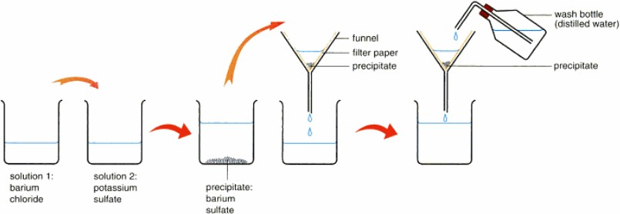

### Preparation of lead (II) sulphate

An insoluble salt of lead (II) sulphate is prepared by precipitation. This is done by mixing solutions containing a sulphate and lead (II) ions

A soluble salt of lead is mixed with a soluble sulphate

When lead ions combine with the sulphate ions, lead (II) sulphate is formed Pb2+(aq) + SO42-(aq)→ PbSO4(s)

Lead (II) nitrate solution is put in a beaker and the solution is heated. Dilute sulphuric acid is then added. A white precipitate of lead (II) sulphate is formed. The precipitate is filtered off as a residue and washed with distilled water. The crystals are then dried.

Pb(NO3)2(aq) + H2SO4 (aq)→ 2HNO3(aq) +PbSO4(s)

Ionically

Pb2+(aq)+ 2NO3-(aq) + 2H+(aq) + SO42-(aq)→ 2NO3-(aq) + 2H+(aq)+ PbSO4(s)

Pb2+(aq) + SO 2-(aq)→ PbSO (s)

4 4

### Preparation of lead (II) chloride

Dilute hydrochloric acid is put in a beaker and lead (II) nitrate solution is added. A white precipitate is formed which is filtered off. The precipitate is washed and dried.

Pb(NO3)2(aq) + 2HCl (aq)→ 2HNO3(aq) +PbCl2(s) Ionically

Pb2+(aq)+ 2NO3-(aq) + 2H+(aq) + 2Cl-(aq)→ 2NO3-(aq) + 2H+(aq)+ PbCl2(s)

Pb2+(aq) + 2Cl-(aq)→ PbCl2(s)

### Preparation of Soluble Salts

Soluble salts are prepared by the action of an acid on a metal, metal carbonate, metal oxide, metal hydroxide or alkali

Soluble salts of lead, copper, iron and zinc can be prepared as follows;

1. Add metal, metal oxide or metal carbonate to dilute acid until the metal is in excess and heat
2. Filter off the excess solid and concentrate the filtrate by heating
3. Cool the solution to crystallize and filter off the crystals
4. Dry the crystals to obtain a dry salt

### Preparation of copper (II) sulphate from sulphuric acid and copper (II) oxide

Dilute sulphuric acid is put in a beaker and copper (II) oxide is added little by little until in excess. The excess oxide is the filtered off.

The filtrate which remains in the container is concentrated by heating. The solution is left to cool for some time.

Crystals are formed and then filtered off and put on a filter paper for drying CuO(s) + H2SO4(aq) → CuSO4(aq) + H2O(l)

CuSO4(aq) + 5H2O(l) → CuSO4.5H2O(s)

NB: Salts of lead (II) nitrate, zinc sulphate and magnesium sulphate can be prepared in the same way.

### Preparation of zinc sulphate from zinc

A beaker is half filled with dilute sulphuric acid and zinc is added Effervescence of hydrogen gas occurs

If the reaction is slow, add copper (II) sulphate to speed up the reaction Add more zinc metal to make sure that all the acid has been used up Warm gently

Filter to remove excess zinc and other insoluble impurities. The filtrate is a colourless solution containing zinc sulphate

Allow the filtrate to crystallize by heating it so that water can freely evaporate Colourless needle like crystals will be obtained after evaporation

Zn(s) + H2SO4(aq) → ZnSO4(aq) + H2(g) ZnSO4(aq) +7 H2O(g) → ZnSO4.7 H2O(s)

**NB:**Other salts such as magnesium sulphate, copper (II) sulphate and iron (II) sulphate can be prepared in the same way. But with copper (II) sulphate, concentrated sulphuric acid is used instead of dilute sulphuric acid with copper metal.

### Preparation of salts by action of an acid on a carbonate

E.g.Preparation of lead (II) nitrate from lead (II) carbonates

Dilute nitric acid is put in a beaker and lead (II) carbonate added little at a time until no more reacts

Filter off excess lead (II) carbonate and collect a colourless filtrate

Evapourate the filtrate. After evapouration crystals of lead (II) nitrate are formed. PbCO3(s) + 2HNO3(aq) → Pb(NO3)2(aq)+ CO 2 (g) + H2O(l)

Salts of copper (II) sulphate, copper (II) nitrate, zinc sulphate and calcium chloride can be prepared in the same way.

### Preparation of salts from an acid and an alkali (Neutralisation)

E.g. Preparation of sodium chloride

Pipette 25cm3 of sodium hydroxide into a conical flask Add 2 drops of phenolphthalein indicator

Run dilute hydrochloric acid from the burette dropwise until the colour of the solution turns from pink to colourless. The solution at this time is neutral.

Note the volume of the acid that was used. The whole process is repeated using exactly the same volume of the acid and base but without the addition of the indicator.

The solution obtained contains sodium chloride

Transfer this solution to an evaporating basin and evapourate it to dryness After evapourating crystals of sodium chloride are formed

NaOH(aq) + HCl(aq) → NaCl(aq) + H2O(g)

The process can also be used to prepare salts of potassium and ammonium

#### *Experiment illustrating neutralization*

25.0cm3of acid, as a standard solution, is placed in a conical flask using pipette. A few drops of the indicator are added & titrated with an alkali from the burette until the indicator changes colour, showing that all the acid has just reacted. Volume of alkali added is measured. Prepare another 25.0cm3of acid again, using the same pipette addthe same volume of alkali as before to prevent excess alkali/acid because both the reactants& products are aqueous. The product is then evaporated to dryness to obtain the salt.

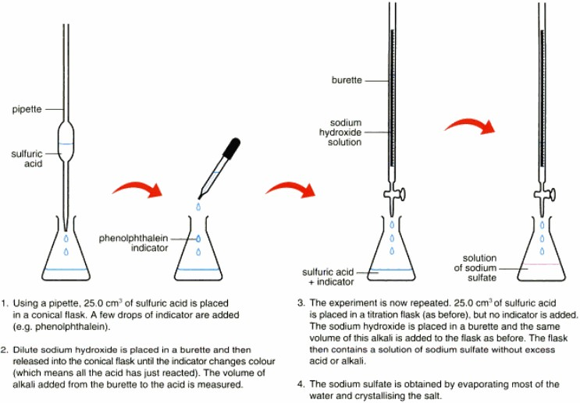

#### *Reacting Metal with Acid*

Only metals like zinc and magnesium, which moderately react with dilute acids, are used.

*E.g. Reacting zinc with dilute sulphuric acid to prepare zinc sulphate*

Zn(s) + H2SO4(aq) → ZnSO4(aq) + H2O(l)

Zinc is added to dilute sulphuric acid until in excess to ensure no more sulphuric acid is present. Then the mixture is filtered off to separate zinc from zinc sulphate. The filtrate which contains zinc sulphate is then placed in evaporating dish to evaporate most of water then it‘s cooled after zinc sulphate crystals are formed. The crystals are then filtered and squeezed between filter papers to dry.

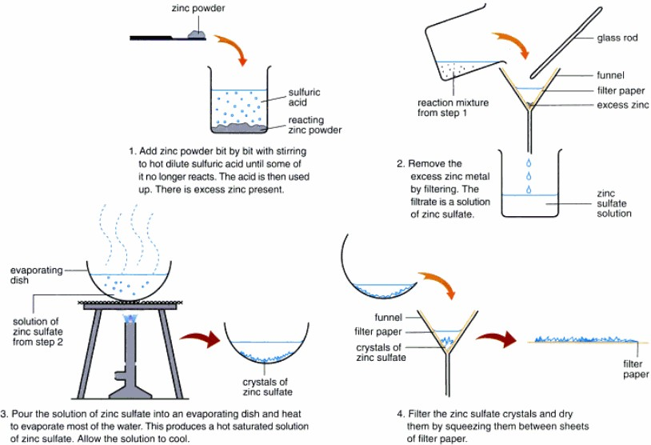

#### *By Reacting an Insoluble Base with Acid*

*E.g. Reacting magnesium oxide with Acids*

MgO(s) + H2SO4(aq) → MgSO4(aq) + H2(g)

The same method as reaction of acid with metal is used, so refer to diagram and above explanation, substituting reactants and products.

#### *By Reacting a Carbonate with Acid*

*E.g. Reacting calcium carbonate with Acids*

K2CO3(s) + H2SO4 (aq) →K2SO4 (aq) + CO2 (g) + H2O (l)

The same process is used as reaction of acid with metal, just that carbon dioxide is produced. Carbon dioxide can be tested by bubbling it into limewater which will turn limewater colourless to milky.

### Action of heat on salts Carbonates

* Potassium and sodium carbonates are stable and do not decompose on heating
* Ammonium carbonate decomposes when heated to give ammonia gas, Carbon dioxide and water

(NH4)2CO3(s) → NH3(g) + CO2(g) + H2O(l)

* The rest of the carbonates decompose on heating to form metal oxides and Carbon dioxide gas

|  |  |  |  |  |
| --- | --- | --- | --- | --- |
| MgCO3(s) | → | MgO(s) | + | CO2(g) |
| White powder  ZnCO3(s) | → | White residue  ZnO(s) | + | Colourless gas  CO2(g) |

White powder Yellow residue - hot colourless gas White residue – cold

PbCO3(s) → PbO(s) + CO2(g)

White powder White residue – hot colourless gas Yellow residue - cold

CuCO3(s) → CuO(s) + CO2(g)

Green powder Black residue Colourless gas

NB: The difference between lead oxide and zinc oxide is that lead oxide is brown when hot and yellow when cold while zinc oxide is yellow when hot and white when cold.

### Nitrates

* Ammonium nitrate decomposes on heating to give dinitrogen oxide and water

NH4NO3(s) → N2O(g) + H2O(l)

* Metal nitrates decompose following the reactivity series

Potassium Sodium

Calcium Magnesium

Decompose to pale yellow metal nitrites and oxygen 2MNO3(s) → 2MNO2 (s) + O2 (g)

Decompose on heating to form metal oxides, nitrogen dioxide and oxygen 2M (NO3)2(s) → 2MO(s) + 4NO2 (g) + O2 (g)

115

Aluminum Zinc

Iron Lead Copper

Mercury Silver

Decompose on heating to form their corresponding metals, nitrogen dioxide and oxygen M(NO3)2(s) → M(s) + 2NO2(g) + O2 (g)

Potassium and sodium nitrate melt into colourless liquids and then decompose to pale yellow nitrites and oxygen

2KNO3(s) → 2KNO2 (s) + O2 (g)

2NaNO3(s) → 2NaNO2 (s) + O2 (g)

Mercury and silver nitrates decompose on heating to form their corresponding metals, nitrogendioxide and oxygen

Hg(NO3)2(s) → Hg(s) + 2NO2 (g) + O2 (g)

Ag(NO3)2(s) → Ag(s) + 2NO2 (g) + O2 (g)

The rest of the nitrates i.e. from calcium to copper nitrates decompose on heating to form metal oxides, nitrogen dioxide and oxygen

2Ca (NO3)2(s) → 2CaO(s) + 4NO2 (g) + O2 (g)

2Cu (NO3)2(s) → 2CuO(s) + 4NO2 (g) + O2 (g)

2Pb (NO3)2(s) → 2PbO(s) + 4NO2 (g) + O2 (g)

### Sulphates and hydrates

Most sulphates are hydrated and when heated, they lose their water of crystallisation to form anhydrous salts which are resistant to further heating and therefore do not decompose. Therefore hydrated sulphates do not decompose on heating e.g.

MgSO4.7 H2O(s) → MgSO4(s) + 7 H2O(l) CuSO4.5 H2O(s) → CuSO4(s) + 5H2O(l)

Blue White

Na2SO4.10H2O(s) → Na2SO4(s) + 10H2O(l) FeSO4.7 H2O(s) → FeSO4(s) + 7 H2O(l)

On further heating, the anhydrous iron (II) sulphate formed decomposes to give sulphur dioxide, sulphur trioxide and leaves a brown solid of iron (III) oxide

FeSO4(s) → Fe2O3(s) + SO2(g)+ SO3(g)

When ammonium sulphate is heated it decomposes to give ammonia, sulphur trioxide and water (NH4)2SO4(s) → NH3 (g) + SO3(g) +H2O(l)

### Solubility of salts

Solubility: is defined as the mass of solute dissolved in a fixed mass of a solvent at a particular temperature to give a saturated solution.

Or it is the number of grams of solute dissolved in 100g of water to give a saturated solution at a particular temperature

Or solubility of a solute in a solvent at a given temperature is the number of moles of a solute necessary to saturate one kilogram of a solvent at that temperature

NB: Solubility increases with temperature for most of the salts

Saturated solution: Is one which cannot dissolve any more solute at a given temperature and pressure

Or

A saturated solution is one which contains much more solute than it can dissolve at that temperature

### Solubility can be expressed as

1. Mass of solute (g) per 100g of a solvent i.e. grams per 100g of solvent (g/100g of solvent)
2. Mass of solute (g) per 1000g of a solvent i.e grams per 1000g of solvent (g/1000g of solvent)

Some salts are highly soluble in water e.g. potassium nitrate, sodium nitrate, sodium chloride, potassium chloride, sodium carbonate, potassium carbonate.

Others are sparingly soluble in water at room temperature e.g. lead chloride, silver chloride, barium sulphate, lead sulphate, calcium carbonate etc…

The solubility of these sparingly soluble salts increases as temperature increases.

### Solubility curves

A solubility curve is a plot of mass of solute dissolved in 100g of water against temperature Or: solubility curve is a graph of solubility versus temperature for a solute

From solubility curves above:

The salt whose solubility increases most with increase in temperature is potassium nitrate The salt whose solubility decreases most with increase in temperature is calcium sulphate

The temperature at which two curves intercept is the temperature at which solubility of the two salts is the same

The salt whose solubility shows very little dependence on temperature is sodium chloride

### Uses of solubility

If a solubility curve of a salt is available, it can be used to obtain the solubilities of theh salt at various temperatures

The solubility curve can be used to determine the temperature at which a certain quantity of salt, when dissolved in water can produce a saturated solution

The solubility curve can be used to calculate the mass of salt obtained by cooling the solution from a higher to a lower temperature

Example

1. Calculate the mass of potassium chlorate that can be crystallized by cooling the solution from 70oC to 30oC
2. Use the solubility curve to determine the solubility of potassium chlorate at 50oC

### Solution:

The solubility of potassium chlorate at 70oC is 160g/100g water and solubility at 30oC is 60g/100g water. Therefore the mass of potassium chlorate that can be crystallized by cooling the solution from 70oC to 30oC = 160-60 =100g

The solubility of potassium chlorate at 50oC is 100g/100g water. This is obtained by extrapolation of the line indicated by the dotted line on the graph

### Determination of solubility of salts

**E.g. Determination of solubility of potassium nitrate**

Some potassium nitrate crystals are crushed in a mortar and placed in a boiling tube. Little water is added to about halfful. The boiling tube is put in a beaker of water and the beaker is warmed. More potassium nitrate crystals are added while stirring until some remain undissolved at the bottom of the tube.

Read the temperature of the solution. When the temperature reads 55oC, put off the flame and allow the apparatus to cool. When the temperature drops to 50oC, decant the saturated solution into a weighed dish leaving the solid potassium nitrate behind

Calculate the mass of potassium nitrate dissolved in 100g of water at 50oC, using the results obtained. This will be the solubility of potassium nitrate at 50oC

### Sample results

Mass of dish =14.32g

Mass of dish + potassium nitrate solution =35.70g Mass of dish + potassium nitrate solid =18.60g Temperature of the saturated solution = 50oC **Therefore**

Mass of water =35.70 – 18.60 =17.10g

17.10g of water dissolved 4.28g of potassium nitrate =18.60-14.32 = 4.28g 17.10g of water dissolved 4.28g of potassium nitrate

18.60g of water will dissolve =

100g of water dissolve =  g

=25g

Therefore, the solubility of potassium nitrate is 25g/100g of water at 50oC

### Exercise

1. 10g of a saturated sodium chloride solution was evaporated and 6g of solid sodium chloride was left. Calculate
   1. Solubility of sodium chloride (Ans = 150g)
   2. The percentage of sodium chloride in a saturated solution (Ans = 60%)
2. 75g of a saturated solution contains 30g of a salt. Calculate its solubility(Ans=66.67g/100g of water)
3. The solubility of X is 40g/100g of water. Calculate the mass of X that can be dissolved in 60g of water to give a saturated solution (Ans = 24g)
4. The table below shows the solubilities of salt P in water at different temperatures

|  |  |  |  |  |  |  |
| --- | --- | --- | --- | --- | --- | --- |
| Temperature /oC | 10 | 20 | 30 | 40 | 50 | 60 |
| Solubilities (g/100g of solvent) | 18 | 20 | 24 | 30 | 38 | 50 |

* 1. Plot a graph of solubility of P
  2. Use your graph to determine solubility of P at 25oC (Ans =22g/100g of water)
  3. Calculate the mass of P that would dissolve in 45g of water at 25oC (Ans =9.9g)

### 17. Carbon and its compounds Carbon

This is the element in group IV of the periodic table. It has atomic number 6 and atomic mass 12

### Occurrence of carbon

Pure carbon is found in the form of diamond and impure carbon as graphite. Carbon is a constituent of numerous naturally occurring substances such as coal, mineral oils, carbonates, organic matter and in air as carbon dioxide.

### Allotropes of carbon

**Allotropy:** is the existence of an element in more than one form, without change in physical state. These different forms are called **allotropes**.

An allotrope is one of two or more distinct forms of an element. Carbon has three allotropes: diamond, graphite and amorphous carbon. Others elements that show allotropy are:

1. Oxygen with two allotropes, that is, ordinary oxygen (O2) and ozone (O3).
2. Tin with two allotropes, that is, grey tin and white tin.
3. Sulphur has five allotropes, that is, amorphous sulphur, monoclinic sulphur, rhombic sulphur, plastic sulphur and colloidal sulphur.
4. Phosphorus with two allotropes, that is white/yellow phosphorus and red phosphorus.

### Graphite

Graphite is a black, soft, slippery, hexagonal crystalline substance. Its atoms are joined by strong covalent bonds.

### Structure of graphite

Graphite is a two dimensional layered structure. The carbon atoms within the layers are arranged in hexagonal rings and each carbon atom is covalently bonded to three other carbon atoms.

For each carbon atom, three out of the four valence electrons localized during the formation of the covalent bonds. The remaining electron is delocalized (mobile) over the whole layer. The mobile electrons are free to move through the structure and therefore enable graphite to conduct heat and electricity.

The hexagonal layers lie on top of one another and are joined by weak van der waals‘ forces which enable layers to slide over each other easily. That is why graphite is soft and can be used as a lubricant.

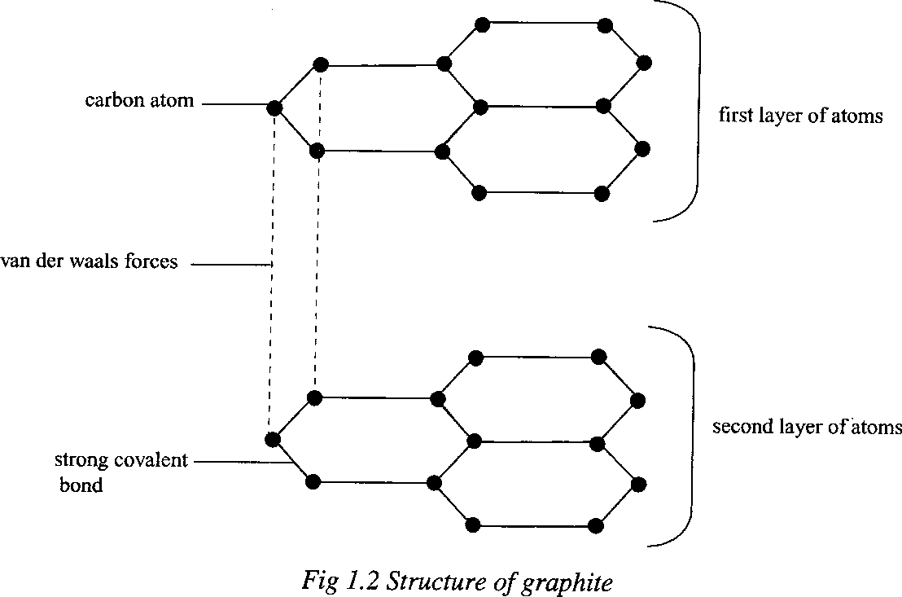

### Properties of graphite

1. It is a black material which feels greasy on touching
2. It is opaque and shiny
3. It has a density of 2.3g/cm3
4. It has hexagonal structures
5. It conducts electricity. This because it contains delocalised electrons. When an electric field is applied, these electrons move freely conducting electric current.
6. Writes well on papers
7. Graphite is soft and slippery because the layers within the structure are held together by weak van de waals‘ forces which makes it possible for the layers to slide over each other easily.

### Uses of graphite

1. Used as protective coating for iron substances to prevent rusting.
2. Used as an electrode in electrolytic cells. Since graphite conducts electricity
3. As a lubricant for dynamos and electric motors.
4. For making pencil leads

### Diamond

It is a colourless, transparent and sparkling crystalline substance. It is the hardest substance known.

### Structure of diamond

Diamond has a tetrahedral structure in which each carbon atom is joined by covalent bonds to four other carbon atoms.

The valence electrons are all used in forming covalent bonds and therefore they are localized. This structure is extended throughout the substance in three dimensions.

Diamond is a poor conductor of heat and electricity because it does not have free and mobile electrons.

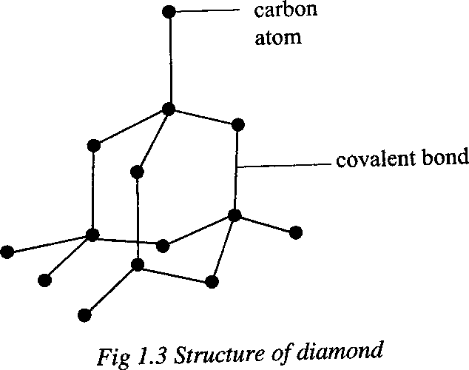

### Uses of diamond

1. Used for manufacturing drilling and cutting hard substances such as glass and rock.
2. It is used to make jewelry e.g. necklaces and ear rings because of its high refractive index giving it a shiny appearance.

### Amorphous carbon

Amorphous carbon is black and has the lowest density among all the allotropes of carbon. It is a fair conductor of electricity. It is a non-crystalline substance. Amorphous carbon exists in several forms including wood charcoal, animal charcoal and lampblack. Coke and soot are other forms of impure amorphous carbon. **Animal charcoal** is made by heating animal bones and remains in a limited supply of air. **Coke** is made by heating coal in absence of air. **Wood charcoal** is formed by burning in a limited supply of air. It can be used to remove poisonous gases such as ammonia, sulphur dioxide and chlorine. It is also useful as fuel. **Lamp black** is made by burning oil in a limited supply of air e.g. kerosene, petroleum and turpentine. It is used in making printers ink, shoe polish, carbon paper and car tyres.

### Uses of amorphous carbon

1. It is found in **wood charcoal** formed by burning wood with a limited supply of air. Wood charcoal is used as a source of fuel for cooking. Also coke is used as a source of energy.
2. It is found in animal charcoal, which is used to remove the brown colour from sugar during its manufacture.
3. **Lampblack** obtained by burning oils with a limited supply of air, is used in sugar during its manufacture.
4. Coke is used as a reducing agent in extraction of metals from their ores e.g. iron.

### Proof for allotropy of carbon

When equal masses of graphite, diamond and amorphous carbon are separately burnt in excess pure oxygen, each produces the same quantity of carbon dioxide and no other product. The carbon dioxide is tested using limewater which turns milky. This proves that graphite, diamond and amorphous carbon are made up of the same substance, carbon.

C(s) + O2(g)→ CO2(g)

### Differences between diamond, graphite and amorphous carbon

|  |  |  |  |
| --- | --- | --- | --- |
| **Property** | **Diamond** | **Graphite** | **Amorphous carbon** |
| Appearance | Colourless and  transparent | Grey-black, opaque  and shiny | Black, opaque and  dull |
| Hardness | Hardest | Soft, greasy and  soapy | Soft |
| Burning in air | Burns at 900oC | Burns at 700 oC | Burns at 500 oC |
| Density | 3.5g/cm3 | 2.3g/cm3 | 1.5g/cm3 |
| Conduction of  electricity | Poor | Good | Fair |
| Structure | Giant molecular | Hexagonal | Indefinite |
| Bonding electrons | All 4 electrons | Uses only three  electrons |  |

**Chemical properties of carbon**

All allotropes of carbon have similar chemical properties but different physical properties.

### Reaction with oxygen

When carbon is burnt in excess pure oxygen, carbon dioxide is formed.

C(s) + O2(g) → CO2(g)

When carbon is burnt in limited supply of oxygen, carbon monoxide is formed.

2C(s) + O2(g) → 2CO(g)

Exhaust fumes from cars contain carbon monoxide because of incomplete combustion of petrol or diesel.

### Combustion of charcoal in oxygen

Some powdered wood charcoal is placed in a deflagrating spoon and heated over a Bunsen burner flame until it glows red-hot. The spoon is immediately transferred into a jar of oxygen

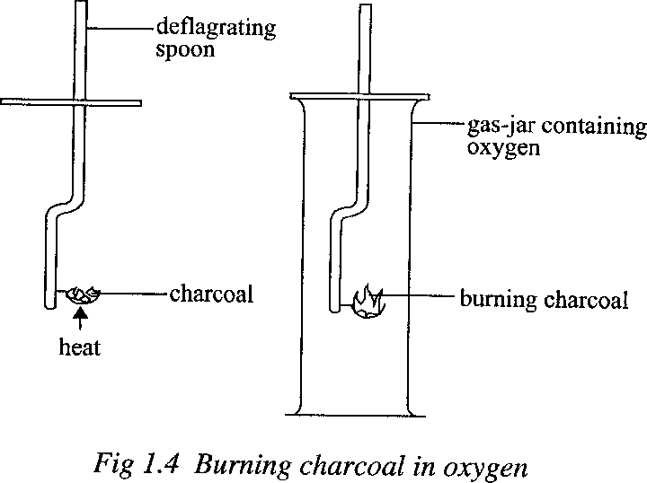

Charcoal continues to burn slowly with a yellow flame without any further heating. The amount of charcoal gradually decreases and finally only a small amount of ash is left. The presence of ash implies that wood charcoal is not pure carbon.

C(s) + O2(g) → CO2(g)

### Reaction of carbon with metallic oxides

Carbon reduces oxides of metals that are lower than it in the activity series. Such oxides include copper(II) oxide, zinc oxide, lead(II) oxide and iron(III) oxide. All these are reduced to free metal while carbon is oxidised to carbon dioxide.

2CuO(s) + C(s) → 2Cu(s) + CO2 (g)

2ZnO(s) + C(s) → 2Zn(s) + CO2 (g)

2PbO(s) + C(s) → 2Pb(s) + CO2 (g)

2Fe2O3(s) + 3C(s) → 4Fe(s) +3CO2 (g)

This reaction is used in extraction of the metals. Those metals higher in reactivity series than carbon have a higher affinity for oxygen and will not give it up to carbon.

### It reduces concentrated nitric acid to nitrogen dioxide

4HNO3 (aq) + C(s) → 2H2O (l) + 4NO2 (g) + CO2 (g)

### It reduces concentrated sulphuric acid to sulphur dioxide

2H2SO4 (aq) + C(s) → 2H2O (l) + 2SO2 (g) + CO2 (g)

### Oxides of carbon

* + 1. **Carbon dioxide**

The amount of carbon dioxide in the atmosphere is about 0.03 percent by volume. It is produced as a waste product during respiration of plants and animals. It is also formed during combustion of fuels such as wood, petrol etc.

### Experiment:

**Laboratory preparation of carbon dioxide**

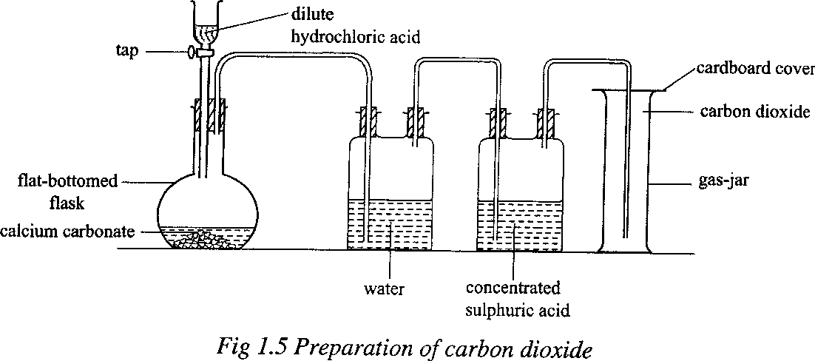

Dilute hydrochloric acid from a tap funnel is added to calcium carbonate in a flat-bottomed flask Effervescence occurs and a colourless gas, which is carbon dioxide, is formed according to the equation.

CaCO3(s) + 2HCl (aq) → CaCl2 (aq) + H2O + CO2 (g)

The gas is then passed through a bottle containing water or potassium hydrogen carbonate solution to absorb any hydrochloric acid fumed.

It is then passed through concentrated sulphuric acid to dry it.

The gas is collected by downward delivery in a gas-jar since the gas is denser than air.

### Ionic equation

Ca2+(aq) + CO32-(aq) + 2H+(aq ) + 2Cl- (aq) → Ca2+(aq) + 2Cl- (aq) + H2O(l) + CO2 (g) 2H+ (aq) + CO32-(aq) → H2O(l) + CO2 (g)

NB: If the gas is notrequired dry it can be collected over water. This is possible because carbon dioxide is only slightly soluble in water.

Dilute sulphuric acid is not used with calcium carbonate because the reaction produces calcium sulphate which is sparingly soluble and thus forms a coating on the calcium carbonate which stops further reaction.

CaCO3(s) + H2SO4 (aq) → CaSO4(s) + H2O (l) + CO2 (g)

Lead (II) carbonate is also not used because when it reacts with dilute hydrochloric acid or sulphuric acid, the reaction soon slows down and then stops. This is due to the formation of lead

1. chloride or lead (II) sulphate, both of which are insoluble salts.

The insoluble salt coats the carbonate preventing it from reacting with the acid.

PbCO3(s) + 2HCl(aq) → PbCl2(s) + CO2(g) + H2O(1) PbCO3(s) + H2SO4(aq) → PbSO4(s) + CO2(g) + H2O(1)

### Kipp’s apparatus

A continuous supply of carbon dioxide can be obtained from a Kipp‘s apparatus using calcium carbonate and dilute hydrochloric acid.

### Industrial preparation of carbon dioxide

In industries, carbon dioxide is obtained as a by-product of fermentation of sugars to alcohol.

C6H12O6(aq) → 2C2H5OH(aq) + 2CO2(g)

It is also obtained from the manufacture of cement. **Cement** is made by heating limestone (calcium carbonate) with some sand and silicates to form impure calcium oxide.

CaCO3(s) → CaO(s) + CO2(g)

### Properties of carbon dioxide Physical properties

* 1. It is a colourless gas
  2. It has a faint sharp test
  3. It has a very faint smell
  4. It does not support burning
  5. It is slightly soluble in water forming carbonic acid. H2O(l) + CO2(g) ⇌ H2CO3(aq)
  6. It turns litmus pink since it is a weak acidic gas.

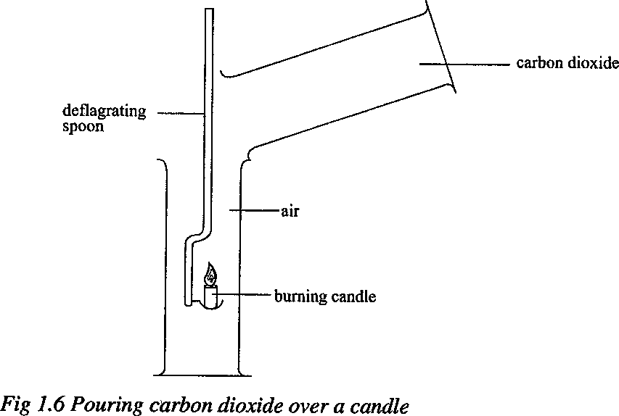

* 1. It is denser than air. When carbon dioxide in a jar is poured into another jar containing a lighted candle, the candle is extinguished. This shows that carbon dioxide is denser than air. It displaces air from the jar containing a lighted candle hence ―starves‖ the candle of oxygen.

### Chemical properties

1. **Effect of carbon dioxide on burning magnesium**

When a piece of burning magnesium ribbon is lowered into a gas-jar containing carbon dioxide, it continues to burn for a short time with a spluttering flame. Black particles of carbon are formed on the sides of the gas-jar and white ash of magnesium oxide is also formed.

2Mg(s) + CO2(g) → 2MgO(s) + C(s)

Magnesium continues to burn in carbon dioxide because of its higher affinity for oxygen than carbon. The heat from the burning magnesium decomposes carbon dioxide into carbon and oxygen. The decomposition of carbon dioxide provides more oxygen which supports continued burning of magnesium oxide.

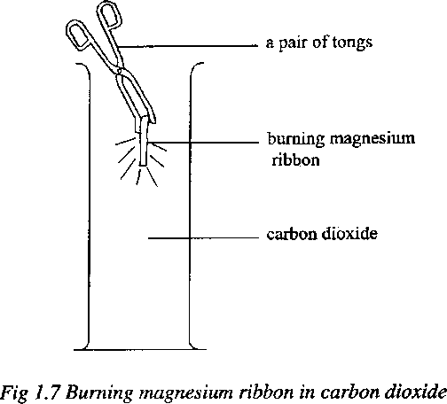

### Effect of carbon dioxide on calcium hydroxide solution (lime-water)

When carbon dioxide is bubbled through lime-water, the lime-water turns milky. The white precipitate is due to the formation of an insoluble substance, calcium carbonate, in water.

Ca(OH)2(aq) + CO2(g) → CaCO3(s) + H2O(l)

The above test is used to distinguish carbon dioxide from any other gas. However, if excess carbon dioxide is bubbled through the milky solution, the white precipitate dissolves to form a colourless solution due to the formation of calcium hydrogencarbonate, which is soluble in water.

CaCO3(s) + H2O (l) + CO2 (g) → Ca(HCO3)2(aq)

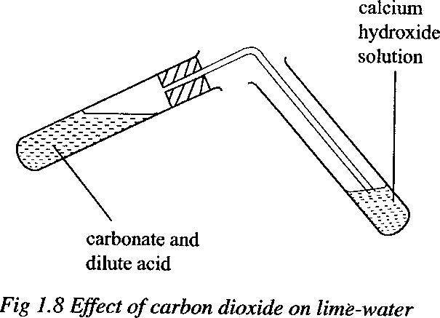

### Reaction with alkalis

Sodium hydroxide solution readily absorbs carbon dioxide to produce sodium carbonate.

2NaOH(aq) + CO2(g) → Na2CO3(aq) + H2O(l)

With excess carbon dioxide, a white precipitate of sodium hydrogen carbonate is formed. The precipitate is sparingly soluble in cold water.

Na2CO3(aq) + H2O(l) + CO2(g) → 2NaHCO3(s)

When a jar of carbon dioxide is placed in a trough containing sodium hydroxide solution, the solution quickly rises into the jar. This is because the gas is rapidly absorbed into the solution. Carbon dioxide reacts with sodium hydroxide solution.

2NaOH(aq) + CO2(g) → Na2CO3(aq) + H2O(l)

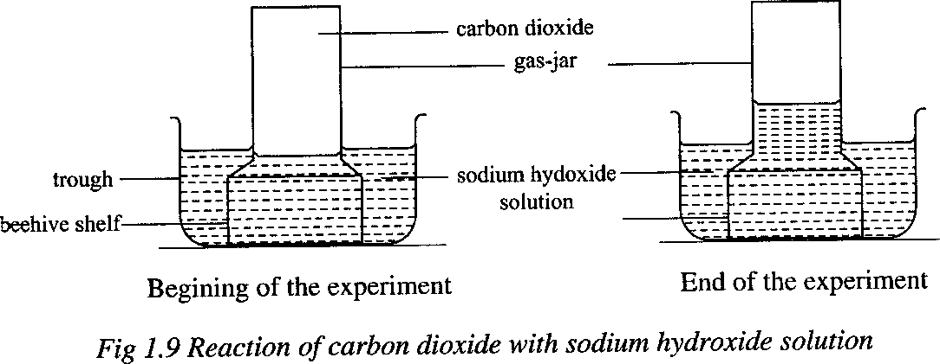

When solid sodium hydroxide is exposed to air, a colourless solution is formed and later a white crystalline solid is formed. Sodium hydroxide is deliquescent and therefore absorbs water from air to form a solution. The solution absorbs carbon dioxide from air forming a white crystalline solid of sodium carbonate decahydrate.

2NaOH(s) + CO2(s) + 9H2O(l) – Na2CO3.10H2O(s)

### Uses of carbon dioxide

1. Carbon dioxide is used in the manufacture of **carbonated drinks**because of its pleasant taste in water.
2. Carbon dioxide is used as a **refrigerating agent for perishable goods**
3. Pieces of solid carbon dioxide are sometimes dropped into clouds to cool them to form rain.
4. Carbon dioxide is used in **fire extinguishers.** Carbon dioxide being denser than air forms a layer around the burning material. It covers the fire and ‗starves‘ it of oxygen hence the fire is put out.
5. It is used during photosynthesis by green plants
6. It is used in the manufacture of sodium carbonate and sodium hydrogen carbonate

### Exercise

1.

a.

* 1. Draw a labeled diagram of the set-up of the apparatus that can be used to prepare a dry sample of carbon dioxide in the laboratory
  2. Write an equation that leads to the formation of carbon dioxide
  3. Write an ionic equation for the reaction leading to the formation of carbon dioxide
     1. Carbon dioxide was passed through calcium hydroxide solution. Describe and explain the reaction that took place.

c.

* + - 1. State what would be observed if burning magnesium ribbon was lowered into a jar of carbon dioxide
      2. Write equation for the reaction that takes place

2.

1. Describe the structure of graphite
2. State two properties in which graphite differs from diamond
3. Graphite was heated in excess air and the gas given off passed through aqueous calcium hydroxide for a long time
   1. State what was observed
   2. Write equations for the reaction (s)

### Carbon monoxide

Carbon monoxide is a poisonous, colourless gas with practically no smell. It is present in coal gas and other gaseous fuels. It is formed by the partial combustion of carbon.

2C(s) + O2(g) → 2CO(g)

### Laboratory preparation of carbon monoxide

Charcoal is put in a combustion tube and heat is applied until red hot. Carbon dioxide is passed over heated charcoal in a combustion tube. Carbon monoxide is produced.

C(s) + CO2(g) → 2CO(g)

The mixture of excess carbon dioxide and carbon monoxide is passed over concentrated potassium hydroxide solution which absorbs carbon dioxide. Carbon monoxide is then collected over water because it is insoluble in water.

2KOH(aq) + CO2(g) → K2CO3(aq) + H2O(l)

### Apparatus

**Preparation of carbon monoxide from sodium methanoate (HCOONa)**

Sodium methanoate is put in a flask and concentrated sulphuric acid is added drop wise through a tap funnel.

Effervescence occurs and carbon monoxide is collected over water. In the flask, sodium methanoate is first converted to methanoic acid which is later dehydrated with concentrated sulphuric acid

2HCOONa(aq) + H2SO4(aq) → HCOOH(aq) + Na2SO4(aq) HCOOH(aq) → CO(g) + H2O(l)

### Preparation of carbon monoxide from ethanedioic acid

Oxalic acid crystals are placed in a flask and concentrated sulphuric acid added through a thistle funnel. The mixture is then warmed, effervescence occurs and a mixture of carbon dioxide and carbon monoxide is produced. The mixture is then passed over concentrated potassium hydroxide which absorbs carbon dioxide. Carbon monoxide is then collected over water.

H2C2O4 (aq) → CO2 (g) + CO(g) + H2O(l) 2KOH(aq) + CO2(g) → K2CO3(aq) + H2O(l)

### Test for carbon monoxide

It burns with a blue flame forming carbon dioxide 2CO(g) + O2(g) → 2CO2(g)

### Properties of carbon monoxide

1. It is a colourless gas.
2. It has no effect on litmus paper, that is, it is a neutral gas.
3. It burns in air with a blue flame forming carbon dioxide. 2CO(g) + O2(g) → 2CO2(g)

This reaction also takes place in a charcoal burner when there is a sufficient supply of air.

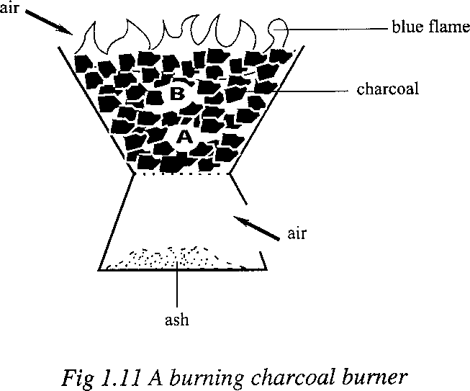

At A, there is plentiful supply of oxygen and charcoal burns to form carbon dioxide.

C(s) + O2(g) → CO2(g)

At B, the rising carbon dioxide is reduced by red-hot charcoal to form carbon monoxide.

CO2(g) + C(s) → 2CO(g)

At the surface of the burner, the hot carbon monoxide burns in the air with a blue flame to form carbon dioxide.

2CO(g) + O2(g) → 2CO2(g)

If the charcoal burner is in a poorly ventilated room with insufficient air, the reaction at the surface fails to takes place. The poisonous carbon monoxide is released into the room. If someone stays in such a room, he or she may die within a short while due to carbon monoxide poisoning.

1. It is insoluble in water.
2. It is a reducing agent. It reduces some metallic oxides of copper, lead, zinc and iron, that is, oxides of metals below carbon in activity series. The porcelain boat is heated strongly and the excess carbon monoxide is lighted at the jet.

CuO(s) + CO(g) → Cu(s) + CO2(g)

(black) (brown)

Fe2O3(s) + 3CO(g) → 2Fe(s) + 3CO2(g)

(red-brown) (grey) ZnO(s) + CO(g) → Zn(s) + CO2(g)

(white) (grey)

PbO(s) + CO(g) → Pb(s) + CO2(g)

Lead(II) oxide (yellow) is reduced to a grey solid. Carbon monoxide does not, however, reduce the oxides of metals higher than carbon in the reactivity series. Such metals have a higher affinity for oxygen than carbon monoxide.

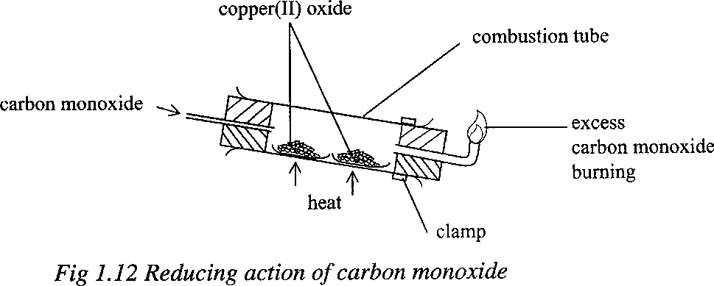

1. It is a poisonous gas because it forms a fairly stable compound with haemoglobin which reduces the oxygen-carrying capacity of blood.

### Uses of carbon monoxide

1. In the manufacture of synthetic petrol.
2. In the reduction of ores and refining of nickel.
3. In the manufacture of methanol used in anti-freezer mixtures in cold countries to prevent ice from forming in car radiators.
4. Used as fuel in form of producer gas. Producer gas is produced when air is passed over red-hot coke.

### Differences between carbon monoxide and carbon dioxide

|  |  |
| --- | --- |
| **Carbon dioxide** | **Carbon monoxide** |
| Has a faint smell | Has no smell |
| Turns lime water milky | Does not |
| It is not a reducing agent | It is a strong reducing agent |
| Slightly soluble in water and alkalis | Insoluble in water and alkalis |

|  |  |
| --- | --- |
| Reacts with alkalis forming carbonates | Does not |
| Turns blue litmus paper red | Neutral to litmus |
| Not poisonous | Poisonous |
| Denser than air | Less dense than air |
| Is an acidic gas | Is not acidic |
| Does not burn | Burns with a blue flame |
| No action on oxides | Reduces metallic oxides |
| Reacts with heated charcoal to form carbon  monoxide | No action on charcoal |

**Exercise**

1)

1. Name the element present in pure charcoal
2. Explain why it is dangerous to use charcoal stove in a poorly ventilated room.
3. Write an equation for the reaction between charcoal and heated iron(III) oxide.
4. The figure below shows an experimental setup to investigate the effect of carbon monoxide on oxides of metals.

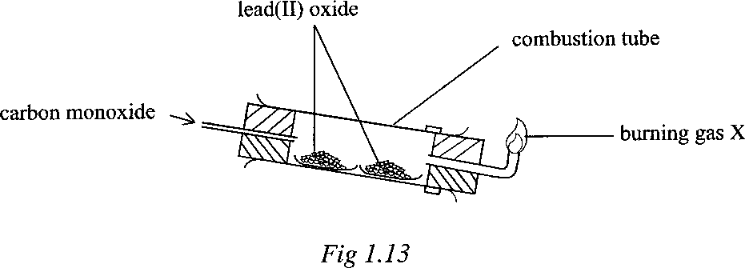

a)

* 1. State the conditions for the reaction taking place in the combustion tube.
  2. Write the equation for the reaction taking place in the combustion tube.

b)

1. Name the gas X being burnt at the jet.
2. Why is it necessary to burn gas X?
3. Write equation for the combustion of gas X.
4. Name any other oxide that can be used instead of lead(II) oxide.
5. What would you expect to happen if lead(II) oxide was replaced with magnesium oxide? Give a reason for your answer.

### Carbonates and hydrogen carbonates Carbonates

Carbonates are salts derived from carbonic acid (H2CO3). Aluminium carbonate does not exist.

### Summary of properties of carbonates

Potassium Sodium

Calcium Magnesium Zinc

Iron Lead Copper

Soluble in water

Do not decompose on heating

Insoluble in water

Decompose on heating to form metal oxides and carbon dioxide PbCO3(s) → PbO(s) + CO2 (g)

### Effects of heat on carbonates

Carbonates of potassium and sodium are not decomposed by heat. It is only lithium carbonate in group I that decomposes on heating.

Li2CO3(s) → Li2O(s) + CO2(g)

Carbonates of calcium, magnesium, zinc, iron, lead and copper are decomposed by heat to an oxide and carbon dioxide.

When a **white** solid**(powder)** of **lead(II) carbonate** is heated strongly in a test-tube, a colourless gas which turns lime-water milky is given off and a **brown residue** of lead(II) oxide when **hot** and **yellow** when **cold** is formed.

PbCO3(s) → PbO(s) + CO2(g)

Brown residue when hot Yellow residue on cooling

When a **green** solid **(powder)** of **copper(II) carbonate** is heated, a **black residue** of copper(II) oxide is formed.

CuCO3(s) → CuO(s) + CO2(g)

Black residue

When a **white solid (powder)** of **zinc carbonate** is strongly heated, a **yellow residue** when **hot**

and **white** when **cold** is formed

ZnCO3(s) → ZnO(s) + CO2(g)

Yellow residue when hot White residue on cooling

When a **green** solid **(powder)** of **iron (II) carbonate** is heated, a **brown residue** of copper(II) oxide is formed.

FeCO3(s) → FeO(s) + CO2(g)

Brown residue

White solids ofmagnesium carbonate and calcium carbonate decompose to white solids of magnesium oxide and calcium oxide respectively.

MgCO3(s) → MgO(s) + CO2(g) CaCO3(s) → CaO(s) + CO2(g)

Ammonium carbonate sublimes when heated. The cause of this sublimation is that ammonium carbonate dissociates on heating to ammonia, water and carbon dioxide, which recombine on cooling.

(NH4)2CO3(s) →2NH3(g) + CO2(g) + H2O(l)

### Solubility of carbonates in water

Carbonates of lithium, potassium, sodium and ammonium are soluble in water. The other carbonates are insoluble in water.

### Testing for carbonate (CO32-)

Add a dilute hydrochloric or sulphuric or nitric acid to the solution or solid to be tested. Effervescence with liberation of a colourless gas that turns lime-water milky indicates the presence of a carbonate (CO32-) or a hydrogen carbonate.

2H+ (aq) + CO32-(aq) → H2O(l) + CO2 (g)

### Hydrogen carbonates

These are salts derived from carbonic acid and are formed by partial replacement of hydrogen in the acid by a metal. Therefore hydrogen carbonates are acidic salts. Common hydrogen carbonates include sodium hydrogen carbonate (NaHCO3) and calcium hydrogen carbonate (Ca(HCO3)2)

All hydrogen carbonates are soluble in water

Hydrogen carbonates are decomposed by heat to produce carbonates, carbon dioxide and water Ca(HCO3)2(s) → CaCO3(s) + CO2(g) + H2O (l)

2NaHCO3(s) → Na2CO3(s) + CO2 (g) + H2O (l)

2KHCO3(s) → K2CO3(s) + CO2 (g) + H2O (l)

### What happens when sodium hydroxide is exposed to air?

When sodium hydroxide is exposed to air, it absorbs water forming a solution. The solution then absorbs carbondioxide from the air and forms a crystalline solid of washing soda (sodium carbonate decahydrate Na2CO3.10 H2O)

2NaOH(s) + CO2 (g) + 9H2O (l)→ Na2CO3.10 H2O(s)

On further exposure, the hydrated sodium carbonate decahydrate loses its water of crystallisation forming a white powder of sodium carbonate monohydrate

Na2CO3.10 H2O(s)→ Na2CO3.H2O(s) + 9H2O (l)

This white powder later absorbs carbon dioxide to form sodium hydrogen carbonate Na2CO3.H2O(s) + CO2 (g) → 2NaHCO3(s)

### Distinguishing between a carbonate and a hydrogen carbonate

Add magnesium sulphate or magnesium chloride solution to the test solution. A white precipitate indicates the presence of a carbonate.

Mg2+(aq) + CO32-(aq) → MgCO3(s) Mg2+(aq) + 2HCO3-(aq) → Mg(HCO3)2(aq)

Hydrogencarbonates gives no precipitate but on heating, the magnesium hydrogencarbonate decomposes to the insoluble magnesium carbonate (white precipitate).

Mg(HCO3)2(aq) → MgCO3(s) + H2O(l) + CO2(g)

### Exercise

1. Element X belongs to group II in the periodic table.
   1. Write the formula of the carbonate of X.
   2. The carbonate of X was heated strongly until no further change.
      1. Write the equation for the reaction.
      2. Name one reagent which can be used to identify the gaseous product.
   3. The residue in (b) was added to excess dilute nitric acid and warmed.
      1. State what would be observed.
      2. Write the equation for the reaction.
2. The figure below shows an experimental setup to investigate the effect of heat on lead(II) carbonate.

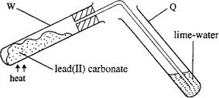

1. Write the equation for the reaction taking place in test-tube W.
2. State what is observed in test-tube Q.
3. What is observed in test-tube Q if lead(II) carbonate is replaced with sodium carbonate? Give a reason for your answer.
4. (a) Write the equation for the reaction that would take place if
5. Dilute hydrochloric acid is added to sodium hydrogencarbonate.
6. Sodium hydrogen carbonate is strongly heated.
   1. State what would be observed and write equation for the reaction that would take place if magnesium sulphate solution is added to a solution containing
      1. Carbonate ions.
      2. Hydrogencarbonate ions.

### Calcium Oxide (quicklime) Manufacture of calcium oxide

Calcium oxide is manufactured mainly from limestone, which is heated to very high temperatures in a kiln. The limestone is mixed with coke or coal and it is fed into the kiln at the top. Coke or coal burns and the heat decompose the limestone into the oxide and carbon dioxide.

CaCO3(s) → CaO(s) + CO2(g)

The lime sinks to the bottom of the kiln and is removed; carbon dioxide is allowed to escape.

It can also be obtained by strongly heating sea shells. Sea shells contain calcium carbonate which decomposes into the oxide and carbon dioxide.

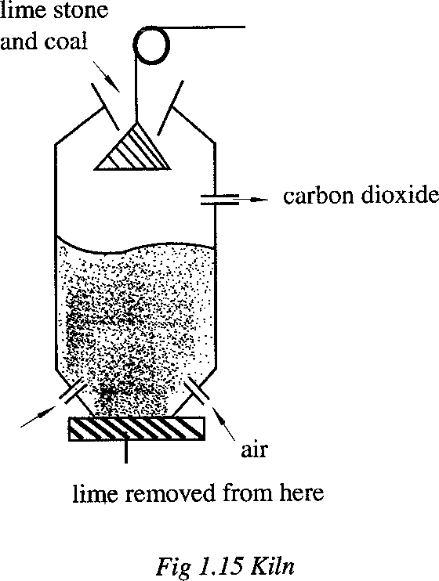

### Uses of calcium oxide

1. Used in extraction of iron, to remove silica impurities.
2. Used in production of lime-water.

### Sodium carbonate (soda ash) Laboratory preparation of sodium carbonate

Dilute hydrochloric acid is poured on to calcium carbonate.

Effervescence occurs and the gas (carbon dioxide) produced is passed through water to remove traces of acid.

CaCO3(s) + 2HCl(aq) → CaCl2(aq) + H2O(l) + CO2(g)

Then carbon dioxide is passed into a moderately concentrated solution of sodium hydroxide for sometime until finally a white precipitate of sodium hydrogencarbonate appears.

2NaOH(aq) + CO2(g) → Na2CO3(aq) + H2O(l) (1st stage) Na2CO3(aq) + H2O(l) + CO2(g) → 2NaHCO3(s) (2nd stage)

The white precipitate is filtered off and washed two or three times with cold water. The solid is transferred into a dish and heated to a constant mass. Sodium carbonate is obtained as a fine white powder.

2NaHCO3(s) → Na2CO3(s) + H2O(l) + CO2(g)

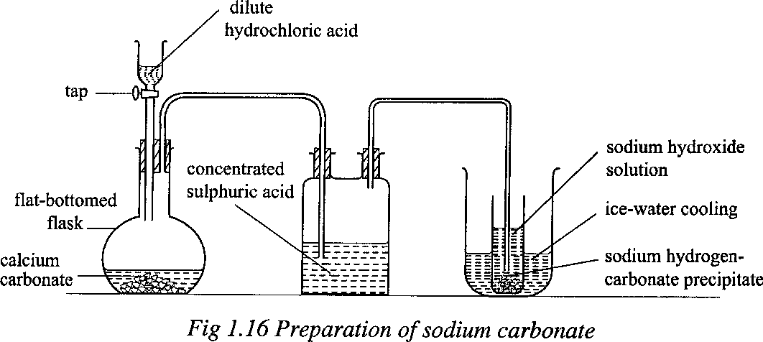

### Manufacture of soda ash (sodium carbonate) by solvary process

Soda ash is obtained at Lake Magadi in Kenya by the solvary process.

The raw materials in this process are calcium carbonate (limestone) and sodium chloride in form of brine. The ammonia dissolves in sodium chloride.

The mixture is reacted with carbondioxide down a large tower called the **carbonator** in which there is an upwards flow of carbon dioxide (from decomposition of calcium carbonate) under pressure. Sodium hydrogen carbonate is produced

NH3(g) + CO2(g) + H2O(l) → NH4HCO3(aq) NH4HCO3(aq) + NaCl(aq) → NaHCO3(s) + NH4Cl(aq)

Sodium hydrogen carbonate precipitates in the lower part of the tower in form of a wet sludge, which is tapped off from the bottom of the tower.

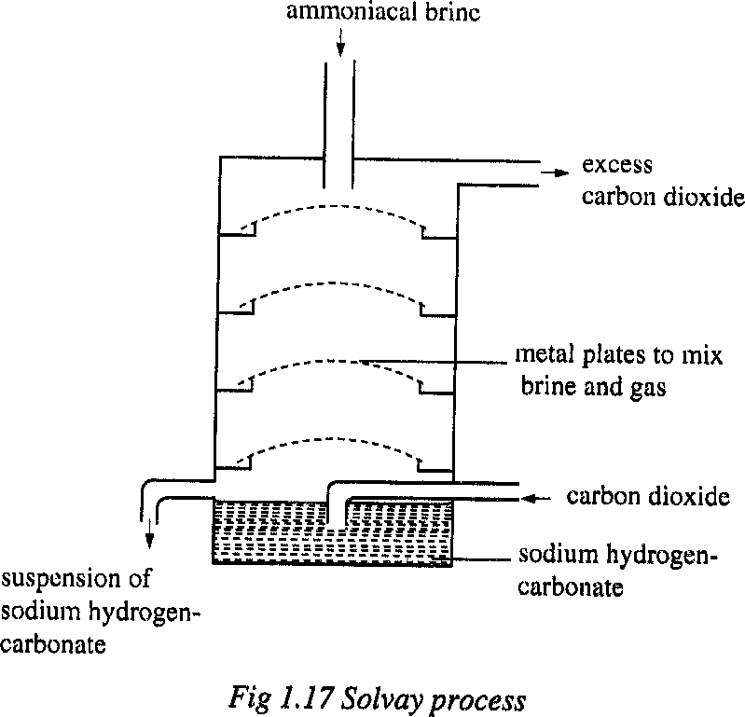

After filtration and washing to remove ammonium compounds, sodium hydrogencarbonate is heated to produce sodium carbonate.

2NaHCO3(s) → Na2CO3(s) + CO2(g) + H2O(g)

Carbon dioxide is recycled for use. Ammonia is recovered from the ammonium chloride by reacting ammonium chloride with calcium hydroxide, obtained by adding water to calcium oxide (from decomposition of calcium carbonate). Ammonia is recycled for use.

CaO(s) + H2O(l) → Ca(OH)2(s)

2NH4Cl(aq) + Ca(OH)2(s) → 2NH3(g) + CaCl2(aq) + 2H2O(l)

Therefore, the end products of solvary process are calcium chloride and sodium carbonate. Calcium chloride is used in extraction of sodium.

### Uses of sodium carbonate

1. It is used for softening of water for domestic purpose. Calcium ions which are the principal cause of hardness in water; are precipitated from water as calcium carbonate by the addition of sodium carbonate.

Ca2+ (aq) + CO32-(aq) → Ca CO3 (s)

1. It is used in manufacture of glass. Ordinary glass is made by mixing calcium carbonate, silicon dioxide (sand) and sodium carbonate together and melting them. The resulting mixture of sodium and calcium silicates produces glass on cooling.
2. It is used to make dry soap powders.

### Washing soda

Washing soda is sodium carbonate decahydrate (Na2CO3.10H2O).When exposed to air, the crystals lose mass and become coated with a fine white powder. Each molecule of washing soda gives up, to the atmosphere, nine molecules of water of crystallization forming sodium carbonate monohydrate (Na2CO3.H2O).

Na2CO3.10H2O(s) → Na2CO3.H2O(s) +9H2O(l)

Such an action, that is, the giving up of water of crystallization to the atmosphere is termed as efflorescence.

Washing soda is used for softening water by precipitating the calcium ions from solution as calcium carbonate.

Ca2+(aq) + CO32-(aq) → CaCO3(s)

### Exercise

1. (a) State what would be observed if sodium carbonate solution was added to
   1. Aqueous calcium hydroxide.
   2. Dilute sulphuric acid.

(b) Write ionic equations for the reactions in (a) (i) and (ii).

1. A mixture containing copper(II) sulphate and copper(II) carbonate was shaken with water and filtered.
2. Identify the residue.
3. To the residue was added dilute sulphuric acid.
   1. State what was observed.
   2. Write the equation for the reaction.

### The Carbon cycle

Carbon cycle is the balancing of carbon dioxide in air i.e. describes the processes that increase or decrease the carbon dioxide concentration in the environment (atmosphere). The atmosphere contains about 0.03% of carbondioxide by volume and this volume is kept almost constant.

### Processes that add carbondioxide to the atmosphere

1. **Combustion:** Carbon and its compounds burn in air to produce carbon dioxide e.g. burning of coke, coal, wood, petrol, oils etc.

C(s) + O2(g) → CO2(g)

1. **Respiration:** When sugars are oxidized in the body, carbondioxide is produced C6H12O6 (l) + 6O2(g) → 6CO2(g) + 6H2O (l)
2. **Thermal decomposition of calcium carbonates:** Carbon dioxide passes into air when limestone or chalk is heated.

CaCO3 (s) → CaO(g)+ CO2 (l)

1. **Fermentation:** in the manufacture of ethanol during fermentation carbon dioxide is produced as a bi-product.

C6H12O6 (l) → 2C2H5OH (l) + CO2 (g) + Energy

### Processes that remove carbondioxide from the atmosphere

1. **Photosynthesis:**Green plants absorb carbon dioxide from the atmosphere to make their own food

6CO2 (g)+ 6H2O (l) →C6H12O6 (l) + 6O2 (g)

1. **Hardening of mortar:** Mortar and white ash remain slaked lime which slowly absorbs carbon dioxide is produced

Ca(OH)2 (aq) + CO2 (g) → CaCO3 (s) + H2O (l)

1. **Solution in water:** Rain dissolvescarbon dioxide to form a weak acid (carbonic acid) which runs into rivers, lakes, seas and oceans

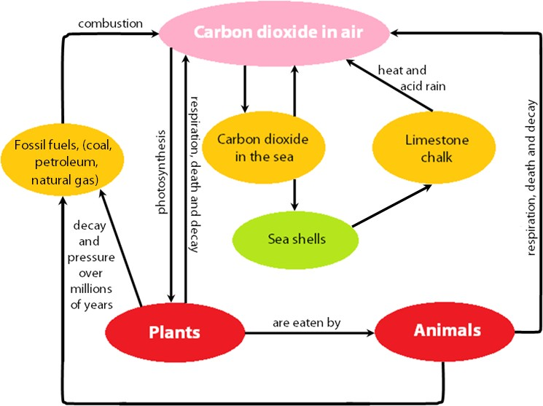

### Exercise

* 1. (a) Zinc carbonate was strongly heated in a test-tube until no further change.
     1. State what was observed.
     2. Write the equation for the reaction which took place.

1. The residue formed in (a) above was added to dilute sulphuric acid and heated.
   1. Write the equation for the reaction.
   2. State what was observed.
   3. (a) Define allotropy.
2. Give the three allotropes of carbon.
3. Give two examples of other elements which show allotropy and name their allotropes.
   1. (a) Name two common reagents used in the laboratory preparation of carbon dioxide.
4. State what is observed when carbon dioxide is bubbled in fairly concentrated sodium hydroxide solution for sometime.
5. Write the equation(s) of the reaction(s) that take(s) place.
   1. (a) Describe the structure of graphite.
6. Explain why graphite conducts electricity whereas diamond does not.
7. State any two uses of diamond.
8. Describe how you would show by a chemical test that graphite is made up carbon atoms.
   1. Carbon monoxide was passed over strongly heated copper(II) oxide.
      1. State what was observed.
      2. Write the equation for the reaction.
      3. Name any other oxide that shows similar reaction with carbon monoxide.
   2. (a) Draw a well labeled diagram for preparation of sodium carbonate in the laboratory.

(b) (i) What is observed when washing soda (Na2CO3.10H2O) is exposed to atmosphere for sometime.

* 1. (a) Copper (II) carbonate was heated strongly until there was no further change.
     1. State what was observed.
     2. Write an equation for the reaction.
     3. Name one reagent which can be used to identify the gaseous product.

1. Excess dilute sulphuric acid was added to the residue in (a) and the mixture warmed.
   1. State what was observed.
   2. Write an equation for the reaction.
   3. (a) (i) How can calcium oxide (quicklime) be obtained on large scale? Diagram not required.

(ii) Write equation for the reaction that occurs.

1. (i) What would be observed when fresh calcium oxide is added to water in a beaker?

(ii) Write equation for the reaction that would occur.

1. Dilute hydrochloric acid was added to calcium oxide.
   1. State what is observed.
   2. Write the equation for the reaction that occurs.
2. To the product in (c) was added a solution of carbonate ions.
   1. State what would be observed.
   2. Write the equation for the reaction that occurs.
3. State any two uses of calcium oxide.

### Hardness of water

Hard water is that which does not form lather (foam) readily with soap.

Hardness of water is due to presence of calcium ions (Ca2+) or magnesium ions (Mg2+) present in water

Soft water is that which readily forms lather with soap There are two types of hard water

* Temporary hard water
* Permanent hard water

### Temporary hard water

This is the water which becomes soft on boiling. Temporary hard water is due to the presence of calcium hydrogen carbonate (Ca(HCO3)2) or magnesium hydrogen carbonate (Mg(HCO3)2) dissolved in water

### Treatment of temporary hard water

Temporary hard water can be softened by:

### Boiling

When temporary hard water is boiled, it becomes soft. This is because boiling decomposes calcium hydrogen carbonate or magnesium hydrogen carbonate to calcium carbonate or magnesium carbonate respectively thus removing the calcium (Ca2+) ionsor magnesium (Mg2+) ions from water making it soft

Mg(HCO3)2(aq) → MgCO3(s) + CO2(g) + H2O(l) Ca(HCO3)2(aq) → CaCO3(s) + CO2(g) + H2O(l)

### Addition of washing soda (Na2CO3.10H2O)

This removes temporary hardness from water as it reacts with hydrogen carbonates ions dissolved in water

Ca(HCO3)2(aq) + Na2CO3(aq) → CaCO3(s) + 2NaHCO3(aq)

### Addition of slaked lime to water

This precipitates calcium carbonate hence removing calcium ions from water making it soft Ca(HCO3)2(aq) + Ca(OH)2(aq) → 2CaCO3(s) + 2H2O(l)

### Addition of aqueous ammonia

This also precipitates calcium ions out of water making it soft

Ca(HCO3)2(aq) + NH4OH(aq) → CaCO3(s) + NH4 HCO3(aq) + H2O(l)

### Addition of naturally occurring zeolite or the manufactured permutit (sodium aluminium silicate (Na2Al2Si2O8.xH2O)

This removes calcium (Ca2+) ions by precipitation of calcium aluminium silicate (CaAl2Si2O8.xH2O)

CaSO4(aq) + Na2Al2Si2O8.xH2O(aq) → CaAl2Si2O8.xH2O(s) + Na2SO4(aq)

### Advantages of hard water

1. Strengthens teeth and bones since it contains calcium
2. Allows for use of cheap lead pipes for water supply. Does not cause lead poisoning
3. Necessary for formation of animal shells. Some aquatic animals need calcium to form their shells e.g. water snails.

### Disadvantages of hard water

1. **Leads to wastage of soap as it needs much soap before it forms lather**. Initially soap is used in removing calcium sulphate from water before a lather is formed

### Produces scum which leaves dirty marks on clothes

Scum can also damage silk and nylon clothes.

Scum: is a solid precipitate formed when hard water reacts with soap. Scum is chemically called calcium stearate (C17H35COOCa)

C17H35COONa(aq) + CaSO4(aq) → (C17H35COO)2Ca(s) + Na2SO4(aq)

1. **Leaves fur in kettles and pans in which it is boiled**. This fur is a poor conductor of heat and therefore wastes fuel or energy.

Fur: fur is solid calcium carbonate or magnesium carbonate formed inside kettles or pans

1. **It forms boiler scales inside boilers**; this is also a coat of calcium carbonate or magnesium carbonate formed inside boilers. Both fur and boiler scales waste fuel as heat can‘t pass through them easily.

### 19. Electrolysis

Electrolysis is the decomposition of an electrolyte in aqueous solution or molten state by passing an electric current through it.

### Definitions

1. **Conductors and non conductors**

**Conductors:** These are substances that allow electricity to pass through them

In electrolytes, the conducting particles are called ions while in metals the conducting particles are electrons.

Some substances do not conduct electricity in solid state e.g. solid sodium chloride or gaseous statee.g. hydrogen chloride gas but conduct well in aqueous (solution) or molten form. This is because in solid, the compounds consist of ions held together by strong forces of attraction but ions separate in molten or solution form and can move freely.

**Non-conductors/Insulators**: These are substances that do not allow the passage of electricity through them

### Electrolytes and non-electrolytes

An electrolyte is an ionic compound which conducts an electric current in aqueous solution or in molten state and is decomposed by it.

Electrolytes are composed of ions. In the solid state, the ions are rigidly held in regular positions and are not able to move freely. Melting the solid breaks the forces between the ions and therefore the ions are free to move in a molten electrolyte. Dissolving a solid in water or any other polar solvent, causes the breakdown of the lattice setting the ions free in aqueous state.

**Types of electrolytes** Strong electrolytes Weak electrolytes Non electrolytes

**Strong electrolyte:** This is a compound which is completely ionised in dilute solution and in molten state e.g. salts such as sodium chloride and mineral acids e.g. hydrochloric acid

HCl(aq) → H+(aq) + Cl-(aq) NaCl(aq) → Na+(aq) + Cl-(aq)

**Weak electrolyte**: This is a compound which is only slightly ionized in dilute solution and in the molten state. They have very few mobile ions and therefore slightly conduct an electric current

e.g. water, carbonic acid, ethanoic acid and ammonia solution.

H2CO3(aq) ⇌2H+(aq) + CO32-(aq) CH3COOH(aq) ⇌ H+(aq) + CH3COO-(aq) H2O(l) ⇌H+(aq) + OH-(aq)

NH4OH(l) ⇌ NH4+(aq) + OH-(aq)

**Non electrolyte:** This is a solution or molten compound which cannot be decomposed by an electric current e.g. sugar, alcohols, benzene and most organic compounds

**A non-electrolyte** is a solution or a molten compound which does not conduct electricity and therefore cannot be decomposed by an electric current e.g. paraffin, sugar solution, ethanol etc. Non-electrolytes exist only in the form of molecules and are incapable of ionisation. The molecules have no charge and are therefore not able to carry an electric current.

### Electrodes

These are poles of carbon (graphite) or metal where current enters and leaves the electrolyte. The types of electrodes include;

**Cathode:** This is a negative electrode at which electrons enter the electrolyte or leave the external circuit

**Anode:** This is the positive electrode at which the electrons leave/the electrolyte or enter the external circuit.

**NB**: An electrode must be a good conductor of electricity and should not react with the electrolyte.

### A simple arrangement during electrolysis

**Ions**

An ion is a charged particle. Types of ions include:

**Cation:** This is a positively charged ion that will move to the cathode during electrolysis e.g. all metallic ions e.g. Na+, NH4+, H+, Cu2+, Pb2+ etc.

**Anion:** This is a negatively charged ion that moves to the anode during electrolysis e.g. all non- metal ions and radicals e.g. Cl-, SO42-, OH-, NO3-, Br- etc.

### Faradays

This is the quantity of electricity carried by one mole of electrons and is equal to 96500 coulombs (C)

(1Faraday = 1mole of electrons =96500C)

### Exercise

The shows the electrical conductivity of substances W, X and Y

|  |  |  |  |
| --- | --- | --- | --- |
| **Substance** | **Solid state** | **Molten state** | **Aqueous solution** |
| W X  Y | Conducts Doesn‘t conduct  Doesn‘t conduct | Conducts Conducts  Doesn‘t conduct | Not soluble Conductors  Not soluble |

1. Which of the substances is likely to be copper(II) sulphate? Explain.
2. Give the type of bonding that is present in substance
   1. W.
   2. X.
   3. Y.
3. Which one of the substances is likely to be plastic? Explain.
4. What particles are responsible for conducting electricity in substance
   1. W?
   2. X?

### Theory of electrolysis (Ionic theory)

This states that electrolytes consist of ions which are positively and negatively charged particles that move to different electrodes during electrolysis.

In ionic compounds, these charges are held together by electrostatic forces but in solution or molten state, these ions are free to move. The positive ions move to the cathode and the negative to the anode.

### What happens to anions at the anode?

When an electric current is applied to the electrolyte, the negatively charged ions called **anions** move to the positively charged electrode called the **anode**. Once there, they lose electrons to become atoms and are said to be **discharged** i.e. 2Xn-(aq or l) → X2 (g) + ne

### What happens to cations at the cathode?

The positively charged ions called **cations** move to the negatively charged electrode called cathode where they gain electrons and become atoms which are then said to be **discharged**i.e. Mn+(aq or l) + ne→ M(s)

### Selective discharge of ions

When two or more ions of similar charges are present under similar conditions in a solution e.g. K+ and H+ or SO42- and OH-, one is preferentially selected for discharge. The selective discharge depends on the following factors.

### Position of the metal or group in the electrochemical (activity) series

If there are two ions with the same charge in the solution, the least reactive ion is discharged first. For example, in the electrolysis of sodium chloride solution, both Na+ and H+ (from water) are present and migrate to the cathode. The H+ being less reactive than the Na+ is discharged first.

If Cu2+ and H+ ions are both present in solution, both migrate to the cathode but the H+ being less reactive than the Na+ is discharged first.

The electrochemical series for ions is given below.

Cations Anions

K+ SO42-

Na+ NO3-

Ca2+ Cl- Reactivity Reactivity Mg2+ Br- Decreasing Decreasing Al3+ I-

Zn2+ OH-

Fe2+ Pb2+ H+ Cu2+ Hg2+

Ag+

### The nature of electrodes

This factor sometimes influences the choice of ion discharge.

E.g. when a solution of copper (II) sulphate is electrolysed using copper electrodes, copper ions are discharged at the cathode but neither SO42- nor OH- are discharged at the anode. Instead the anode dissolves.

Reaction at the cathode Cu2+(aq) + 2e → Cu(s) Reaction at the anode Cu(s) → Cu2+(aq) + 2e

When copper (II) sulphate solution is electrolysed using the copper cathode and carbon anode, the copper is discharged at the cathode and OH- is discharged at the anode.

Reaction at the cathode Cu2+(aq) + 2e → Cu(s) Reaction at the anode

4OH- (aq) → 2H2O(l) + O2(g)

E.g. Electrolysis of a solution of sodium chloride with mercury as a cathode and with platinum as cathode. With platinum, the hydrogen ion is discharged in accordance with the order of the activity series, sodium ion being higher in the series. The cathode product is hydrogen gas. If the mercury cathode is used, there is a possibility of discharging sodium ion to form sodium amalgam with mercury. This requires less energy than the discharge of hydrogen ions to form hydrogen gas and so occurs in preference.

### Concentration of the ions

Increase of concentration of an ion tends to promote its discharge. For example in concentrated sodium chloride solution, there are hydroxide ions and chloride ions but the concentration of the

chloride ions exceeds that of the hydroxide ions and therefore chloride ions are discharged. The more concentrated ions are discharged in preference to ones which are less concentrated.

### Electrolysis of dilute sulphuric acid

This is commonly called electrolysis of water.

Ions present:

From sulphuric acid are H+ and SO42- From water are H+ and OH-.

### Reaction at cathode:

The hydrogen ions migrate to the cathode, gain electrons and become hydrogen gas. 2H+(aq) + 2e- →H2(g)

### Reaction at the anode:

The hydroxide ions and sulphate ions migrate to the anode. The hydroxide ions being less reactive than sulphate ions are discharged and oxygen gas is formed.

4OH-(aq) →2H2O(l) + O2(g) + 4e-

### Overall equation

4H+(aq) + 4OH-(aq) → 2H2(g) + O2(g)+ 2H2O(l)

### Electrolysis of dilute sulphuric acid in an apparatus called a voltammeter

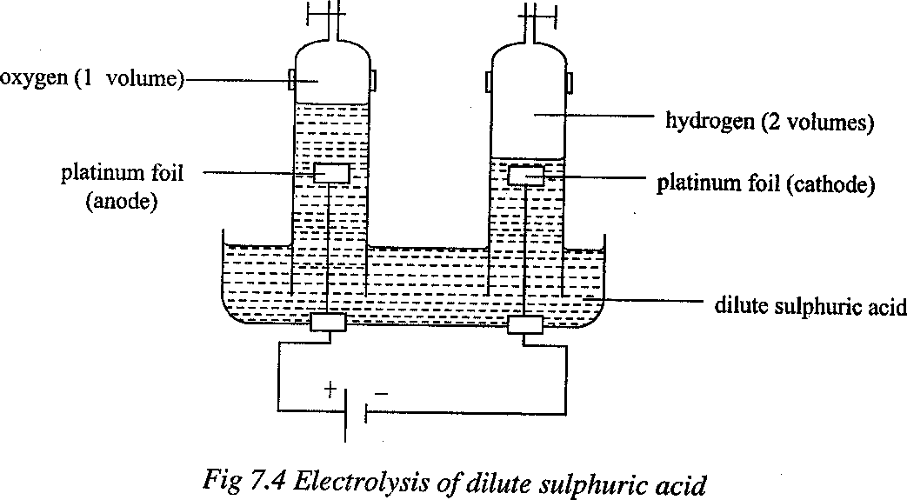

**Note**:

1. pH changes at the anode and cathode:

The acidity at the cathode decreases (pH increases) because the hydrogen ions are discharged as hydrogen gas and therefore the concentration of hydrogen ions in solution decreases. At the anode, the acidity increases (pH decreases). The discharge of hydroxide ions disturbs the ionic equilibrium of water and therefore more water ionizes to restore it.

H2O(l) → H+(aq) + OH-(aq)

Therefore the excess hydrogen ions produced, with incoming sulphate ions, is equivalent to increased concentration of sulphuric acid. This means that the total acidity at anode and cathode together remains constant. This implies that the final change is that water is decomposed to produce hydrogen and oxygen. **That is why it is called electrolysis of water.**

1. Two volumes of hydrogen are produced at the cathode and one volume of oxygen produced at the anode i.e. Hydrogen : Oxygen =2:1

### Overall equation

4H+(aq) + 4OH-(aq) → 2H2(g) + O2(g)+ 2H2O(l)

### Electrolysis of molten lead(II) bromide

The bulb does not give out light while the lead(II) bromide is solid showing that no electric current passes through the solid lead (II) bromide. As the lead(II) bromide melts, the bulb gives out light. After a while, a brown colouration is observed at the anode and a shiny grey solid (lead) is deposited at the cathode.

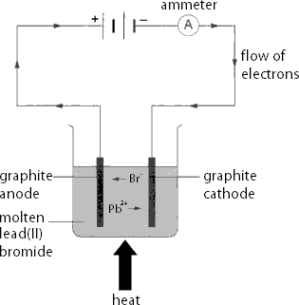

Reaction at the anode:

2Br-(1) → Br2(l) + 2e-

Reaction at the cathode:

Pb2+(l) + 2e- → Pb(s)

1. Write equations which represent the discharge of the following ions at the
   1. Cathode
      1. Ag+(aq)
      2. Cu2+(aq)
      3. Al3+(aq)
      4. Na+(l)
   2. Anode
      1. Cl-(aq)
      2. OH-(aq)
      3. I-(aq)
2. Write down the ions present in the following substances.
   1. Dilute sulphuric acid.
   2. Copper(II) sulphate solution.
   3. Molten sodium chloride.
   4. Concentrated sodium hydroxide solution.
   5. Glucose solution.
3. Write down the ions that migrate to the anode and cathode when an electric current is passed through the following substances.
   1. Dilute hydrochloric acid
   2. Silver nitrate solution
   3. Molten magnesium chloride
   4. Sodium hydroxide solution
4. The table below shows the observations made when an electric current was passed through two substances Q and Z.

|  |  |
| --- | --- |
| **Substance** | **Observation** |
| Molten Q | Conducts an electric current and a brown substance is deposited at the cathode. |
| Molten Z | Conducts an electric current and it is not decomposed. |

* 1. Which of the two substances would not conduct electricity in solid state? Explain.
  2. In what other state would you expect substance Q to conduct electricity?
  3. Name the particles that are responsible for conducting electricity in substance Q and Z.
  4. Give the type of bonding that is present in substances Q and Z.

5.

1. Which ions would be discharged at the electrodes during electrolysis of a dilute solution containing
2. K+ and Mg2+?
3. Zn2+ and Ag+?
4. SO 2- and OH-?

4

1. NO3- and OH-?
2. Write the equation for the discharge of the ions in (a) (i) and (iv).

**Electrolysis of copper(II) sulphate solution**(using copper electrodes – active electrodes)

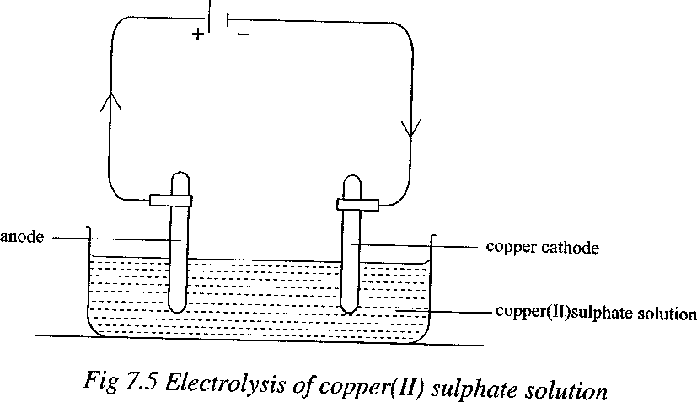

Ions present:

From copper(II) sulphate: Cu2+ and SO 2-

4

From water: H+ and OH- Reaction at cathode:

Copper(II) ions and hydrogen ions migrate to cathode. Copper(II) ions are discharged because they are less reactive than hydrogen ions. Copper(II) ions gain electrons from the cathode and copper is deposited. A brown layer of copper is deposited at the cathode and thus the mass of the cathode increases.

Cu2+(aq) + 2e- → Cu(s) Reaction at anode:

Both the sulphate and hydroxide ions migrate to the anode but none loses its electrons. Instead the copper anode itself loses electrons and as it does so, it becomes copper(II) ions which dissolves in solution. The anode electrode dissolves and its mass decreases.

Cu(s) → Cu2+(aq) + 2e-

**Electrolysis of copper(II) sulphate solution**(using copper cathode and platinum anode) Ions present: From copper(II) sulphate: Cu2+ and SO42-

From water: H+ and OH-.

Copper(II) ions and hydrogen ions move to the cathode. Copper(II) ions being less reactive than hydrogen ions are discharged. Copper(II) ions gain electrons and copper is deposited. The blue colour of the electrolyte (copper(II) sulphate solution) fades as copper is deposited because copper(II) ions are removed from the solution.

Cu2+(aq) + 2e- → Cu(s)

Sulphate ions and hydroxide ions move to the anode. Hydroxide ions being less reactive than sulphate ions are discharged by giving up their electrons. Bubbles of a colourless gas (oxygen) are formed at the anode.

4OH- (aq) → 2H2O(l) + O2(g) + 4e-

The overall equation is obtained by adding the two equations after multiplying the first equation by 2, to obtain the same number of electrons in both equations.

2Cu2+(aq) + 4e- → 2Cu(s)

4OH-(aq) → 2H2O(l) + O2(g) + 4e-

Overall equation: 2Cu2+(aq) + 4OH- (aq) → 2Cu(s) + 2H2O(l) + O2 (g)

### Electrolysis of concentrated copper(II) chloride solution

(using carbon anode and copper cathode)

Copper(II) ions from copper(II) chloride and hydrogen ions from water migrate to the cathode. Copper(II) ions are discharged because they are more concentrated than hydroxide ions, thus chlorine gas (greenish yellow gas) is liberated.

Cu2+(aq) + 2e- → Cu(s)

Chloride ions from copper(II) chloride and hydroxide ions from water move to the anode but chloride ions are discharged because they are more concentrated than hydroxide ions, thus chlorine gas (greenish yellow gas) is liberated.

2Cl- (aq) → Cl2(g) + 2e-

The overall equation is obtained by adding the two equations. Cu2+(aq) → Cl2(g) → Cu(s) + 2e-

However, if the copper(II) chloride solution is very dilute, some discharge of hydroxide ions will also occur. As the copper(II) chloride solution is diluted, there will not be a point at which chlorine ceases to be produced and oxygen replaces it. Instead, a mixture of the two gases will come off, with the proportion of oxygen gradually increasing. The same case arises in the electrolysis of sodium chloride solution and hydrochloric acid, because the same anions are involved.

### Summary of the effects of electrolysis

|  |  |  |  |  |  |  |
| --- | --- | --- | --- | --- | --- | --- |
| **Solution electrolysed** | **Ions in solution** | **Cathode of** | **Anode of** | **Product at cathode** | **Product at anode** | **Observation** |
| Conc. HCl | H+, OH-, Cl- | Platinum or carbon | Carbon | Hydrogen | Chlorine | Solution becomes alkaline  Bubbles of colourless gas at the cathode , greenish yellow gas at the anode |
| NaOH | Na+, H+, OH- | Platinum | Platinum | Hydrogen | Oxygen | Bubbles of colourless gas at the cathode and anode  Solution becomes neutral |
| Conc. NaCl | Na+, H+, OH-, Cl- | Platinum or carbon | carbon | Hydrogen | Chlorine | Bubbles of colourless gas at the cathode, greenish yellow gas at the anode  Solution becomes alkaline  NaOH is formed |
| Conc. NaCl | Na+, H+, OH-, Cl- | Mercury | Carbon | Sodium | Chlorine | Solution is diluted, grey metal at the cathode, greenish yellow gas at the anode |
| CuSO4  solution | Cu2+, H+, OH-,  2-  SO4 | Copper | Carbon/Pt | Copper | Oxygen | Blue colour fades  Brown solid at the cathode  Bubbles of the colourless gas at the anode  Solution becomes more acidic  H2SO4 is produced |

|  |  |  |  |  |  |  |
| --- | --- | --- | --- | --- | --- | --- |
| CuSO4  solution | Cu2+, H+, OH-,  2-  SO4 | Copper | Copper | copper | Copper anode dissolves | No change in pH  Brown solid at the cathode and Cathode mass increases  Anode mass decreases |
| Molten PbBr2 | Pb2+, Br- | Carbon | Carbon | Lead | Bromine | No change  Grey solid at the cathode Brown liquid at the anode |
| Dilute H2SO4 | 2-  H+, OH-, SO4 | Pt | Pt | Hydrogen | Oxygen | Total acidity at cathode and anode reduces, Bubbles of colourless gas at the cathode and anode |
| Conc. CuCl2 | Cu2+, H+, OH-, Cl- | Carbon | Carbon | Copper | Chlorine | Solution is diluted  Brown solid at the cathode Greenish yellow gas at the anode |
| Conc. CuCl2 | Cu2+, H+, OH-, Cl- | Copper | Copper | Copper | Copper anode dissolves | No change in pH  Brown solid at the cathode and Cathode mass increases  Anode mass decreases |

**Exercise**

1. Acidified water was electrolysed using platinum electrodes.
   1. Write an equation for the reaction that took place at the
      1. Anode
      2. Cathode
   2. Name one other substance that can be used as electrode in the electrolysis of acidified water.
2. An aqueous solution of silver nitrate solution was electrolysed using platinum electrodes.
   1. Write an equation for the reaction at
      1. Anode
      2. Cathode
   2. Write the overall equation for the reactions taking place at anode and cathode.
   3. Write the equations for the reactions at anode and cathode is silver nitrate solution was electrolysed using silver electrodes.
3. Dilute hydrochloric acid was electrolysed using carbon electrodes.
   1. Name the product(s) formed at the anode.
   2. Write the equation for the reaction at cathode.
4. An aqueous solution of zinc nitrate was electrolysed using platinum electrodes. Write an equation for the reaction at
5. Anode
6. Cathode.
7. A concentrated solution of copper(II) chloride was electrolysed using copper anode and copper cathode. Write an equation for the reaction at
8. Anode
9. Cathode

### Laws of electrolysis

The laws of electrolysis were stated by Faraday. According to his laws, the amount of substance produced during electrolysis depends on the

1. Time of passing a steady current (t).
2. Magnitude of the steady current (I).
3. Charge on the ion of the element (n).

### Faraday’s first law

It states that the mass of a substance deposited at the electrodes is directly proportional to the quantity of electricity passed. This can be illustrated by the graph below.

Mass of substance deposited

(g)

Quantity of electricity (c)

Quantity of electricity = current x time

i.e. Q = I x t.

Therefore, the quantity of electricity can be found by measuring the current (I) in amperes and the time (t) in seconds for which it flows. The unit for quantity of electricity is a coulomb (C). One coulomb is equivalent to one ampere of current flowing for one second.

### Exercise

Calculate the quantity of electricity used when a current of

1. 2 A is passed through an electrolyte for 20 minutes.
2. 10 A is passed through an electrolyte for 2 hours.
3. 12 A is passed for 2 minutes and 20 seconds.

### Faraday’s second law

It states that the mass of a substance deposited at the electrodes is inversely proportional to the charge on its ion. For example, if the same quantity of electricity is separately passed through a solution of silver ions and copper(II) ions, it is found that the number of moles of silver deposited are twice the number of moles of copper deposited.

### Faraday

This is the quantity of electricity required to deposit one mole of a substance from an ion with a single charge. One mole of silver ions requires one faraday (1 mole of electrons) to discharge at the cathode.

Ag+(aq) + e- → Ag(s)

One mole of copper(II) ions requires 2 faradays (2 moles of electrons) to discharge at the cathode.

Cu2+(aq) + 2e- → Cu(s)

One mole of aluminium ions requires 3 faradays to discharge at the cathode.

A13+(aq) + 3e- → A1(s)

Two moles of chloride ions require 2 faradays to discharge as one mole of chlorine molecules at the anode.

2Cl-(aq) → Cl2(g) + 2e-

From the above examples, one mole of electrons is equivalent to 1 faraday. 1 faraday is equivalent to 96500 coulombs.

### Example I: Quantity of electricity

A current of 4 amps was passed through a solution of magnesium sulphate solution for 5 minutes.

Calculate the quantity of electricity

1. Required to deposit one mole of magnesium.
2. Used.

### Solution:

1. Mg2+(aq) + 2e- → Mg(s)

2 faradays are required to liberate 1 mole of magnesium.

Quantity of electricity required to liberate 1 mol of magnesium

= 2 x 96500 = 193000 C

1. Q = It

Q = 4 x 5 x 60 = 1200 C

### Example II: Atomic mass of a substance deposited

When a current of 0.45 amps was passed through a solution of copper(II) sulphate for 1500 seconds, 0.222 g of copper were deposited. Calculate the relative atomic mass of copper.

Solution:

Q = It

Q = 0.45 x 1500 = 675 C

Cu2+(aq) + 2e- → Cu(s)

2 faradays are required to liberate 1 mol of copper. Quantity of electricity required to liberate 1 mol of copper.

= 2 x 96500 = 193000 C.

675 C deposit 0.222 g of copper. 1 C deposits 0.222 g of copper.

675

193000 C deposit 0.222 x 193000 g of copper.

675

Thus the relative atomic mass of copper is 63.5.

### Example III: Moles of a substance deposited

A current of 10 amps is passed through molten magnesium chloride for 4 hours. How many moles of magnesium metal are produced by this electrolysis?

### Solution:

Q = It

But t = 4 x 60 x 60

Q = 10 x 4 x 60 x 60 Q = 144000 C

Mg2+(aq) + 2e- → Mg(s)

2 faradays liberate 1 mol of magnesium.

So 2 x 96500 C produces 1 mol of magnesium. 1 C produces 1 mol of magnesium.

2 x 96500

144000 C would produce 1 x 144000 mol of magnesium.

2 x 96500

0.746 mol of magnesium

### Exercise

1. How many coulombs are required to discharge the following ions.
   1. Zn2+
   2. Na+
   3. Fe3+ (iv)Pb2+

(v) OH- (vi)H+

(vii) Br-

1. Molten aluminium chloride was electrolysed for 200 seconds using a current of 40A.
2. Write the equation for the reaction at
   1. Cathode.
   2. Anode.
3. Calculate the quantity of electricity used.
4. Calculate the quantity of electricity in coulombs required to deposit one mole of
   1. Aluminium
   2. Chlorine molecules.
5. Calculate the mass of aluminium deposited when a current of 960 A passes through a solution of aluminium(III) oxide in fused cryolite for 800 seconds.
6. What volume of oxygen measured at s.t.p would be liberated in electrolysis of dilute sulphuric acid by 96000 coulombs. (1 mole of gas occupies 22.4 litres at s.t.p.)

### Application of electrolysis

1. **Electroplating**

This is the process of coating a metal with another metal by the process of electrolysis. Electroplating is done to protect metals from corrosion and to improve their appearance. The metal to be plated is made the cathode in a suitable electrolyte containing ions of the plating material. For example, during silver plating, the metal to be plated is made the cathode in a silver salt solution as an electrolyte and pure silver is made the anode.

The silver salt solution contains positively charged silver ions which are attracted to the cathode (metal to be plated). Once there, they gain electrons to form silver atoms.

Ag+(aq) + e+ → Ag(s)

The anode (plate of pure silver) loses its electrons and forms silver ions which dissolve in the solution to replace the ones moving to the cathode. The process continues until an adequate layer of silver has been deposited on the metal being plated.

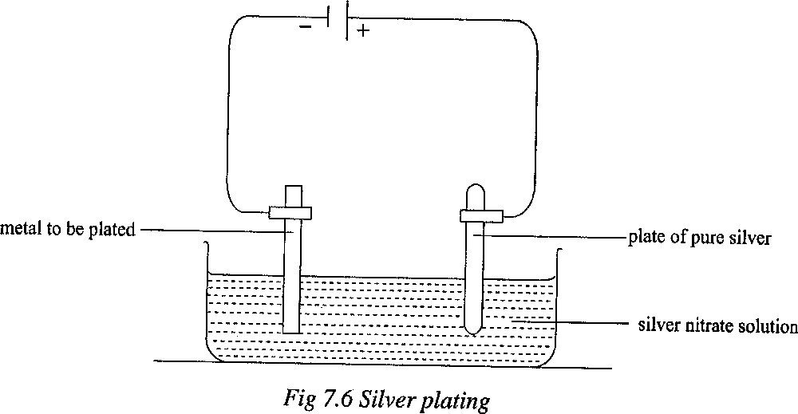

Other metals which can be used to coat other metals include chromium, nickel, copper and gold. When iron is to be chromium plated, it is first electroplated with nickel to prevent corrosion and then with chromium.

For successful electroplating, the material to be plated should be clean and the electric current, temperature and concentration of the electrolyte should be exactly right. When a very low current is used, electrolysis proceeds very slowly and a very smooth deposit can be obtained.

### Exercise

1)

* 1. Name the substance that can be used as the anode and cathode during
     1. Chromium plating of iron metal.
     2. Nickel plating of steel.
  2. Name the positive ions that must be present in the electrolyte used in a(i) and (ii).
  3. Write the equation for the reaction taking place at cathode in a(ii) [valency of nickel (Ni) = 2]

### Anodizing

Anodizing is the electrolytic process of coating objects made of aluminium with a very thin oxide film to protect the metal from corrosion.

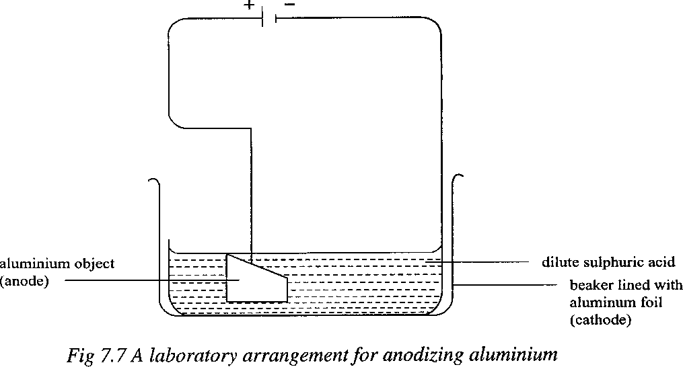

To ensure a very thin film of oxide, the oxidation is carried out by electrolysis, using the aluminium object as the anode. The electrolyte is usually dilute sulphuric acid which gives oxygen at the anode on electrolysis (refer to electrolysis of dilute sulphuric acid).

4OH-(aq) →2H2O(l) + O2(g) + 4e-

Under the correct conditions, oxygen reacts with the surface of the aluminium and coats it with a thin invisible but protective coating of aluminium oxide.

4Al(s) + 3O2(g) → 2Al2O3(s)

### Purification of metals

Metals such as copper and zinc may be refined, that is purified by electrolysis. The impure metal is made the anode and the pure metal the cathode. The electrolyte is a solution containing the metal.

### Extraction of metals

Reactive metals such as aluminium and sodium are extracted by electrolysis of the fused electrolytes

### Manufacture of chemicals

The most important example is the manufacture of sodium hydroxide, chlorine and hydrogen using the flowing mercury cathode cell. In the manufacture of sodium hydroxide, concentrated chloride solution (brine) is electrolysed using a graphite (carbon) anode and a flowing mercury cathode. The mercury cathode enables sodium ions to discharge in preference to hydrogen ions. Sodium is deposited at the cathode and chlorine is liberated at the anode.

Na+(aq) + e- → Na(s) 2Cl+(aq) → Cl2(g) + 2e+

The sodium formed dissolves in the mercury cathode to form a solution called **sodium amalgam**. The amalgam is mixed with water producing sodium hydroxide solution, hydrogen and pure mercury.

2NaHg(l) + 2H2O(l) → 2NaOH(aq) + H2(g) + 2Hg(l)

Sodium amalgam

Mercury is then recycled by use of a pump. Hydrogen is collected as a by-product. Sodium hydroxide solution is evaporated to dryness.

Sodium hydroxide is used in the manufacture of soap, rayon, paper and in the purification of bauxite for aluminium extraction.

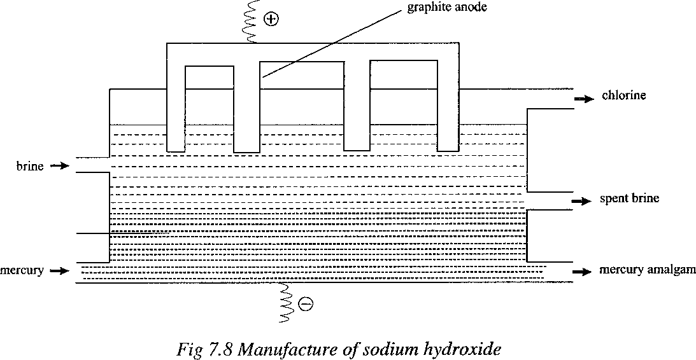

### Exercise

1. Copper(II) sulphate solution was electrolysed using the set up shown in the figure below.

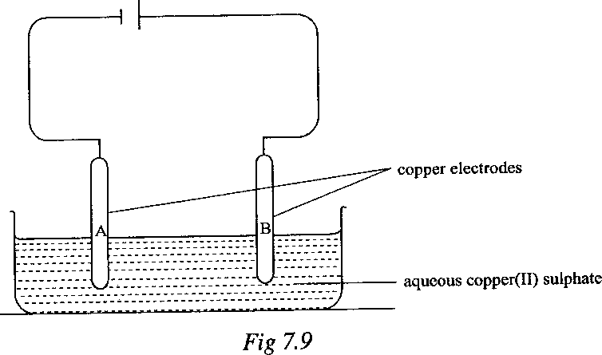

* 1. Name electrodes A and B
  2. Write down all the ions present in aqueous copper(II) sulphate.
  3. Describe what happens to each electrode during electrolysis.

1. Write an equation for the reaction that took place at A and B.
2. Comment on the colour of the solution after electrolysis.
3. The figure below shows electrolysis of dilute sulphuric acid using carbon electrodes. A current of 11.0 amps was passed for 5 minutes and 20 seconds through the circuit.
4. Name gas
   1. X.
   2. Y.
5. Write the equation for the reaction at
   1. Anode.
   2. Cathode.
6. Calculate the volume of gas Y produced at room temperature.

(IF = 96500 C, 1 mole of gas at room temperature occupies 24 dm3)

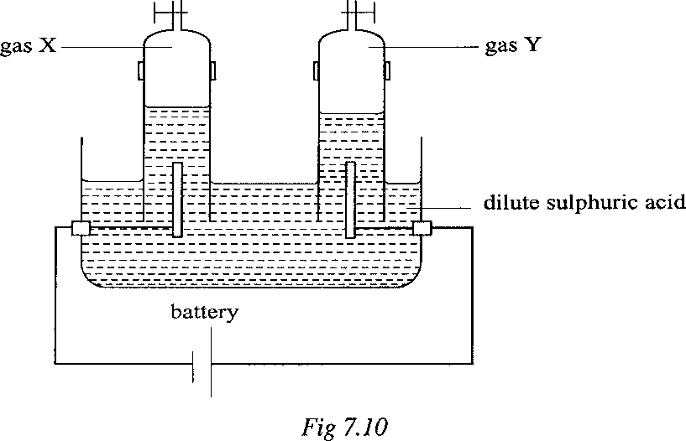

1. (a) Molten lead(II) bromide was electrolysed between carbon electrodes.
   1. State what was observed at the cathode and anode.
   2. Write an equation for the reaction that took place at each electrode.

(b) Calculate the mass of the product formed at the cathode when a current of 2 amps is passed for 1 hour and 30 minutes. (Pb = 207, Br = 80)

1. (a) What is meant by electroplating?

(b) Draw a labeled diagram of an apparatus that can be used in the laboratory to copper plate an object.

1. A current of 0.25 amps was passed through copper(II) sulphate solution for 40 minutes.

Calculate the

1. Quantity of electricity used.
2. Quantity of electricity which deposits one mole of copper.
3. Mass of copper deposited during the electrolysis.
4. Moles of copper deposited. (Cu = 64, 1 F = 96500 C)
5. The circuit shown in the figure below was used in an experiment to study the effect of electricity on lead(II) bromide.
6. State what was observed.
   1. Before lead(II) bromide had melted.
   2. After lead(II) bromide had completely melted.
7. Explain your answer in (a)
8. Write equation for the reaction that took place at
   1. Y.
   2. X.

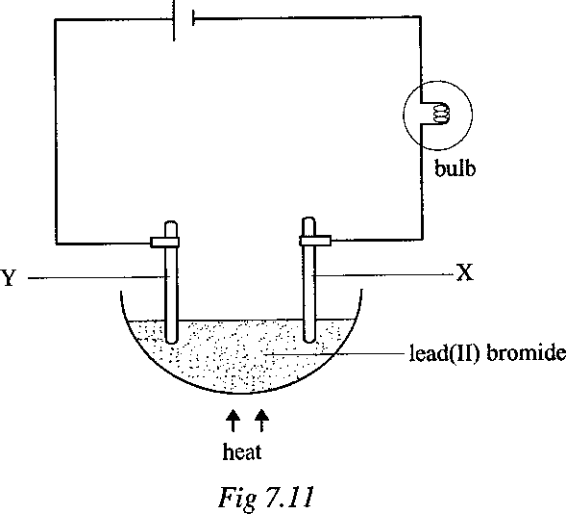

1. Copper(II) sulphate solution was electrolysed using carbon electrodes.
2. State what was observed at the
   1. Anode.
   2. Cathode.
3. Explain your answer in (a) (ii).
4. Write equation(s) which took place at the anode.
5. Write overall equation for the reactions.
6. The figure below shows an arrangement of the apparatus used for the purification of copper.
7. Name the substance used as
   1. Anode.
   2. Cathode.
8. Name the electrolyte.
9. Write equation for the reaction that took place at
   1. X.
   2. Y.

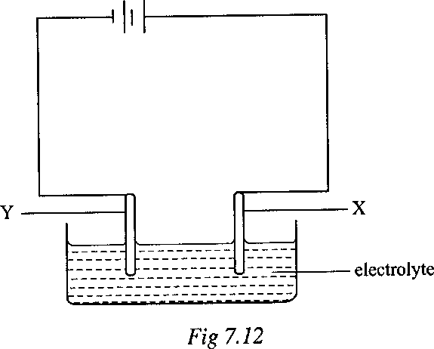

1. An aqueous solution of potassium iodide was electrolysed in a U-tube using carbon electrodes. Iodide was formed at the anode and it dissolved to form a yellowish brown

solution around the electrode. At the cathode, bubbles of a colourless gas were seen to evolve. The solution near the cathode had a pH of about 11.

1. Explain with an equation how the change from iodide ions to iodine took place at the anode.
2. What was the gas evolved at the cathode?
3. A solution of potassium iodide in water is neutral (pH = 7). Explain why the pH increased to 11 near the cathode during electrolysis.

**20. Formulae, stoichiometry and the mole concept**

* 1. **Relative Atomic Mass**

**Comparing Atomic Masses with the Carbon Atom**

To compare to a carbon atom, a carbon-12 atom is used. The mass of the isotope is 12 times

greater than hydrogen atom so

of carbon-12 atoms is equivalent to the mass of one hydrogen

atom.

*Relative Atomic Mass* - the average mass of one atom of the element (averaging isotopes) when

compared with

mass of a carbon-12 atom.

Ar =

**Note:** The Relative Atomic Masses are already stated on the periodic table above each chemical formula.

### Relative Molecular Mass and Relative Formula Mass

Using the relative atomic masses (Ar), it‘s possible to calculate Relative Masses of molecules and ionic compounds

### Relative Molecular Mass

Molecules contain atoms joined together, e.g. Cl2

Average mass (molecular mass) of Cl2= add relative atomic masses of both atoms. Examples:

The molar mass of oxygen molecules (O2) =2 X O

=2X16

=32g

The molar mass of water molecules (H2O) =2 X H + 1 X O

=2X1+ 1 X 16

=18g

*Relative Molecular Mass –* the average mass of one molecule of substance (averaging isotopes)

when compared with

mass of a carbon-12 atom.

In short: Mr = =

**Relative Formula Mass**– same as relative molecular mass but for ions or ionic compounds only *Relative Formula Mass–* total relative atomic masses of all atoms in a formula of ionic compound

E.g. Relative formula mass of MgSO4 Mr = 24x1 + 32x1 + 4x16 = 120

### Note: Relative molecular mass and relative formula mass have no units Exercise

Calculate the relative formula masses or relative molecular masses of the following compounds (H=1, Cl=35.5, Cu=64, S=32, O=16, Na=23, C=12, Fe=56, Zn=65, N=14, Pb=207, Ag=108 )

1. Hydrogen chloride
2. Copper (II) sulphate
3. Sodium hydroxide
4. Sodium carbonate
5. Iron (II) sulphate
6. Copper (II) chloride
7. Zinc nitrate
8. Lead (II) carbonate
9. Silver chloride
10. Copper (II) sulphate pentahydrate
11. Sodium carbonate decahydrate

### Percentage Composition

**Percentage by mass = (     x 100)%**

E.g.

1. Determine the percentage composition of each element in sodium chloride RFM of NaCl = 23 + 35.5 =58.5

% of Na =   x 100 = 39.32%

1. Determine which oxides of iron of Fe2O3 or Fe3O4 has more iron.

Mr (Fe2O3) = 2(56) + 3(16) = 160

Percentage of Fe in Fe2O3

=(

x 100) %

=(

x 100) %

=(

x 100) %

= 70%

Mr (Fe3O4) = 3(56) + 4(16) = 232

Percentage of Fe in Fe2O3 = (

x 100) %

= 72%

Fe3O4 has more iron composition than that of Fe2O3.

### Calculating the Mass of an Element in a Compound

Use the example of Fe2O3 in the example above. The percentage mass of iron in iron (III) oxide is 70%. Therefore to calculate mass of iron in a 200g compound of iron (III) oxide is (0.7 x 200)g = 140g

e.g. Determine the mass of iron in 200g of Fe2O3. Mr(Fe2O3)= 2(56) + 3(16) = 160

Mass of Fe in Fe O = ( x 200g

2 3

=(

= 140g

x 200g

### Calculating the Mass of Water in a Compound

Compound with water mass is ‗hydrated‘ and has H2O in their formula.

e.g. Calculate water mass in 12.5g hydrated copper sulphate, CuSO4.5H2O

Mass of 5H O in CuSO .5H O = (    x mass of sample

2 4 2

RFM of CuSO4.5H2O = 64 + 32 + 4(16)+5(2+16) =250

=(

= 4.5g

x 12.5g

* 1. **Mole Counting Particles** Unit for particles = **mole** Symbol = **mol**

1 mol = 6 x 1023 atoms

### Moles of Particles

**Calculating the Number of Moles**

n =

E.g 1: How many moles are in 3 x 1024 molecules of water, H2O?

n =

= 5 mol

e.g 2: Calculate the number of molecules in 0.25 mole of CO2. Hence, how many atoms are present?

0.25mol =

Number of particles = 0.25 mol x 6 x 1023

= 1.5 x 1023 molecules

Number of atoms = total number of atoms in CO2 x number of particles

= 3 x 1.5 x 1023

= 4.5 x 1023 atoms

### Molar Mass

*Molar mass* – the mass of one mole of any substances

### For substances consisting of atoms

It is the Ar of the element in grams. Eg. Ar(C) = 12, molar mass = 12g

### For substances consisting of molecules

It is the Ar of the substance in grams. Eg. Ar(H2O) = 18, molar mass = 18g

### For substances consisting of ions

It is the Ar of substance in grams. Eg. Ar(NaCl)= 58.5, molar mass= 58.5g

### Calculations Using Molar Mass

n =

E.g. Find the mass of 0.4 mol of iron atom.

0.4 =

m = n x Mr

m = 0.4 x 56 = 22.4 g

### Or

1 mole of iron weighs 56g

0.4mol of iron weigh 0.4 x 56 = 22.4 g

### Different Kinds of Chemical Formulae

Ethene formula is C2H6

*Molecular Formula* – shows the actual formula and kinds of atoms present, e.g. C2H6. It expresses the composition of a compound showing the actual number of atoms in the compound. *Empirical Formula* – shows the simplest whole number ratio of the atoms present in a compound,

e.g. C2H6, ratio 1:3, therefore C1H3, simply CH3

*Structural Formula* – shows how atoms are joined in the molecule. It can be represented by ball- and-stick model or diagrammatically.

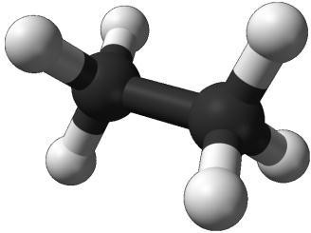

*Ball-and-Stick Diagrammatic*

**a. Calculating the Empirical Formula of a Compound**

Find the empirical formula of an oxide of magnesium consisting of 0.32g of oxygen and 0.48g of magnesium. (Mg = 24, O = 32)

### Solution

Elements present Composition by mass

|  |  |
| --- | --- |
| Mg | O |
| 0.48 | 0.32 |
|  |  |
|  |  |
| = 0.02 mol | = 0.02 mol |
|  |  |
|  |  |
| 1 | 1 |

Number of moles

Divide by the smallest number

Mg1O1

Therefore, the empirical formula is MgO

### Calculating the Empirical Formula from Percentage Composition

An oxide of sulphur consists of 40% sulphur and 60% oxygen (S = 32, O = 16)

### Solution

Elements present Percentage composition

|  |  |
| --- | --- |
| S | O |
| 40 | 60 |
|  |  |
|  |  |
| = 1.25 mol | = 3.75 mol |
|  |  |
|  |  |
| 1) | 3 |

Number of moles

Divide by the smallest number

S1O3

Therefore, the empirical formula is SO3

### From Empirical formula to Molecular Formula

Find the molecular formula of propene, CH2, having molecular mass of 42.

**Solution** Molecular formula will be CnH2n

### Solution

Relative molecular mass = 12 n (from carbon Ar) + 2n (2 x hydrogen Ar) = 14n 14 n = 42

n = 3 Therefore, C3H6

The complete combustion of 7.5g of an organic compound, Q containing carbon, hydrogen and oxygen gave 17.8g of carbon dioxide and 9.27g of water. Calculate the simplest formula of Q.

Solution:

Molar mass of CO2 = 12 + 16 x 2 = 44g

44g of carbon dioxide contain 12g of carbon. 1g of carbon dioxide contains g of carbon.

17.8g of carbon dioxide contains   g of carbon.

= 4.86g of carbon Molecular mass of H2O = 1 x 2 + 16 = 18g

18g of water contain 2g of hydrogen.

1g of water contains  g of hydrogen.

9.27g of water contain    g of hydrogen

= 1.03g of hydrogen

Mass of oxygen = 7.5 – (4.86 + 1.03) = 1.61g of oxygen

|  |  |  |  |
| --- | --- | --- | --- |
| Elements present: | C | H | O |
| Composition by mass: | 4.86 | 1.03 | 1.61 |

Number of moles: 4.86 1.031.61

|  |  |  |  |
| --- | --- | --- | --- |
| 12 | | 1 | 16 |
| 0.41 | | 1.03 | 0.10 |
| Mole ratio: | 0.411.030.10 | |  |
|  | 0.10 0.10 | | 0.10 |
| Simplest ratio: | 4 : 10 : | | 1 |

Thus the simplest formula of Q is C4H10O.

### Example

A compound Y contains 15.8% aluminium, 56.2% oxygen and 28% sulphur. (S=32, Al = 27 O

=16). (i) Calculate the empirical formula of Y.

(ii) The molecular mass of Y is 342g. Determine the molecular formula of Y.

### Solution:

|  |  |  |  |
| --- | --- | --- | --- |
| Elements present: | A1 | S | O |
| Percentage composition: | 15.8 | 28 | 56.2 |

Number of moles: 15.82856.2

27 32 16

0.59 0.88 3.5

Mole ratio: 0.590.88 3.5

|  |  |  |
| --- | --- | --- |
| 0.59 | 0.59 | 0.59 |
| 1 | 1.5 | 6 |

Multiply by 2 throughout 1 x 2 1.5 x 2 6x 2 to obtain whole numbers:

Simplest ratio: 2 : 3 : 12

The empirical formula of compound Y is given by Al2S3O12 or Al2(SO4)3.

ii) (Al2S3O12) n = 342

[(27 x 2) + (32 x 3) + (16 x 12)]n = 342

342n = 342

342 342

n = 1

The molecular formula of Y is Al2S3O12 or Al2(SO4) 3.

### Exercise

1. A compound contains 43.4% by mass of sodium, 11.3% carbon and 45.3% oxygen. Calculate the simplest formula of the compound (Na = 23, C = 12, O = 16)
2. A compound contains 40% carbon, 6.67% hydrogen, the rest being oxygen. The relative molecular mass of the compound is 180 (C=12, H =1, O = 16). Determine the empirical formula of the compound and the molecular formula of the compound
3. An oxide of an element X was made of 50% X. Calculate the simplest formula of the oxide (X = 32, O = 16)
4. A compound of molar mass 400 with 28% iron, 48% oxygen and the rest being sulphur was dissolved in water. Calculate the empirical formula and molecular formula of the compound .(Ans =Fe2(SO4)3)
5. When hydrated sodium carbonate crystals (Na2CO3.xH2O) were exposed to air for a long time, there was loss of mass of 62.9%. What is the amount of the water of crystallisation? (Na=23, C=12, O=16, H=1)

Na2CO3.xH2O(s) → Na2CO3(s) + xH2O(l) .(Ans x=10)

1. A white crystalline salt (Z.xH2O) contains 51.2% of water of crystallisation. If the formula mass of the crystals is 120, calculate the amount of water of crystallisation.(Ans x=7)

### Molar Volume of Gases

#### *The Avogadro’s Law*

Equal volume of gases at the same temperature and volume contain equal number of particles or molecules.

**Molar Volume of Gas** – volume occupied by one mole of gas

One mole of all gases at standard temperature and pressure (s.t.p.) = 22.4dm3

One mole of all gases at room temperature and pressure (r.t.p.) = 24dm3 1dm3 = 1000cm3

Formulae:

Number of moles of a gas (n) =

Volume of a gas = Number of moles (n) x Molar volume (Mr)

### Example

What is the number of moles of 240cm3 of Cl2 at r.t.p.?

### Solution

Since 24000cm3 of chlorine gas contain 1 mole

Then 1cm3 of chlorine gas contains

moles

240cm3 of chlorine gas contain

moles = 0.01 mol

**Or** Number of moles of a gas (n) =    =

moles = 0.01 mol

### Molar Volume and Molar Mass

Gases have same volume but not necessarily same mass Example: 1 mole of hydrogen gas (H2) has a mass of 2g, 1 mole of Carbon Dioxide gas (CO2) has a mass of 44g **Example**

Find the volume of 7g of N2 at r.t.p.

### Solution

Step 1: Find the number of moles from the mass of nitrogen Molar mass of N2 =2 x 14 =28g

Number of moles of a gas (n) = =  moles = 0.25 mol

Step 2: Find the volume of nitrogen, now with formula of gas Volume of a gas = Number of moles (n) x Molar volume (Mr)

Volume of gas = 0.25 mol x 24

= 6 dm3 (or 6000cm3)

### Calculations using chemical equations

* + 1. **Constructing Chemical Equations**

#### *E.g. Reaction Between Hydrogen and Oxygen*

**Word Equation:** Oxygen + Hydrogen → Water

To write the **chemical equation**, we use symbols of atoms/molecules: O2 + H2 → H2O

BUT THIS IS IMBALANCED! A BALANCED EQUATION **MUST** HAVE THE SAME NUMBER OF ATOMS OF EACH ELEMENT ON BOTH SIDES! THEREFORE...

|  |  |  |  |  |
| --- | --- | --- | --- | --- |
| O2 | + | H2 | → | H2O |
| O |  | H |  | H |
| O |  | H |  | H  O |

From above, we know that H2O is short 1 oxygen atom. Therefore we multiply the product by 2 first. Note: all atoms in molecules are automatically multiplied by 2.

|  |  |  |  |  |
| --- | --- | --- | --- | --- |
| O2 | + | H2 | → | 2H2O |
| O |  | H |  | H |
| ~~O~~ |  | H |  | H |
|  | | | | H |
| H |
| ~~O~~ |
| ~~O~~ |

Now we can cancel off oxygen atoms. However, hydrogen atoms on the reactant side are short of 2 atoms. Therefore, we multiply the hydrogen molecule by 2 so that the short is balanced. The equation is fully balanced when we are able to cancel off all atoms of that element on both sides.

|  |  |  |  |  |
| --- | --- | --- | --- | --- |
| O2 | + | 2H2 | → | 2H2O |
| O |  | ~~H~~ |  | ~~H~~ |
| ~~O~~ |  | ~~H~~ |  | ~~H~~ |
|  |  | ~~H~~ |  | ~~H~~ |
|  |  | ~~H~~ |  | ~~H~~ |
|  |  |  |  | ~~O~~ |
|  |  |  |  | ~~O~~ |

### Calculations from Equations

* + - 1. **Reacting Masses**

In every equation, each atom is rational to each other. Suppose we want to find moles of *X* atoms that reacted to form 0.25 mole of *Y* atoms. We always put the atom we want to find as numerator and the denominator being the atom we know.

E.g. *X* + 2*Z* → *2Y*

Find the ratio first:

Then multiply the ratio by no. of moles of *Y* to find the reacting mole of *X*.

Number of moles of X = x 0.25 = 0.125 mole

Therefore 0.125 mole of *X* reacted with 0.25 mole of *Y*.

To find the reacting mass of *X*, e.g. *Y* is given as 35g, we simply multiply the mole by the mass of *Y* as they are always in ratio:

0.125 x 35 = 4.375 g

### Example

Lead (II) nitrate reacts with potassium iodide according to the equation Pb(NO3)2(aq) + 2KI (aq)→ PbI2(s) + 2KNO3 (aq)

Calculate the mass of lead (II) iodide that will be formed when 33.2g of potassium iodide reacts with excess lead (II) nitrate (K=39, N=14, O=16, Pb=207, I=127)

### Solution

Find the ratio first:

RFM of potassium iodide (KI) =39 + 127 = 166

Moles of potassium iodide =

= 0.2moles

Number of moles of PbI = x 0.2 = 0.1 mole

2

Therefore 0.1 mole of PbI2reacted with 0.2 mole of *KI*.

The reacting mass of PbI2 = moles of PbI2 X RFM of PbI2 RFM of PbI2 = 207 + 2(127) = 461

Mass of PbI2 = 0.1 x 461

=46.1g

### Exercise

1. Ammonium chloride reacts with calcium hydroxide according to the equation Ca(OH)2(s) + 2NH4Cl (aq)→ CaCl2(s) + 2NH3(g) +2H2O (l)

If 14.8g of calcium hydroxide was reacted completely with ammonium chloride, what mass of ammonia gas will be evolved? (H=1, N=14, O=16, Ca=40) (Ans = 6.8g of ammonia)

1. Calculate the loss in mass when 10g of calcium carbonate is heated to a constant mass (Ca=40, C=12, O=16) (Ans =4.4g)
2. Calculate the mass of ammonium chloride that will just react completely with 14.8g of calcium hydroxide (N=14, H=1, Cl=35.5) (Ans = 21.4g)

### Reacting Masses and Volumes

First, find the ratio of moles and multiply the mole of the gas volume you want to find with the volume of gas at room temperature (24dm3)

#### *Example*

MgCl2 is formed by reacting Mg and HClaccording to equation: Mg(s) + 2HCl (aq) → MgCl2(s) + H2 (g)

Find the amount of hydrogen gas, in cm3, formed when 14.6g of HClis reacted at room temperature. (H=1, Cl=35.5)

### Solution

Ratio: Find the ratio first:

Then multiply the ratio by no. of moles of *HCl* to find the reacting mole of *H2*.

RFM of HCl = 1 + 35.5 = 35.5

Moles of HCl = = 0.4moles

Number of moles of *H2* =  x moles of HCl=  x 0.4moles = 0.2 moles

To find the volume of *H2*, simply multiply the mole by the molar volume at room temperature: Volume of *H2*= moles of *H2* x Molar gas volume at room temperature

= 0.2 x 24 dm3= 4.8 dm3

But 1dm3 = 1000cm3 4.8dm3 x 1000 = 4800 cm3

4 800cm3 of gas is formed

### Exercise

1. Ammonium chloride reacts with calcium hydroxide according to the equation Ca(OH)2(s) + 2NH4Cl (aq)→ CaCl2(s) + 2NH3(g) +2H2O (l)

If 14.8g of calcium hydroxide was reacted completely with ammonium chloride, what volume of ammonia gas will be evolved? (H=1, N=14, O=16, Ca=40, I mole of gas occupies 24dm3 ) (Ans

= 9.6dm3 of ammonia)

1. Carbon burns in oxygen according to the following equation C (s) + O2 (g)→ CO2(g)

Calculate the volume of carbondioxide collected at s.t.p when 10g of carbon is burnt (c =12, one mole of a gas occupies 22.4l at s.t.p) (Ans = 18.6 litres)

1. When heated strongly, potassium nitrate decomposes according to the equation 2KNO3(s) → 2KNO2(s) + O2(g)

Calculate the volume of oxygen evolved at s.t.p by heating 5g of potassium nitrate (K=39, N=14, O=16, 1mole of a gas occupies 22.4litres at s.t.p)

1. 3.4g of a mixture containing calcium carbonate and calcium sulphate was reacted with excess hydrochloric acid and 448cm3 of carbon dioxide measured at s.t.p was evolved
   1. Write the equation for the reaction
   2. Calculate
      1. Mass of calcium carbonate in the mixture
      2. Percentage of calcium carbonate in the mixture

(Ca=40, C=12, O=16, 1mole of a gas occupies 22400cm3 at s.t.p)

### Calculations involving energy changes

Carbon reacts with sulphur according to the equation C(s) + 2S(s) → CS2(s) ∆H = +116kJmol-1

The amount of heat absorbed when 16g of sulphur reacts with excess carbon is (C=12, S=32)

### Solution

2moles of sulphur absorb 116kJ 2 x 32g of sulphur absorb 116kJ

1g of sulphur absorb  kJ

16g of sulphur absorbs

kJ = 29kJ

### Exercise

1. The formation of methanol from hydrogen and carbon dioxide is represented by the following equation

2H2(g) + 2CO(g) →CH3OH (l) ∆H = -92kJmol-1

What would be the energy released when 3.2g of methanol is formed? (C=12, H=1, O=16)

1. Methane burns in oxygen according to the equation CH4(g) + 2O2(g) →CO2(g) + 2H2O (l) ∆H = -890kJmol-1

Calculate the volume of methane at s.t.p that will turn in excess oxygen to produce 2670kJ (1 mole of a gas occupies 22.4dm3 at s.t.p)

1. Calculate the heat produced when 48g of graphite is burnt in excess oxygen (C=12, O=16, H=1, ∆H = -390kJmol-1)

### Concentration of Solutions

*Concentration of solution* tells the number of solute in a volume of solution

It is the amount of a substance dissolved in a certain amount of solution. It is expressed either in grams per litre (gl-1 or gdm-3) or moles per litre (moll-1 or moldm-3)

Concentration (C) =

### Molarity

**Molarity:** Is the number of moles of a substance contained in one litre of a solution But 1 litre = 1000cm3

Therefore, molarity can also be defined as the number of moles of a substance contained in 1000cm3 of a solution

Units of molarity = moles per litre (moll-1) or moles per dm3 (moldm-3)

### Molar solution

This is the solution containing one mole of a substance per litre of solution i.e. solutions which are 1M.

### Standard solution

This is a solution whose concentration is exactly known or is the solution which contains a known mass and a known volume.

### Calculating the Amount of Solute Examples

1. Calculate the number of moles that are 20g of sodium hydroxide (Na=23, O=16, H=1)

### Solution

RFM of NaOH =23+16+1 = 40

Number of moles of NaOH, n =

= n =

= 0.5mol

1. 4g of sodium hydroxide was dissolved in water to make 200cm3 of a solution. Calculate the molarity of the standard solution formed

### Solution

RFM of NaOH =23+16+1 = 40

Number of moles of NaOH, n =

200cm3 of solution contain 0.1mol of sodium hydroxide

= n =

= 0.1mol

1cm3 contains

mol of sodium hydroxide

1000cm3 contains

mol of sodium hydroxide

=0.5moles per dm3 of sodium hydroxide

=0.5M

1. What is the mass of solute in 600cm3 of 1.5M NaOH solution?

### Solution

1000cm3 contains 1.5 mol of sodium hydroxide

1cm3 contains

mol of sodium hydroxide

600cm3 contains

x 600 mol of sodium hydroxide

=0.9mol

From

Moles (n) =

Mass (m) = moles (n) x Relative formula mass (Mr )

RFM of NaOH =23+16+1 = 40

m = 0.9 x 40

= 36g

1. How many grams of sodium sulphate crystals Na2SO4.10H2O would be required to make 500cm3 of 0.01M solution (Na=23, S=32, O=16, H=1)

### Solution

1000cm3 contains 0.01 mol of Na2SO4.10H2O

1cm3 contains

mol of Na2SO4.10H2O

500cm3 contains (

x 500) mol of Na2SO4.10H2O

=0.005mol

From

Moles (n) =

Mass (m) = moles (n) x Relative formula mass (Mr)

RFM of Na2SO4.10H2O = 2x23 +32 +4x16 +10(2x1 + 16) = 323 m = 0.005 x 323

= 1.615g

### Exercise

1. How many moles of sulphuric acid are contained in 250cm3 of 0.1M sulphuric acid? (Ans

= 0.0025M)

1. Calculate the mass of nitric acid (HNO3) required to make 200cm3 of 2M solution (Ans=25.2g)

### Quantitative analysis

Is the measurement of the concentration of the elements/compounds in a known substance

### Volumetric Analysis

Is a measure of the concentrations of an acids/alkalis in solution

### Acid-alkali Titrations in Volumetric Analysis

It needs: - a *standard solution*: a solution of known concentration, and

- a solution of unknown concentration

### Detecting the End Point

**End point** is the point at which neutralisation of acid and alkali is complete

* Sharp indicators (phenolphthalein and methyl orange) are used to detect end points effectively
* Litmus and universal indicators are not used as the changes at the end point are not sharp

### A Typical Acid-alkali Titration

The diagram shows how titration is used to find concentration of sulphuric acid (H2SO4) using Sodium hydroxide (NaOH)solution

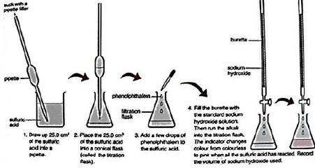

### Calculating molarity of a solution using a standard solution

When concentration of one of the solutions is given in a neutralisation reaction, the concentration of the other solution can be calculated using the following steps

1. Write a balanced equation for the reaction
2. Calculate the number of moles of the standard solution
3. Using the mole ratio, calculate the number of moles of the second solution
4. State the volume which contains the moles
5. Calculate the number of moles in the specified volume e.g. 1000cm3
6. State the molarity with units i.e. mol/litre or M

Note: Calculate concentration in grams per litre using the formula Concentration = Molarity x RFM

### Examples

30.0 cm3 of 0.100 M NaOH reacted completely with 25.0 cm3 of H2SO4 in a titration. Calculate the concentration of H2SO4 in mo mol/dm3 given that:

2NaOH(aq) + H2SO4(aq) → Na2SO4(aq) + 2H2O(l)

### Solution

**Step 1:** Find the reacting mole of NaOH

1000 cm3 of solution contain 0.1moles of sodium hydroxide

1cm3 contains  moles

30cm3 contain

moles = 0.0030 moles

**Step 2:** Write the chemical equation for the reaction 2NaOH(aq) + H2SO4(aq) → Na2SO4(aq) + 2H2O(l)

**Step 3:** Find the ratio of number of moles of H2SO4 to number of moles of NaOH 2NaOH(aq) : H2SO4(aq) =2:1

**Step 4:** Use ratio to find number of moles of H2SO4 that reacted

2 moles of the NaOH reacts with 1 moles of H2SO4 1 moles of the NaOH reacts with moles of H2SO4

0.030 moles of the NaOH reacts with  moles of H2SO4

=0.0015moles

**Step 5:** Find the concentration of H2SO4 in mol/dm3

25cm3 of solution contains 0.0015 moles of H2SO4 1cm3 contains moles of H SO

2 4

1000cm3 contain  moles of H SO

2 4

= 0.06M

Molarity of H2SO4 = 0.06M

### Uses of Titrations in Analysis

* + 1. **Identification of Acids and Alkalis Example:**

An acid has formula of H2XO4. One mole of H2XO4 reacts with 2 moles of NaOH.

A solution of the acid contain 5.0g/dm3 of H2XO4. In titration, 25.0cm3 of acid reacted with 25.5cm3 of 0.1 M NaOH. Calculate the concentration of acid in mol/dm3 and find X of the acid and its identity

### Solution

**Step 1:** Find the reacting mole of NaOH

1000 cm3 of solution contain 0.1moles of sodium hydroxide

1cm3 contains  moles

25.5cm3 contain

moles = 0.00255 moles

**Step 2:** Write the chemical equation for the reaction

2NaOH(aq) + H2XO4(aq) → Na2XO4(aq) + 2H2O(l)

**Step 3:** Find the ratio of number of moles of H2XO4 to number of moles of NaOH 2NaOH(aq) : H2XO4(aq) =2:1

**Step 4:** Use ratio to find number of moles of H2XO4 that reacted 2 moles of the NaOH reacts with 1 moles of H2XO4

1 moles of the NaOH reacts with moles of H2XO4

0.0255 moles of the NaOH reacts with  moles of H2XO4

=0.01275moles

**Step 5:** Find the concentration of H2XO4 in mol/dm3

25cm3 of solution contains 0.01275 moles of H2XO4 1cm3 contains moles of H XO

2 4

1000cm3 contain  moles of H XO

2 4

= 0.51M

Molarity of H2XO4 = 0.51M

Since 1000cm3 of H2XO4 contains 0.051 mol and 5 g of H2XO4.

∴ 0.051 mol of H2XO4 has a mass of 5g of H2XO4

1 mole of H XO has a mass of

2 4

= 98 g

Hence, Mr of X = 98 – 2(1) – 4(16) = 32.

∴ X is sulphur and H2XO4 is sulphuric acid

**b. Percentage Purity of Compounds**

Percentage purity = ( X 100)%

### Example:

* 1. g of an impure sample of hydrated sodium carbonate (Na2CO3.10H2O) was dissolved in 250 cm3 of solution. 20 cm3 of this solution was required to completely react with 25 cm3 of 0.1M hydrochloric acid. Calculate:
     1. The molarity of pure hydrated sodium carbonate
     2. The mass of pure hydrated sodium carbonate per litre of solution
     3. The percentage;
        1. Purity
        2. Impurity of hydrated sodium carbonate

Solution

1. Moles of hydrochloric acid that reacted

1000 cm3 of hydrochloric acid contain 0.1moles

1cm3 contains  moles

25 cm3 contain

moles = 0.0025 moles

From the equation

2 moles of the acid reacts with 1 moles of sodium Carbonate

1 moles of the acid reacts with moles of the Carbonate

0.025 moles of the acid reacts with  moles of the Carbonate

=0.00125moles

20 cm3 of sodium carbonate solution contains 0.00125 moles of the carbonate 1cm3 contains  moles of the carbonate

1000cm3 contain 1cm3 contain  moles of sodium hydroxide

= 0.0625M

Molarity of sodium hydroxide = 0.0625M

1. Molarity

Molar mass of Na2CO3.10H2O (Na = 23, C = 12, O = 16, H = 1)

=23X2 + 12 + 16X3 + 10X (2+16) = 286

Concentration in grams per litre = 17.875g

1. Percentage
   1. Purity Note: 7.2g of impure hydrated sodium carbonate was dissolved in 250 cm3 of solution. To calculate the percentage purity, the mass of the pure sample in 250 cm3 of solution should be calculated

1000cm3 contains 17.785g of pure hydrated sodium carbonate

1cm3 contains  g of pure hydrated sodium carbonate

250 cm3contains  X 250 g of pure hydrated sodium carbonate

= 4.4688g of pure hydrated sodium carbonate

Percentage purity =

=62.07%

* 1. Percentage impurity =  = 37.93%

Or Percentage impurity = 100 -62.07 = 37.97%

### Determination of basicity of an acid

The basicity of an acid is the number of hydrogen ions, H+ (aq) which can be produced by one mole of the acid in solution. The general formula of an acid can be written as HnX or HnA; where

n= basicity of the acid

A or X = the acid radical e.g. chloride (Cl), sulphate (SO4), phosphate (PO4) etc.

Hence HX is monobasic H2X is dibasic H3X is tribasic

In an experiment 20.0 cm3 of a 0.1M acid HnA required 10.0cm3of a 0.1M required 10.0cm3 of 0.2M sodium hydroxide solution for complete neutralisation.

1. Write the equation for the reaction
2. Calculate:

Solution

1. The number of moles of the acid that reacted
2. The number of moles of sodium hydroxide solution that reacted
3. Determine the basicity of the acid

**a.**

### b.

* 1. Moles of the acid

1000 cm3 of acid contain 0.1moles

1cm3 contains  moles

20 cm3 contain

moles = 0.00250 moles

* 1. Moles of sodium hydroxide soltuion

1000cm3 contain 1cm3 contain 0.2 moles of sodium hydroxide

1cm3 contain  s moles of sodium hydroxide

10 cm3 of solution contains

moles of sodium hydroxide

= 0.002 moles of sodium hydroxide

c. Basicity of the acid

To determine the basicity of the acid, the value of n should be determined From the equation:

|  |  |  |  |
| --- | --- | --- | --- |
| Mole ratio | HnA : |  | NaOH |
|  | 1 | : | n |
| Moles: | 0.02 | : | 0.002 |
|  | n | = | 1 |

Hence HnA is a monobasic acid (HA)

### c. Determination of water of crystallisation in oxalic acid (COOH)2. xH2O

20 cm3 of 0.1 M sodium hydroxide solution was required to completely neutralise 20 cm3 of solution containing 6.4g of the oxalic acid (COOH)2. xH2O solution. 2moles of sodium hydroxide react with 1 mole of oxalic acid(C=12, O=16, H=1)

Calculate:-

1. The moles of sodium hydroxide that reacted
2. The molecular mass of (COOH)2.xH2O
3. The value of X (number) of moles of water of crystallisation in (COOH)2.xH2O Solution
4. Moles of sodium hydroxide

1000 cm3 contain 0.1moles of sodium hydroxide

1cm3 contains

20 cm3 contain

moles of sodium hydroxide

moles of sodium hydroxide

= 0.002 moles of sodium hydroxide

1. Molecular mass of (COOH)2.xH2O

Hint: - To calculate molecular mass in this case, the molarity and concentration in grams per litre should be known;

Molarity of (COOH)2. xH2O Given that:-

2 moles of sodium hydroxide react with 1 mole of oxalic acid

1 mole of sodium hydroxide reacted with ½ moles of oxalic acid

0.02 moles of sodium hydroxide react with  moles of oxalic acid

=0.01 moles of oxalic acid 20 cm3 of oxalic acid solution contains 0.001 moles

1 cm3 of oxalic acid solution contains  moles

1000 cm3 of oxalic acid solution contains  moles =0.005M

= 128

Note: Relative molecular mass and relative formula mass have no units

1. Value of x

(COOH)2. xH2O = 128 12 + 32 + X (2+16) = 128

90 + 18X = 128

X =

X = 2.1

Number of moles of water of crystallisation =2. Hence (COOH)2. 2H2O

### Exercise

1. 25cm3 of sodium hydroxide reacted completely with 20cm3 of 0.1M hydrochloric acid.

Calculate the concentration of sodium hydroxide in

* 1. moles per litre (Ans = 0.08mol/litre)
  2. Gram per litre (Ans = 3.2g/litre)

1. 25cm3 of a solution of sulphuric acid required 32cm3 of 0.1M sodium hydroxide for neutralization. Calculate the molarity of the acid(Ans = 0.1M)
2. 20cm3 of sodium carbonate reacted completely with 25cm3 of 0.8M hydrochloric acid.

Calculate the concentration of sodium carbonate in

* 1. moles per litre (Ans = 0.5mol/litre)
  2. Gram per litre (Ans = 53g/litre)

1. 20cm3 of an acid R.xH2O were dissolved in 1 litre of aqueous solution. 25cm3 of this solution required 16cm3 of 0.5M sodium hydroxide solution. Calculate the relative formula mass of the acid and determine x (Acid : alkali=1:2, R=89, H=1, O=16)Ans: x=2
2. 25cm3 of an acid HX was neutralized by 24 cm3 of a solution containing 5g of sodium hydroxide per litre.
   1. Calculate the molarity of the acid
   2. If the acid solution contained 24g/l; calculate
      1. The RFM of the acid
      2. The RAM of X (Ans X= 19)
3. 0.008g of a metallic oxide MO was dissolved in 80cm3 of 0.05M sulphuric acid. The resultant solution which contained excess acid required 10 cm3 of a solution containing 16g of sodium hydroxide per litre for complete neutralisation (H = 1, O =16, S =32, Na = 23).
   1. Write an equation for the reaction between
      1. MO and sulphuric acid
      2. Sodium hydroxide and sulphuric acid
   2. Calculate the number of moles of
      1. Sodium hydroxide used
      2. Excess sulphuric acid
      3. Sulphuric acid which reacted with MO
   3. Calculate the molar mass of MO and the atomic mass of M (Ans M = 24)

7.

1. If the acid solution contained 24g/l; calculate
   1. The RFM of the acid
   2. The RAM of X (Ans X= 19)

### Calculations of volume of solutions Example

What volume of 0.2M sodium hydroxide is required to neutralise 25cm3 of 0.1M hydrochloric acid?

### Solution

NaOH(aq) + HCl(aq) → NaCl(aq) + H2O(l)

Moles of HCl =    moles

=0.0025Moles

But 1 mole of acid reacts with 1 mole of base Moles of NaOH = moles of HCl

0.2moles of NaOH are dissolved in 1000cm3

1 moles of NaOH are dissolved in  cm3

0.0025Moles of NaOH are dissolved in   cm3

=12.5 cm3

### Exercise

1. 25cm3of a 0.02M sodium hydroxide solution reacted with Vcm3 of an aqueous solution containing 0.0025moles/cm3 of Z. calculate the volume V (2 moles of NaOH react with 1 mole of Z)
2. What volume of 0.1M hydrochloric acid would react with 25.0cm3 of sodium carbonate (Na2CO3) solution containing 5.20g of anhydrous salt in 1dm3 of solution (Na=23, C=12, O=16)
3. What volume of 0.05M sulphuric acid is required to neutralise completely 2.80g of potassium hydroxide? (K=39, O=16, H=1)
4. 7.5g of compound U occupy, 5.6dm3 at s.t.p. Determine the molar mass of U.

**1.9. Volumes of gases**

According to Avogadro‘s law, equal volumes of all gases at the same temperature and pressure contain equal molecules

|  |  |  |  |
| --- | --- | --- | --- |
| E.g. 2H2(g) | + | O2(g) → | 2H2O(g) |
| 2moles |  | 1mole | 2mole |

2Volumes 1Volume 2Volumes

### Example

20cm3 of carbon monoxide is mixed with 30cm3 of oxygen and exploded. What is the composition by volume of the resulting gas after cooling the mixture to the original temperature? **Solution**

|  |  |  |  |
| --- | --- | --- | --- |
| 2CO(g) | + | O2(g) → | 2CO2 (g) |
| 2moles |  | 1mole | 2mole |
| 2Volumes  20cm3 |  | 1Volume  10cm3 | 2Volumes  20cm3 |

Therefore, 20cm3 of carbondioxide react with 10cm3 of oxygen and (30-10)cm3 of oxygen remained un reacted. The carbon dioxide produced is equal to 20cm3. Thus the gaseous product contained 20cm3 of carbon dioxide and 20cm3 of excess oxygen.

### Gay Lussac’s law

The law states that when gases react, they do so in volumes which bear a simple ratio to one another and so the volume of gaseous products produced, all the volumes are measured at the same temperature.

The law does not apply to solids and liquids

### Example

10cm3 of carbon monoxide is mixed with 20cm3 of oxygen in limited air and allowed to cool at original temperature and pressure. What is the volume of the gas after the reaction?

|  |  |  |  |
| --- | --- | --- | --- |
| 2CO(g) | + | O2(g) → | 2CO2 (g) |
| 2moles |  | 1mole | 2mole |
| 2Volumes  10cm3 |  | 1Volume  5cm3 | 2Volumes  10cm3 |

So the volume of excess oxygen =20-5 = 15cm3 Volumes of carbon dioxide =10cm3

Total volume = product + excess oxygen Total volume = (15 x 10) = 25cm3

### Gas laws Boyle’s law

This states that, the volume of a fixed mass of a gas is inversely proportional to its pressure at a constant temperature

V α

and PV = constant

Where P = Pressure and V = Volume Therefore

P1 V1 = P2 V2

### Charles’ law

This states that, the volume of a fixed mass of a gas is directly proportional to its absolute temperature at a constant temperature

V α T and = a constant

Where T = absolute temperature (Temperature in Kelvins (K)) and V = Volume Therefore

=

### NB: To convert oC to K i.e. K= oC + 273

**The Ideal gas equation**

This is the general equation obtained by combining both Charles‘ and Boyle‘s laws From Boyle‘s law P1 V1 = P2 V2

From Charles‘ law=

=

### Exercise

1. The volume of a fixed mass of a gas is 200cm3 at 0**o**C and 760mmHg pressure. Calculate the volume of the gas at 100 **o**C and 380mmHg pressure.
2. Calculate the volume of hydrogen measured at 25 **o**C when 88g of potassium react with water at a pressure of 760mmHg (K=39, volume of the gas at s.t.p is 22400cm3)

### Qualitative analysis

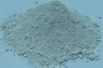**Cu 2+**

Colour of solid

**Blue**

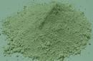 **green**

**green**

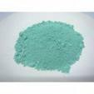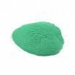

**green**

**Cu 2+**

**Fe 2+**

**Cu 2+**

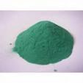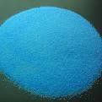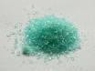

**Fe 2+**

**Cu 2+**

**Fe 2+**

**Blue**

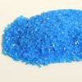**Cu 2+**

**Blue**

**Cu 2+**

**green Cu 2+**

**White**

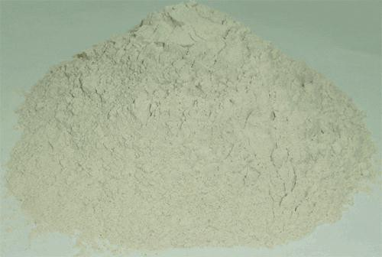 **Yellow**

**white**

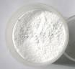

**Zn 2+**

**Pb2+**

**Al3+**

**yellow**

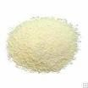**Fe 3+**

**Fe 2+**

**Cu 2+**

**Green Fe 2+**

**Powdery, or crystalline solid**

**Fe 3+**

1

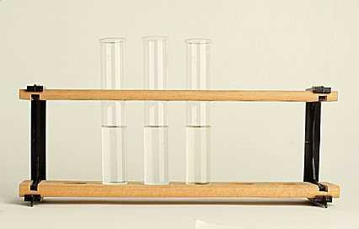

**Add water to the solid**

**Solid dissolves to form colourless solution**

**NH4**

**+**

**Pb 2+**

**Al**

**3+**

**Zn 2+**

**Colourlesssolution**

**2**

4

**Add water to the solid**

**Solid dissolves to form**

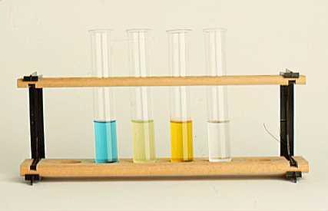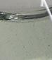

**NH4**

**+**

**Cu 2+**

**Fe 2+ Fe 3+**

**Pb 2+**

**Al 3+**

**Zn 2+**

**Green**

**solution**

**Colourless solution**

**Yellow**

**solution**

**Blue solution**

3

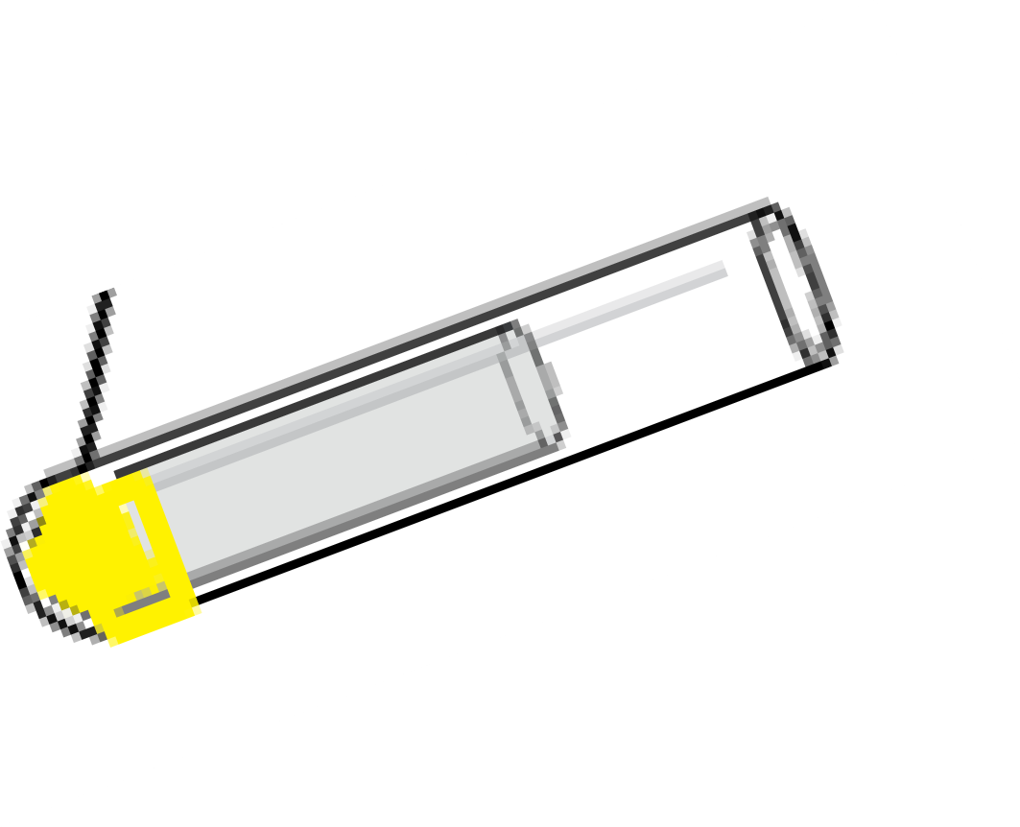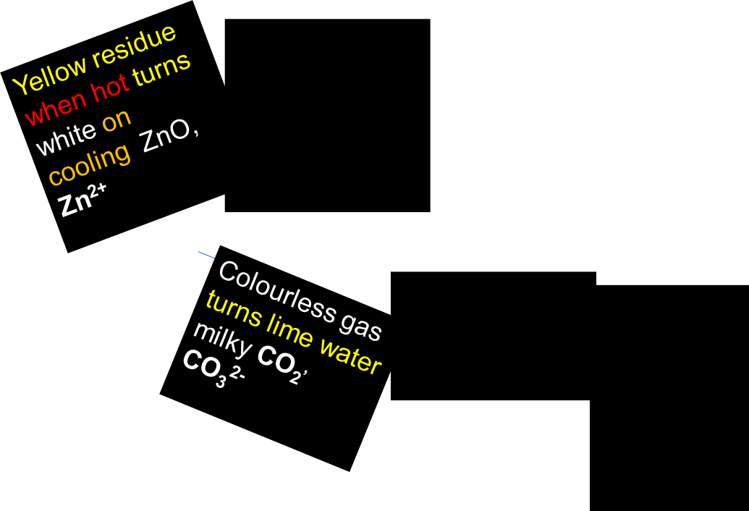

Brown residue when hot turns yellow on cooling PbO, **Pb2+**

**Black residue**

**CuO, Cu2+**

**Brown residue FeO, Fe2+ CuO, Cu2+**

Colourless gas turns acidifed potassium dichromate solution green **SO2,**

**SO42-**

Colourless gas turns red litmus blue and forms dense white fumes with concentrated hydrochloric acid NH**3,**

**NH4+**

**Action of heat on a solid**

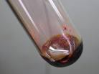**Heat solid gently and then strongly**

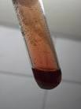

**Brown gas that turns wet blue litmus red**

**Nitrogen dioxide gas therefore NO3**

**-**

5

**Add acid to solid or residue**

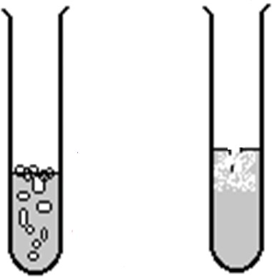**Bubbles of a colourless gas that turns lime water milky**

**Carbondioxide gas therefore CO 2-**

**3**

6

# Add aqueous ammonia drop wise until excess

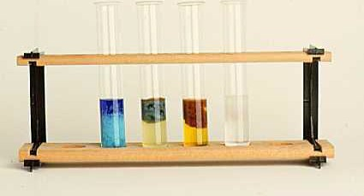

**Reddish brown ppt insoluble Fe 3+**

**Green ppt insoluble turns brown on standing Fe 2+**

**Blue ppt soluble to form deep blue solution**

**Cu 2+**

**confirmed**

**White ppt soluble Zn2+**

**White ppt insoluble Pb2+, Al3+**

7

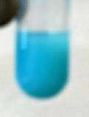

**Blue ppt insoluble**

**Add sodium hydroxide solution drop wise until**

**excess**

**Cu 2+**

8

# Add aqueous ammonia drop wise until excess

**Pale blue ppt soluble in excess to form a deep blue solution**

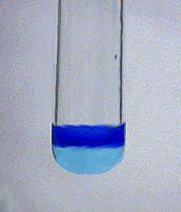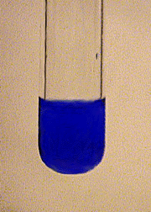

**Cu2+ confirmed**

9

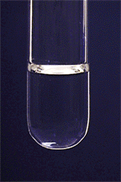

**Colourless solution**

**Pb2+ , Zn2+ ,Al3+ probably present**

10

**White ppt**

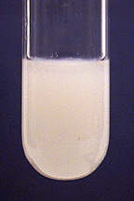

11

## Add sodium hydroxide solution drop wise until excess

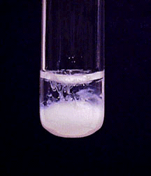

**Pb2+ , Zn2+, Al3+ probably present**

**White ppt soluble to form colourless solution**

12

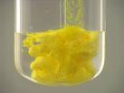

**Yellow ppt insoluble**

**Pb 2+**

**Add potassium Iodide solution drop wise until excess**

13

**Cu 2+**

**gives slightly similar results but check if you**

**have observed a pale blue ppt with sodium**

**hydroxide solution**

**Barium nitrate solution followed by dilute nitric acid solution**

**White ppt**

14



**White ppt**

**SO42-**

**Silver nitrate solution followed by dilute nitric acid solution**

15



**White ppt**

**Cl -**

**confirmed**

# Lead nitrate solution



**White ppt**

**CO3 , Cl , SO4**

**2-**

**-**

**2-**

**confirmed**

**Cl- on warming the white ppt dissolves but reappears on cooling**

**CO32- on adding acid white ppt dissolves with effervescence/bubbles of a gas which turns lime wate**1**r**6 **milky**

**Lead nitrate solution followed by dilute nitric acid solution**

**White ppt**



**SO42-**

**Cl-**

17

**Filtration**

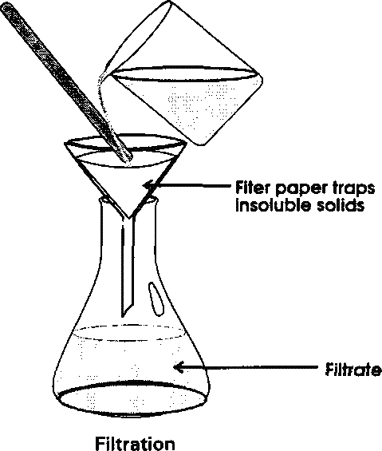

**White residue**

**Colourless filtrate**

18

### Sulphur and its compounds

* 1. **Sulphur**
* Non metal
* Yellow solid
* Atomic number 16 and atomic mass 32
* Has 3 allotropes
* Insoluble in water but soluble in organic solvents
* Sulphur occurs as hydrogen sulphide in petroleum gases

### Extraction of sulphur by the Frasch’s process

A hole about 30 cm in diameter is dug into the soil and the hole is lined with an iron pipe. A sulphur pump is sunk into the iron pipe. It consists of three concentric tubes.

In the outermost tube, superheated water at 170oC and at a pressure of 10 atmospheres, to keep it in a liquid form, is sent down to the beds or deposits of sulphur. The sulphur melts and flows into the reservoir at the base of the pump.

Hot compressed air under a pressure of about 15 atmospheres is sent down through the innermost tube. It pushes the molten sulphur and water up through the middle tube and it‘s collected in containers. Water is evaporated off and almost 99% pure sulphur is obtained.

### Extraction of sulphur

* 1. **Extraction of sulphur from natural gas**

Natural gases obtained during the refining of petroleum contain hydrogen sulphide which is absorbed by special solvents. The gas is removed from the solvent and a small portion of the gas is burnt in air to form sulphur dioxide.

2H2S (g) + 3O2 (g) → 2H2O (l) + 2SO2 (g)

The remaining portion of the gas is left to react with the sulphur dioxide to form sulphur and water. The water is evaporated off.

2H2S (g) + SO2 (g) → 3S (s) + 2H2 O (l)

### Uses of sulphur

1. Used in the manufacture of sulphuric acid
2. Used to dust vines to prevent the growth of fungi
3. Used in making calcium hydrogen sulphite (Ca(HSO3)2), which is used as a bleacher of wood pulp in manufacture of paper
4. For the vulcanisation of rubber, a process which converts the soft pliable rubber into the hard, tough substance of which motor tyres and similar products are made
5. Used in the manufacture of dyes, fireworks, sulphur compounds such as carbon disulphide (CS2)
6. Used in making ointments for treatment of skin diseases such as ringworm

### Allotropes of sulphur

Sulphur has five allotropes: monoclinic sulphur, rhombic sulphur, amorphous sulphur, plastic sulphur, and colloidal sulphur

They are basically two allotropes

### Rhombic sulphur

Rhombic sulphur is also referred to as octahedral sulphur or α-sulphur. It has an octahedral shape hence its name.

It has a melting point of 113 oC and has a density of 2.06g/cm3 It is stable and exists below 96 oC

### Preparation of rhombic or octahedral sulphur (alpha sulphur)

Dissolve some powdered sulphur in carbon disulphide in a boiling tube. Place it in a beaker after extinguishing all flames in the area around. Filter off the solution into another dry beaker and place a clean filter paper on top of the beaker. Pierce some small holes in the filter paper and place the set up near a window for a day to allow the carbon disulphide to evaporate. Large rhombic crystals of sulphur will form.

### Monoclinic sulphur

Monoclinic sulphur is also referred to as prismatic sulphur or β-sulphur. Its crystals are needle shaped.

It has a melting point of 119 oC and has a density of 1.98 g/cm3. It exists only above 96 oC

### Preparation of monoclinic sulphur (Beta sulphur)

Place some powdered sulphur in an evaporating dish. Carefully heat it until it melts. Stir and gradually add more sulphur until the crucible is full of molten sulphur. Stop heating and allow it to cool. A crust will form on the surface of sulphur. Carefully pierce through the crust and immediately pour off the liquid sulphur inside. Cut away the crust by cutting around the edge of the crucible with a knife. Small needle shaped crystals will be seen inside the evaporating dish.

### Transition temperature

This is the temperature at which a change from one form of sulphur to another form takes place. It is 96oC. Rhombic sulphur is stable below 96oC. Above this temperature, it slowly changes to the monoclinic form. Monoclinic stable is stable above 96oC and therefore below this temperature it slowly changes to the rhombic form.

### Differences between rhombic sulphur and monoclinic sulphur

Rhombic sulphur consists of relatively large yellow, translucent, octahedral crystals with a melting point of 114oC while monoclinic sulphur consists of needle shaped, pale yellow transparent crystals with a melting point of 119oC

Rhombic sulphur has a density of 2.06g/cm3while monoclinic sulphur has a density of 1.98 g/cm3.

Crystals of rhombic sulphur are stable below 96oC while monoclinic sulphur is stable above 96

oC.

### Amorphous sulphur

Amorphous sulphur is formed by oxidation of hydrogen sulphide by air. When a saturated solution of hydrogen sulphide is left exposed to air for two days, an almost white powder of amorphous sulphur is formed.

2H2S(aq) + O2(g) → 2S(s) + 2H2O(l)

### Plastic sulphur

When boiling sulphur is quickly cooled by pouring it into cold water, yellow/brown elastic solid called plastic sulphur is formed.

### Colloidal sulphur

When dilute hydrochloric acid is added to dilute sodium thiosulphate, a yellow suspension of colloidal sulphur is formed

Na2S2O3(aq) +2HCl(aq) → 2NaCl(aq) +H2O(l) + S(s)+ SO2(g)

### Properties of sulphur

* + 1. **Physical properties**

It is yellow non-metal. It is insoluble in water. It is a poor conductor of heat and electricity.

### Chemical properties of sulphur

* + - 1. **Action of heat on sulphur (in absence of air)**

When a yellow solid of sulphur is heated, it melts at about 113oC to aclear amber liquid which flows easily like water. Sulphur contains small rings of atoms, S8; the liquid flows with ease because the rings have been separated. On further heating at about 160oC, the sulphur becomes brown and viscous. It flows slowly because the small rings of 8 atoms break and longer chains are formed. These chains twist together and do not flow readily over one another.

On further heating, the liquid becomes very dark, reddish brown in colour and less viscous again. The chains break and become shorter which can flow more readily. Sulphur boils at 444oC and forms a brown vapour. On cold surfaces, the vapour condenses directly into a yellow sublimate.

### Combustion of sulphur (in a plentiful supply of air)

When burning sulphur is plunged into a gas-jar of air, the sulphur burns with a blue flame leaving a misty gas

The mist is due to traces of sulphur trioxide formed simultaneously with sulphur dioxide. S(s) + O2 (g) → SO2 (g)

### Reaction with metals and non-metals

The mixture of iron filings and sulphur when heated glows giving a black solid of iron (II) sulphide

Fe(s) + S(s) → FeS(s)

A hot copper foil glows in sulphur vapour forming a black solid, copper (I) sulphide. 2Cu(s) + S(s) → Cu2S(s)

Carbon combines directly with sulphur to form a liquid, carbon disulphide. Very high temperatures are required for this reaction to occur.

C(s) + 2S(s) → CS2(l)

### Action of acids on sulphur

Dilute acids do not act upon sulphur. It is oxidized by hot concentrated sulphuric acid with formation of sulphur dioxide

S(s) + 2H2SO4(s) → 3SO2(g) + 2H2O(l)

Sulphur is oxidized by hot concentrated nitric acid to sulphuric acid. Bromine is added to speed up the rate of reaction.

S(s) + 6HNO3(s) → H2SO4(aq) + 6NO2(g) + 2H2O(l)

* 1. **Oxides of sulphur**
     1. **Sulphur dioxide**
        1. **Laboratory preparation of sulphur dioxide**

**Preparation of sulphur dioxide**

Hot concentrated sulphuric acid reacts with copper turnings giving off sulphur dioxide. The gas is dried by passing it through a bottle containing concentrated sulphuric acid and collected in a gas-jar by downward delivery since it is denser than air

Cu(s) + 2H2SO4(l) → CuSO4 (aq) + 2H2O(l) + SO2(g)

Instead of using copper turnings, it is also possible to prepare the gas by using sodium sulphite and dilute sulphuric acid

Na2SO3 (aq) + H2SO4 (aq) → Na2SO4 (aq) + H2O (l) + SO2 (g)

Sulphur dioxide is very soluble in water and therefore heating reduces its solubility in water formed in the flask. Since sulphur dioxide is very soluble in water, it cannot be collected over water.

### Properties of sulphur dioxide

1. It is a colourless gas with an irritating smell
2. It is more dense than air
3. It turns damp blue litmus paper red because it is an acidic gas H2O (l) + SO2 (g) → H2SO3 (aq)
4. It is very soluble in water and its solubility in water can be shown by the fountain experiment
5. It is a powerful reducing agent
   1. It reduces iron (III) ions in the brown iron (III) sulphate solution to iron (II) ions in the green iron (II) sulphate solution. Sulphur dioxide is oxidised to sulphuric acid

2Fe3+(aq) + SO2(g) + H2O(l) → 2Fe2+(aq) + 4H+(aq) + SO42-(aq)

* 1. Sulphur dioxide reduces concentrated nitric acid to nitrogen dioxide, the sulphur dioxide being oxidized to sulphuric acid. Brown fumes are observed

SO2 (g) + 2HNO3 (l) → H2SO4 (l) + 2NO2 (g)

* 1. Sulphur dioxide reduces yellow acidified potassium dichromate solution to green chromium (III) sulphatesolution and itself oxidized to sulphuric acid. This is a characteristic test for sulphur dioxide

3SO2 (g) + Cr2O72- (aq) + 2H+ (aq) → 3SO42- (aq)+ 2Cr3+ (aq) + H2O (l)

* 1. It reduces acidified potassium permanganate (VII) solution to a colourless solution

1. Sulphur dioxide acts as an oxidizing agent when it reacts with a more powerful reducing agent than itself.
   1. When sulphur dioxide is dissolved in water, it forms sulphurous acid which is a bleaching agent. Sulphurous acid takes up oxygen from the dye to form sulphuric acid. The removal of oxygen from a dye converts the dye to a colourless compound. This is essentially a different reaction from that of other bleaching agents, which oxidize the dye to a colourless compound.

3SO2 (g) + 2H2O (l) + Dye → H2SO4(aq) + (Dye + 2H (colourless)

* 1. Sulphur dioxide reacts with hydrogen sulphide to form a yellow deposit of sulphur. Sulphur dioxide oxidizes hydrogen sulphide to water by supplying oxygen and itself reduced to sulphur

2H2S (g) + SO2 (g) → 2H2O (l) + 3S (s)

* 1. Burning magnesium continues to burn in sulphur dioxide for sometime forming a white powder of magnesium oxide and sulphur

2Mg (s) + SO2 (g) → 2MgO (s) + S (s)

### Uses of sulphur dioxide

1. It is used for the manufacture of sulphuric acid in the contact process
2. It is used as a bleaching agent in paper industry and also to bleach wool, silk and sponges
3. It is used as a preservative of foods e.g. orange juice and fruits where it reacts with oxygen and prevents oxidation
4. It is used for fumigation of houses since it is poisonous and kills microorganisms

### Sulphur trioxide

* + - 1. **Preparation of sulphur trioxide**

It is prepared by passing a mixture of dry sulphur dioxide and dry air over heated vanadium (V) oxide (or platinised asbestos) at a temperature of 450 – 500 o C under a pressure of 200 atmospheres. Sulphur trioxide is seen as dense white fumes which are solidified in a freezing mixture of ice and sodium chloride.

2 SO2 (g) + O2 (g) ⇌ 2 SO3 (g)

### Sulphuric acid

Sulphuric acid is a dibasic mineral acid.

### Industrial manufacture of sulphuric acid by the contact process

The raw materials are sulphur dioxide, oxygen and water.

### Stage 1: preparation of sulphur dioxide

Sulphur is burnt in air to produce sulphur dioxide S(s) + O2 (g) → SO2 (g)

Sulphur dioxide may contain some impurities such as arsenic compounds which may ‗poison the catalyst‘, that is, make the catalyst ineffective. Therefore sulphur dioxide is cleaned to remove the impurities then is dried.

### Stage II: Conversion of sulphur dioxide to sulphur trioxide

Then sulphur dioxide is mixed with air and passed along heated pipes containing pellets of vanadium pentoxide (V2O5) (catalyst) at a temperature of 450 – 500 oC under a pressure of 200 atmospheres. Sulphur trioxide is formed.

2 SO2 (g) + O2 (g) ⇌ 2 SO3 (g)

Sulphur trioxide formed is dissolved in concentrated sulphuric acid to produce a fuming liquid called **oleum**.

SO3 (g) + H2SO4 (l) → H2S2O7 (l)

### Stage III: Conversion of sulphur trioxide to acid

The oleum is diluted with a known amount of water to give concentrated sulphuric acid.

H2S2O7 (l) + H2O (l) → 2H2SO4 (aq)

**Note:** Sulphur trioxide is not dissolved in water directly because the reaction is too exothermic and the heat produced from the reaction vapourises the acid forming only tiny droplets of the acid leading to a spray of sulphuric acid which would affect the workers in the factory.

**The whole process is summarized in the figure below**

* + 1. **Properties of sulphuric acid**
       1. **Physical properties**

It is a colourless and ordourless oily liquid

Has a high affinity for water (hygroscopic) and that is why it is used as a drying agent It has a density of 1.86g/cc and boils at 338oC

It does not show any acidic properties unless water is present.

**Note: Sulphuric acid has a high affinity for water. Never add water to the concentrated acid because it can explode.** It is therefore advisable to add the acid to water rather than water to acid.

### Chemical properties

1. **As an acid**

Sulphuric acid behaves as a strong acid in dilute concentration

* 1. Metals above hydrogen in the reactivity series displace hydrogen from sulphuric acid Zn (s) + H2SO4 (aq) → ZnSO4 (aq) + H2 (g)
  2. Reacts with bases to form salt and water only

ZnO (s) + H2SO4 (aq) → ZnSO4 (aq) + H2O (l)

* 1. It neutralises alkalis like sodium hydroxide solution to form a salt and water only 2NaOH(aq) + H2SO4 (aq) → Na2SO4 (aq) + 2H2O (l)
  2. It reacts with carbonates and hydrogen carbonates liberating carbon dioxide Na2CO3 (s) + H2SO4 (aq) → Na2SO4 (aq) + H2O (l)+ CO2(g)

2NaHCO3 (s) + H2SO4 (aq) → Na2SO4 (aq) + H2O (l) + 2CO2(g)

### As an oxidizing agent

When **concentrated** and **hot**, it acts as an oxidizing agent to both metals and non metals and it is reduced to sulphur dioxide. It accepts electrons or supplies oxygen in its reaction.

* 1. It oxidizes copper to copper (II) sulphate. Reaction with zinc and iron produces similar results.

Cu(s) + 2H2SO4(l) → CuSO4 (aq) + 2H2O(l) + SO2(g)

* 1. It oxidizes hydrogen sulphide to sulphur forming a yellow deposit.

H2S (g) + H2SO4 (l) → S (s) + 2H2O(l) + SO2(g)

* 1. It oxidizes sulphur and carbon to their oxides.

|  |  |  |  |  |  |  |  |
| --- | --- | --- | --- | --- | --- | --- | --- |
| 3S(s) | + | 2H2SO4(l) |  | → | 2H2O(l) | + | 3SO2(g) |
| C(s) | + | 2H2SO4(l) | → | CO2 (g) + | 2SO2(g) | + | 2H2O(l) |

### As a dehydrating agent.

Sulphuric acid has a very high affinity for water and can remove it from substances including air, that is, it is hygroscopic. It can be used as a drying agent for most gases.

* 1. When concentrated sulphuric acid is poured onto sugar (sucrose) in a beaker the sugar turns yellow then brown and finally a black spongy mass of charcoal rises filling the beaker. Steam is given off and the whole mass becomes very hot. The acid takes out the elements of water from sugar leaving a black mass of carbon.

C12H22O11(s) → 12C (s) + 11H2O(l)

Similar reactions take place when other carbohydrates are used C6H12O6(s) → 6C (s) + 6H2O(l)

* 1. When concentrated sulphuric acid is added to blue crystals of copper (II) sulphate (hydrated) and warmed, they change to a white solid of anhydrous copper (II) sulphate as water of crystallisation is removed by concentrated sulphuric acid.

CuSO4 .5H2O(s) → CuSO4 (s) + 5H2O(l)

* 1. Other substances which are dehydrated by concentrated sulphuric acid include ethanol, methanoic acid and oxalic aid

C2H5OH(l)→ C2H4 (g) + H2O(l)

Ethanol

HCOOH(l) → CO(g) + H2O(l)

Methanoic acid

H2C2O4 (s)→ CO (g) + CO 2 (g) + H2O(l)

Oxalic acid

### Action of concentrated sulphuric on nitrates and chlorides

Concentrated sulphuric acid displaces hydrochloric acid from metallic chlorides and nitric acid from nitrates e.g. it reacts with sodium chloride when heated forming white fumes of hydrogen chloride gas which dissolves in water forming hydrochloric acid.

2NaCl (s) + H2SO4 (aq) → Na2SO4 (aq) + 2HCl (g) (With heating) NaCl (s) + H2SO4 (aq) → NaHSO4 (aq) + HCl (g) (Without heating) It also reacts with potassium nitrate to form nitric acid

KNO3 (s) + H2SO4 (aq) → KHSO4 (aq) + HNO3(aq)

### Uses of sulphuric acid

1. It is used in the manufacture of detergents
2. It is used in car batteries and accumulators as an electrolyte
3. It is used in manufacture of fertilizers such as ammonium sulphate NH3(g)+ H2SO4 (aq) → (NH4)2SO4 (s)
4. Used in extraction of metals and also cleaning them prior to plating
5. Used in manufacture of paints, dyes and explosives

### Sulphates

**Action of heat on sulphates (SO42-)**

Most sulphates are hydrated and when heated, they lose their water of crystallisation to form anhydrous salts which are resistant to further heating and therefore do not decompose. Therefore hydrated sulphates do not decompose on heating e.g.

MgSO4.7 H2O(s) → MgSO4(s) + 7 H2O(l) Na2SO4.10H2O(s) → Na2SO4(s) + 10H2O(l)

When a blue solid of hydrated copper (II) sulphate is heated, water vapour is given off as water of crystallisation is lost, giving a white solid (residue). On further heating, it decomposes to form white fumes of sulphur trioxide and a black residue of copper (II) oxide.

CuSO4.5 H2O(s) → CuSO4(s) + 5H2O(l)

Blue White

CuSO4(s)→CuO(s) + SO3 (g)

Overall equation:

CuSO4.5H2O → CuO(s) + SO3 (g) + 5H2O(l)

On heating hydrated iron (II) sulphate (green), it loses its water of crystallisation FeSO4.7 H2O(s) → FeSO4(s) + 7 H2O(l)

On further heating, the anhydrous iron (II) sulphate formed decomposes to give white fumes of sulphur trioxide together with sulphur dioxide and leaves a brown residue of iron (III) oxide FeSO4(s) → Fe2O3(s) + SO2(g)+ SO3(g)

When ammonium sulphate is heated it decomposes to give ammonia, sulphur trioxide and water (NH4)2SO4(s) → NH3 (g) + SO3(g) +H2O(l)

### Testing for soluble sulphate(SO42-)

1. **Using dilute hydrochloric acid and barium chloride solution.** To the solution add dilute hydrochloric acid followed by barium chloride solution. A white precipitate of barium sulphate is formed

BaCl2(aq) + Na2SO4(aq) →BaSO4(s) + 2NaCl(aq)

### Using dilute nitric acid and barium nitrate solution.

To the solution adddilute nitric acid and barium nitrate solution. A white precipitate is formed. Ba(NO3)2(aq) + Na2SO4(aq) →BaSO4(s) + 2NaNO3 (aq)

### Ionic equation

Ba2+(aq) + SO42-(aq) → BaSO4(s)

**Note:**Carbonate ions (CO32-) and sulphite ions (SO32-) are precipitated as barium carbonate and barium sulphite respectively, if carbonate and sulphite ions are present in solution.

|  |  |  |
| --- | --- | --- |
| Ba2+(aq) | + | CO32-(aq) →BaCO3(s) |
| Ba2+(aq) | + | SO32-(aq) → BaSO3(s) |

The purpose of adding dilute nitric acid or hydrochloric acid is to remove the carbonate ion and sulphite ions if they are present in solution.

|  |  |  |  |  |  |
| --- | --- | --- | --- | --- | --- |
| 2H+(aq) | + | CO32-(aq) | → | H2O(l) + | CO2(g) |
| 2H+(aq) | + | SO32-(aq) | → | H2O(l) + | SO2(g) |

The sulphite ions (SO42-) remain in solution because they do not react with dilute hydrochloric acid acid or nitric acid.

### Using lead (II) nitrate solution

Also lead (II) nitrate solution forms a white precipitate of lead (II) sulphate with a sulphate. Pb2+(aq) + SO42-(aq) →PbSO4(s)

### Hydrogen sulphide

* + 1. **Laboratory preparation of hydrogen sulphide**

Add concentrated hydrochloric acid to iron (II) sulphide. Effervescence occurs and the hydrogen sulphide formed is collected over warm water because it is quite soluble in cold water

FeS(s) + 2HCl(aq) → FeCl2(aq) + H2S(g) Dilute sulphuric acid may be used

FeS(s) + H2SO4(aq)→FeSO4(aq) + H2S(g)

To prepare hydrogen sulphide from sulphur, iron (II) sulphide is first prepared by heating the mixture of iron and sulphur.

Fe(s) + S(s) →FeS(s)

Hydrogen sulphide can be dried by using **anhydrous calcium chloride**. Concentrated sulphuric acid is not used to dry the gas because it reacts with hydrogen sulphide forming a yellow precipitate of sulphur.

H2SO4(aq) + 3H2S(g)→4H2O(l) + 4S(s)

### Testing for hydrogen sulphide

A strip of filter paper is soaked in lead (II) ethanoate (lead (II) acetate) solution and dropped into a gas jar of hydrogen sulphide. The paper turns black. This colour change is caused by precipitation of black lead (II) sulphide.

(CH3COO)2Pb(aq) + H2S(g) → PbS(s)+2CH3COOH(aq)

Black

### Properties of hydrogen sulphide

* + - 1. **Physical properties**

1. The gas is colourless
2. It has a repulsive smell similar like rotten eggs.
3. It is also fairly soluble in water forming a weak acidic solution
4. It is denser than air
5. The gas is extremely poisonous

### Chemical properties

1. Hydrogen sulphide is a powerful reducing agent

It reduces reducing agents and itself oxidized to sulphur which appears as a pale yellow precipitate

* 1. Hydrogen sulphide reduces iron (III) chloride to iron (II) chloride. When hydrogen sulphide is passed through iron (III) chloride solution (yellow solution) a yellow precipitate of sulphur appears. On filtering, a green solution of iron (II) chloride appears as the filtrate

H2S(g) + 2FeCl3(aq) → 2FeCl2(aq) + 2HCl(aq) + S(s)

* 1. Hydrogen sulphide reacts with concentrated nitric acid to form brown fumes of nitrogen dioxide and a yellow deposit of sulphur. Also the mixture becomes hot. The hydrogen sulphide reduces the nitric acid to nitrogen dioxide.

2HNO3(l) + H2S(g) →2H2O(l) + 2NO2(g) + S(s)

1. Combustion of hydrogen sulphide
   1. *With plentiful supply of air*

Hydrogen sulphide burns with a blue flame forming water and sulphur dioxide.

2H2S(g) + 3O2(g) → 2SO2(g)+ 2H2O(l)

* 1. *With a limited supply of air*

When hydrogen sulphide is burnt in a limited supply of air, a yellow deposit of sulphur is formed. The oxygen supply cannot oxidize the gas completely and therefore free sulphur is deposited.

2H2S(g) + O2(g) → 2H2O(l) + 2S(s)

1. Reacting with salts of metals

Hydrogen sulphide can precipitate insoluble sulphides of copper and lead only by reacting with solutions of their salts. A dark brown precipitate of copper (II) sulphide and a black precipitate of lead (II) sulphide are formed

|  |  |  |  |  |
| --- | --- | --- | --- | --- |
| CuSO4(aq) | + | H2S(g) → | CuS(s) + | H2SO4(aq) |
| Pb(NO3)2(aq) | + | H2S(g) → | PbS(s) + | 2HNO3(aq) |
| Pb(NO3)2(aq) | + | H2S(g) → | PbS(s) + | 2HNO3(aq) |

### 23. Nitrogen and its compounds

* 1. **Nitrogen Occurrence of nitrogen**

Atomic number 7, atomic mass 14. It is one of the main elements needed for plant growth.

Nitrogen is the most abundant gas in the atmosphere, occupying about 78 per cent by volume. It occurs in nature in a combined state as in minerals such as sodium nitrate. It is found in living things in form of proteins.

### Laboratory preparation of nitrogen from air

The methods include:

### Thermal decomposition of ammonium nitrite

Ammonium nitrate when heated decomposes to give nitrogen. NH4NO2(s) → N2 (g) + 2H2O(l)

Ammonium nitrite is prepared from the reaction between sodium nitrite and ammonium chloride NH4Cl(s) + NaNO2(s) → NH4NO2(s) +NaCl(s)

### Reduction of copper (II) oxide using ammonia

3CuO(s) + 2NH3(g) → 3Cu(s) + N2(g) + 3H2O(l)

* + 1. Direct combination of chlorine and ammonia gives nitrogen and ammonium chloride

Cl2(g) + 8NH3(g)→ N2(g) + 6NH4Cl(s)

### Industrial preparation of nitrogen from air

The raw material is air. It is done by systematically removing carbondioxide and oxygen leaving nitrogen.

It is done in stages. These include:

* + 1. The air is pumped into the set up
    2. It is then passed through sodium hydroxide solution which removes carbondioxide

Sodium hydroxide absorbs and removes carbondioxide from the air mixture and forms sodium carbonate

2NaOH (aq) + CO2 (g) → Na2CO3 (aq) + H2O (l)

* + 1. It is then passed over heated copper in the furnace to remove oxygen

It removes the oxygen by reacting it with the hot copper leading to formation of copper oxide 2Cu (s) + O2 (g) → 2CuO (s)

* + 1. The remaining air is mainly composed of nitrogen which is collected over watersince it is slightly less dense than air.

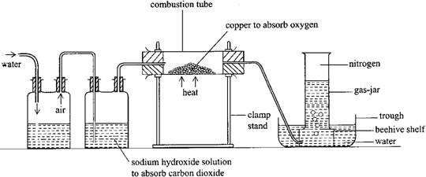

### Note:

* It can be dried by passing the gas through a U-tube containing glass beads wetted with concentrated sulphuric acid to dry it and then collected in a syringe.
* Nitrogen formed by this method is not pure. It contains several impurities, mainly the noble gases as well as unreacted oxygen.
* Commercially nitrogen is manufactured through fractional distillation of liquid air.

### Test for nitrogen

Nitrogen is almost inactive (inert) at ordinary temperatures. There is almost no positive test for it. This is because nitrogen is composed of diatomic molecules, the atoms of which are held together very strongly by three (triple) covalent bonds. Only when sufficient energy is supplied to break these bonds does nitrogen react. Because of being inert, it has no simple positive test. It can only be identified by its negative response to the following tests for other common gases.

1. Nitrogen extinguishes a burning splint and the gas does not burn. This distinguishes it from other gases that support burning like oxygen and dinitrogen oxide or any combustible gas such as hydrogen, carbon monoxide, hydrogen sulphide.
2. Nitrogen has no smell. This distinguishes it from gases such as sulphur dioxide ammonia, hydrogen chloride.
3. Nitrogen has no action on lime-water. This distinguishes it from carbon dioxide.

### Properties of nitrogen

**23.5.1.1. Physical properties**

1. Nitrogen is a colourless and tasteless gas.
2. It is slightly soluble in water under ordinary conditions.
3. It is slightly less dense than air.
4. Nitrogen and hydrogen combine at high temperatures and pressure in the presence of a catalyst to form ammonia.

N2(g) + 3H2(g) → 2NH3(g)

1. Nitrogen reacts only with the reactive metals (magnesium and calcium). When these metals are heated strongly, they burn in nitrogen forming the corresponding nitride, which is white in colour.

3Mg(s) + N2(g) → Mg3N2(s)

3Ca(s) + N2(g) → Ca3N2(s)

The heat produced by the burning magnesium ribbon or calcium is strong enough to break the triple bond in the nitrogen molecule forming free nitrogen atoms. The free atoms are very reactive and combine with these metals to form a nitride. If a burning wooden splint is placed in a jar of nitrogen, it gets extinguished. This is because the heat it produces is not sufficient to break the tripple bond between the nitrogen atoms

The nitrides dissolve in water to form the corresponding hydroxide and ammonia. Mg3N2(s) + 6H2O(1) → 3Mg(OH)2(aq) + 2NH3(g)

Ca3N2(s) + 6H2O(1) → 3Ca(OH)2(aq) + 2NH3(g)

1. In thunderstorms, a small amount of nitrogen reacts with the oxygen in the air to form nitrogen monoxide and nitrogen dioxide.

N2(g) + O2(g) → 2NO(g) 2NO(g) + O2(g) → 2NO2(g)

The electrical discharge in a thunderstorm provides sufficient energy for this reaction to occur.

### Uses of nitrogen

1. Used in the Haber process for the manufacture of ammonia.

N2(g) + 3H2(g) → 2NH3(g)

1. It is used in food packaging, for example in crisp packets, to keep the food fresh and in this case to prevent the crisps being compressed.
2. Liquid nitrogen is used as a refrigerant.
3. Because of its unreactive nature, nitrogen is used as an inert atmosphere for some processes and chemical reactions. For example, empty oil tankers are filled with nitrogen to prevent fires.

### Nitrogen monoxide (nitrogen(II) oxide)

* + 1. **Laboratory preparation of nitrogen monoxide**

The experiment is set up as shown in figure 2.2. Copper is covered with water and concentrated nitric acid added, about equal in volume to the water. Vigorous effervescence occurs and brown fumes dissolve in water over which nitrogen monoxide (main product) is collected as a colourless gas. A green solution of copper(II) nitrate is left in the flask.

3Cu(s) + 8HNO3(aq) → 3Cu(NO3)(aq) + 4H2O(l) + 2NO(g)

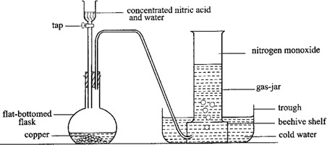

Nitrogen dioxide (the brown fumes) is produced partly by the action of the acid upon the copper and partly by the oxidation of the main product (nitrogen monoxide) by the oxygen of the air in the flask.

Cu(s) + 4HNO3(1) → Cu(NO3)2(aq) + 2NO2(g) + 2H2O(l) 2NO(g) + O2(g) → 2NO2(g)

### Tests for nitrogen monoxide

1. **Exposure to air**

Remove the cover from a gas-jar of nitrogen monoxide. Brown fumes are at once produced due to oxidation of the gas by oxygen of the air to nitrogen dioxide.

2NO(g) + O2(g) → 2NO2(g)

### Action on iron(II) sulphate solution

When a cold solution of iron(II) sulphate is poured in a gas-jar containing nitrogen monoxide, a dark brown or black colouration is observed due to formation of nitros- iron(II) sulphate.

FeSO4(aq) + NO(g) → FeSO4.NO(aq)

### Properties of nitrogen monoxide

1. It is colourless and almost insoluble in water
2. It is slightly denser than air.
3. It is neutral to litmus.
4. It supports the combustion of those burning materials whose flames are hot enough to decompose it and so liberate free oxygen with which the material may combine. The gas extinguishes a splint, candle, sulphur and glowing charcoal, but the gas supports the combustion of strongly burning phosphorus or magnesium.

P4(s) + 10NO(g) → 2P2O5(s) + 5N2(g) 2Mg(s) + 2NO(g) → 2MgO(s) + N2(g)

### Nitrogen dioxide

* + 1. **Laboratory preparation of nitrogen dioxide**

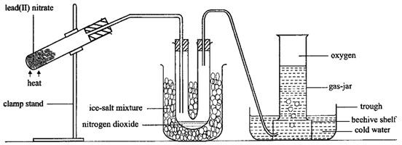

The experiment is set up as shown in figure 2.3. When lead(II) nitrate is heated, it makes a cracking sound giving off a brown gas (nitrogen dioxide) and oxygen. Nitrogen dioxide is

liquefied in the freezing mixture and collects in the tube as green liquid. The oxygen passes on as gas and escapes or it is collected over water.

2Pb(NO3)2(s) → 2PbO(s) + 4NO2(g) + O2(g)

Lead(II) nitrate is the most suitable to use because it crystallizes without water of crystallization, which is found in crystals of most nitrates and which would interfere with the preparation.

Nitrogen dioxide may also be prepared by the action of concentrated nitric acid on copper turnings. The gas is collected by downward delivery in a gas-jar.

Cu(s) + 4HNO3(1) → Cu(NO3)2(aq) + 2NO2(g) + 2H2O(1)

### Properties of nitrogen dioxide

1. It is a brown gas.
2. It has a pungent, irritating smell and it is a poisonous gas.
3. It is soluble in water forming a pale blue solution containing nitric acid and nitrous acid. Nitrogen dioxide is a mixed acid anhydride.

2NO2(g) + H2O(1) → HNO3(aq) + HNO2(aq)

1. Nitrogen dioxide neutralizes alkalis forming a mixture of their corresponding nitrates and nitrites. In this case nitrogen dioxide acts as an acid.

2NaOH(aq) + 2NO2(g) → NaNO3(aq) + NaNO2(aq) + H2O(1)

2KOH(aq) + 2NO2(g) → KNO3(aq) + KNO2(aq) + H2O(1)

1. Nitrogen dioxide does not burn, but supports combustion of substances whose flames are hot enough to decompose it and so liberate free oxygen with which the substance may combine. It supports the combustion of carbon, sulphur, phosphorus and magnesium. 2C(s) + 2NO2(g) → 2CO2(g) + N2(g)

2S(s) + 2NO2(g) → 2SO2(g) + N2(g)

2P4(s) 10NO2(g) → 2P4O10(s) + 5N2(g)

4Mg(s) + 2NO2(g) → 4MgO(s) + N2(g)

1. Nitrogen dioxide oxidizes red hot metals and itself reduced to nitrogen. 4Cu(s) + 2NO2(g) → 4CuO(s) + N2(g)

4Zn(s) + 2NO2(g) → 4ZnO(s) + N2(g)

1. When nitrogen dioxide is heated at temperatures above 150oC, it dissociates to give nitrogen monoxide and oxygen. The brown colour of nitrogen dioxide fades to give a colourless gas which is the mixture of nitrogen monoxide and oxygen.

2NO2(g) → 2NO(g) + O2(g)

### Ammonia

* + 1. **Laboratory preparation of ammonia**

The apparatus is set up as shown in figure 2.4. The flask has to be slanted to prevent water produced by the reaction from running into the hot flask when it causes the glass to crack. A mixture of calcium hydroxide and ammonium chloride is first ground thoroughly. Then it is placed in the flask and heated, producing ammonia which is collected by downward displacement of air since it is less dense than air. The gas is dried by calcium oxide (quicklime).

Ca(OH)2(s) + 2NH2C1(s) → CaC12(s) + 2H2O(1) + 2NH3(g)

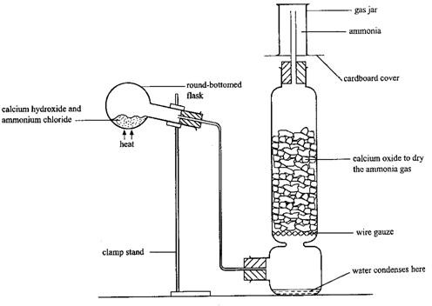

Instead of calcium hydroxide, sodium hydroxide or potassium hydroxide solution may be used, in which case the flask would be placed in the vertical position and heated.

NaOH(aq) + NH4Cl(s) → NaCl(aq) + H2O(l) + NH3(g) KOH(aq) + NH4Cl(s) → KCl(aq) + H2O(l) + NH3(g)

Ammonium sulphate may be used instead of ammonium chloride. Ca(OH)2(s) + (NH4)2SO4(s) → CaSO4(s) + 2H2O(l) + 2NH3(g)

The usual drying agents such as concentrated sulphuric acid and anhydrous calcium chloride are not used because ammonia reacts with them to form ammonium sulphate and tetraamine calcium chloride respectively.

2NH3(g) + H2SO4(l) → (NH4)2SO4(s) CaCl2(s) + 4NH3(g) → Cac12.4NH3(s)

### Industrial preparation of ammonia (Haber process)

Dry nitrogen and hydrogen in the ratio of one to three respectively, are passed over a catalyst of iron with some traces of aluminium oxide present. The reaction occurs at the surface of the catalyst, therefore, the catalyst should be finely divided to increase the surface area over which the reaction occurs. Aluminium oxide improves the performance of the catalyst by making it more porous thus providing a higher surface area for the reaction. The temperature is between 450oC – 500oC. The gases are under a pressure of 250 atmospheres to 500 atmospheres. Ammonia is produced.

N2(g) + 3H2(g) → 2NH3(g)

Ammonia is removed from the mixture of gases by cooling the mixture with a freezing mixture. It is only ammonia that liquefies and can be removed from the mixture. The unreacted nitrogen and hydrogen are recycled (figure 2.5).

Nitrogen used in this process is obtained by fractional distillation of liquid air and hydrogen is obtained from natural gas or electrolysis of brine.

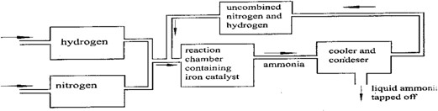

### Tests for ammonia

The gas has a characteristic chocking smell. It turns damp red litmus paper blue and forms white fumes with concentrated hydrochloric acid or hydrogen chloride.

### Properties of ammonia

It is a colourless gas with a choking smell. It is less dense than air and thus collected by upward delivery. It is an alkaline gas and therefore turns red litmus blue. It is the only common alkaline gas.

### Solubility of ammonia in water

It is very soluble in water to give an alkaline solution. The great solubility of ammonia is due to the reaction of the gas with water. Ammonia is a base and removes protons from water to produce ammonium ions and hydroxide ions.

NH3(g) + H2O(l) →NH4+(aq) + OH-(aq)

The solution is only weakly alkaline because of the reversible nature of this reaction, which results in a relatively low concentration of hydroxide ions. Ammonia gas dissolved in water is usually known as aqueous ammonia.

### Experiment to demonstrate the high solubility of ammonia gas in water

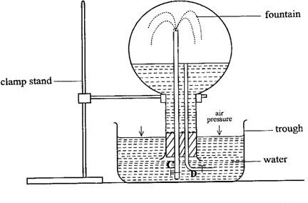

This is an experiment to demonstrate the high solubility of ammonia gas in water. A large round thick walled flask is filled with ammonia gas. It is then fitted with two glass tubes C and D with clips at one end (figure 2.6). The flask is inverted over a trough of water and the clip on tube D opened to allow in a few drops of water and then closed. These are shaken with ammonia to dissolve it. If the red litmus solution is added to water in the trough, water in the flask will turn to

blue indicating that it is an alkaline gas which dissolved in water. The clip on the tube C is opened. Water runs up the tube and spreads at the end of the tube forming a fountain.

The few drops of water, which entered through tube D, dissolved all the ammonia gas in the flask so that a partial vacuum was created in the flask. When the clip on tube C was opened, atmospheric pressure pushed the water up the tube forming a fountain.

### Action of ammonia on copper(II) oxide

When a stream of dry ammonia is passed over very strongly heated copper(II) oxide as shown in figure 2.7, a colourless liquid (water) forms in the U-tube. The black oxide turns brown and a colourless gas collects in the jar over water. Ammonia reduces the copper(II) oxide to copper and itself oxidized to nitrogen.

3CuO(s) + 2NH3(g) → 3H2O(l) + N2(g)

Here ammonia behaves as a reducing agent. A similar reaction takes place with the oxides of lead and iron.

3PbO(s) + 2NH3(g) → 2Pb(s) + 3H2O(l) + N2(g) Fe2O3(s) + 2NH3(g) → 2Fe(s) + 3H2O(l) + N2(g)

This experiment can also be used to demonstrate that ammonia contains nitrogen.

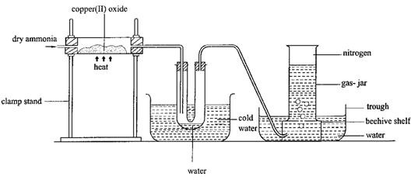

### Combustion of ammonia

Ammonia is a good reducing agent, which means that it can be easily oxidised. Ammonia burns with a green/yellow flame, in an atmosphere of air slightly enriched by oxygen forming nitrogen and water.

4NH3(g) + 3O2(g) → 2N2(g) + 6H2O(l)

The figure 2.8 shows how ammonia is burnt. The role of the glass wool is to distribute oxygen evenly throughout the gas vessel.

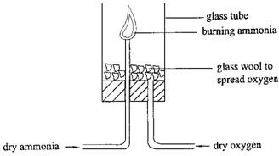

In presence of catalyst, ammonia is oxidised to nitrogen monoxide.

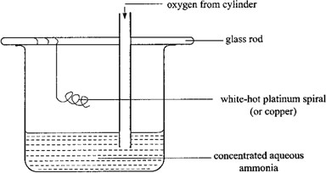

The figure 2.9 shows that set of the experiment. A hot platinum or copper wire which acts as a catalyst is suspended in a beaker of concentrated ammonia and oxygen is bubbled through the solution. The metal catalyst remains red-hot because the reaction is exothermic. Brown fumes of nitrogen dioxide, which are formed due to oxidation of nitrogen monoxide, are observed.

4NH3(g) + 5O2(g) → 4NO(g) + 6H2O(l)

2NO(g) + O2(g) → 2NO2(g)

The fumes later turn white due to formation of ammonium nitrate. 4NO2(g) + O2(g) +2H2O(g) → 4HNO3(g)

NH3(g) + HNO3(g) → NH4NO3(g)

### Reaction with hydrogen chloride

Ammonia reacts with hydrogen chloride to form white fumes, which turn to a white solid of ammonium chloride on standing.

NH3(g) + HCl(g) → NH4Cl(s)

### Reaction with chlorine

Ammonia burns spontaneously in chlorine forming a mist of hydrogen chloride. 2NH3(g) + 3Cl(g) → N2(g) + 6HCl(g)

In excess ammonia, dense white fumes of ammonium chloride are formed. Hydrogen chloride formed reacts with excess ammonia to form the white fumes, which later settle to a white solid.

2NH3(g) + 3Cl2(g) → N2(g) + 6HCl(g) HCl(g) + NH3(g) – NH4Cl(s)

This can be represented by one equation. 3Cl2(g) + 8NH3(g) → N2(g) + 6NH4Cl(s)

### Uses of ammonia

1. Ammonia solution is used in laundry work to remove temporary hardness.
2. Ammonia is used to manufacture ammonium sulphate and ammonium nitrate used as fertilizers.
3. It is used in manufacture of nitric acid.
4. It is used in production of nylon.
5. It can be used as a refrigerant because it evapourates readily, removing heat from the surrounding as it does so. It can be easily liquefied by compression.

### Exercise

**Study the following reaction scheme.**

Air Gas W Sulphuric acid Solid Y

Ammonia

Natural gas Gas X Nitric acid Solid Z

1. Identify the substances W, X, Y and Z.
2. State the method used to obtain gas W from the air.
3. Write the reaction leading to the formation of
   1. ammonia
   2. Y
   3. Z
4. State any use of solid Z.

### Ammonia solution

* + - 1. **Preparation of ammonia solution**

It can be prepared by dissolving ammonia in water using the setup shown in figure 2.10. The filter is used in passing ammonia into water in order to prevent the ‗sucking back‘ of water from the beaker into the reaction flask. Ammonia is so soluble in water that, in the process of dissolving, too much of it could dissolve at one time creating a low gaseous pressure in the reaction flask as well as in the delivery tube by the atmospheric pressure outside. The funnel is arranged with its rim only just immersed in order to ensure that when water is sucked into the funnel, contact with the water is broken and the water falls back into the beaker rather than being sucked back along the delivery tube.

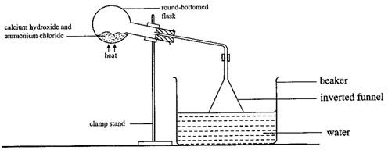

### Ammonium salts

* + - 1. **Nitrogenous fertilizers**

Fertilizers supply crops with inorganic elements required for their growth. Such elements include nitrogen, phosphorus, potassium and calcium. Nitrogen is one of the most important elements required for the growth of plants. However, the plants are not able to take in elemental nitrogen. They obtain it in the form of nitrates. Ammonium salts also supply plants with nitrogen since they are converted by soil bacteria to nitrates. Nitrogenous fertilizers supply nitrogen together with various other elements to plants. Majority of them are ammonium salts. They include ammonium sulphate (AS), ammonium nitrate (AN), di- ammonium phosphate (DAP), calcium ammonium nitrate (CAN) and ammonium sulphate nitrate (ASN).

In the laboratory, ammonium salts are made by reacting the appropriate acid with ammonia. For example, ammonium sulphate is made by neutralizing sulphuric acid with ammonia.

2NH3(g) + H2SO4(aq) → (NH4)2SO4(aq)

In industry, ammonium sulphate cannot be made using sulphuric acid, as the later is very expensive. Instead, it is made by reacting ammonium carbonate with calcium sulphate. Ammonium carbonate is first prepared by saturating ammonia solution with carbon dioxide.

2NH3(g) + CO2(g) + H2O(l) → (NH4)2CO3(aq)

Solid calcium sulphate is added and the mixture is stirred forming ammonium sulphate solution and calcium carbonate.

(NH4)2CO3(aq) + CaSO4(s) → (NH4)2SO4(aq) + CaCO3(s)

Calcium carbonate is removed by filtration and solid ammonium sulphate is obtained by crystallization.

### Effect of heat on ammonium salts

1. Ammonium chloride sublimes when heated. The cause of this sublimation is that ammonium chloride dissociates on heating to ammonia and hydrogen chloride, which recombine on cooling.

NH4Cl(s) → NH3(g) + HCl(g)

Also ammonium carbonate sublimes. (NH4)2CO3(s) → 2NH3(g) + CO2(g) + H2O(g)

1. Ammonium sulphate decomposes on heating into ammonia and sulphuric acid. Although the reaction is similar to that of ammonium chloride no sublimation occurs because sulphuric acid is less volatile than ammonia. The ammonia gas escapes before sulphuric acid volatiles such that the two cannot recombine.

(NH4)2SO4(s) → 2NH3(g) + H2SO4(g)

1. Ammonium nitrate is decomposed to nitrogen(I) oxide (dinitrogen oxide) and water. NH4NO3(s) → N2O(g) + 2H2O(g)

Dinitrogen oxide is a colourless gas. It is fairly soluble in water and neutral to litmus. It is denser than air and a glowing splint is relit when lowered into a gas-jar containing dinitrogen oxide. The heat decomposes dinitrogen oxide into oxygen and nitrogen. It is oxygen that relights the glowing splint.

2N2O(g) → 2N2(g) + O2(g)

**Caution:** Ammonium nitrate should not be heated in the laboratory because it explodes on strong heating.

1. Ammonium nitrate decomposes to nitrogen and water. NH4NO2(s) → N2(g) + 2H2O(g)

### Test for ammonium salts

When ammonium salts are heated with an alkali, a colourless gas (ammonia) which has a pungent choking smell and turns wet red litmus paper blue is given off.

NH4+(aq) + OH-(aq) → NH3(g) + H2O(l)

### Exercise

State what would be observed and write an ionic equation for the reaction that would take place when aqueous ammonium chloride was

1. Heated with sodium hydroxide solution.
2. Added to silver nitrate solution.

### Reactions of ammonia solution and sodium hydroxide solution

Ammonia solution neutralizes acids forming a salt and water only. 2NH4OH(aq) + H2SO4(aq) → (NH4)2SO4(aq) + 2H2O(l)

Ammonia solution precipitates metal hydroxides from solutions containing the metal ions. When a few drops of ammonia solution are added to a solution of copper(II) ions, a blue precipitate is formed.

Cu2+(aq) + 2OH-(aq) → Cu(OH)2(s)

When excess aqueous ammonia is added to the blue precipitate, the precipitate dissolves to form a deep blue solution containing complex tetraamine copper(II) ions.

Cu(OH)2(s) + 4NH3(aq) → [Cu(NH3)4]2+(aq) + 2OH-(aq)

A solution of zinc ions forms a white precipitate with a few drops of aqueous ammonia. The precipitate dissolves in excess ammonia solution to form a colourless solution containing complex tetraamine zinc ions.

Zn2+(aq) + 2OH-(aq) → Zn(OH)2(s)

Zn(OH)2(s) + 4NH3(aq) → [Zn(NH3)4]2+(aq) + 2OH-(aq)

Iron(II), iron(III), lead(II) and aluminum ions form precipitates of the hydroxides with aqueous ammonia which are insoluble in excess ammonia solution.

Fe2+(aq) + 2OH-(aq) →Fe(OH)2(s)

(green) Fe3+(aq) + 3OH-(aq) → Fe(OH)3(s)

(brown) Pb2+(aq) + 2OH-(aq) → Pb(OH)2(s)

(white) A13+(aq) + 3OH-(aq) → A1(OH)3(s)

(white)

A solution of aluminium, Zinc and lead(II) ions reacts with sodium hydroxide solution to form a white precipitate that is soluble in excess sodium hydroxide solution to form a colourless solution.

A13+(aq) + 3OH-(aq) → A1(OH)3(s)

A1(OH)3(s) + OH-(aq) → A1(OH)4-(aq)

(aluminate ion) Zn2+(aq) + 2OH-(aq) → Zn(OH)2(s)

Zn(OH)2(s) + 2OH-(aq) → Zn(OH)42-(aq)

(zincate ion) Pb2+(aq) + 2OH-(aq) → Pb(OH)2(s)

Pb(OH)2(s) + 2OH-(aq) → Pb(OH)42-(aq)

(plumbate ion)

Iron(II) and iron(III) ions in solution, react with sodium hydroxide solution to give a green and brown precipitate respectively, insoluble in excess sodium hydroxide solution.

Fe2+(aq) + 2OH-(aq) → Fe(OH)2(s)

Fe3+(aq) + 3OH-(aq) → Fe(OH)3(s)

Magnesium and calcium ions in solution react with sodium hydroxide solution to give a white precipitate insoluble in excess sodium hydroxide solution.

Ca2+(aq) + 2OH-(aq) →Ca(OH)2(s)

Mg2+(aq) + 2OH-(aq) →Mg(OH)2(s)

### Nitric acid

* + - 1. **Laboratory preparation of nitric acid**

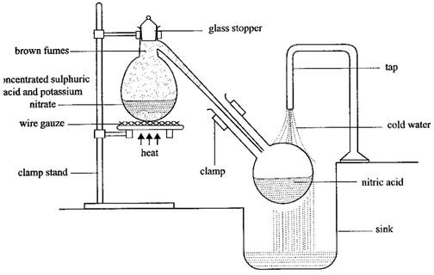

When a mixture of potassium nitrate and concentrated sulphuric acid is heated gently, potassium nitrate gradually dissolves and effervescence occurs givning off nitric acid which is condensed in another flask placed in a sink and cooled by tap water as shown in figure 2.11.

KNO3(s) + H2SO2(l) → KHSO4(s) + HNO3(g)

Brown fumes of nitrogen dioxide are produced during heating because of thermal decomposition of nitric acid.

4HNO3(g) → 2H2O(l) + 4NO2(g) + O2(g)

The experiment must be carried out in all-glass apparatus because nitric vapour attacks rubber and cork.

### Industrial preparation of nitric acid

Nitric acid is manufactured by the catalytic oxidation of ammonia. Ammonia and excess air are passed over a heated platinum catalyst at about 800oC, forming nitrogen monoxide. The reaction is exothermic.

4NH3(g) + 5O2(g) → 4NO(g) + 6H2O(l)

Nitrogen monoxide is cooled and reacts with oxygen from excess air to produce brown fumes of nitrogen dioxide.

2NO(g) + O2(g) →2NO2(g)

Nitrogen dioxide together with excess air is dissolved in hot water to form nitric acid. 2H2O(l) + 4NO2(g) + O2(g) → 4HNO3(aq)

### Uses of nitric acid

1. In the manufacture of fertilizers such as ammonium nitrate. It is manufactured by reacting ammonia gas and nitric acid.

NH3(g) + HNO3(aq) → NH4NO3(aq)

1. Used for the manufacture of dyes and explosives.
2. Used in manufacture of drugs.

### Properties of nitric acid

It behaves chemically in two ways.

1. It is a strong acid.
2. It is a powerful oxidizing agent.

### Nitric acid acting as a strong acid

Nitric acid is a very strong acid, being almost completely ionized in dilute solution with the production of the hydrogen ion and the nitrate ion.

HNO3(aq) → H+(aq) + NO3-(aq)

This ionization confers on it the usual acidic properties, modified to some extent by powerful oxidizing action of the acid.

1. It liberates carbon dioxide from carbonate and hydrogencarbonate. CuCO3(s) + 2HNO3(aq) → Cu(NO3)2(aq) + H2O(l) + CO2(g)

NaHNO3(s) + HNO3(aq) → NaNO3(aq) + H2O(l) + CO2(g)

1. It reacts with oxides and alkalis to form salt and water only. CuO(s) + 2HNO3(aq) →Cu(NO3)2(aq) + H2O(l)

NaOH(aq) + HNO3(aq) → NaNO3(aq) + H2O(l)

1. Hydrogen is liberated when very dilute acid ia added to magnesium. Mg(s) + 2HNO3(aq) → Mg(NO3)2(aq) + H2(g)

Magnesium is the only metal that liberates hydrogen with nitric acid and only when the acid is very dilute. Other metals are oxidised by the acid to the corresponding nitrates.

### Nitric acid as an oxidizing agent

1. When concentrated nitric acid is added to a green solution of iron(II) sulphate and warmed, it oxidizes it to a yellow or brown solution of iron(III) sulphate.

Fe2+(aq) → Fe3+(aq) +e-

1. Concentrated nitric acid reacts with copper giving off nitrogen dioxide. 4HNO3(l) + Cu(s) → Cu(NO3)2(aq) + 2H2O(l) + 2NO2(g)

If the acid is 50% concentrated (equal volume of water as the volume of acid), nitrogen monoxide is formed.

3Cu(s) + 8HNO3(aq) →3Cu(NO3)2(aq) + 4H2O(l) + 2NO(g)

Lead reacts with nitric acid in a similar way. Aluminium and iron are made assive because of the formation of the oxide layer, which forms a protective layer over the metal and stops further reaction.

1. Reaction with non-metals
   1. Concentrated nitric acid reacts with sulphur to give brown fumes of nitrogen dioxide.

S(s) + 6HNO3(l) →H2SO4(aq) + 2H2O(l) + 6NO2(g)

* 1. When a piece of red-hot charcoal is put into concentrated nitric acid, it continues to burn and brown fumes are formed.

C(s) + 4HNO3(l) →CO2(g) + 4NO2(g) + 2H2O(l)

* 1. When red phosphorus is gently heated with moderately dilute nitric acid, brown fumes are formed.

P(s) + 5HNO3(aq) – H3PO4(aq) + H2O(l) + 5NO2(g)

1. Other oxidation reactions

When hydrogen sulphide is passed through moderately dilute nitric acid, a pale yellow precipitate of sulphur and nitric acid is reduced to nitrogen monoxide. With concentrated nitric, nitrogen dioxide is formed.

3H2S(g) + 2HNO3(aq) → 3S(s) + 2NO(g) + 4H2O(l) H2S(g) + 2HNO3(l) → S(s) + 2NO2(g) + 2H2O(l)

### Nitrates

* + 1. **Action of heat on nitrates**

Nitrates of potassium and sodium when heated melt to a colourless liquid and then slowly decompose to give a pale yellow nitrate and a colourless gas which rekindles (re-lights) a glowing splint.

2NaNO3(s) → 2NaNO2(l) + O2(g)

2KNO3(s) →2KNO2(l) + O2(g)

Lead(II) nitrate makes a cracking sound when heated. The sound is due to the fact that the air inside the crystals splits them when it expands due to heating. A brown mixture of nitrogen dioxide and oxygen is given off. Lead(II) oxide (residue) is brown when hot and yellow when cold.

2Pb(NO3)2(s) →2PbO(s) + 4NO2(g) + O2(g)

Most metallic nitrates decompose to a metal oxide, nitrogen dioxide (brown fumes) and oxygen gas which relights a glowing splint.

2Ca(NO3)2(s) →2CaO(s) + 4NO2(g) + O2(g)

(white) (white)

2Mg(NO3)2(s) →2MgO(s) + 4NO2(g) + O2(g)

(white) (white)

2Zn(NO3)2(s) → 2ZnO(s) + 4NO2(g) + O2(g)

(white)

2Cu(NO3)2(s) →2CuO(s) + 4NO2(g) + O2(g)

(green) (black)

Zinc oxide is yellow when hot and white when cold. Zinc nitrate and copper(II) nitrate are hydrated and when heated do not produce a cracking sound. They melt first and dissolve in their water of crystallization forming a solution. The solution then evaporates and when most of the water has evapourated, decomposition starts. Mercury(II) nitrate and silver nitrate decompose to the metal, nitrogen dioxide and oxygen.

Hg(NO3)2(s) → Hg(1) + 2NO2(g) + O2(g) 2AgNO3(s) → 2Ag(s) + 2NO2(g) + O2(g)

### Exercise

When a green compound W was heated strongly, a brown gas was given off and a black residue remained.

1. Name the
   1. brown gas
   2. black residue
2. Write the equation for the reaction.
3. Dilute nitric acid was added to the black residue and warmed.
   1. State what was observed.
   2. Write the equation for the reaction.
4. To the products in (c) was added aqueous ammonia drop wise until in excess.
   1. State what was observed.
   2. Write the equation(s) for the reaction(s) that took place.

### Test for nitrates

1. Brown ring test:

To a solution of a nitrate in a test-tube, an equal volume of freshly prepared iron(II) sulphate solution is added. The test-tube is held in a slanting position and very carefully concentrated sulphuric acid is poured down the sides of the test-tube. Concentrated sulphuric acid is denser than the solution and therefore sinks to the bottom. A brown ring forms where the two layers meet as shown in figure 2.12.

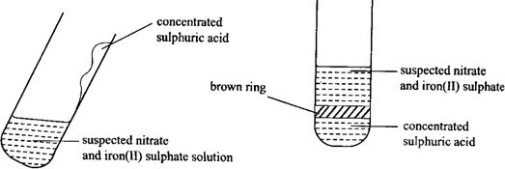

The formula of the brown ring is FeSO4.NO. Concentrated sulphuric acid reacts with nitrate ions to give nitric acid.

H+(aq) + NO3-(aq) → HNO3(aq)

Nitric acid formed then oxidizes iron(II) to iron(III) and itself reduced to nitrogen monoxide.

Fe2+(aq) →Fe3+(aq) + e-

4HNO3(aq) → 2H2O(l) + 4NO(g) + 3O2(g)

Nitrogen monoxide combines with the remaining iron(II) sulphate to form the dark brown compound, nitroso-iron(II) sulphate.

FeSO4(aq) + NO(g) →FeSO4.NO(aq)

The ring disappears if the solution is shaken. This is because when concentrated sulphuric acid and water mix, a lot of heat is evolved which decomposes the compound.

FeSO4.NO(aq) →FeSO4(aq) + NO(g)

1. Using hot concentrated sulphuric acid

A solid nitrate is gently heated with concentrated sulphuric acid in a test-tube forming nitric acid. The top part of the tube is heated to decompose nitric acid forming brown fumes of nitrogen dioxide.

4HNO3(g) → 2H2O(l) + 4NO2(g) + O2(g)

1. Copper and concentrated sulphuric acid

Mix a solid nitrate with copper and heat gently with concentrated sulphuric acid. Nitric acid formed reacts with copper forming brown fumes of nitrogen dioxide.

Cu(s) + 4HNO3(l) → Cu(NO3)(aq) + 2H2O(l) + 2NO2(g)

### Exercise

1. Nitric acid is manufactured by catalytic oxidation of ammonia.
   1. Name
      1. Two raw materials, other than ammonia that are used in the manufacture of nitric acid.
      2. The catalyst used.
   2. Write equation for the reaction between nitric acid and ammonia.
   3. State one use of the product in (b).
2. (a) Describe the industrial preparation of nitric acid from ammonia. Your description should include equations for the reactions that occur.
3. Explain what happens when concentrated nitric acid is added to copper.
4. Describe one chemical test that can be used to confirm the presence of a nitrate.
5. State what would be observed if concentrated nitric acid was heated with iron(II) sulphate solution.
6. (a) Draw a labeled diagram of the apparatus that can be used to prepare ammonia

in the laboratory.

1. Describe an experiment that can be carried out to show that ammonia is a soluble alkaline gas.
2. A copper coil was heated strongly and held over a concentrated solution of ammonia in a beaker. Oxygen was then bubbled into ammonia solution.
3. State what was observed.
4. Explain the observation in (i).
5. (a) A piece of burning magnesium was introduced into a jar of nitrogen.
6. State what was observed.
7. Write an equation for the reaction that took place.
8. Water was added to the product of the reaction in (a) and the resultant mixture tested with litmus.
   1. State what was observed.
   2. Write an equation for the reaction.
9. Name one other metal that reacts with nitrogen in a similar way to magnesium.
10. When compound x is heated with concentrated sulphuric acid, a gas which forms dense white fumes with ammonia is liberated.
    1. Identify the anion in x.
    2. Write an ionic equation for the reaction between a solution of x and silver nitrate.
    3. State what would be observed if lead(II) nitrate solution was added to solution of x and the mixture heated.
11. In the industrial preparation of ammonia, nitrogen is reacted with hydrogen.
12. Write the equation for the reaction.
13. Give the conditions under which the reaction takes place.
14. State what is observed when aqueous ammonia is added drop wise to copper(II) sulphate solution until in excess.
15. Write an equation for the reaction between ammonia and hydrogen chloride gas.
16. State what was observed in (iv) above.
17. Dilute nitric acid reacts with copper to form a colourless gas, which on exposure to air gives brown fumes soluble in water.
    1. Write the equation for the reaction between copper and nitric acid.
    2. Name the colourless gas.
    3. Explain how the brown fumes are formed.
    4. Write the equation to show the reaction between water and the brown fumes.
18. Excess lead(II) oxide was added to warm dilute nitric acid and the mixture was stirred. After cooling, the mixture was filtered and a solution of ammonium hydroxide was added to the filtrate.
    1. Write an equation for the reaction between lead(II) oxide and nitric acid.
    2. State what was observed when ammonium hydroxide solution was added to the filtrate drop wise until in excess.
    3. Write an equation for the reaction in (b) above.
19. What would be observed if dilute sodium hydroxide solution was added drop wise until in excess to a solution of
20. Fe2+ salt.
21. Fe3+ salt.
22. (a) Describe how zinc sulphate crystals can be prepared from zinc in the laboratory.
23. A small amount of zinc sulphate was dissolved in dilute nitric acid and the resultant solution divided into two portions.
    1. State what would be observed when sodium hydroxide solution is added to the first portion drop wise until in excess.
    2. Write the equation(s) of the reaction(s) that took place.
24. (i) State what would be observed when aqueous ammonia is added to the second portion drop wise until in excess.

(ii) Write the equation(s) for the reaction(s)

1. Study the figure 2.13 and answer questions that follow.

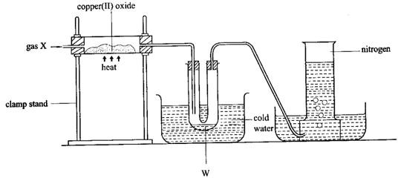

* 1. Name
     1. gas X
     2. liquid W.
     3. one reagent that can be used to identify W.
  2. (i) State what is observed in the combustion tube.

1. Write the equation for the reaction.
2. Name another oxide that shows similar reaction with gas X.
   1. Why is it possible to collect nitrogen gas as shown?
   2. Nitrogen gas can be obtained from air on a large scale. State the method used.
3. Lead(II) nitrate was heated strongly in the apparatus shown in figure 2.14.

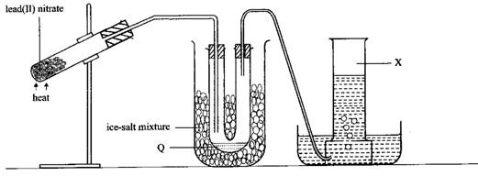

* 1. Identify

(iii)Liquid Q. (iv)Gas X.

* 1. (i) State what was observed in the test-tube during the heating.

(ii) Write the equation for the reaction that took place.

* 1. To the residue was added dilute nitric acid and the mixture warmed.
     1. Write the equation for the reaction.
     2. State what was observed.
  2. To the resultant product in (c) was added sodium hydroxide solution drop wise until in excess.
     1. State what was observed.
     2. Write the equation(s) for the reaction(s) that took place.

1. Figure 2.15 shows the apparatus used for combustion of ammonia.
   1. Name
      1. gas Q
      2. X
   2. Write the equation for the reaction that occurred in the test-tube.
   3. Name another substance that can be used instead of ammonium sulphate.
   4. State the role of
      1. The glass wool.
      2. Calcium oxide.
   5. Explain why concentrated sulphuric acid is not used instead of calcium oxide.
   6. Write the equation for the combustion of ammonia.
   7. State one industrial use of ammonia.

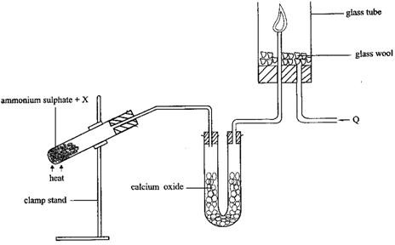

1. Figure 2.16 shows an experimental setup for the laboratory preparation of nitrogen gas.

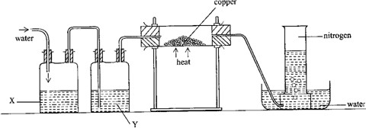

* 1. What is the purpose of passing water into bottle X?
  2. Name liquid Y and state its role.
  3. (i) State the role of copper turnings.

1. State the conditions for the reaction taking place in the combustion tube.
2. Write the equation for the reaction taking place in the combustion tube.
   1. Explain why nitrogen gas collected in this experiment is not pure.

### 24. Chlorine and its compounds

* 1. **Chlorine**

Chlorine is element number 17 in the periodic table of elements. It belongs to group VII, the halogens. Chlorine comes from the Greek word chloros, meaning green.

### Laboratory preparation of chlorine

1. By oxidation of concentrated hydrochloric acid with manganese(IV) oxide

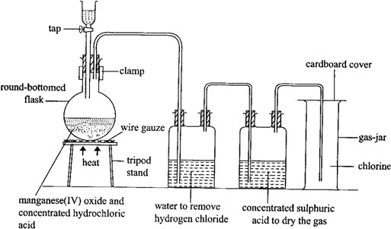

The experiment is set up as shown in figure 3.1. Concentrated hydrochloric acid is poured into a flask containing manganese(IV) oxide and the flask shaken well. The mixture is heated and chlorine gas formed is passed through a bottle containing water to dissolve any fumes of hydrogen chloride, which are produced from concentrated hydrochloric acid. It is then dried by passing it through concentrated sulphuric acid and collected in a gas-jar by downward delivery because it is denser than air.

MnO2(s) + 4HCl(l) → MnCl2(aq) + 2H2O(l) + Cl2(g)

1. By oxidation of concentrated hydrochloric acid with potassium permanganate solid potassium permanganate is placed in a flask and concentrated hydrochloric acid is dropped on to it from a tap funnel as shown in figure 3.2 Green/yellow gas is produced which is collected over brine.

2KMnO4(s) + 16HCl(l) – 2KCl(aq) + 2MnCl2(aq) + 8H2O(l) + 5Cl2(g)

The experiment need not be conducted in a fume-chamber, if the gas is collected over brine.

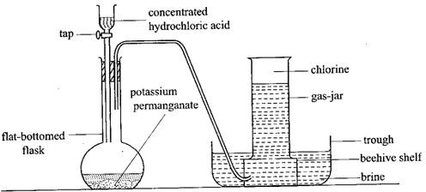

1. Preparation of chlorine from bleaching powder

Dilute nitric acid or hydrochloric acid can be used together with bleaching powder. The experiment is set up as shown in figure 3.2

CaOCl2(s) + 2HNO3(aq) → Ca(NO3)2(aq) + H2O(l) + Cl2(g)

CaOCl2(s) + 2HCl(aq) → CaCl2(aq) + H2O(l) + Cl2(g)

### Industrial manufacture of chlorine

Chlorine is produced commercially by the electrolysis of sodium chloride solution (brine) using a carbon anode and a mercury cathode. Sodium is deposited at the cathode and chlorine gas liberated at the anode.

Reaction at cathode: Na+(aq) + e- → Na(s)

Reaction at anode:

2Cl-(aq) → Cl2(g) + 2e-

Sodium ion is discharged because it requires less energy than the discharge of hydrogen ions in case a mercury cathode is used.

### Properties of chlorine

Chlorine bleaches damp blue and red litmus paper. Blue litmus paper is bleached after turning red. It is a greenish yellow gas with a chocking irritating smell. It is fairly soluble in water.

### Reaction with phosphorus

When a piece of yellow phosphorus is lowered in a gas-jar full of chlorine, it burns spontaneously (without application of heat) giving off white fumes of phosphorus trichloride (phosphorus(III)chloride) and phosphorus pentachloride (phosphorus(V) chloride).

P4(s) + 6Cl2(g) → 4PCl3(s) P4(s) + 10Cl2(g) → 4PCl5(s)

### Affinity for hydrogen

Chlorine readily combines with substances, which contain hydrogen. When a piece of filter paper is dipped in warm turpentine (C10H16) and then dropped in a gas-jar full of chlorine, there is a red flash accompanied by a violent reaction and a black cloud of solid particles of carbon is formed. Chlorine combines with hydrogen in turpentine leaving the black carbon behind.

C10H16(l) + 8Cl2(g) → 10C(s) + 16HCl(g)

### Reaction with hydrogen

When a jet of burning hydrogen is lowered into a gas-jar full of chlorine, hydrogen continues to burn with a white flame and clouds of steamy fumes of hydrogen chloride are formed (figure 3.3). The greenish yellow colour of chlorine gradually disappears.

H2(g) + Cl2(g) → 2HCl(g)

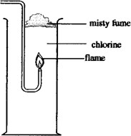

### Reaction with hydrogen sulphide

Chlorine reacts with hydrogen sulphide forming a yellow particles of sulphur and white fumes of hydrogen chloride.

H2S(g) + Cl2(g) →2HCl(g) + S(s)

### Action of chlorine on iron

A stream of dry chlorine gas is passed over a coil of iron wire as shown in figure 3.4. On heating the iron wire, it glows and continues to burn without further application of the flame. It reacts with chlorine to form brown fumes of iron(III) chloride which condense in a bottle placed at the end of the combustion tube as black crystals.

2Fe(s) + 3Cl2(g) → 2FeCl3(s)

A tube containing the drying agent, anhydrous calcium chloride, is connected to the bottle to prevent water from the atmosphere from entering the bottle as this would be absorbed by iron(III) chloride which is very deliquescent. Excess chlorine, which is poisonous, escapes into the fume chamber.

The formation of iron(III) chloride and not iron(II) chloride shows that chlorine is an oxidizing agent. Iron(II) chloride is immediately oxidised by chlorine to iron(III) chloride.

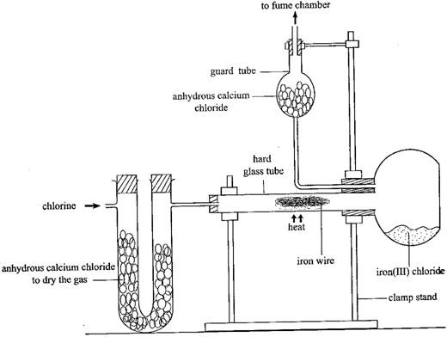

Sodium chloride can be prepared in similar way. 2Na(s) + Cl2(g) → 2NaCl(s)

Iron(II) chloride (white solid) is made in the same way, using dry hydrogen chloride instead of chlorine.

2HCl(g) + Fe(s) → FeCl2(s) + H2(g)

Sodium, potassium, calcium and magnesium burn in chlorine forming white fumes of the chloride which settle to a white solid.

Note: When iron(III) chloride crystals are dissolved in water they give a deep yellow solution from which yellow crystals of hydrated iron(III) chloride may be obtained by evaporation to the point of crystallization.

### Reaction with a dutch metal

When a thin strip of dutch metal (alloy of copper and zinc, mainly copper) is placed in a gas-jar full of chlorine, it burns spontaneously with a green flame (due to the copper) to form copper(II) chloride and a little of zinc chloride.

Cu(s) + Cl2(g) →CuCl2(s) Zn(s) + Cl2(g) → ZnCl2(s)

### Action of chlorine on iron(II) chloride solution

When a stream of chlorine is bubbled through a pale green solution of iron(II) chloride, the colour of the solution changes to yellow. Chlorine oxides the iron(II) ions to iron(III) ions.

2FeCl2(aq) + Cl2(g) → 2FeCl3(aq)

Or 2Fe2+(aq) + Cl2(g) →2Fe3+(aq) + 2Cl-(aq)

### Reaction with alkalis

* 1. Cold dilute alkalis

When chlorine gas is bubbled through cold aqueous alkalis, the hypochlorite and the chloride of the metal are formed.

Cl2(g) + 2NaOH(aq) →NaOCl(aq) + NaCl(aq) + H2O(l) Cl2(g) + 2KOH(aq) →KOCl(aq) + KCl(aq) + H2O(l)

* 1. Hot concentrated alkalis

When chlorine is passed into hot concentrated alkalis, a mixture of the chlorate and the chloride is formed.

6KOH(aq) + 3Cl2(g) →KClO3(aq) + 5KCl(aq) + 3H2O(l)

6NaOH(aq) + 3Cl2(g) →NaCl3(aq) + 5NaCl(aq) + 3H2O(l) or 6OH-(aq) + 3Cl2(g) → ClO3-(aq) + 5Cl-(aq) + 3H2O(l)

### Bleaching action of chlorine

Chlorine reacts with water forming hypochlorous acid and hydrochloric acid.

Cl2(g) + H2O(l) → HCl(aq) + HOCl(aq)

Hypochlorous acid is a very reactive compound and readily gives up its oxygen to the dye, to form a colourless compound, that is, the dye is oxidised to a colourless compound.

Dye + HOCl(aq) →HCl(aq) + (dye + O)

Colourless

Dry litmus paper is not bleached by chlorine because there is no formation of hypochlorous acid. Sodium hypochlorite and potassium hypochlorite have a bleaching effect.

### Effect of sunlight on chlorine water

Chlorine gas is passed into distilled water for sometime until the water becomes yellow- green in colour. When an inverted tube containing this chlorine water is exposed to sunlight as shown in figure 3.5, a colourless gas (oxygen) which re-lights a glowing splint is formed.

2Cl2(g) + 2H2O(l) → 4HCl(aq) + O2(g) (overall equation) This occurs in two stages.

* 1. Formation of hypochlorous acid and hydrochloric acid as a result of reaction between water and chlorine.

H2O(l) + Cl2(g) →HOCl(aq) + HCl(aq)

* 1. Decomposition of hypochlorous acid to liberate oxygen.

2HOCl(aq) → 2HCl(aq) + O2(g)

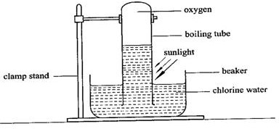

### Displacement reactions of chlorine

Chlorine is higher in the reactivity series than bromine and iodine and therefore can displace them from solutions of their salts in water. This is because chlorine is more reactive than bromine and iodine due to the fact the incoming electron is more strongly attracted into the outer energy level of the smaller atom. The attraction force on the electron will be greater for chlorine than for bromine and iodine, since the outer energy level of chlorine is closer to the nucleus. As one goes down the group, the extra election is further away from the nucleus. It will, therefore, be attracted less strongly thus the reactivity of the halogens decreases down the group.

Order of reactivity of halogens F Flourine – most reactive

C1 Chlorine Br Bromine

I Iodine – least reactive

When chlorine gas is bubbled into a solution of potassium bromide in water, the colourless solution immediately turns red due to formation of bromine water.

2KBr(aq) + Cl2(g) →2KCl(aq) + Br2(aq)

Chlorine displaces iodine from potassium iodine solution forming a dark brown solution due to formation of iodine.

2KI(aq) + Cl2(g) →2KCl(aq) + I2(aq)

Bromine can displace iodine from iodides but cannot displace chlorine from chlorides. Therefore on addition of few drops of bromine to a solution of potassium iodine in water, the solution becomes brown due to the formation of iodine.

2KI(aq) + Br2(l) → 2KBr(aq) + I2(aq)

### Tests for chlorine

It is a greenish yellow gas, which turns damp blue litmus paper red, then bleaches it. Since the gas is acidic, the damp blue litmus paper first turns red and then bleached.

### Uses of chlorine

1. It is used as a bleaching agent. It is used in paper industry and textile industry to bleach wood pulp and cotton respectively.
2. It is used in the manufacture of hydrogen chloride by burning hydrogen and chlorine. H2(g) + Cl2(g) → 2HCl(g)
3. Chlorine is used to kill micro-organisms during sewage and water treatment.
4. It is used in manufacture of polychloroethene or polyvinyl chloride.

### Hydrogen chloride

* + 1. **Laboratory preparation of hydrogen chloride**

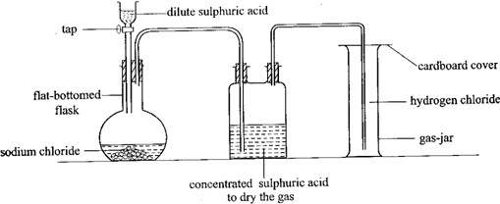

Concentrated sulphuric acid is added to sodium chloride in the flask as shown in figure 3.6. Effervescence occurs and misty fumes of a gas are formed. The gas is passed through a bottle containing concentrated sulphuric acid to dry it and collected by upward displacement of air since the gas is denser than air.

H2SO4(l) + NaCl(s) → NaHSO4(aq) + HCl(g)

Sodium sulphate is not formed because it requires higher temperatures than is provided in this experiment. Sodium chloride is the one most commonly used because it is cheap and readily available.

### Test for hydrogen chloride

It produces a white precipitate of silver chloride with silver nitrate solution. AgNO3(aq) + HCl(g) →AgC1ls) + HNO3(aq)

It also produces dense white fumes of ammonium chloride with ammonia. NH3(g) + HCl(g) → NH4Cl(g)

### Properties of hydrogen chloride

1. It is a white fuming gas with a choking smell.
2. It turns damp blue litmus paper red.
3. It is very soluble in water. This can be shown by the fountain experiment.
4. It liberates hydrogen from certain metals. All metals above copper in the reactivity series react with hydrogen chloride to form hydrogen and the corresponding chloride.

Fe(s) + 2HCl(g) → FeCl2(s) + H2(g) Mg(s) + 2HC2(g) → MgCl2(s) + H2(g)

### Hydrochloric acid

* + 1. **Preparation of hydrochloric acid**

It can be prepared by dissolving hydrogen chloride gas in water using the setup shown in figure 3.7. The filter funnel is used in passing hydrogen chloride into water in order to prevent the ‗sucking back‘ of water from the beaker into the reaction flask. Hydrogen chloride is so soluble in water that, in the process of dissolving, too much of it could dissolve at one time creating a low gaseous pressure in the reaction flask as well as in the delivery tube by the atmospheric pressure outside. The funnel is arranged with its rim only just immersed in the water in order to ensure that when water is sucked into the funnel, contact with the water is broken and the water falls back into the beaker rather than being sucked back along the delivery tube.

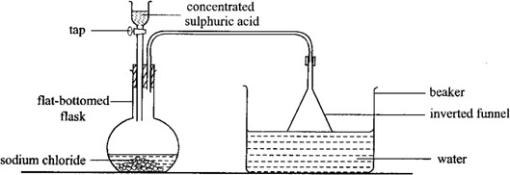

### Properties of hydrochloric acid

1. It turns blue litmus paper red.
2. It reacts with metals producing hydrogen gas. It reacts with metals above hydrogen in the activity series.

Mg(s) + 2HCl(aq) → MgCl2(aq) + H2(g) Zn(s) + 2HCl(aq) → ZnCl2(aq) + H2(g)

1. It liberates carbon dioxide from carbonates and hydrogencarbonates. CaCO3(s) + 2HCl(aq) → CaCl2(aq) + H2O(l) + CO2(g)

NaHCO3(s) + HCl(aq) →NaCl(aq) + H2O(l) + CO2(g)

1. It reacts with alkalis and basic oxides producing salt and water only. NaOH(aq) + HCl(aq) →NaCl(aq) + H2O(l)

CuO(s) + 2HCl(aq) → CuCl2(aq) + H2O(l)

1. Concentrated hydrochloric acid reacts with oxidizing agents such as potassium permanganate liberating chlorine gas.

2KMnO4(s) + 16HCl(l) → 2KCl(aq) + 2MnCl2(aq) + 8H2O(l) + 5Cl2(g)

### Uses of hydrochloric acid

1. It is used in removal (de-scaling) of rust from iron before it is galvanized. It is also used in cleaning metals before they are electroplated.
2. It is used in manufacture of plastics such as polychloroethene.

### Properties of hydrogenchloride in methylbenzene

Dry hydrogen chloride is a covalent compound and therefore it dissolves in organic solvents such as methylbenzene. In the solution, the dissolved hydrogen chloride does not ionize, and remains in the molecular state because methibenzene is not a proton (H+) acceptor. Therefore the solution contains no ions and does not conduct electricity. Water, however, is a proton acceptor and in dilute aqueous solution, hydrogen chloride is fully ionized.

HCl(g) + H2O(l) →H3O+(aq) + Cl-(aq)

These ions are responsible for conducting electricity in the solution. The oxonium ion liberates hydrogen with the more electropositive metals and carbon dioxide with carbonates and hydrogencarbonates.

Mg(s) + 2H3O+(aq) →Mg2+(aq) + 2H2O(aq) + H2(g) CO32-(aq) + 2H3O+(aq) →3H2O(l) + CO2(g)

HCO3-(aq) + H3O+(aq) → 2H2O(l) + CO2(g)

Thus these properties are not shown by hydrogen chloride in methylbenzene, that is, the solution does not contain hydrogen or oxonium ions responsible for acidic characteristics and the solution contains no ions which carry an electric current.

### Testing for soluble chloride

To the solution of the suspected chloride in water, add dilute nitric acid followed by silver nitrate solution. A white precipitate of silver chloride will be observed.

Ag+(aq) + Cl-(aq) →AgCl(s)

To the white precipitate add ammonia solution. The precipitate dissolves to form a colourless solution.

AgCl(s) + 2NH3(aq) → Ag(NH3)2+(aq) + Cl-(aq)

Nitric acid prevents the precipitation of other insoluble silver salts such as silver carbonate. The only common insoluble chlorides are lead(II) chloride and silver chloride. Lead (II) chloride is soluble in hot water.

### Exercise

1. (a) Draw a well labeled diagram to show how a sample of dry hydrogen chloride can be prepared in the laboratory.
2. Dry hydrogen chloride gas was passed over heated iron filings. Write an equation for the reaction that took place.
3. The solid product in (b) was dissolved in water and aqueous sodium hydroxide added to the resultant solution drop wise until in excess.
   1. State what was observed.
   2. Write equation for the reaction.
4. Chlorine gas was passed through a solution of the product in (b)
   1. State what was observed.
   2. Write an ionic equation for the reaction.
5. (i) Name one reagent that can be used to test for the anion formed in (d).

(ii) State what is observed when the reagent you have named is used.

1. (a) A mixture consists of sulphur and iron filings. Explain briefly how a sample of sulphur can be obtained from the mixture.
2. A sample of the mixture in (a) was heated in a porcelain dish.
   1. State what was observed.
   2. Write equation for the reaction that took place.
3. State what would be observed and write ionic equation(s) for the reaction(s) that take place when
   1. A solution of silver nitrate is added to potassium chloride solution.
   2. A solution of barium chloride is added to sodium sulphate solution.
4. Chlorine can be prepared in the laboratory from hydrochloric acid.
   1. Name the other reagent used in the preparation of chlorine.
   2. State the conditions for the reaction.
   3. Write an equations for the reaction which takes place between hydrochloric acid and the reagent you have named in (i).
5. During the preparation of chlorine in the laboratory, the gas may be passed through water and concentrated sulphuric acid before collection.
6. State the use of
   1. water
   2. concentrated sulphuric acid
7. Chlorine is a bleaching agent when in the presence of water.
   1. Write an equation for the reaction between chlorine and water.
   2. Using equations, explain the bleaching action of chlorine.
8. (i) State what would be observed if chlorine was bubbled through a solution of iron(II) sulphate.

(ii) Write an equation for the reaction between chlorine and iron(II) chloride.

1. Burning sodium was plunged into a jar of chlorine.
   1. State what was observed.
   2. Write the equation for the reaction.
2. (a) Draw a labeled diagram of the apparatus you would use to prepare chlorine in the laboratory, using potassium permanganate.
3. State what is observed when
   1. A piece of yellow phosphorus is lowered in a jar of chlorine.
   2. Burning turpentine (C10H16) is lowered in a jar of chlorine.
   3. Chlorine is bubbled into a solution of potassium iodide.
4. (a) With the aid of a well labeled diagram describe an experiment in the laboratory to show that hydrogen chloride gas is very soluble in water.
5. State what is observed when hydrogen chloride is
   1. Bubbled in lead(II) nitrate solution.
   2. Passed through a gas-jar of ammonia.
6. Hydrogen chloride was dried and passed over heated iron filings.
   1. State what would be oserved.
   2. Write equation of the reaction that took place.
7. (a) (i) Draw a well labeled diagram to show the preparation of iron(III) chloride using chlorine.
8. State what would be observed during the reaction.
9. Write an equation leading to the formation of iron(III) chloride.

(b) (i) State what would be observed if aqueous ammonia was added to a solution of iron(III) chloride.

(ii) Write an ionic equation for the reaction in (b) (i).

1. (a) State what would be observed if chlorine is passed through
   1. litmus solution
   2. Aqueous potassium iodide.
   3. Cold dilute sodium hydroxide solution.

(b) Write an equation for the reaction that takes place in (ii).

1. When a compound M is heated with concentrated sulphuric acid, a gas that forms dense white fumes with ammonia is liberated.
2. Identify the anion in M
3. (i) State what would be observed when a solution of M is added to silver nitrate solution.

(ii) Write an ionic equation for the reaction which occurs in (i) above.

1. State what would be observed when lead(II) nitrate solution is added to a solution of M and the mixture warmed.
2. (a) The substance Y reacts with solid chloride to produce hydrogen chloride.
   1. Identify Y.
   2. State the conditions for the reaction. (iii)Write the equation for the reaction.

(b) (i) Name the substance that is formed when hydrogen chloride is dissolved in water.

(ii) Explain why an aqueous solution of hydrogen chloride is an electrolyte whereas the solution of the gas in methylbenzene is a non-electrolyte.

### 25. Extraction of metals

* 1. **Introduction**

The major factor determining the method used for extraction of metals from their ores is the position of the metals in the electrochemical series. An ore is a naturally occurring substance from which a metal can be extracted.

Very reactive metals, that is, those higher in the activity series occur mainly as chlorides. They are extracted by electrolysis of their fused salts. Such metals include potassium, sodium, calcium, magnesium and aluminium.

Metals in the middle of the series such as zinc, iron, lead and copper mainly occur as oxides, carbonates and sulphides. They are extracted by reduction of the ore. **Chemical reduction** involves the extraction of a metal from its ore by heating the ore with a strong reducing agent such as coke. This method is used in extraction of iron. **Thermal reduction** involves roasting (heating directly in air). It is applicable in the extraction of metals such as zinc, copper and lead. At some stage in this process, the method might be intergrated with chemical reduction.

Metals lower in activity series, that is, mercury, silver and gold mainly occur as free metals in the earth‘s crust. They are mainly dug up in the pure form.

### Concentration of ores

Very often ores are found contaminated with earthly impurities. The following methods are employed to pick out richer ores.

### Magnetic separation

Many metals ores containing magnetic impurities are partially refined in this way. The crushed ore is placed on a conveyer belt, which has a magnetic roller at one end. As the ore passes over the magnetic roller, it is separated into two parts, one containing the partially refined ore and the other containing all the magnetic impurities.

### Froth flotation

Froth flotation is the process in which the ore is powdered, mixed with oil and water, and air is brown through. The froth contains the ore which is skimmed off.

### Hydrolic method

The rock containing the ore is blasted with a stream of water and earthly matter is washed away, leaving the heavier ores.

### Mechanical sorting

It is a physical method of separating an ore from earthly matter by hand picking. However, this method has a limited application because some particles of the desired ore can be thrown away.

### Solvent extraction

The ore is dissolved in the solvent. Some components of the ore dissolve in the solvent while others do not.

### Sodium

Sodium occurs as sodium carbonate (soda ash), sodium nitrate and sodium chloride (rock salt).

### Extraction of sodium

Sodium metal is extracted by electrolysis of fused sodium chloride (obtained from rock salt or seawater) to which calcium chloride has been added to lower its melting point from 800oC to about 600oC. This saves electrical energy and therefore makes the process more economical. An iron cathode and a carbon (graphite) anode are used. At 600oC, sodium and chlorine would react violently together to reform sodium chloride. To prevent this reaction, the Down‘s cell (figure 8.1) contains steel gauze around the graphite anode to keep them apart. Chlorine gas produced as a by-product is collected in a cylinder. Molten sodium collects in the inverted trough, placed over the cathode, rises up the pipe, and is tapped off

and collected under dry nitrogen. Nitrogen is inert under ordinary conditions and therefore hardly reacts with sodium. This process is called **Down’s process**.

Reaction at the cathode:

Na+(l) + e+ → Na(s)

Reaction at the anode:

2C1-(l) → Cl2(g) + 2e-

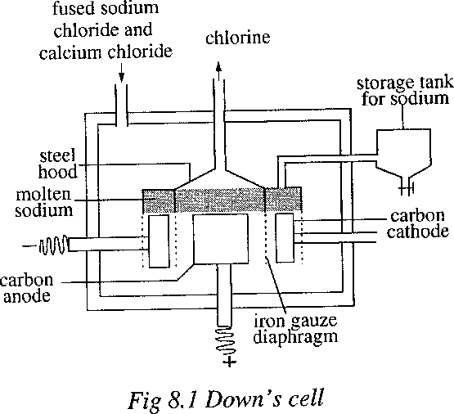

### Uses of sodium metal

1. It is used in the manufacture of anti-knock compound, tetraethyl lead, added to petrol (regular) to make it super which does not make the engine knock. ―Knocking‖ in a car engine is caused by the petrol and air mixture burning too rapidly in the cylinders, giving a sudden blow or knock to the piston, which is not good for the engine. Tetraethyl lead slows down the combustion process of a mixture of petrol and air.
2. It is used in manufacture of sodium cyanide which is used in extraction of gold.
3. Used in nuclear reactions to absorb some of the heat produced during the reactions.

### Copper

The principal ores of copper are copper pyrites (CuFeS2), cuprite (Cu2O), copper(I) sulphide (Cu2S) and malachite (CuCO3.Cu(OH)2).

### Extraction of copper

Copper pyrites is the ore usually used for the extraction of copper and there are three stages involved.

1. The concentration of the ore to remove impurities.
2. Roasting and reduction.
3. Refining of the impure copper.

### Concentration of the ore

The ore is concentrated by a process of **froth flotation**. The ore is crushed into a fine powder and poured into a tank containing water and a frothing agent such as pine oil. Compressed air is blown into the tank to keep the mixture in constant agitation. As a result of agitation, impurities sink to the bottom of the tank. The ore particles stick to the frothing agent and float on the surface. The ore particles with the frothing agent are skimmed off and dried. Sulphuric acid is added to separate the ore from the frothing agent.

### Roasting and reduction

The ore is roasted in air to produce copper(I) sulphide. 2CuFeS2 (s) + 4O2(g) →CuS(s) + 3SO2(g) + 2FeO(s)

Sulphur dioxide escapes from the top of the furnace. By adding silicon dioxide, SiO2, and heating in absence of air, the iron(II) oxide is converted into a slag of iron(II) silicate, FeSiO3, which floats on top of the molten copper(I) sulphide and it is tapped off.

FeO(s) + SiO2(s) →FeSiO3(1)

Copper(I) sulphide is reduced to the metal by heating a regulated supply of air. Cu2S(s) + O2(g) → 2Cu(s) + SO2(g)

This copper produced is impure and is called blister copper because of the blistered appearance on the copper surface caused by the escaping gases on cooling.

### Refining of the impure copper

The impure copper is purified (refined) by electrolytic process using copper(II) sulphate solution as the electrolyte. The cathode is pure copper and the impure copper is made the anode as shown in figure 8.2.

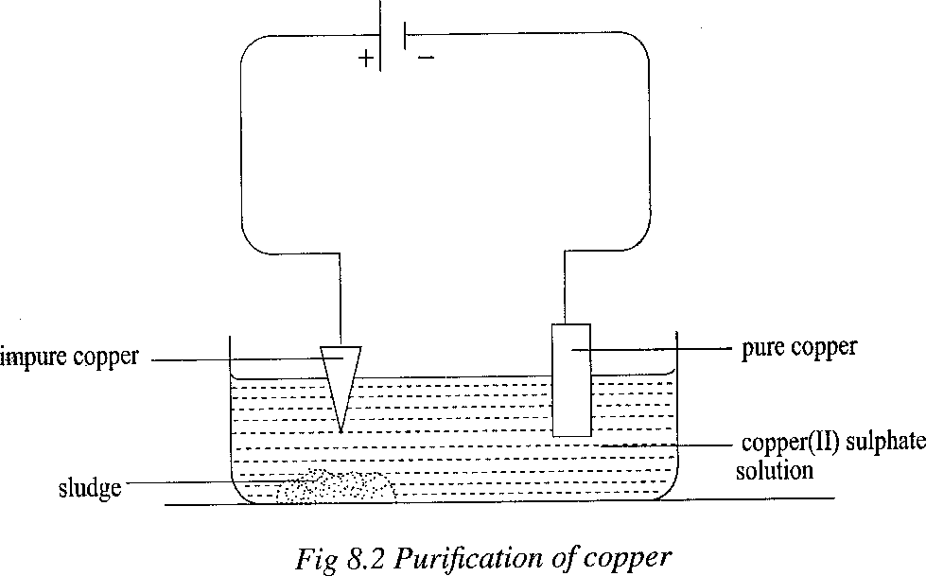

During electrolysis, the copper atoms of the anode lose electrons to form copper(II) ions which dissolve in the solution.

Cu(s) → Cu2+(aq) + 2e-

Then the copper(II) ions are attracted to the cathode where they gain electrons and become copper atoms.

Cu2+(aq) + 2e- → Cu(s)

The overall effect is that copper gradually dissolves from the anode and is deposited on the cathode. Copper from the cathode is removed by stripping.

Impurities which are higher than copper in the activity series, such as iron, also dissolve from the anode but are not deposited on the cathode. They accumulate in solution in the electrolyte. Impurities which are lower than copper in the activity series do not dissolve at all. They fall to the bottom of the container as sludge. The elements which were present in the original copper ore.

### Uses of copper

1. Copper is used as a conductor of electric power in wires and cables.
2. It is used for making bronze which is used for manufacturing ball bearings.
3. It is used for making kettles for brewing beer.
4. Used for making roofing sheets because it is corrosion resistant.

### Iron

The main iron ores are haematite (Fe2O3), magnetite (Fe3O4), iron disulphide (pyrites, FeS2) and spathic iron ore (FeCO3).

### Extraction of iron

Haematite and magnetite are the most commonly used ores for the extraction of pure iron. The ore is first mixed with coke and limestone and the mixture is fed into the blast furnace from the top of the furnace (figure 8.3). Hot air is blown into the furnace at the bottom which comes into contact with the red hot coke, producing carbon dioxide.

C(s) + O2(g) →CO2(g)

Higher up the furnace, the source of oxygen is less and more coke combines with carbon dioxide produced to form carbon monoxide.

C(s) + CO2(g) → 2CO(g)

Carbon monoxide produced reduces the iron oxides to molten iron. Fe3O4(s) + 4CO(g) →3Fe(l) + 4CO2(g)

Fe2O4(s) + 3CO(g) → 2Fe(l) + 3CO2(g)

Molten iron runs to the bottom of the furnace and is tapped off into moulds where it is solidified. The moulds are called ‗Pigs‘ and therefore this impure form of iron is called pi- iron. Limestone is decomposed by heat to calcium oxide and carbon doxide.

CaCO3(s) →CaO(s) + CO2(g)

The iron contains impurities such as silicon dioxide (sand), which combine with calcium oxide to form a molten slag that floats on top of the molten iron and it is tapped off.

CaO(s) + SiO2(s) → CaSiO3(l)

The wastes gases, mainly nitrogen and oxides of carbon, escape from the top of the furnace. They are used in a heat exchange process of heat incoming air and so help to reduce the energy costs of the process. Slag is used in making road foundations, phosphorus fertilizers and cement.

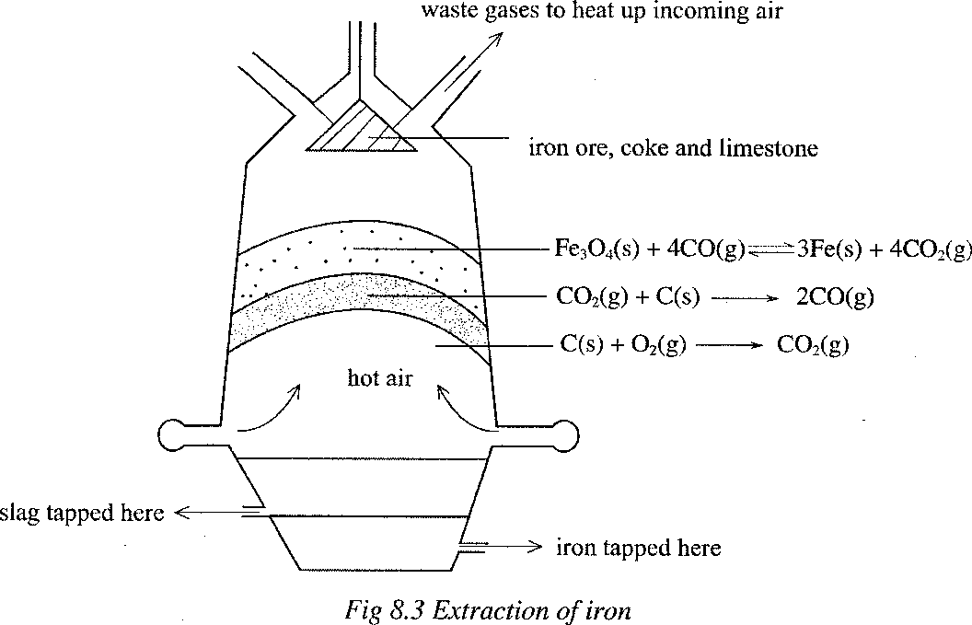

### Casting iron (pig-iron)

This is impure iron containing impurities such as carbon, sulphur, phosphorus and silicon. It has a low melting point and it is brittle. It is used in places where it cannot be subjected to great strain or stress, for example, in manufacture of Bunsen burner bases and domestic boilers.

### Wrought iron

This is the purest form of iron and is obtained from cast iron by heating it with iron(III) oxide in a furnace lined with limestone. Iron(III) oxide supplies oxygen for the oxidation process. When hot air is fed into the furnace, non-metallic impurities such as carbon and sulphur are oxidized to their oxides and are removed as waste gases.

C(s) + O2(g) →CO2(g)

S(s) + O2(g) →SO2(g)

Phosphorus and silicon are oxidized to solid oxides.

4P(s) + 5O2(g) →2P2O5(s)

Si(s) + O2(g) →SiO2(s)

Calcium oxide (from decomposition of limestone) reacts with these solid oxides, forming calcium phosphate and calcium silicate, which float on the surface of the iron as slag.

3CaO(s) + P2O5(s) →Ca3(PO4) 2(l)

CaO(s) + SiO2(s) → CaSiO3(l)

Wrought iron is malleable. It is very tough and therefore can withstand some strain. It can be used to make iron nails, iron sheets and agricultural implements.

### Steel

Steel is an alloy of pure iron with a small percentage of carbon and other elements. Other such as tungsten, chromium, nickel and manganese which are added to produce types of steel (table 8.1) with different properties. Steel is hard, tough, strong and malleable.

|  |  |  |
| --- | --- | --- |
| **S t e e l** | **C o m p o s i t i o n** | **U s e s** |
| M i l d s t e e l | 99% iron, 0.5% carbon | Car bodies, large structures |
| H a r d s t e e l | 9 9 % i r o n , 1 % c a r b o n | Cutting tools, razor blades |
| Manganese steel | 87% iron, 13% manganese | D r i l l b i t s , s p r i n g s |
| S t a i n l e s s s t e e l | 74% iron, 18% chromium, 8% nickel | Cutlery, kitchen sinks, surgical instruments |
| T u n gst en s t e e l | 95% iron, 5% tungsten | Edges of high-speed cutting tools |

Table 8.1 Different types of steel

### Recycling of metals

With increasing use of metals, natural deposits of metal ores will eventually run out. The metal ores will last longer if metals are recycled. For example, tin can be removed from scrap food cans to be reused in making new food cans.

Metal ores can also be made to last longer by use of alternative materials. For example, instead of using iron, plastic materials can be used in making dustbins. Many parts of cars are now made of plastic materials. This is also advantageous in that plastic materials do not corrode and can be moulded into much more complex shapes and textures than the metals which they have replaced.

### Alloy

An alloy is a metallic substance consisting of a mixture of two or more metals or a mixture of a metal with a non-metal. Alloys have suitable properties when compared with pure metals. Alloys are usually less malleable and ductile than pure metals. They also have low melting points and electrical conductivity than pure metals. For example, solder has a lower melting point than lead and tin. Because of its low melting point, solder can be used to join metals. Examples of common alloys are given in table 8.2.

|  |  |  |
| --- | --- | --- |
| **A l l o y** | **C o m p o s i t i o n** | **U s e s** |
| B r a s s | C o p p e r a n d z i n c | Ornaments, buttons and screws |
| B r o n z e | C o p p e r a n d t i n | O r n a m e n t s |
| D u r a l u m i n | Aluminium with small amounts of magnesium, manganese and copper | Aircraft and bicycle parts |
| S o l d e r | T i n a n d l e a d | J o i n i n g m e t a l s |
| S t e e l | R e f e r t o t a b l e 8 . 1 | R e f e r t o t a b l e 8 . 1 |
| Copper coinage | C o p p e r , t i n a n d z i n c | C o i n s |
| T y p e m e t a l | L e a d , a n t i m o n y a n d t i n | P r i n t i n g |
| Silver coinage | C o p p e r a n d n i c k e l | C o i n s |

Table 8.2 Common alloys

### Exercise

1. (a) Extraction of metals is essentially a reduction process. Explain the statement using extraction of iron as an example. Write the equation to illustrate your answer.
2. State the conditions under which iron may react with
   1. Oxygen.
   2. Water.
   3. Chlorine.
3. Write an equation for the reaction in (b) (ii) and (iii).
4. Steel is an alloy of iron.
   1. Explain what is meant by an alloy.
   2. Name the elements which are used in making stainless steel.
   3. State one use of stainless steel.
   4. Suggest a reason why the use of stainless is preferred to that of pure iron.
5. (a) Sodium metal is extracted by electrolysis of fused sodium chloride to which calcium chloride has been added.
   1. Give a reason for the addition of calcium chloride.
   2. Name a material that can be used as the cathode and another that can be used as the anode.
   3. Write equations for the reaction that take place at each electrode.
   4. Describe how the product at the cathode is collected.
   5. Name one other element that can be extracted by similar method.
6. Name a place in Uganda where a plant for the extraction of sodium could be constructed. Give a reason for your answer.
7. Describe what would be observed if a small piece of sodium metal was heated and quickly plunged into a gas-jar of oxygen. Write an equation for the reaction that takes place.
8. Iron is extracted by a reduction process in the blast furnace.
9. Name two raw materials used besides the iron ore.
10. Write the equation leading to the production of iron from its ore.
11. State one use of iron.
12. State what is observed when iron nail, is dropped in beaker of copper(II) sulphate solution.
13. (a) (i) What is an alloy?

(ii) Give an example of an alloy.

(b) State two uses of the alloy in a (ii)

1. (a) Name one ore of iron and write its formula.
2. During the extraction of iron, limestone and coke are added into the blast furnace. Explain why each of the following are added into the blast furnace.
   1. Coke
   2. Limestone

### 26. Organic chemistry

* 1. **Introduction**

Organic chemistry is a branch of chemistry dealing with compounds of carbon except oxides of carbon, carbonates, hydrogencarbonates and carbides of metals. Carbon has the ability to form bounds to itself. These bounds are very strong and can be single, double or triple bonds. Owing to this fact, chains of varying sizes can be formed which contribute to a wide range of stable compounds. These compounds are known as organic compounds. Carbon forms four covalent bonds making it possible to have different groups attached to the chains of carbon atoms. This will also lead to a wide diversity of compounds being formed.

### Hydrocarbons

Hydrocarbons are compounds containing hydrogen and carbon atoms. They have a molecular formula, CxHy, where x and y are whole numbers. They are classified into several types according to their structures. The main classes of hydrocarbons are alkanes, alkenes and alkynes.

### Homologous series

A series of compounds related to each other is called a homologous series e.g. alkanes, alkenes and alkynes. Each member is called a **homologue.** A homologous series has the following characteristics.

1. All members conform to a general molecular formula. For example, in case of alkanes, the general molecular formula is CnH2n+2 where n≥1.
2. Each member differs in molecular formula from the next by CH2, for example members of the alkanes are CH4, C2H6, C3H8 and so on.
3. All members show similar chemical reactions though they vary in vigour.
4. The physical properties of members change gradually in the same direction along the series.

### Functional groups

A functional group is the most reactive part of any organic compound. It determines the chemical properties of the homologous series. For example, for alkanes, alkenes, alkynes and alcohols, the functional groups are carbon-hydrogen bond, carbon-carbon double bond, carbon-carbon triple bond and hydroxyl group (-OH) respectively.

### Alkanes

Alkanes are hydrocarbons with the general molecular formula, CnH2n+2, where n ≥ 1, for example methane (CH4), ethane (C2H6), propane (C3H8), butane (C4H10), pentane (C5H12), hexane (C6H14), heptanes (C7H16), octane (C8H18), nonane (C9H20), decane (C9H22) et. Alkanes are **saturated hydrocarbons.** This means that the molecules of alkanes consist of carbon and hydrogen atoms and single covalent bonds only. In other words, all the atoms exert their usual combining power with other atoms. That is each carbon atom is bonded to four other atoms. This is illustrated below.

H H

׀׀

H – C – C – H Ethane

׀׀

H H

### Structural formula

The structural formula shows the sequence and arrangement of atoms in a molecule. For example, the structural formula of propane is shown below.

H H H

׀׀ ׀

H – C – C – C – H or CH3CH2CH3

׀׀

H H

### Exercise 9.1

Write the structural formula for each of the following hydrocarbons.

1. Hexane
2. Butane

### Alkyl groups

Removal of one hydrogen atom from an alkane molecule leaves a monovalent group called an alkyl group. Table 9.1 shows some groups and their molecular formulae.

|  |  |  |  |
| --- | --- | --- | --- |
| **A l k a n e** | **Molecular formula** | **Alkyl group** | **Molecular formula** |
| M e t h an e E t h a n e P ro p an e B u t a n e P e nt an e | C H 4  C 2 H 6  C 3 H 8  C 4 H 1 0  C 5 H 1 2 | M e t h y l E t h y l P r o p y l B u t y l P e n t y l | C H 3 -  C 2 H 5 -  C 3 H 7 -  C 4 H 9 -  C 5 H 1 1 - |

### Nomenclature of alkanes

The general rules of naming organic compounds were laid down by the International Union of Pure and Applied Chemistry (I.U.P.A.C.)

### Rules of naming alkanes:

1. The first step is to choose the longest chain of carbon atoms which is called the parent chain. In the structural formula below, the longest chain has eight carbon atoms and thus it is taken as the parent chain and it is called octane.

CH3

׀ 4׀

3

CH3 – CH – CH – CH2 – CH2 – CH2 – CH2

׀

2CH3

׀

It is possible at times to have longest chains of carbon atoms and the one which is taken as a parent chain is that one which has a higher number of the chains. In the structural formula below, the parent chain has three side chains and it is called heptanes.

1. After identifying the parent chain, the carbon atoms are numbered from one end to the other. The numbering should be in such a way that the carbon atoms carrying the side chain gets the lowest number and the position of the side chain is indicated by the number assigned to the carbon atom to which it is attached.
2. If there are more than one side chain, then the numbering of the carbon atoms is done in such a way that the sum of the numbers used to locate the side chains is lowest and this is called the lowest sum rule. Consider the structural formula below.

From left to right, the sum of the numbers where the side chains are attached

= 2 + 3 + 6 = 11

From right to left, the sum of the numbers where the side chains are attached

= 2 + 5 + 6 = 13

Therefore, the numbering is from left to right and hence the name of the compound is 2,3,6-trimethylheptane.

1. If there is more than one type of side chain, then the side chains are prefixed and should be put in alphabetical order preceding the name of the parent chain.

In case of a particular side chain appearing twice of three times, then di, tri, tetra, pent etc, are used. The locants (numbers used to locate a side chain) are written in increasing order separated by commas and hyphens (-) separates the numbers from the prefix. Refer to the example in (c), that is 2,3,6-trimethylheptane.

### Exercise

1. Give the names of the following structural formulae.
   1. CH
   2. Ch
   3. Ch
   4. Ch
   5. Ch
2. Write the structural formula of the following compounds.
   1. 2,2-dimethylpentane
   2. 3-ethylhexane
   3. 2-methylpropane

### General properties of alkanes

* + - 1. **Physical properties**

1. The first four members are gases, the next twelve members are liquids and the rest are waxy solids at room temperature.
2. They are insoluble in water but soluble in non-polar solvents like trachloromethane.
3. They are less dense than water. Their densities rise gradually with increasing molecular mass.

### Chemical properties

1. Alkanes burn in air forming carbon dioxide and water. CH4(g) + 2O2(g) → CO2(g) + 2H2O(g)

In a limited supply of air, carbon monoxide is formed. 2CH4(g) + 3O2(g) → 2CO(g) + 4H2O(g)

During combustion, a great deal of heat is liberated. Owing to that fact, alkanes are used as fuels for industrial and domestic purposes. For example, butane is used in gas cigarette lighters. Methane is found in natural gas and bio gas. It is used in gas appliances. Butane found in petrol is used to run petrol engines.

1. They undergo substitution reactions with the halogens, producing corresponding compounds. **A substitution reaction** is a reaction in which one atom or group of atoms in a molecule is replaced by another. For example, methane reacts with chlorine forming chloromethane and hydrogen chloride, the reaction being catalysed by light (photo catalysis).

CH4(g) + Cl2(g) → CH3Cl(g) + HCl(g)

One hydrogen atom of the methane molecule has been replaced by a chlorine atom. In a similar way, excess of chlorine may produce dichloromethane (CH2Cl2), trichloromethane (CHCl3) and tetrachloromethane (CCl4).

CH3Cl(g) + Cl2(g) → CH2Cl2(l) + HCl(g)

Dichloromethane CH2Cl2(g) + Cl2(g) → CHCl3(l) + HCl(g)

Trichloromethane CHCl3(g) + Cl2(g) → CCl4(l) + HCl(g)

tetrachloromethane

### Exercise

When a mixture of ethane and chlorine was exposed to sunlight, the colour of chlorine disappears.

1. Write the equation for the reaction that takes place when ethane is mixed with a limited amount of chlorine.
2. Name the type of reaction.
3. What is the role of sunlight in this reaction?

### Isomerism

Isomerism is the occurrence of two or more compounds with the same molecular formula but different structural formulae. Compounds which have the same molecular formula but different structural formulae are called **isomers.** All alkanes with more than four carbon atoms have more than one structure for a given molecular formula, that is, they exhibit isomerism. The greater the number of carbon atoms in an alkane, the greater the number of possible isomers.

The easiest way of finding the isomers is to draw the longest chain of carbon atoms first and reduce it by one carbon atom at a time.

Isomers of butane (molecular formula, C4H10)

Isomers of pentane (molecular formula, C5H12)

### Exercise

Compound Q has a molecular formula, C6H14. Give the structural formulae and names of possible isomers of compound Q.

### Petroleum (crude oil)

Petroleum is an organic mineral. Petroleum was formed from the remains of plants and animals which lived millions of years of ago. Their dead bodies sank to the bottom of seas and were soon covered with mud and sand. The chemical effects of pressure, heat and bacteria converted the remains into petroleum. Petroleum is composed mainly of hydrocarbons although some of its constituents contain elements such as oxygen, sulphur and nitrogen.

### Fractional distillation of petroleum

Petroleum is a complex mixture of gases, liquids and solids. Its components can be separated by fractional distillation. Petroleum is pumped through a furnace where it is heated by electricity or gas in a furnace to about 400oC. The hot liquid crude oil is then passed into a fractionating tower which consists of trays and bubble caps placed at different levels of different temperatures. In other words, each tray is a little cooler than the one below because it is a little further from the source of heat. As the hot mixture of gases and vapours passes up the tower from tray to tray via bubble caps, the various vapours condense at different levels, according to their boiling points. The products which are gases at room temperature leave at the top of the tower as shown in figure 9.1. The fractions (groups of compounds of similar size) collected in each tray are tapped off and redistilled. After fractional distillation, impurities are removed. The commonest impurity is sulphur, which is removed and used to manufacture sulphuric acid. The table 9.2 shows the different fractions of crude oil and their uses.

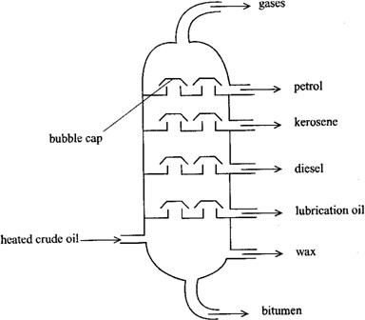

Straight-chain alkanes obtained from the fractional distillation of crude oil, are purified and mixed with an aqueous solution of yeast. The yeast acts on the alkanes and converts them to proteins, which are separated out and dried. The end-product is a powder which is used as animal feed.

|  |  |
| --- | --- |
| **F r a c t i o n** | **U s e s** |
| 1. Gas ( propane and butan | Fuel for cooking and lighting |
| 2. P e t r o l | M o t o r a n d a v i a t i o n f u e l |
| 3. P a r a f f i n o i l ( k e r o s e n e | L i g h t i n g a n d h e a t i n g |
| 4. G a s o i | T o m a k e p e t r o l |
| 5. D i e s e l o i | D i e s e l e n g i n e s |
| 6. L u b r i c a t i n g o | Lubrication in machine parts |
| 7. W a x e s a n d b i t u m e | Vaseline, greases and candles  Road and runway surfacing |

Table 9.2 Fractions of crude oil and their uses

### Cracking

Fractional distillation of crude oil yields only about 20 percent of petrol. With the demand for petrol increasing, it has become necessary to devise a new process of obtaining it, that is, by cracking of gas oil. **Cracking** is the process of breaking down the long chain hydrocarbons into shorter-chain molecules. Large molecules of oils can be broken down into smaller molecules of petrol and gases by cracking.

C10H22 → C7H16 + C3H6(g)

oil petrol

The molecules of petrol contain 5-9 carbon atoms and gases are mainly alkenes containing 2 to 4 carbon atoms.

### Bio gas

Bio gas is formed by the anaerobic action of bacteria on cellulose and other organic matter. Bio gas contains 65-75% methane and other gases include carbon dioxide, ammonia and hydrogen sulphide. The source of bio gas is animal wastes and to some extent plant wastes. A simple bio gas generator consists of a container in which animal wastes or plant wastes are mixed with a limited amount of water and then covered to exclude aerial oxidation. At temperatures of 25-30oC, the anaerobic bacteria present decompose the wastes to form bio gas. Bio gas is used for cooking and lighting purposes.

### Advantages of bio gas production

1. Bio gas is cheap to produce.
2. The solid by-product is used as fertilizers since it contains a high nitrogen content.

### Disadvantages of bio gas production

Some of the gases contained in bio gas are air pollutants. When bio gas is burnt, sulphur dioxide is formed by oxidation of hydrogen sulphide.

2H2S(g) + 3O2(g) → 2H2O(g) + 2SO2(g)

Sulphur dioxide leads to the formation of acid rain which results in damage to plants and aquatic organisms (refer to the effects of air pollution, chapter 12). Hydrogen sulphide reacts with many metals. The tarnishing of silver objects is due to the reaction with hydrogen sulphide to form silver sulphide, which is black. Paints which contain lead compounds are also discoloured, due to the formation of black lead(II) sulphide. Hydrogen sulphide and ammonia, which are contained in bio gas, cause eye irritation.

### Alkenes

The alkenes are members of a homologous series of general molecular formula, CnH2n, where ≥ 2. They are characterized by a carbon-carbon double bond as their functional group and therefore alkenes are unsaturated compounds. An **unsaturated compound** is one in which some atoms do not exert all their combining powers with other atoms. For example in alkenes, not all the carbon atoms are bonded to four other atoms as illustrated below.

### Nomenclature

In accordance with I.U.P.A.C. system, alkenes are named by dropping the ending ‗ane‘ from the names of the corresponding alkenes and replacing it with the suffix ‗ene‘ for example ethane (C2H4), propene (C2H6), butane (C4H8), pentene (C5H10) etc.

### Ethene

* + 1. **Laboratory preparation of ethene**

Ethene is obtained by dehydration of ethanol by excess hot concentrated sulphuric acid. The experiement is set up as shown in figure 9.2. The mixture is heated with care to about 180oC. Ethene is evolved and is passed through a bottle containing sodium hydroxide solution to remove sulphur dioxide, a by-product in small amount formed as the ethanol reduces sulphuric acid slightly. Ethene is collected over water since it is insoluble in water.

CH3CH2OH(1) → CH2=CH2(g) + H2O(g)

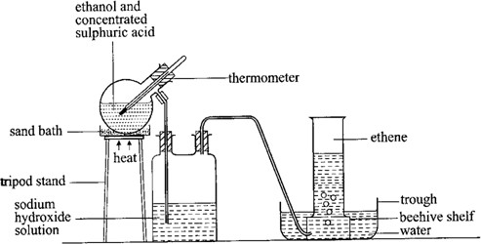

When the reaction is complete, the junction between the flask and the bottle should be disconnected to avoid the possibility of sodium hydroxide solution ―sucking back‖ into hot concentrated sulphuric acid.

### Properties of ethene

Ethene as the first alkene may be used to indicate some of the physical and chemical properties of alkenes.

### Physical properties

1. Ethene is a colourless, sweet smelling and non-poisonous gas.
2. It is slightly less dense than air.
3. It is insoluble in water but soluble in organic solvents.

### Chemical properties

1. **Combustion**

Ethene burns in air and the products of complete combustion are carbon dioxide and steam. The flame tends to be smoky due to unburnt carbon because of the high proportion in ethen.

C2H4(g) + 3O2(g) → 2CO2(g) + 2H2O(g)

### Addition reactions

Alkenes are reactive compounds because the double bonds are readily converted to single bonds by addition of other atoms. So ethene undergoes addition reactions. An **addition reaction** is a reaction I which a molecule adds to an unsaturated molecule by breaking a double or a triple bond.

### (i) Reaction with bromine

When ethene is passed through liquid bromine, the liquid becomes colourless. This acts as a distinguishing test between saturated compounds such as alkanes and unsaturated ones such as alkenes and alkyenes.

CH2=CH2(g) + Br2(l) → BrCH2CH2Br(l)

1,2-dibromoethane

Addition of bromine across the double bond takes plae readily in the presence of an organic solvent such as tetrachloro methane (CCl4) or ether. The solvent dissolves the halogen to form a solution such that when ethene is bubbled through the solution, the reaction takes place more efficiently.

### (ii) Reaction with bromine water

Bromine dissolves partially in water to form a solution called **bromine water** which contains hypobromous acid and hydrobromic acid.

Br2(l) + H2O(l) → HOBr(aq) + HBr(aq)

Since hydrobromic acid is a volatile liquid (can easily vaporize), hypobromous acid remains in the solution to participate in the reaction with the alkene.

CH2=CH2(g) + HOBr(aq) → Br-CH2CH2-OH(aq)

2-bromoethanol

Therefore, when ethene is bubbled through bromine water, the red colour of bromine water is discharged.

### Reaction with hydrogen

Ethene combines with hydrogen if the two are passed over finely divided nickel catalyst at about 150oC. Platinum catalyst is used at room temperature. The reaction is called **catalytic hydrogenation.**

CH2=CH2(g) + H2(g) → CH3CH3 (g)

CH2=CH2(g) + H2(g) → CH3CH3 (g)

This reaction is applied in changing double bonds in vegetable oils into single bonds. For example in margarine production. The hardening of liquid vegetable oils into solid fats is called **addition hydrogenation.** The oil is heated and mixed with a finely divided nickel catalyst, and then hydrogen is blown through the mixture under pressure.

* 1. Ethene decolourises acidified or alkaline potassium permanganate solution (from purple to colourless). Also this reaction is a characteristic test for an unsaturated compound.

### Uses of ethene

1. In the manufacture of plastics such as polyethene.
2. In the manufacture of ethanol.
3. In the process of ripening of fruits.

### Exercise

1. The compound with the molecular formula C10H22 can undergo the following reaction:

C10H22 → C8H18 + W

* 1. Name the process involved in this reaction.
  2. To which hydrocarbon series does W belong?
  3. Name gas W.
  4. Write the equation for complete combustion of gas W.
  5. Gas W was bubbled through
     1. Bromine.
     2. Bromine water.
  6. Write the equation for the reaction that took place in e(i) and (ii).
  7. Name the product formed in e(i)

1. Two hydrocarbon compounds are represented by the molecular formulae, C3H6 and C3H8
   1. To which hydrocarbon series does each of them belong?
   2. Give the name of each compound.
   3. Describe any chemical test that can be used to distinguish between the two compounds.
   4. Which one of the compounds is unsaturated?
   5. The unsaturated compounds named in (d) was reacted with hydrogen under certain conditions.
      1. State the conditions necessary for the reaction to take place.
      2. Name the type of reaction.
      3. State one industrial application of the type of reaction named in (ii).

### Alkynes

Alkynes are a homologous series of unsaturated hydrocarbons of the general formula, CnH2n-2, where n ≥ 2. They contain carbon-carbon triple bond (– C ≡ C –) as the functional group. They are unsaturated compounds.

### Nomenclature

The alkynes are named by dropping the ending ‗ane‘ of the corresponding alkane and replacing it with the suffix ‗yne‘. The table 9.3 shows the molecular formulae and names of the first five alkynes.

|  |  |
| --- | --- |
| **A l k y n e** | **Molecular formula** |
| E t h y n e | C 2 H 2 |
| P r o p y n e | C 3 H 4 |
| B u t y n e | C 4 H 6 |
| P e n t y n e | C 5 H 8 |
| H e x y n e | C 6 H 1 0 |

Table 9.3 Molecular formulae and names of first five alkynes

### Ethyne (acetylene)

Ethyne as the first alkyne may be used to indicate some of the physical and chemical properties of alkynes.

### Physical properties of ethyne

1. Ethyne is a colourless, odourless and sweet smelling gas.
2. It is slightly soluble in water.

### Chemical properties of ethyne

1. **Combustion**

Ethyne burns in air with a yellow sooty flame forming carbon dioxide and steam. The reaction is exothermic. The soot is due to unburnt carbon because of its high content in ethyne.

2C2H2(g) + 5O2(g) → 4CO2(g) + 2H2O(g)

### Addition reactions

The triple bond in ethyne contributes a lot to its chemical properties. Ethyne undergoes addition reactions with the substances that react with alkenes except that ethyne reacts more slowly than alkenes. For example, it takes ethyne sometime to decolourize bromine unlike ethene which does it almost instantaneously.

* 1. Ethyne decolorizes bromine. The triple bond is first converted into a double bond, then into a single bond.

HC ≡ CH + Br2 → Br-CH = CH-Br

1,2-dibromoethene Br-CH=CH-Br + Br2 → Br2CHCHBr2

1,1,2,2-tetrabromoethane

* 1. A mixture of ethyne and hydrogen when passed over a nickel catalyst at about 150oC produces ethene.

HC ≡ CH + H2 → CH2=CH2

Further hydrogenation can occur and the final product is ethane.

CH2=CH2 + H2 → CH3CH3

### Uses of ethyne

1. Used in manufacture of polyvinyl chloride plastic which has a wide variety of uses.
2. Used in oxy-acetylene flame, used in welding and metal cutting.

### Exercise

Two hydrocarbon compounds, Q ans Z, are represented by the molecular formula C5H12 ans C3H4 respectively.

1. Give the name of each hydrocarbon.
2. To which homologous series does each of them belong?
3. Which hydrocarbon contains multiple bonds?
4. Write the equation for complete combustion of Z.
5. Name the products of incomplete combustion of Z.

### Alkanols (alcohol)

Alkanols are a homologous series of the general formula, CnH2n+1OH, where n ≥ 1. The functional group of the alkanols is the hydroxyl group (-OH).

### Nomenclature

Alcohols are systematically named as alkanols, that is, the name is a particular member is obtained by dropping the ending ‗e‘ of the corresponding alkane and replacing it with the suffix ‗o1‘. The table 9.4 shows the molecular formulae and name of the first five alkanols.

|  |  |  |
| --- | --- | --- |
| **Number of carbon atoms** | **Molecular formula** | **N a m e** |
| 1 | C H 3 O H | M e t h a n o l |
| 2 | C 2 H 5 O H | E t h a n o l |
| 3 | C 3 H 7 O H | P r o p a n o l |
| 4 | C 4 H 9 O H | B u t a n o l |

|  |  |  |
| --- | --- | --- |
| 5 | C 5 H 1 1 O H | P e n t a n o l |

Table 9.4 Molecular formulae and names of first five alkanols

### Ethanol (ethyl alcohol)

* + 1. **Manufacture of ethanol**

Ethanol is prepared by fermentation of sugars in the presence of yeast. **Fermentation** is a process in which sugars are decomposed by enzymes into alcohol. Cassava is crushed and heated in steam under pressure to extract starch. Starch is treated with malt (partially spouted barley) for an hour at 60oC. Malt supplies an enzyme, diastase, which hydrolyses starch to sugar, maltose.

2C6H10O5(aq) + H2O(1) → C12H22O11(aq)

starch maltose

Yeast is then added at room temperature and one of its enzymes, **maltase**, catalyses the hydrolysis of maltose to glucose.

C12H22O1(aq) + H2O(1) → 2C6H12O6(aq)

glucose

Another enzyme present in yeast, **zymase**, catalyses the decomposition of glucose to ethanol and carbon dioxide.

C6H12O6(aq) → 2C2H5OH(aq) + 2CO2(g)

The resulting solution is crude ethanol which is converted to pure ethanol by fractional distillation.

In Uganda, locally crude ethanol (known as ―Tonto‖) is obtained from bananas. Juice is extracted from ripe bananas by squeezing them using spear grass leaves or banana leaves. The juice is filtered to remove any solid impurities. The filtrate (juice) is then poured into a locally made wooden container where it is mixed with ground roasted sorghum. The container is covered and the mixture is allowed to ferment for two days. The resulting solution is crude ethanol, locally known as ―Tonto‖.

Alternatively, millet is ground to flour and the flour is mixed with water to form a paste which is covered in a container or buried in the ground for a few days so that it can ferment. The fermented paste is removed and roasted to obtain malt. Miller grains are soaked in water for sometime and allowed to germinate. It is then dried to give yeast. Yeast is added to malt in appropriate proportion. A carefully determined amount of water is then added to the mixture of yeast and malt to form a liquid mixture. The mixture is covered and stored in a warm place for about 3 to 4 days so that an alcoholic drink locally called ―Malwa‖ is formed.

### Properties of ethanol

Ethanol is a colourless liquid with a burning taste. It is soluble in water. It is a hygroscopic substance.

### Chemical properties

1. **Combustion**

Ethanol burns in air with a blue flame to give carbon dioxide and water. The reaction is exothermic.

C2H5OH(l) + 3O2(g) → 2CO2(g) + 3H2O(l)

### Dehydration of ethanol

When excess concentrated sulphuric acid is added to ethanol and the mixture heated to 180oC, ethanol is dehydrated to ethene.

C2H5OH(l) → C2H4(g) + H2O(l)

It is sometimes called elimination reaction because a molecule of water is eliminated from the alcohol to form an alkene.

### Reducing properties

Ethanol can be oxidized to ethanoic acid by an acidified solution of potassium dischromate. During the reaction, the orange solution of acidified potassium dichlomate turns green.

C2H5OH → CH3COOH

ethanoic acid

Also ethanol decolourises acidified potassium permanganate solution. C2H5OH → CH3COOH

### Uses of ethanol

1. Ethanol is used as a solvent for perfumes, vanishes, paints and preparations.
2. It is used in manufacture of organic compounds such as ethanoic acid.
3. Used in alcoholic drinks such as beer, wines and spirits.
4. Ethanol is used as a fuel.

### Exercise

1. When ethanol reacts with concentrated sulphuric acid, a hydrocarbon T is formed.
   1. Give the name of the hydrocarbon T.
   2. To which homologous series does the hydrocarbon T belong?
   3. State the conditions necessary for the reaction to take place.
   4. Name the type of reaction that occurs.
2. (a) State what is observed when methanol is added to acidified potassium dichromate and the mixture heated.

(b) Name the product formed.

### Carboxylic acids and esters Carboxylic acids (Alkanoic acids)

Carboxylic acids are compounds of the homologous series of the general molecular formula CnH2n+1COOH. In this series, CnH2n+1 represents the alkyl (R) groups. So carboxylic acids can be written as RCOOH. The functional group of members in this series is the carboxyl group (-COOH). They are sometimes called **organic acids.**

### Nomenclature

Carboxylic acids are named as derivatives of alkanes by dropping the ending ‗e‘ of the corresponding alkane and replacing it with the suffix ‗oic‘ and the functional group is always at the end of the chain. The first three members in the series are methanoic acid (HCOOH), ethanoic acid (CH3COOH) and propanoic cid (CH3CH2COOH).

### Properties of carboxylic acids

1. **Acidic character**

When carboxylic acids dissolve in water, the solution formed turns blue litmus paper red. When carboxylic acids dissolve in water, they are slightly ionized, that is they are weak acids.

CH3COOH(aq) → CH3COO-(aq) + H+(aq)

ethanoic acid ethanoate ion

* 1. Carboxylic acid react with strongly electropositive metals liberating hydrogen gas.

CH3COOH + 2Na → 2CH3COONa + H2

sodium ethanoate

* 1. Carboxylic acids react with bases to form salt and water. CH3COOH + NaOH → CH3COONa + H2O

CH3COOH + ZnO → (CH3COO) 2Zn + H2O

zinc ethanoate

* 1. Carboxylic acid reacts with carbonates and hydrogencarbonates liberating carbon dioxide.

CH3COOH + NaCO3 → 2CH3COONa + H2O + CO2

### Formation of esters

When a carboxylic acid reacts with an alcohol, a sweet smelling compound called ester is formed.

CH3COOH + C2H5OH → CH3COOC2H5 + H2O

Ethylethanoate (ester)

### Esters

Esters have a formula, RCOOR1, where R and R1 are alkyl groups. Long-chain carboxylic acids are very often referred to as ―fatty‖ acids because their chief source is from esters in animal fats and vegetable oils. Fats and oils are esters occurring naturally in plants and animals. Esters produced from saturated fatty acids are usually solids at room temperature and are called **fats.** Esters obtained from unsaturated fatty acids are usually liquids at room temperature and are called **oils.**

When a mixture of sodium hydroxide or potassium hydroxide solution and an ester is heated, the ester is hydrolysed to form sodium salt. The alkaline hydrolysis of any ester is called **saponification.**

RCOOR1+ NaOH(aq) – RCOONa + R1OH.

### Uses of esters

1. Used for making soap.
2. Used as a solvent for drugs and antibiotics.
3. Used for artificial flavouring.
4. Higher esters such as wax can be used for making candle.

### Soap

Soap is a sodium or potassium salt of a long-chain carboxylic acid, that is, potassium stearate (C17H35COOK) and sodium stearate (C17H35COONa).

### Manufacture of soap

Soap is manufactured by a process called saponification, that is, alkaline hydrolysis of an ester. Vegetable oil for fat is boiled with concentrated sodium hydroxide solution or potassium hydroxide solution, for some time until frothing stops.

RCOOR1 + NaOH → RCOONa + R1OH

The soap is precipitated by addition of concentrated sodium chloride solution. This process is called ‗salting out‘ of soap. Sodium chloride lowers the solubility of soap in the mixture and causes the precipitation of soap which floats on top of the liquid. It is then removed and compressed into a continuous block which is cut into bars.

Hard soap consists of sodium salts of carboxylic acids. Soft soap consists of potassium salts for example potassium stearate. Liquid soap is a mixture of soft soap and coconut oil whereas toilet soaps are produced by adding dyes and perfumes to the purified soap.

### The cleansing action of soap

When soap is added to a cloth in water, the polar end containing COO-Na+ group dissolves in water and non-polar organic end containing the hydrocarbon chain dissolves in non-polar grease or oil deposits in a cloth. Agitation causes emulsification of grease or oil and then dirty tiny droplets are carried away by clean water. If water is hard, soap first reacts with dissolved calcium and magnesium ions to form insoluble salts which are precipitated as scum.

Ca2+(aq) + 2St-(aq) → CaSt2(s) Mg2+(aq) + 2St-(aq) → MgSt2(s)

### Soapless (synthetic detergents)

Detergents are substances that are used to improve the cleaning properties of water by facilitating the emulsification and removal of grease. Soap is a detergent but the name is usually used to for synthetic substitutes for soap. Soapless detergents have a similar structure to soap molecules, that is, a long hydrocarbon portion and a short ionic portion.

Soapless detergents are more effective than soap in hard water since they do not form a scum. This is because the calcium and magnesium salts of the hydrocarbon sulphonic acids of which the detergents are composed, are soluble in water, so there is no precipitate (scum) formed.

In the laboratory, soapless detergents can be prepared by boiling a vegetable oil with concentrated sulphuric acid. The hydrogen sulphate compound formed is then neutralized by adding sodim hydroxide solution. A precipitate forms and on evaporation, a white solid soapless detergent is formed.

In industries, soapless detergents are made by boiling long-chain hydrocarbons (obtained from petroleum) with concentrated sulphuric acid to form hydrocarbon sulphonic acid. The acid is then neutralized with dilute sodium hydroxide or potassium hydroxide solution to produce a salt which has similar properties to the sodium slats of organic acids used as soap.

Soapless detergents can be manufactured in solid form (for example washing powders) or in liquid form (for example washing-up liquids and shampoos). Washing powders contain a number of other components. Phosphates are added to prevent scum formation. Sodium

perborate gives the washing powder a mild bleaching action. Sodium sulphate and silicate help to keep the powder dry and free flowing. Some powders also contain enzymes to digest organic dirt like food stains and blood. Common detergents include Omo, Noimi, Fab and Axion.

### Advantages of synthetic detergents over soap

1. Synthetic detergents are more soluble in water than soap.
2. Synthetic detergents don‘t form scum with hard water unlike soap.

### Advantages of soap over synthetic detergents

1. Soap is biodegradable, that is, it can be decomposed by micro-organisms while some detergents are non-biodegrable. Therefore synthetic detergents can pollute rivers and soil more than soap.
2. Soap is cheaper than detergents.

### Polymerisation

Polymerization is the process by which many small molecules are combined to form a single complex molecule. The small molecules that come together are called **monomers** and the complex molecule formed is called a **polymer.** Polymers are long-chain molecules with repeated units produced by the process of polymerization. There are two types of polymerization, that is, addition polymerization and condensation polymerization.

### Addition polymerization

This is the combination of many molecules of the same compound to form one complex molecule without loss of molecules. It occurs between molecules (monomers) containing double or triple bonds which undergo addition reactions. During the reaction, the double or triple bonds break allowing these molecules to join to one another forming a long chain (polymer). Addition polymers can be easily moulded into different shapes hence production of a variety of items is possible. Polymers formed by addition polymerization include polyethene, polypropene, polyvinyl chloride (P.V.C) and synthetic rubber.

### Polyethene

It is a polymer formed by addition polymerization. Polyethene contains ethene as the monomer. When many (n) ethene molecules combine, they form the polymer, polythene.

nCH2 = CH2 → CH2 – CH2 where n = about 600

There are two common types of polyethene depending on the conditions provided during their manufacture.

### Low-density polyethene

Here the reaction involves heating ethene at about 200oC and pressure of 1200 atmospheres in the presence of a small amount of oxygen. The polymer formed under these conditions is soft because these conditions prevent close packing of chains. This type of polyethene is used in making film and sheet material for plastic bags and wrapping polyethene. It is also used as a film in solar heaters and driers instead of glass.

### High-density polyethene

This is produced through the use of zieglar catalyst at a temperature of 60oC and low pressure of 1 atmoshpere. The polymer formed has fewer branched chains that are closely packed. This is used for making moulds for rigid articles such as crates for milk and beer bottles, toys, water pipes and electric cable pipes.

### Polypropene

The monomer for this polymer is propene. Propene polymerises in presence of a Ziegler catalyst to form a polymer, polypropene.

It is used to make beer bottle crates and ropes such as those used for drying clothes.

### Polyvinyl chloride (P.V.C)

Another name for P.V.C is polychloroethene. The monomer chloroethene (commonly called vinyl chloride), polymerises to form polyvinyl chloride.

Polychloroethene is used to make water pipes, gramophone records and light fittings such as sockets, plugs and bulb-holders.

### Synthetic rubber

Synthetic rubber is made up of two monomers, that is, but-1,3-diene and phenylethene. Therefore synthetic rubber is a co-polymer because it is made up of two different monomers. Polymerization occurs in presence of a peroxide.

n(CH2=CH–CH=CH2) + n(CH2=CH) → (CH2–CH=CH–CH2–CH2–CH–)n

׀׀

C6H5 C6H5

The elasticity of rubber is caused by the coiling of the rubber molecules. When rubber is stretched, the molecules straighten out and when it is released, the molecules coil up again.

### Condensation polymerization

This is the combination of many molecules to form a complex molecule with loss of a molecule such as water. Polymers formed by condensation polymerization include nylon, melamine, Bakelite and polyesters such as terylene. Terylene is mixed with wool to form terylene wool used for making suits and fishing lines. Melamine isused to make trays, plates and many households utensils. Bakelite is used to make electric plugs and radio cases. Starch is also formed from glucose molecules by condensation polymerization.

n(C6H12O6) → (C6H10O5)n + nH2O

glucose starch

### Types of polymers

There are three types of polymers.

### Natural polymers

These are polymers that exist in nature and are mainly manufactured by plants. Table 9.5 shows some of the natural polymers, their monomers and the type of polymerization they undergo.

|  |  |  |
| --- | --- | --- |
| **Polymer** | **Monomer** | **Type of polymerization** |

|  |  |  |
| --- | --- | --- |
| Proteins Starch Silk Cellulose  Rubber | Amino acids Glucose Amino acids Glucose  2-methylbut-1,3-diene | Condensation Condensation Condensation Condensation  Addition |

Table 9.5 Natural polymers

### Natural rubber

Natural rubber is got from latex which slowly extrudes from the bark of rubber trees when it is cut. It is coagulated by addition of ethanoic acid

### Vulcanization of rubber

Natural rubber in its raw form is soft and sticky when warm and therefore it is unsuitable for most of the intended uses. It can be made stronger, harder and more durable by heating it with sulphur at about 140oC. The sulphur atoms are added across the carbon- carbon double bonds to form cross-linkages between the polymeric chains of rubber. This process is called vulcanization of rubber. Table 9.6 shows the properties of raw rubber compared with vulcanized rubber. Vulcanized rubber is used for making toys, tyres, tyre inner tubes and foot wear such as soles and gum boots.

|  |  |
| --- | --- |
| **R a w r u b b e r** | **V u l c a n i z e d r u b b e r** |
| * I t i s s o f t a n d s t i c k * Soluble in organic solvent * E a s i l y m e l t s * T h e r m o p l a s t i c | * I t i s h a r d a n d n o n - s t i c k * Insoluble in organic solvents. * R e s i s t a n t t o h e a t * T h e r m o s e t t i n g . |

Table 9.6 Properties of raw and vulcanized rubber

### Synthetic polymers

These are man-made polymers for example polyethene, nylon, terylene etc. All synthetic polymers are plastic in nature hence are plastics. Plastics are man-made materials composed of giant molecules based on carbon atoms. Plastics are classified into groups according to the changes which occur on heating.

### Thermoplastics (thermosoftening plastics)

These are plastics which become soft and mouldable on heating without undergoing any significant changes and on cooling they harden, for example polyethene, nylon and polyvinyl chloride. There are no cross links between the chains in thermoplastics. On heating, the chains move freely over each other thus the plastic melts.

### Thermosetting plastics (Thermosets)

These are plastics which decompose on heating and cannot be reshaped after manufacture. They are rigid, hard and brittle, for example Bakelite. In thermosetting plastics, there are strong cross links between the chains which gives a rigid structure. Heating has no effect until a temperature high enough to break some of the cross links is reached. Thus the plastic decomposes. There are cross-linking agents that convert thermoplastics into thermosetting plastics, for example sulphur in vulvanisation of rubber.

### Semi-synthetic polymers

Semi-synthetic polymers exist. Rayon is a semi-synthetic polymer because it is made chemically from cellusoe in form of wood pulp. The wood pulp is treated with sodium hydroxide solution and carbon disulphide. This converts the cellulose into a syrup substance called viscose, which is then forced through small holes in a metal plate into a bath of dilute sulphuric acid. The acid converts the viscose solution into glossy transparent filaments which can be twisted to form rayon threads.

### Advantages of synthetic polymers over natural polymers

1. Synthetic polymers are relatively cheaper than natural polymers.
2. They are easy to manufacture.
3. They are usually stronger than the corresponding natural material.

### Disadvantages of synthetic polymers

1. People working in factories producing these polymers are exposed to health harzards as a result of inhaling the fumes from the chemicals used.
2. These polymers are non-biodegradable and therefore they can accumulate damaging the soil.

### Exercise

1. Under certain conditions ethene undergoes a reaction that can be represented by the following equation.

nCH2 = CH2 → CH2 – CH2

* 1. Name the type of reaction.
  2. Name the product of the reaction.
  3. Give any one use of the product.
  4. Explain one major environmental problem associated with the use of the product named in (b).

1. (a) Explain what is meant by polymerization.

(b) State one natural polymer formed by condensation polymerization and state its monomer.

1. The structure of a polymer is as shown below.
   1. Write the structural formula for the monomer of the polymer.
   2. Name the
      1. Monomer.
      2. Polymer.
2. (a) In the manufacture of soap, oil or fat is heated with sodium hydroxide solution.
3. Name the process of making soap.
4. What is the purpose of adding saturated sodium chloride solution?
5. State the chemical nature of soap.
6. Sometimes when soap is used for washing clothes, a scum is formed.
   1. What is a scum?
   2. What causes the formation of scum?
   3. Give the general name given to water which forms scum with soap.
   4. Describe a chemical method by which the type of water you named in b(iii) can be treated to avoid formation of scum. Write equations for the reactions that are involved.
7. (i) Name one soapless detergent that can be used instead of soap.
8. What is the advantage of using soapless detergents rather than soap?
9. What are the disadvantages of using soapless detergents?
10. (a) Crude ethanol is manufactured by the process known as fermentation.
11. Explain what is meant by the term fermentation.
12. Write equation for the reaction that takes place during fermentation.
13. Write equation to show how ethanol can be converted to ehtene and indicate the conditions for the reaction.
14. (i) State what would be observed when ethene is reacted with bromine

(ii) Write an equation for the reaction.

1. (a) explain what is meant by addition polymerization
2. Name one synthetic polymer formed by addition polymerization and state two uses of the named polymer.
3. State two natural polymers.
4. State two advantages of natural polymers over synthetic polymers.
5. (a) State the differences between fats and oils. Give one example of each.
6. Briefly describe how soap can be prepared.
7. State what would be observed if soap solution was shaken with a solution containing magnesium hydrogencarbonate.
8. Explain your answer in (c)
9. State what would be observed if a solution of soapless detergent was used instead of soap solution.
10. The molecular mass of gas x is 28 and its empirical formula is CH2.
    1. Determine the molecular formula of x.
    2. write the
11. Structural formula of x
12. Equation for the reaction between x and bromine.
    1. (i) Name one reagent that could be used to identify x.

(ii) State what would be observed if the reagent named in c(i) was reacted with x.

1. (a) Ethene can be prepared by reacting ethanol and sulphuric acid.
2. State the conditions for the reaction.
3. Write the equation for the reaction.
4. Explain what is meant by the term polymerization.
5. Write an equation for the formation of polyethene from ethene.
6. State two uses of polyethene.
7. Glucose, C6H12O6, can be converted to ethanol by a catalytic reaction caused by an enzyme produced from yeast.
   1. Name the
      1. Reaction in which yeast converts glucose into alcohol.
      2. Enzyme produced by yeast during the reaction.
   2. Write the equation for the reaction that leads to the formation of ethanol.
   3. Briefly describe how ethanol produced can be concentrated.
8. (a) (i) What is a polymer?

(ii) Distinguish between a natural and artificial polymer. In each case give two examples.

1. Describe the process of vulcanization of rubber. In your description include:
   1. The importance of vulcanization of rubber industry.
   2. Two useful items of vulcanized rubber.
2. Ethanol can be converted to substances P and Q according to the reaction scheme shown below.

C2H5OH → C2H4 → C2H6

step1 P step 2 Q

* 1. Name substances P and Q.
  2. write the structural formula of P
  3. Name the reagent used in step 1.
  4. State the products for complete combustion of Q in excess air.
  5. Name the catalyst used in step 2.

### 27. Energy changes

### Introduction

Chemical changes are normally accompanied by energy changes. Energy is neither created nor destroyed but it can be transformed from one form to another form. Chemical energy is transformed into chemical energy in electrochemical cells. Fuels such as coal, store chemical energy which is transformed into heat energy when it is burnt. During metabolism, the chemical energy of food such as carbohydrates is converted to heat energy to keep the body warm, to mechanical energy in muscles ans to electrical energy in the impulses within our nerve fibres. The most common form of energy change in chemical reactions is the heat change, and is our major concern.

### Enthalpy

Enthalpy is the energy (heat) content of a substance which is stored in its bonds. Energy is released when bonds are formed and to break bonds, energy must be supplied. The enthalpy of a substance is denoted by H. Changes in enthalpy are denoted by ∆H (delta H). Enthalpy changes occur in a reaction when some old bonds in the reactants break and new bonds are formed in the products.

### Exothermic and endothermic reactions

An exothermic reaction is one during which heat is liberated to the surroundings. In this kind of reaction heat is given out and therefore, the temperature of the products rises above room temperature but with time it drops to room temperature as heat is losts to the surroundings. At the end of the reaction, the heat content of the products is less than that of the reactants. Therefore the enthalpy (heat) change of the reaction is negative.

i.e. ∆H = H products - H reactants

H = H2 – H1 where H1 = initial enthalpy and H2 = final enthalpy.

Since H2 < H1, the ∆H is negative. This can be illustrated using an energy level diagram figure 10.1.

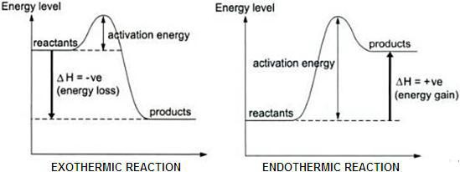

For example, when carbon reacts with oxygen, heat is evolved. C(s) + O2(g) → CO2(g) ∆H = - 393kJ

The chemical energy in carbon and oxygen is partly transferred to chemical energy in carbon dioxide and partly evolved as heat. Thus carbon dioxide has less energy than the starting materials, carbon and oxygen (figure 10.2). Therefore the value of enthalpy change is negative.

An **endothermic reaction** is one during which heat is absorbed from the surroundings. When an endothermic reaction occurs, the heat required for the reaction is taken from the reacting materials and the temperature of the products falls below the initial temperature. Eventually, the temperature of the products raises to room temperature again as heat is absorbed from the surroundings. In this case, the heat content of the products is greater than that of the reactants and the enthalpy change is positive.

i.e. ∆H = H products - H reactants

∆H = H2 – H1

Since H2> H1, then ∆H is positive. Figure 10.3 illustrates an energy level diagram for an endothermic reaction. The units for enthalpy change are kilo joules per mole (kJ mol-1)

For example, when hydrogen reacts with iodine, heat is absorbed from the surroundings. H2 (g) + I2(g) → 2HI(g) ∆H = +52 kJ

Hydrogen iodide has more energy than the starting materials, hydrogen and iodine (figure 10.4). Therefore the value of enthalpy change is positive.

### Exercise

1. State which of the following processes is endothermic and which is exothermic.
2. The breaking of a chemical bond.
3. The formation of a chemical bond.
4. State whether the following reactions are endothermic or exothermic.

(a) H+(aq) + OH-(aq) → H2O(l) ∆H = -57.3 kJ mol-1

(b) C(s) + 2S(l) →CS2 (l) ∆H = + 177 kJ mol-1

### Types of enthalpy changes

**1. Enthalpy of combustion**

Enthalpy of combustion is the enthalpy change that occurs when one mole of a substance burns completely in oxygen. The ∆H valves are always negative because heat is always evolved. For example, the enthalpy of combustion of carbon is -393 kJ mol-1.

C(s) + O2(g) → CO2(g) ∆H = -393 kJ mol-1

### Example: Enthalpy of combustion

Carbon undergoes complete combustion according to the equation. C(s) + O2(g) → CO2(g) ∆H = -393 kJ mol-1

How much heat is given out when 20 g of carbon are completely burnt? Solution:

12 g of carbon burn to give 393 kJ. 1 g of carbon burns to give 393 kJ.

12

20 g of carbon burn to give 393 x 20

12

= 655 kJ

### Determination of enthalpy (heat) of combustion of ethanol

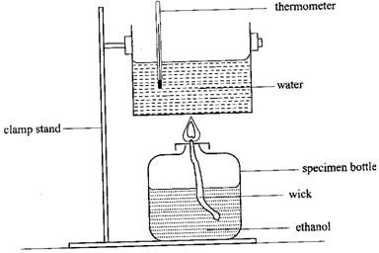

A thin walled tin can is filled with a known volume of water. Ethanol is added to a specimen bottle and a wick is filled in a cork through the bottle‘s mouth. The specimen bottle with its contents is weighed and its mass is recorded. The apparatus is set up as shown in figure 10.5. The initial temperature of the water is recorded and the wick is lighted to heat the water. The water is stired carefully with the thermometer. When the thermometer shows a convenient temperature rise, the flame is blown off and the highest temperature reached is recorded. The bottle and its contents is reweighed after cooling. A tin can is a good conductor of heat and transmits most of the heat directly to the water.

Specimen results:

Initial temperature of water = 24oC Final temperature of water = 40oC Volume of water in the can = 100 cm3

Mass of bottle + ethanol before burning = 32 g Mass of bottle + ethanol after burning = 30 g

Calculations:

Heat energy absorbed by the water = mcθ

Where m = mass of the water.

c = specific heat capacity of the water.

∆θ = temperature rise.

Mass of water, m = density x volume But density of water = 1 g/cm3

m = 1 x 100 = 100 g c = 4.2 J g-1 oC-1

∆θ = 40 – 24 = 16oC

Energy absorbed by water = 100 x 4.2 x 16 = 6720 J Mass of ethanol burnt = 32 – 30 = 2 g

Molar mass of ethanol (C2H5OH) = (12 X 2) + (5 X 1) + 16 + 1 = 46 g 46 g of ethanol contain 1 mol.

2 g of ethanol contain 1 x 2mol.

46

= 0.044 mol.

0.044 mol of ethanol completely burn to give 6720 J. 1 mol of ethanol would burn to give 6720 J.

0.044

= 152727 J or 152.7 kJ

The enthalpy of combustion of ethabol is -152.7 kJ mol-1.

The value obtained in this experiment is not very accurate because of heat losse to surroundings.

### Exercise

1. The following reaction takes place when methanol is burnt in oxygen. 2CH3OH(l) + 3O2(g) → 2CO2(g) + 4H2O(g) ∆H = -1452 Kj mol-1
   1. Is this reaction endothermic or exothermic?
   2. How much heat energy would be liberated by burning
      1. 4 mol of methanol?
      2. 4 g methanol?
2. (a) Write an equation for the combustion of methane in
3. Excess oxygen.
4. Limited oxygen supply.
   1. When 11.5 g of methane are burnt in excess oxygen, 640 kJ of heat are produced.

Calculate the

* + 1. Heat of combustion of methane.
    2. Volume of methane at room temperature that will burn to produce 1560kJ.
    3. Mass of methane that will burn to produce 1060 kJ.
    4. Heat evolved when 4 mol of methane are burnt.
    5. Heat evolved when 32 g of methane are burnt.

1. When 23.6 g of butane were burnt, the heat produced raised the temperature of 50 g of water from 30oC to 40oC.
   1. Write an equation for the complete combustion of butane.
   2. Calculate the heat of combustion of butane.

### 2. Enthalpy of solution

The enthalpy of solution is the enthalpy change that occurs when one mole of a substance is dissolved in sufficient amount of water such that no further heat change occurs on dilution. When one mole of sulphuric acid dissolves in water, heat is evolved. The reaction is exothermic and therefore the enthalpy of solution is negative. Some reactions are endothermic. For example, when sodium chloride dissolves in water, heat is absorbed and therefore the enthalpy of solution is positive.

### Determination of the enthalpy (heat) of solution o f sodium chloride

A known volume of water is palced in a plastic cup and its temperature recorded. A known mass of sodium chloride is added to the water. Carefully water is stirred with a stirrer and the lowest temperature of the solution is recorded.

### Specimen results:

Volume of water = 100 cm3 Mass of sodium chloride = 31 g Initial temperature = 24 oC

Final temperature = 19.27 oC

### Calculations:

Heat evolved = ∆θ

Mass = density x volume

Mass of water = 1 x 100 = 100 g Total mass of solution = 100 + 31 = 131 g Temperature change, ∆θ = 24 – 19.27 = 4.73 oC

Assuming the specific heat capacity of the solution is 4.2 J g-1 oC-1 Heat evolved = 131 x 4.2 x 4.73 = 2602 J or 2.602 kJ Molar mass of NaCl = 23 + 35.5 = 58.5 g

58.5 g of sodium chloride contain 1 mol. 31 g of sodium chloride contain 1 x 31mol

58.5

= 0.53 mol

0.53 mol of sodium chloride absorbed 2.602 kJ 1 mol of sodium chloride would absorb 2.602 kJ

0.53

Enthalpy of solution of sodium chloride is +4.91 kJ/mol.

This value is less than the accurate valuw, +4.97, because of the experimental errors.

### Exercise

1. The heat of solution of sulphuric acid is -70kJmol-1. Calculate the mass of sulphuric acid that will evolve 350 kJ of heat when sulphuric acid is dissolved in water.
2. When 231 g of ammonium nitrate were dissolved in water, 75 kJ of heat were absorbed. Calculate the heat of solution of ammonium nitrate.

### Enthalpy of neutralization

Enthalpy (heat) of neutralization is the enthalpy change that occurs when one mole of aqueous hydrogen ions reacts with one mole of aqueous hydroxide ions to form one mole of water.

H+(aq) + OH-(aq) → H2O(l)

The enthalpy of neutralization of any strong acid and strong alkali is -57.3kJ mol-1 and is constant. This is because the acids and alkalis and the salt produced in the reaction are completely ionized in solution and the net reaction is the formation of water molecules. The enthalpy of neutralization of a weak acid or alkali is less than 57.3 kJ mol-1 and is not constant. This is because weak acids or alkalis are partly ionized in aqueous solution. Some heat is absorbed for complete ionization of the acid or alkalis in order for neutralization to occur. The enthalpy (heat) of ionization affects the overall enthrapy change.

### Determination of heat of neutralization

A known volume of 1 M sodium hydroxide is placed into a placed into a plastic cup. It is stired with a stirrer and its temperature, θ1, recorded. An equal volume of 1 M hydrochloric acid is added to the sodium hydroxide after taking its temperature, θ2. The mixture is stirred well with a stirrer and the highest temperature, θ3, attained by the mixture is recorded.

### Specimen Results:

Volume of 1 M hydrochloric acid = 50 cm3 Volume of 1 M sodium hydroxide = 50 cm3 Temperature of 1 M sodium hydroxide θ1 = 25 oC

Temperature of 1 M hydrochloric acid, θ2 = 24 oC Temperature after mixing, θ3 = 30.83 oC

### Calculations:

Heat evolved (enthalpy change) = mc∆θ

Total volume of solution after mixing = 50 + 50 = 100 cm3 Mass = density x volume

Assuming the density of the solution is 1 g/cm3 Mass of the solution = 1 x 100 = 100 g

Initial temperature (average temperature) = θ1+θ2 = 24 + 25

2 2

= 24.5 oC

Temperature rise = 30.83 – 24.5 = 6.33oC

Assuming the specific heat capacity of a mixture is 4.2 J g-1oC-1 heat evolved = 100 x 4.2 x 6.33

= 2658.6 J or 2.66 kJ

1000 cm3 of sodium hydroxide contain 1 mol 50 cm3 of sodium hydroxide contain = 1 x 50

1000

0.05 mol of sodium hydroxide evolve 2.66 kJ

= 0.05 mol

1 mol of sodium hydroxide would evolve 2.66 kJ

0.05

Heat of neutralization is -53.2kJ/mol

The valve obtained is not very accurate because of experimental errors.

### Exercise

1. 80 cm3 of 1 M nitric acid and 80 cm3 of 1 M sodium hydroxide, both at 25 oC were mixed in a plastic beaker. The mixture was stirred and its maximum temperature was 31.34 oC. (specific heat capacity of the solution = 4.2J/g/oC, density of the solution = 1 g/cm3)
   1. Write the ionic equation for the reaction which took place.
   2. Calculate the
      1. Number of moles contained in 80 cm3 of 1 M sodium hydroxide.
      2. Heat evolved when 80 cm3 of 1 M sodium hydroxide react with 80 cm3 of 1 M nitric acid.
      3. Heat neutralization.
2. Aqueous hydrogen ions react with aqueous hydroxide ions according to the equation. H+(aq) + OH-(aq) – H2O(l) ∆H = 57 kJ mol-1

How much energy is released if

1. 4 mol of hydrogen ions are neutralized?
2. 0.25 mol of hydrogen ions are neutralized?
3. 2 mol of sulphuric acid are completely neutralized.

### Enthalpy of displacement

When zince is added to copper(II) sulphate solution, a displacement reaction occurs. Usually during such reactions heat is evolved.

Zn(s) + CuSO4(aq) → Cu(s) + ZnSO4(aq) or Zn(s) + Cu2+(aq) → Cu(s) + Zn2+(aq)

### Determination of the enthalpy (heat) of displacement of the reaction between copper(II) sulphate solution and zinc

50 cm3 of 0.5 M copper(II) sulphate solution is placed in a plastic beaker. The initial temperature of the solution is recorded. About 2 g of zinc powder is added to copper(II) sulphate solution in the plastic beaker. The mixture is stirred carefully with a thermometer and the highest temperature attained is recorded.

### Specimen Results:

Volume of copper(II) sulphate solution = 50 cm3

Intial temperature = 25.0 oC Final temperature = 28.5 oC

### Calculations:

Heat evolved = mc∆θ Mass = density x volume

Assuming the density of the solution is 1 g/cm3. Mass of the solution = 1 x 50 = 50 g

Assuming the specific heat capacity of the solution is 4.2 Jg-1oC-1 Heat evolved = 50 X 4.2 X (28.5 – 25) = 735 J

1000 cm3 of copper(II) sulphate solution contain 0.5 moles 50 cm3 of copper(II) sulphate = 0.5 x 50

1000

= 0.025 mol

Zn(s) + CuSO4(aq) → ZnSO4(aq) + Cu(s)

The reaction mole ratio of zinc to copper(II) sulphate is 1:1 Moles of zinc that reacted = 0.025 mol

0.025 mol of zinc evolve 735 J

1 mol of zinc would evolve 735 J

0.025

= 29400 J or 29.4 kJ

Heat of displacement is -29.4 kJ/mol.

### Exercise 10.5

1. The amount of ehat evolved when 16 g of copper was displaced from the solution by 2.4 g metal, Q, was 720 kJ. Calculate the heat of displacement. (Q = 24)
2. Iron reacts with copper(II) ions according to the equation. Cu2+(aq) + Fe(s) → Cu(s) + Fe2+(aq) ∆H = -151 kJ mol-1

Calculate the mass of iron that will cause a heat change of -170 kJ.

1. (a) When methane burns in oxygen, heat is produced. Write an equation for the combustion of methane in excess oxygen.

(b) The heat of combustion of methane is -890 kJ mol-1. calculate the volume of methane gas at s.t.p that when burned in excess oxygen would raise the temperature of 178 g of water by 10 oC.

1. (a) Bio gas contains mainly methane. Name two raw materials that can be used to produce biogas.

(b) Methane burns in oxygen according to the equation:

CH4(g) + 2O2 (g) → CO2 (g) + 2H2O(g) ∆H = -890 kJ/mol

Calculate the volume of methane at s.t.p. that will burn in excess oxygen to produce 2670kJ.

1. The enthalpy of combustion of carbon is -393 kJ mol-1.
   1. Write an equation for the complete combustion of carbon.
   2. 80kg of charcoal cost 4,000/=. Calculate the cost of charcoal required to produce 16735kJ.
2. (a) Describe an experiment that can be carried out to determine the heat of combustion of ethanol. Draw a diagram to illustrate your answer.
3. Would you expect the heat of combustion as determined in the experiment in (a) to be greater than, lower than or equal to the theoretical value. Give a reason for your answer.
4. When 0.382 g of ethanol was burnt, the heat evolved raised the temperature of 100 g of water from 16.0 oC to 43.0 oC. Calculate the heat of combustion of ethanol.
5. Name two products, other than water of incomplete combustion of ethanol.
6. (a) 50 cm3 of 2 M hydrochloric acid and 50 cm3 of 2 M sodium hydroxide, both at 22 oC, were mixed in a plastic beaker. The mixture was stirred and its maximum temperature was 35oC. (specific heat capacity of the solution = 4.2 J/g oC, density of the solution = 1 g/cm3)
7. Write an ionic equation for the reaction which took place.
8. Calculate the heat of the reaction.

(b) 50 cm3 of 2 M ammonia solution was used instead of sodium hydroxide solution in (a). State whether the heat of the reaction was greater than, smaller than or equal to the value you have calculated in (a) (ii). Give a reason for your answer.

1. (a) Write an equation to show how ethanol can be prepared form glucose.
2. State how a sample of ethanol obtained from the product of the reaction in (a) can be purified.
3. When 23 g of ethanol was completely burnt, 13600 J of heat was produced. Calculate the molar heat of combustion of ethanol.
4. 7.5 g of methane, CH4 was completely burnt in air. Methane burns in air according to the following equation:

CH4(g) + 2O2(g) → CO2(g) + 2H2O(g) ∆H = 890 kJ mol-1

Calculate the

1. Mass of carbon dioxide formed.
2. Heat evolved.
3. When 6.4 g of zinc powder were added to 250 cm3 of a 0.1 M copper(II) sulphate solution in a plastic cup, 5.45 kJ of heat was liberated.
   1. Explain why a plastic cup was used instead of a metallic cup.
   2. Write an equation for the reaction between zinc powder and copper(II) sulphate.
   3. Calculate the
      1. Number of moles of zinc in 6.5 g of zinc powder.
      2. Number of moles of zinc which reacted with copper(II) sulphate.
      3. Heat energy produced when 1 mole of zinc reacts with 1 mole of copper(II) sulphate.
4. The formation of methanol from hydrogen and carbon monoxide is represented by the equation.

2H2(g) + CO(g) → CH3OH(g) ∆H = -92 kJ/mol

What would be the energy released in kJ mol-1, when 3.2 g of methanol is formed?

1. An experiment was carried out to determine the molar heat of combustion of methanol. A small lamp containing methanol was weighed and then lit. The heat produced by the combustion of methanol was used to raise the temperature of 100 g of water in a metal can (ignore the heat required to raise the temperature of the metal can). The spirit lamp was weighed again after the experiment.

### Results:

Mass of the spirit lamp + contents before heating = 36.17 g.

Mass of the spirit lamp + content after heating = 34.07 g. Temperature of the water before the ecperiment = 20 oC. Temperature of the water after the experiment = 80 oC.

* 1. What was the rise in temperature of water during the experiment?
  2. Calculate the amount of heat obtained by the water during the experiment.
  3. What mass of methanol was burnt during the experiment?
  4. Calculate the heat produced when
     1. 1 g of methanol was burnt.
     2. 1 mol of methanol (CH3OH) molecules is burnt.

1. The following pairs of compounds were reacted together and the maximium temperature rise was recorded for each reaction.
2. 200 cm3 of 2 M sodium hydroxide and 200 cm3 of 2 M ethanoic acid.
3. 200 cm3 of 2 M ammonia solution and 200 cm3 of 2 M ethanoic acid.
4. 200 cm3 of 2 M sodium hydroxide and 200 cm3 of 2 M hydrochloric acid.
5. State the pair which showed the
   1. Highest temperature.
   2. Lowest temperature.
6. Explain your answer in (a) (ii).

### 28. Rate of reaction and equilibrium

* 1. **Rate of reaction**

Some reactions proceed very fast. For example, when aqueous ammonia is added to a solution of lead(II) salts, a white precipitate forms immediately. Some reactions proceed at moderate speed. For example, it takes sometime for the reaction between calcium carbonate and dilute hydrochloric acid to come to completion. Other reactions are slow. For example, it takes iron a few days to rust in moist air. The above mentioned reactions proceed at different rates.

The rate of a chemical reaction is the progress of the reaction in unit time. In other words, the rate of a chemical reaction is the rate at which products are formed or the rate at which reactants are used up in the reaction.

Rate of reaction = concentration in moles per litre

time in seconds

Units for the rate of reaction are moles/litre/second i.e mol/l/s.

### Determination of rate of reaction

Let us consider the reaction between magnesium and dilute hydrochloric acid. Mg(s) + 2HCl (aq) → MgCl2 (aq) + H2(g)

The determination of the rate of this reaction can be done by either measuring the volume of hydrogen evolved with time or by measuring the time a given length of magnesium ribbon takes to dissolve in varying concentrations of the acid.

### Determination of rates of reaction by measuring the volume of the gas evolved with time

A known mass of magnesium and a known volume of dilute hydrochloric acid in a test-tube tied with a thread, are placed in a conical flask and the experiment is set up as shown in figure 11.1. The stopper is opened for a moment so that thread is free. The test-tube drops pouring hydrochloric acid into the conical flask. At the same time, the clock is started. The volume of hydrogen in the syringe is recorded at regular intervals until the reaction is complete.

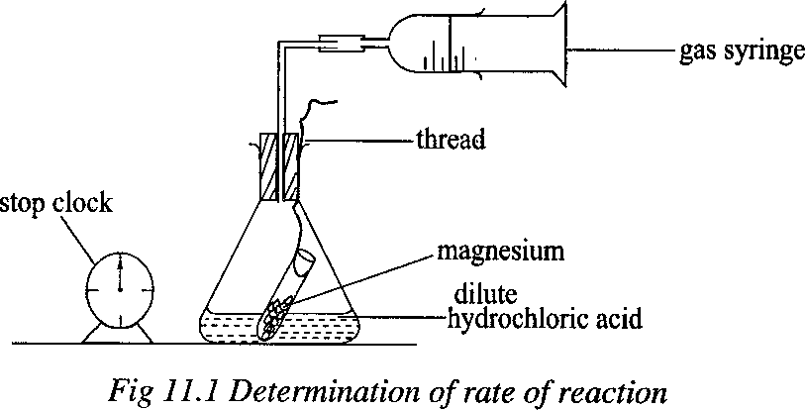

A graph of volume of hydrogen evolved against time is plotted. A typical graph has the form of figure 11.2.

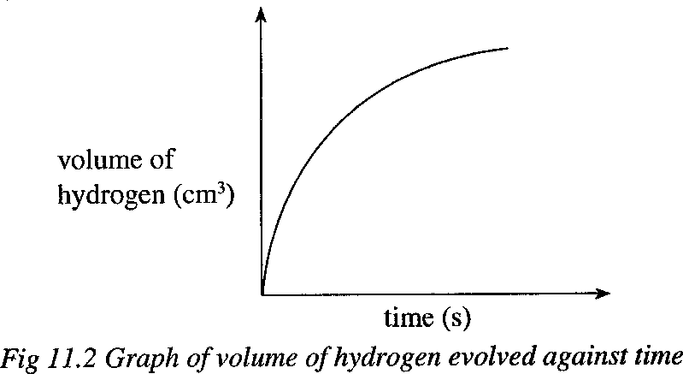

To determine the rate of reaction at a given time, say t1, the tangent to the curve is drawn at that time as shown in figure 11.3. The gradient of the tangent is the rate of reaction at that time, that is y/x. the units are cm3/s.

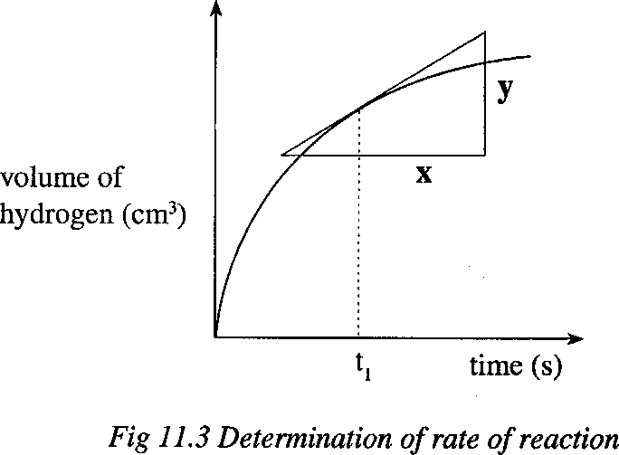

### Exercise

In determination of the rate of reaction, 10 g of calcium carbonate were reacted with dilute hydrochloric acid. The mass of the flask and its contents was weighed with time.

1. Write the equation for the reaction that took place.
2. Sketch a graph of mass of flask and its contents against time.

### Factors affecting the rate of chemical reactions

Factors which affect the rate of a chemical reaction are concentration, temperature, surface are (particle size), pressure, catalyst and light. You are required to perform various experiments to investigate the effect of these factors on the rate of chemical reactions.

### 1. Effect of concentration of reactants on the rate of reaction

The rate of the reaction depends on the frequency with which reacting particles collide, which frequency depends on the concentration of the reactants. The higher the concentration, the higher the frequency of collision and therefore the higher the rate of the chemical reaction.

### Experiment:

**Investigation of the effect of concentration on the rate of the reaction**

Make a mark with blue or black ink on a piece of paper. Place 50 cm3 of 0.05 M sodium thiosulphate solution into a beaker. Add 10 cm3 of 1 M hydrochloric acid to the sodium thiosulphate and at the same time start the stop clock. Gently shake the mixture to mix the solution well and place the beaker on the paper over the mark. Watch the mark through the solution from above the beaker. Stop the clock when the mark just disappears. Vary the concentration of the thiosulphate solution by taking 40, 30, 20 and 10 cm3 each time by adding distilled water. Tabulate your results including 1/time. Plot graphys of

volume of sodium thiodulphate solution against 1/time (time-1) and against time. The rate of reaction is proportional to the reciprocal of time (time-1). Your graphs should appear as shown in figure 11.4a and 11.4b.

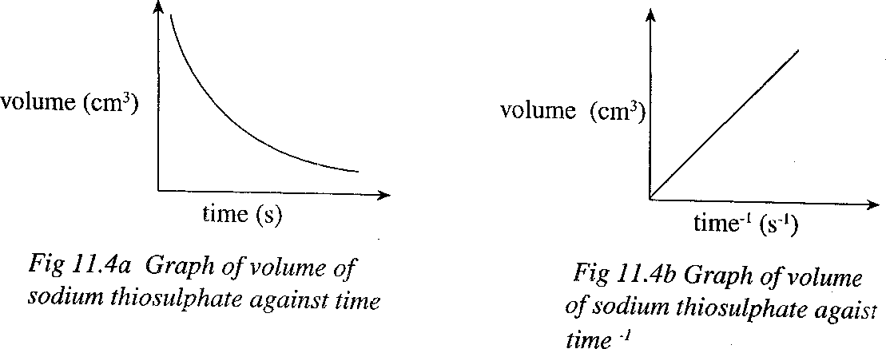

The mark disappears becaue the reaction between hydrochloric acid and sodium thiosulphate forms a precipitate of sulphur which renders the mixture opaque.

NaS2O3(aq) + 2HCl(aq) → 2NaCl(aq) + S(s) + H2O(l) + SO2(g)

Figure 11.4a shows that the higher the volume of the sodium thiosilphate, the less the time taken to form a precipitate. Figure 11.4b shows that the rate of the reaction increases with increase in volume of sodium thiosulphate solution.

### Exercise

Magnesium was reacted with excess dilute sulphuric acid.

1. Write an equation for the reaction that took place.
2. On the same axis, sketch a graph of volume of hydrogen evolved against time when equal volumes the following are reacted with the same mass of magnesium.
   1. 0.5 M sulphuric acid.
   2. 2 M sulphuric acid.
3. On the same axis, sketch a graph of volume of hydrogen evolved against time when the following are reacted with the same concentration and volume of sulphuric acid.
   1. 10 g of magnesium.
   2. 50 g of magnesium.

### Effects of temperature on the rate of reaction

When the temperature is increased, the reacting particles gain more kinetic energy and move at a greater speed. The frequency at which the reacting particles collide increases and thus the rate of the reaction increases. Therefore, the higher the temperature, the higher the rate of reaction.

### Investigation of the effect of temperature on the rate of reaction

The previous experiment can be repeated by reacting sodium thiosulphate solution and hydrochloric acid at varying temperatures, using the same concentration of the thiosulphate. Put a test-tube containing 1 M hydrochloric acid into a beaker of water maintained at 30 oC. After sometime, add at the same time start of 0.05 M sodium thiosulphate solution in a beaker and at the same time start mark. Note the time taken for the mark to disappear. The experiment is repeated using different temperatures. Tabulate your results including 1/time. Plot graphs of temperature against 1/time. The shapes of typical graphs are shown in figure 11.5a and 11.5b.

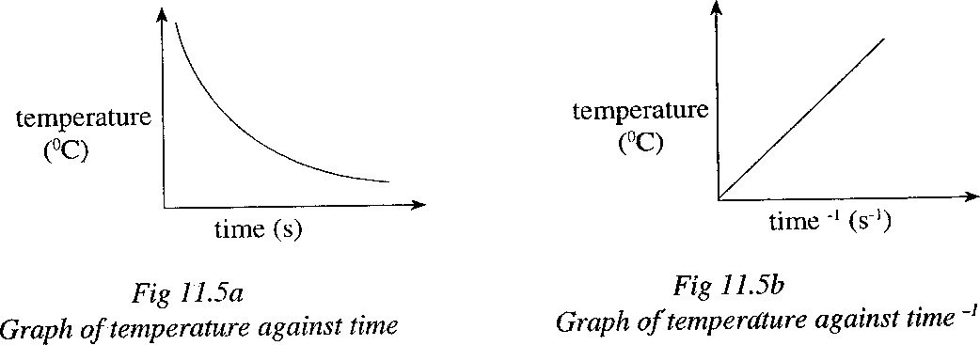

Figure 11.5a shows that the higher the temperature the less the time taken to form a precipitate. Figure 11.5b shows that the rate of the reaction increases with increase in temperature.

### Exercise

Sodium sulphite solution was added to dilute sulphuric acid.

1. Write an equation for the reaction that took place.
2. On the same axis, sketch a graph of volume of sulphur dioxide against time when the reaction was carried out at
   1. 24 oC.
   2. 40 oC.

### Effect of a catalyst on the rate of reaction

A catalyst is a substance which alters the rate of chemical reactions without undergoing any overall chemical change itself. Most catalysts speed up the rate of reaction. The greater the amount of the catalyst but within the limits, the higher the rate of reaction. Powdered catalysts offer a larger surface area over which the reaction takes place and therefore are more effective than one in lump form. Catalysts remain unchanged chemically after a reaction has taken place. Catalysts are very specific to a particular chemical reaction. A catalyst which slows down a reaction is called a negative catalyst.

### Investigation of the effect of catalyst on the rate of reaction

Place 100 cm3 of 0.1 M hydrogen peroxide in a conical flask. Add 0.5 g of manganese(IV) oxide to the hydrogen peroxide in conical flask. Then set up the experiment as shown in figure 11.1. record the volume of oxygen in the syringe at regular intervals unitl the reaction is complete. Repeat the experiment using 1 g of manganese(IV) oxide. When the

graphs of volume of oxygen against time are plotted using the same axes, they appear as shown in figure 11.6.

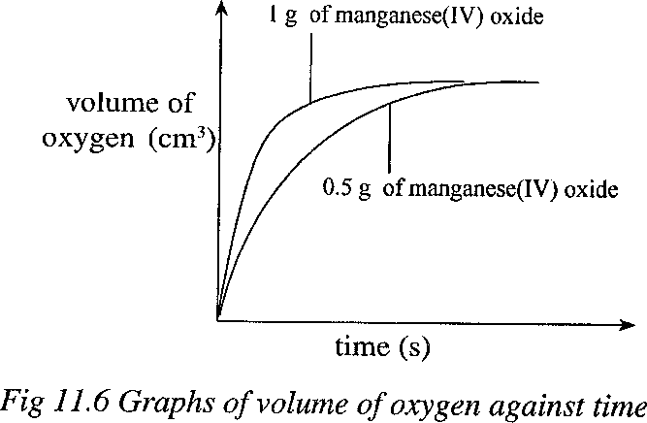

### Exercise

1. Name the catalysts used in the following processes/reactions.
   1. The contact process.
   2. The Haber process.
   3. The decomposition of hydrogen peroxide.
   4. Hydrogenation of oils to form fats.
2. Potassium chlorate decomposes according to the following equation. 2KClO3(s) → 2KCl(s) + 3O2(g)
3. Name the catalyst that may be used in this reaction.
4. On the same axis, sketch a graph of volume of oxygen evolved against time when
   1. The catalyst is not used.
   2. 0.5 g of the catalyst are used.

### Effect of surface area on the rate of reaction

Solid react much more rapidly when powdered than when in large lumps. This is because reactions with solids take place at the surface. Powdered solids present a large surface area over which the reaction occurs than solids in lump form.

### Investigation of the effect of surface area on the rate of reaction

Pour 20 cm3 of 1 M hydrochloric acid in a test-tube. To the conical flask add 10 g of calcium carbonate lumps and then set up the experiment as shown in figure 11.1. Record the volume of carbon dioxide in the syringe at regular intervals until the reaction is complete. Repeat the experiment using the same mass of powdered calcium carbonate. When the graphs of volume of carbon dioxide against time for both powdered calcium carbonate and calcium carbonate lumps, are plotted using the same axes, they appear as shown in figure 11.7.

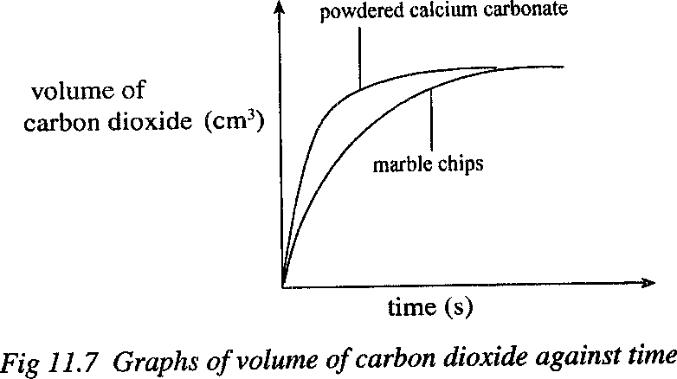

### Exercise

1. Calcium carbonate lumps were mixed with dilute nitric acid in a conical flask. The mass of the flask and its contents was weighed with time.
   1. Write the equation for the reaction that took place.
   2. (i) Sketch a graph of mass of flask and its contents against time. Label the graph A.

(ii) On the same axis, sketch the graph that would be obtained when powdered calcium carbonate is used instead of calcium carbonate lumps. Label the graph B.

1. (a) Which one of the following reaction mixtures will produce hydrogen more quickly at room temperature?
2. Magnesium ribbon + dilute sulphuric acid.
3. Magnesium powder + dilute sulphuric acid.
4. Give a reason for your answer in (a).
5. Suggest two other methods by which the rate of this reaction can be altered.

### Effect of light on the rate of reaction

Some reactions are photosensitive, that is, their rates are affected by light.

### Investigation of the effect of light on the rate of reaction

Add 1 cm3 of sodium chloride solution to two test-tubes. To each test-tube add a few drops of silver nitrate solution. Immediately, a white precipitate forms. Put one test-tube in a dark cup board and the other in sunlight for about 4 minutes. Record your observations.

Sodium chloride solution forms a white precipitate with silver nitrate solution according to the equation.

Ag+(aq) + Cl-(aq) → AgCl(s)

In presence of light, the precipitate darkens because of the decomposition of silver chloride to solver and chlorine. In absence of light, the precipitate remains white.

2AgCl(s) → 2Ag(s) + Cl2(g)

The effects of light on hydrogen peroxide and concentrated nitric acid explain why they are stored in dark-glass bottles.

### Effect of pressure on the rate of reaction

A change in pressure only affects reactions which occur in the gas phase. When pressure of a gaseous mixture is increased, the gases are compressed. This brings the reacting particles together and thus increases the frequency at which the reacting particles together and thus increases the frequency at which the reacting particles collide hence increased rate of reaction.

### 29. Equilibrium

Equilibrium is the point in a reversible reaction when the rate at which the reactants are forming the products is equal to the rate at which the products are dissociating to the reactants. Therefore, at equilibrium, both the products and the reactants are present. A reversible reaction is one which proceeds in both directions, that is, forward and backward.

### 29.1. Factors affecting equilibrium

The factors that affect equilibrium are temperature, pressure, concentration and catalyst. The effect of these factors on equilibrium was first investigated by Louise Le Chatelier who came up with a principle known as **Le chatelier’s principle.** The principle states that when a chemical equilibrium reaction is distributed externally by a change in one of the factors upon which it depends, the equilibrium shifts in a direction so as to reduce the effects of the change.

### Temperature

Consider the Haber process where the reaction is exothermic. 3H2(g) + N2(g) → 2NH3(g) ∆H = 93.63 kJ mol-1

The forward reaction is exothermic and therefore the backward reaction is endothermic. If heat is supplied, the equilibrium shifts in the direction which requires more heat, that is, the backward reaction which uses up the excess heat occurs. However, if the equilibrium vessel is cooled, the equilibrium shifts to the right, producing more ammonia.

### Pressure

In a gaseous system, an increase in pressure leads to a decrease in the volume of the gases involved and the reverse is true. Let us again consider the Haber process.

N2(g) + 3H2(g) → 2NH3(g)

One volume of nitrogen combines with three volumes of hydrogen to produce two volumes of ammonia. The forward reaction occurs with a decrease in volume from four to two volumes. If additional pressure is applied to the system, the equilibrium shifts in the direction of a reduction in volume, that is, the forward reaction is favoured and more ammonia is produced. If pressure of the system is decreased, the equilibrium shifts in the direction of an increase in volume, that is, the backward reaction occurs and more of the reactants are produced. Gaseous equilibrium reactions which are not accompanied by a change in volume, are not affected by pressure changes e.g

N2(g) + O2(g) → 2NO(g)

### Exercise

Consider the following reaction equations: H2(g) + I2(g) → 2HI(g) ∆H = +52 kJ mol-1

3H2(g) + N2(g) →2NH3(g) ∆H = 93.63 kJ mol-1

What will be the effect on the concentration of hydrogen iodide and ammonia in the equilibrium mixture of

* 1. Increasing the temperature?
  2. Decreasing the temperature?
  3. Increasing the pressure?
  4. Decreasing the pressure?

### Concentration

If the concentration of one of the substances present in an equilibrium reaction is changed, the equilibrium shifts in the direction of a decrease in the concentration of the added substance. Consider the following reaction.

N2(g) + O2(g) → 2NO(g)

If extra oxygen is pumped into the reaction vessel, the equilibrium shifts in the direction that results in a decrease in oxygen concentration, that is, the forward reaction occurs and more nitrogen monoxide is produced. If the concentration of one of the reactants decreases instead of increasing, the equilibrium will shift to cancel this decrease and the backward reaction will occur to restore the balance. If more of nitrogen monoxide is added to the equilibrium mixture, the backward reaction will occur producing more reactants, that is, the equilibrium shifts to the left in order to offset the effect of the increase in concentration of nitrogen monoxide. If there is a decrease in the concentration of nitrogen monoxide, the forward reaction is favoured and the equilibrium shifts to the right producing more nitrogen monoxide.

### Catalyst

Catalysts do not have any effect on the position of the equilibrium. In an equilibrium reaction, a catalyst increases the rate of both the forward and backward reactions, that is,

a catalyst enables an equilibrium to be attained much more quickly than when there is no catalyst.

### Industrial applications of chemical equilibrium

This idea of equilibrium is applied in some industrial process. In the Haber process, ammonia is synthesized from nitrogen and hydrogen according to the equation.

N2(g) + 3H2(g) → 2NH3(g) ∆H = -93.63 kJ mol-1

Ammonia is produced with a decrease in volume and therefore high pressure will increase the yield of ammonia. The reaction is exothermic therefore low temperature will favour the production of ammonia. However, by lowering the temperature, the rate of the reaction is reduced. The presence of a catalyst will give a sufficient reaction rate despite the relatively low temperature. In general, a maximum yield of ammonia is obtained by using the following conditions.

* 1. Very high temperature of 250 to 500 atmospheres.
  2. Temperature of about 450 oC.
  3. Catalyst of finely divided iron.

Aluminium oxide is added to make the catalyst more porous hence promoting its effectiveness.

### Exercise

1. The graph below shows the effect of temperature on the rate the reaction between calcium carbonate of the same mass and excess 2 M hydrochloric acid.

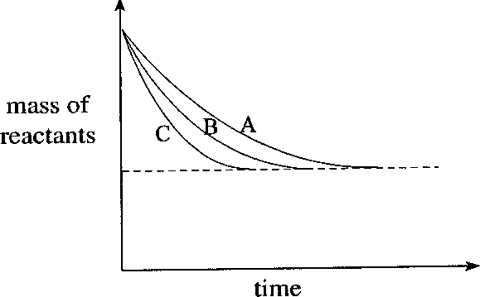

* 1. If curve B is for the reaction at 40 oC, which curve shows the reaction taking place at
     1. 20 oC
     2. 60 oC
  2. Explain why the curves eventually end at the same level.
  3. State one other method that can be used to measure the rate of the reaction between calcium carbonate and hydrochloric acid.

1. A certain mass of zinc powder was reacted with dilute hydrochloric acid at room temperature.
   1. (i) Write an equation for the reaction.

(ii) Draw a graph to show how the volume of the gaseous product varied with time.

* 1. What would be the effect of
     1. Adding copper(II) sulphate solution to the reaction mixture at room temperature?
     2. Using the same mass of zinc granules instead of the zinc powder?
  2. Give a reason for your answer in (b) (ii).

1. 12.0 g of clean magnesium ribbon were added to 50 cm3 of 1 M sulphuric acid. The volume of the gas evolved was measured at fixed time interval until the reaction stopped.
   1. Write the equation of the reaction that took place.
   2. (i) sketch a graph of volume of the gas (on y-axis) against time (on-axis). Label the graph G1.

(ii) On the same axis sketch the graph that would be obtained if 12.0 g of magnesium powder were used instead of magnesium ribbon. Label this graph G2.

* 1. (i) Give a brief explanation of the cause of difference in the graphs G1 and G2.

(ii) Name one other factor that can cause similar results as in b(i) above.

1. (a) 12 g of large pieces of calcium carbonate were reacted with 50 cm3 of 2 M hydrochloric acid at room temperature. The decrease in mass was measured at regular intervals.
2. Write an equation for the reaction.
3. Sketch a graph to show variations of decrease in mass with time.
4. State what would be observed if the same mass of calcium carbonate powder was used instead of the large pieces. Give a reason for your answer.
5. State what would be observed if the same mass of large pieces of calcium carbonate was used at 40 oC. Give a reason for your answer.
6. Which of the two reactants was in excess?
7. The figure 11.11 shows the set up of the experiment used to study the rate of evolution of a gas when 1.0g of powdered calcium carbonate was reacted with 50cm3 of 2 M hydrochloric acid at 25 oC.

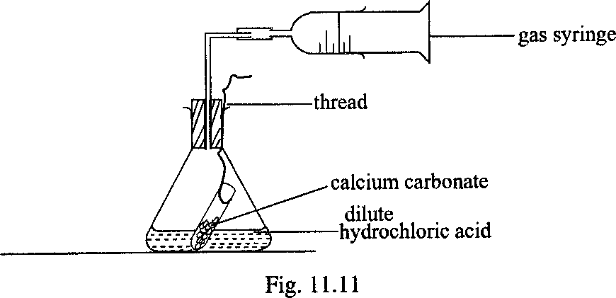

* 1. Sketch a graph to show the variation of the volume of the gas evolved in the reaction with time. Describe the shape of the graph.
  2. On the same diagram in (a) above sketch a graph to show the results obtained when
     1. 1.0 g of powdered calcium carbonate was reacted with 100 cm3 of 1 M hydrochloric acid at 25 oC.
     2. 1.0 g of powdered calcium carbonate was reacted with 50 cm3 of 2 M hydrochloric acid at 25 oC.
  3. Explain the shapes of the graphs you have sketched in (b) (i) and (ii) above.
  4. 1.0 g of powdered calcium carbonate was reacted with 20 cm3 of 2 M hydrochloric acid. Which one of the reactants was in excess?

1. When a certain volume of 0.1 M hydrochloric acid was reacted at room temperature with excess of iron filings, a gas was produced.
   1. Draw a labeled diagram to show how the rate of reaction was determined.
   2. Write equation for the reaction that took place.
   3. Draw a sketch graph of the volume of the gas evolved against time.
   4. State how the rate of reaction would change if the reactions was carried out at a temperature above room temperature.